**Write a map reduce program to join the below given two datasets using Reducer side join.**

**Dataset1.csv**

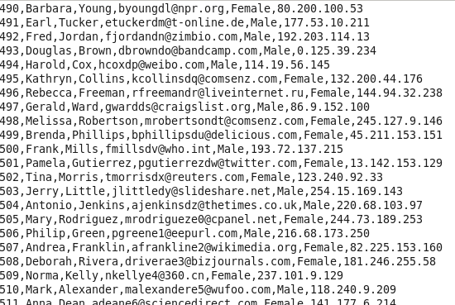

**Dataset2.csv**

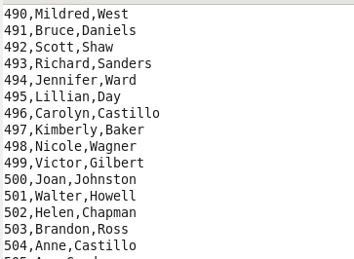

**Driver**

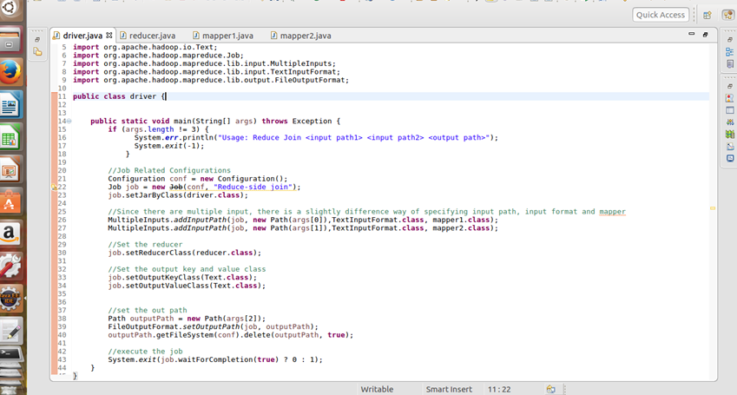

**Mapper 1**

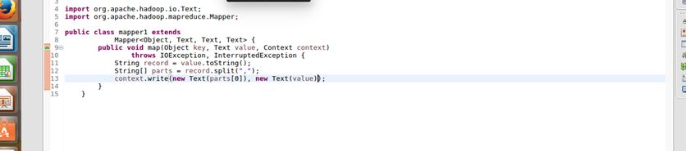

**Mapper 2**

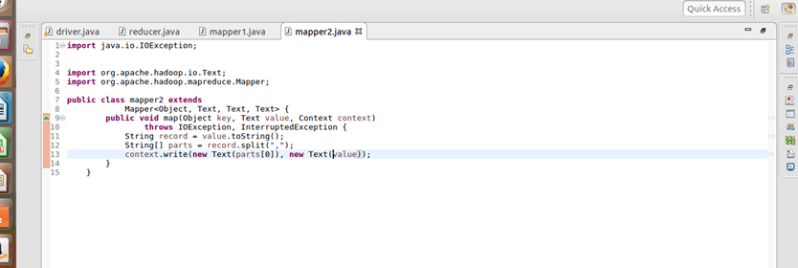

**Reducer**

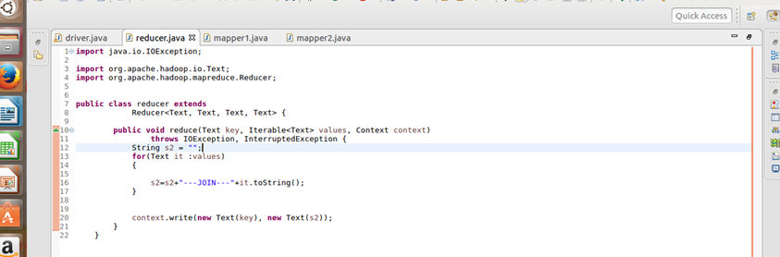

**Output**

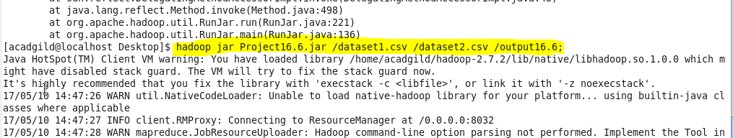

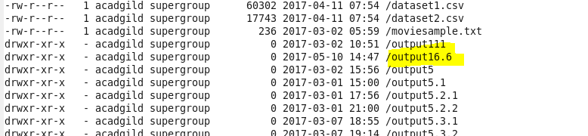

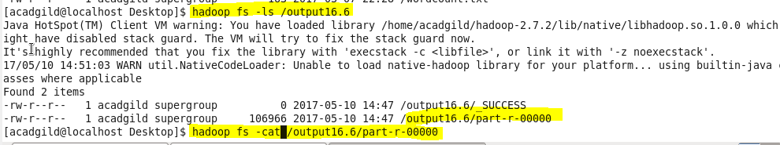

**Final output:**

