**Assignment 17.1**

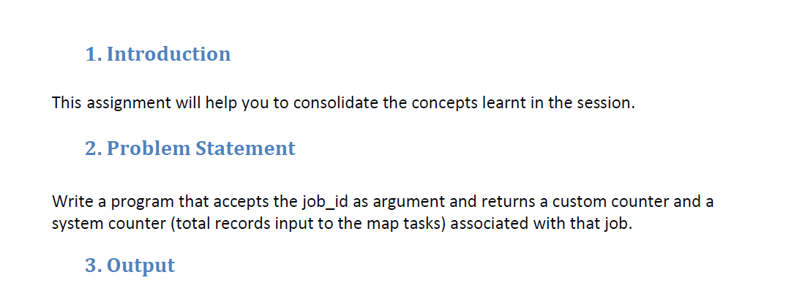

**STEPS:**

1. Initially a regular map reduce job performing word count is created.

2. Three custom counters are created which are as follows:

**> Less_than_3**

**> equal_to_3**

**> more_than_3**

3. These counters track the length of words and are incremented when a word of corresponding length is encountered in the mapper.

4. Further this job is executed and its job Id is given as input to the next job which will display the values of custom counters and system counters (Map input records).

**PROGRAM:**

**DRIVER CLASS**

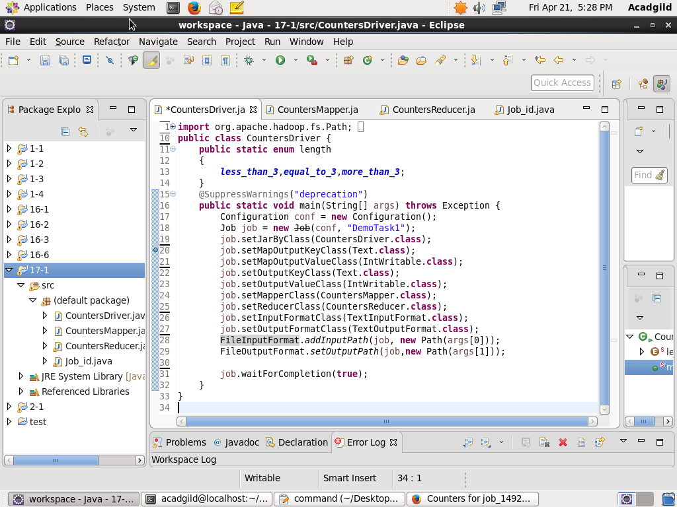

**MAPPER CLASS**

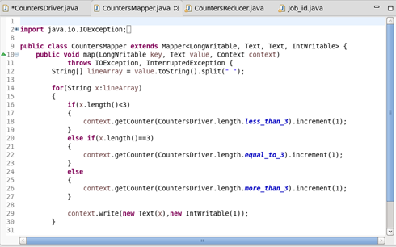

**REDUCER CLASS**

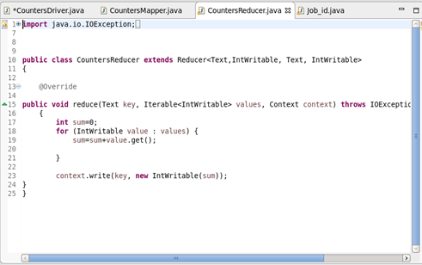

**JOB_ID CLASS**

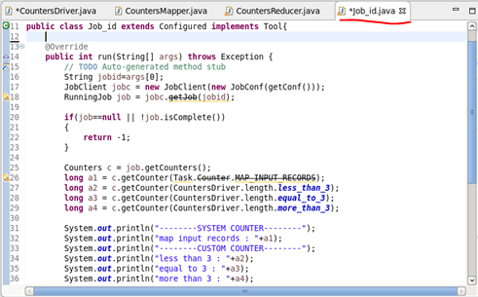

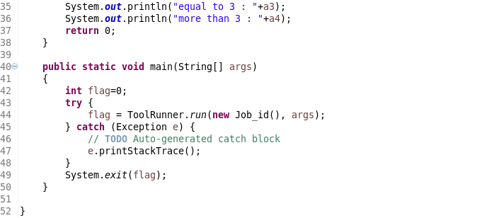

**OUTPUT:**

Executing word count job-

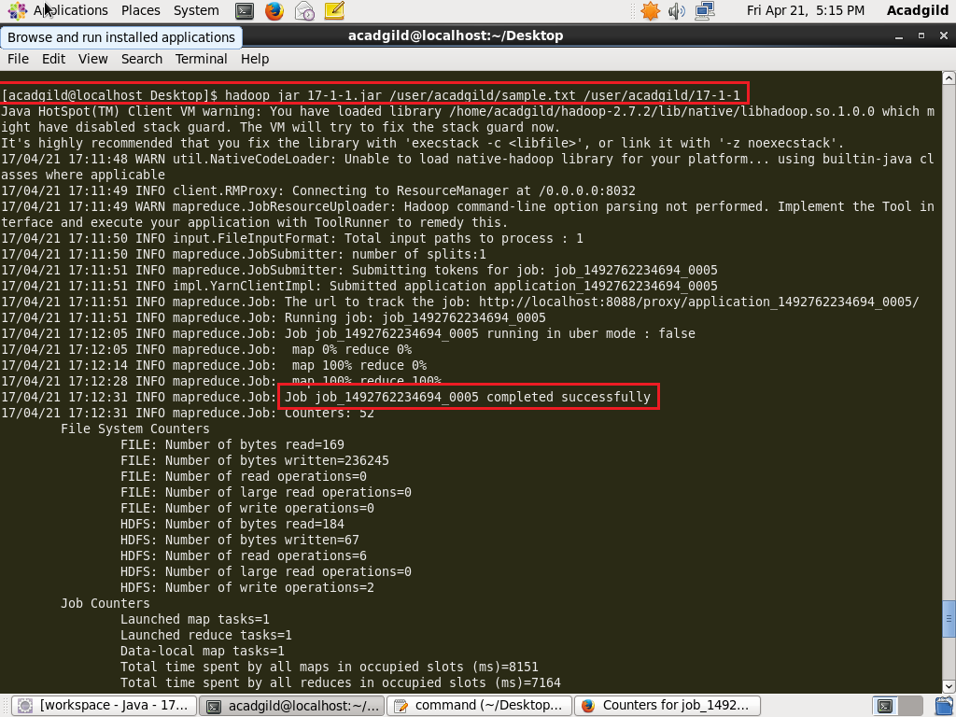

JOB ID is highlighted which is given as input to next job.

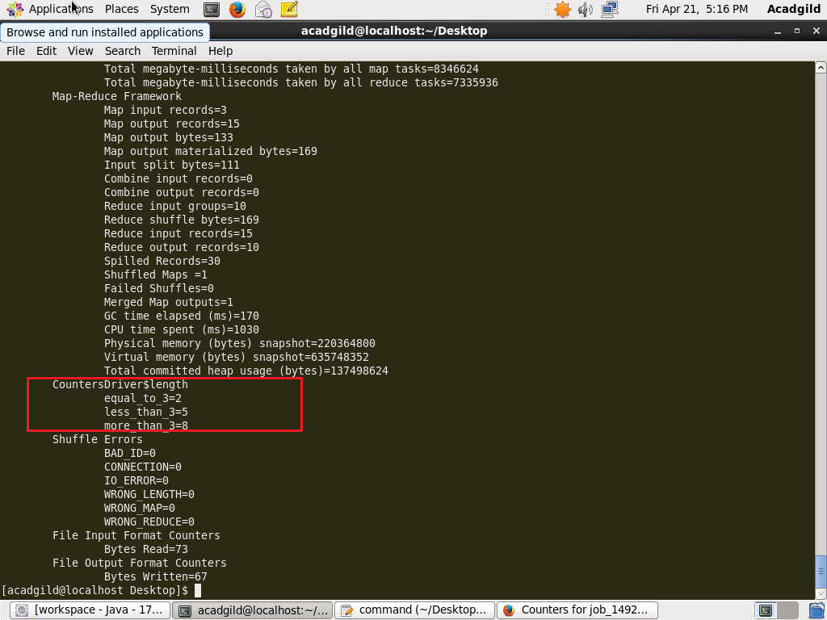

Custom Counters used in the job.

* Executing the next job. Job_id of previous job is given as input
* custom counters as well as system counters(map input records) are displayed as output.

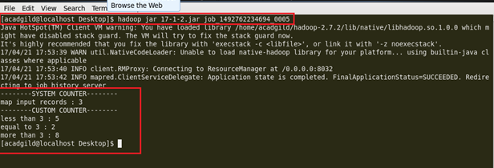

* From job history server so as to verify the values of counters.

