**ASSIGNMENT 24.6**

* Using database

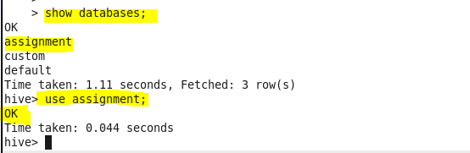

* Dataset

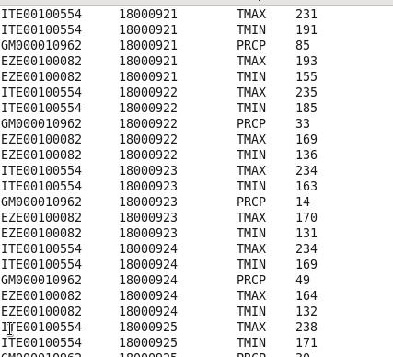

* **Write a hive query to find the minimum temperature observed in a given weather station in a particular year**

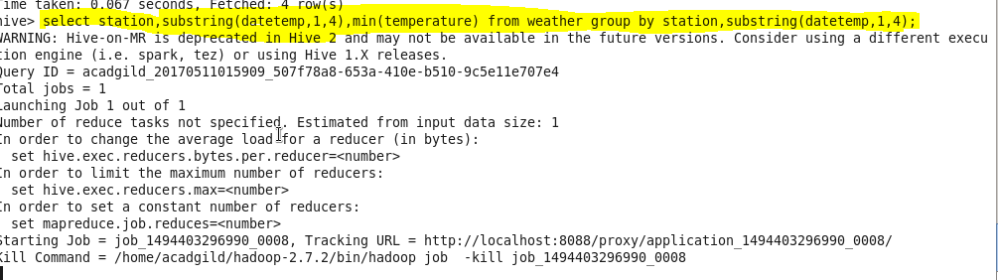

**Output:**

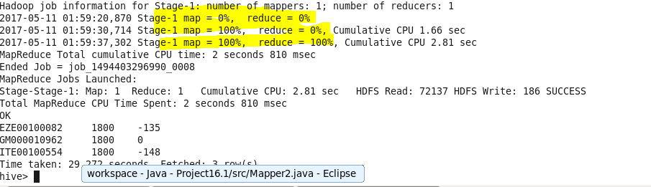

* **Write a hive query to find the maximum temperature observed in a given weather station in a particular year**

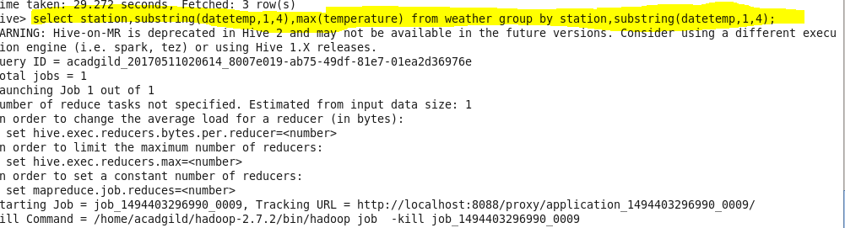

**OUTPUT:**

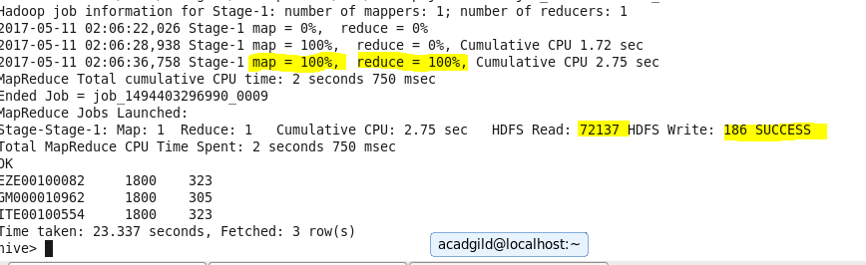

* **Write a hive query to find the number of readings given by each weather station according to the dataset.**

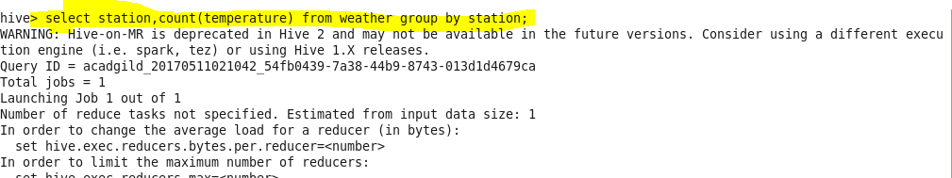

**Output:**

