**Assignment 25.2**

* **Write a Hive Program to find the total number of medals each country won**
* **First we will create table Olympic_data using create command with name,age,country,year,closing_date,sport,gold_medal,silver_medal ,bronze medal and total as columns.**

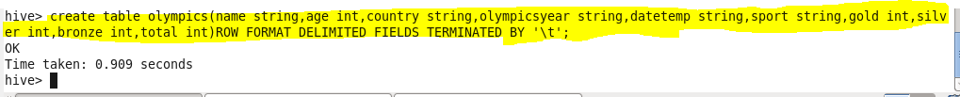

* **We can check our table if created or not using show tables.**

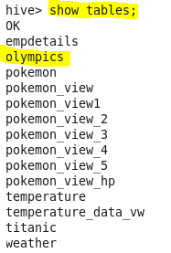

* **now we will load our dataset Olympic_data.csv using LOAD command**

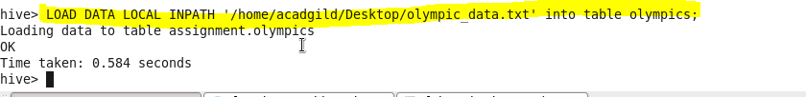

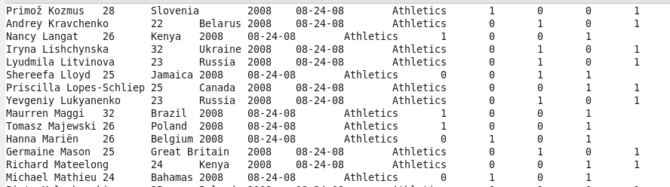

**Since we want the number of medals won by each country so we will group by country**

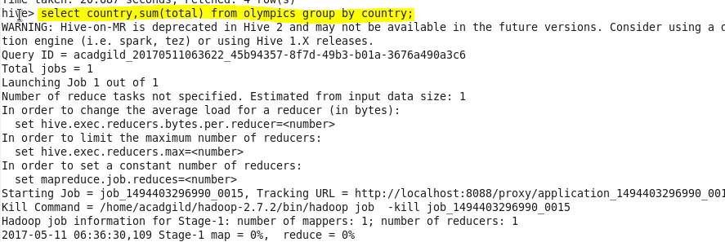

**Output:**

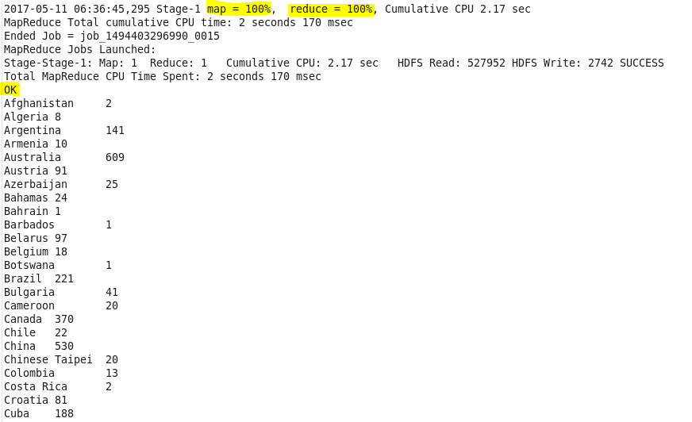

* **Write a Hive program to find the number of gold medals each country won**
* **Since we want gold medal won by every country, so we will group our result by country and filter by medal equal to gold using where condition.**

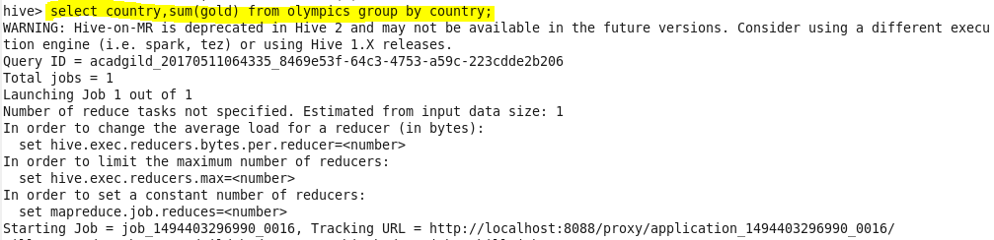

**Output:**

