**ASSIGNMENT 25.4**

Displaying database

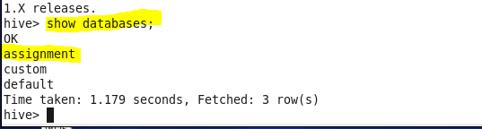

Creating table

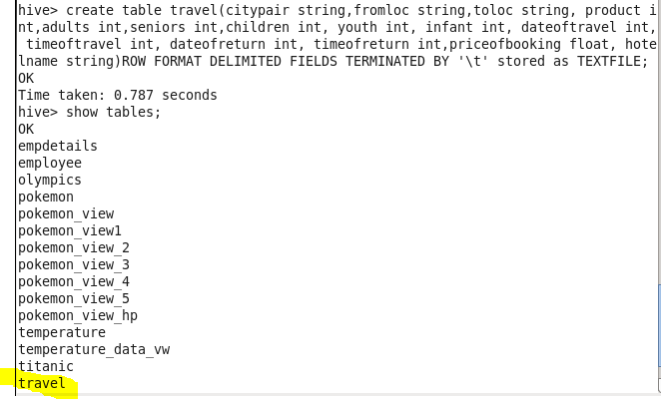

Loading data

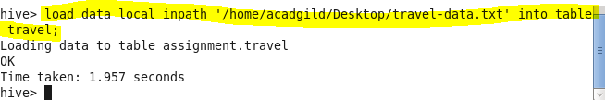

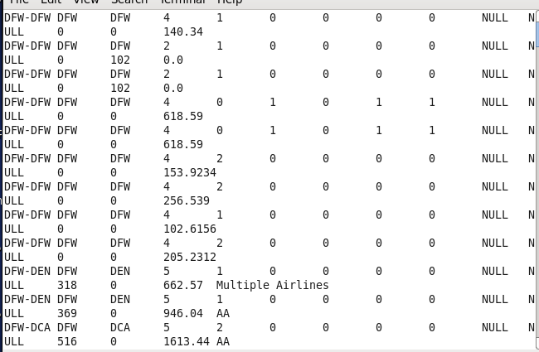

* **Write a hive query to find the top 20 destination people travel the most: Based on the given data**

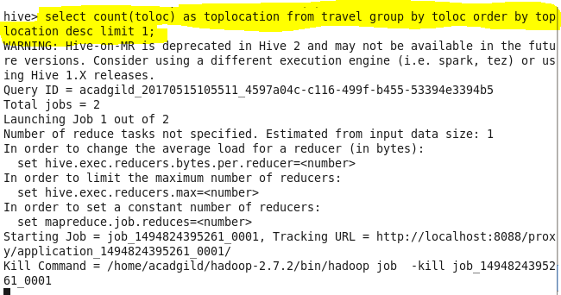

**Output:**

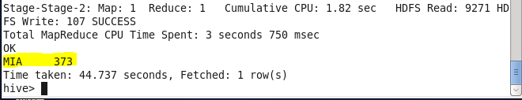

* **Write a hive query to find the top 20 locations from where people travel the most**

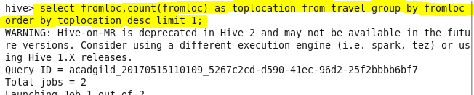

**Output:**

