**ASSIGNMENT26.4**

* **Implement view in hive**

When a query becomes long or complicated, a view may be used to hide the complexity

by dividing the query into smaller, more manageable pieces; similar to writing a function in a programming language or the concept of layered design in software. Encapsulating the complexity makes it easier for end users to construct complex queries from reusable parts.

**Creating and loading data in table cart :**

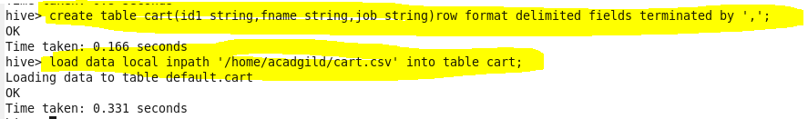

**Creating and loading data in table people:**

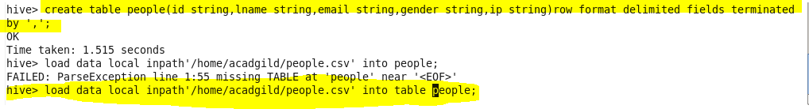

**Let us consider the below join statement**

**FROM (SELECT * FROM people JOIN cart**

**ON (cart.id1=people.id) WHERE last_name=’Henderson’) a**

**SELECT a.first_name WHERE a.id=’40-8340379′;**

* The above query is a nested query where we are joining people and cart and giving a alias name as “a”.Then we are selecting firstname where id is 40-8340379

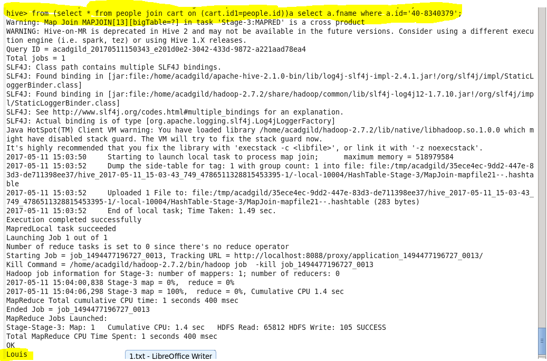

**Instead of using this complicated query we are creating view where we are joining this table as shown**

**Creating view**

C:\Users\612971\AppData\Local\Microsoft\Windows\Temporary Internet Files\Content.Word\26 4 join.png

**Now we are accessing data from this view and selecting the first_name where id=40-8340379**

**Output**

