**ASSIGNMENT 35.1**

* **Create a employee table in Mysql and columns as Emp_id, Emp_name,**

**Dept_name(Hadoop Developer), Emp_sal.**

We start by creating a database in mysql and the table employee inside it.

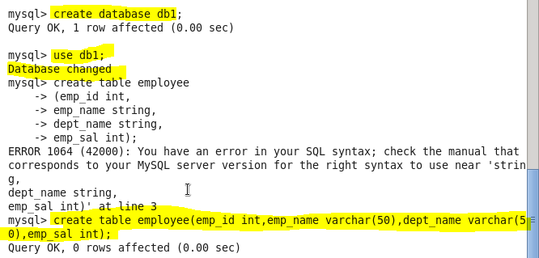

Inserting data in the MySql table:

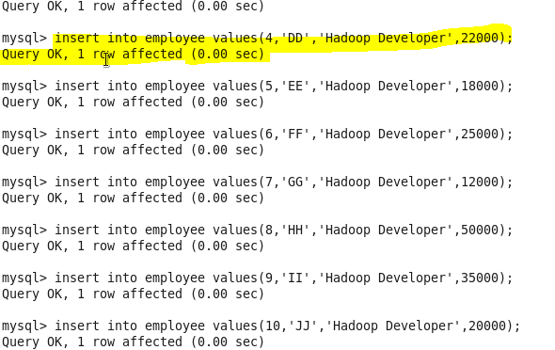

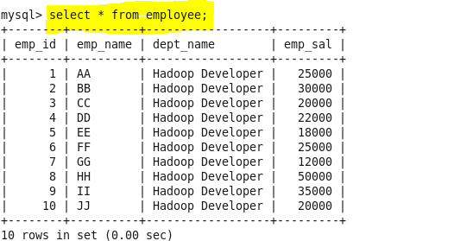

**● Import the employee table contents into the HDFS directory using Sqoop**.

Sqoop tool ‘import’ is used to import table data from the table to the Hadoop file system as a text file or a binary file.

We first create our own directory in hdfs to store the data named sqoopoutput:

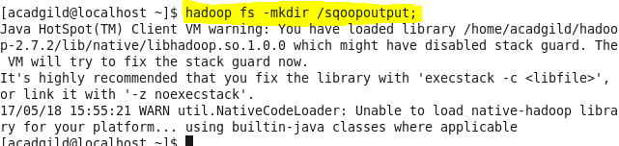

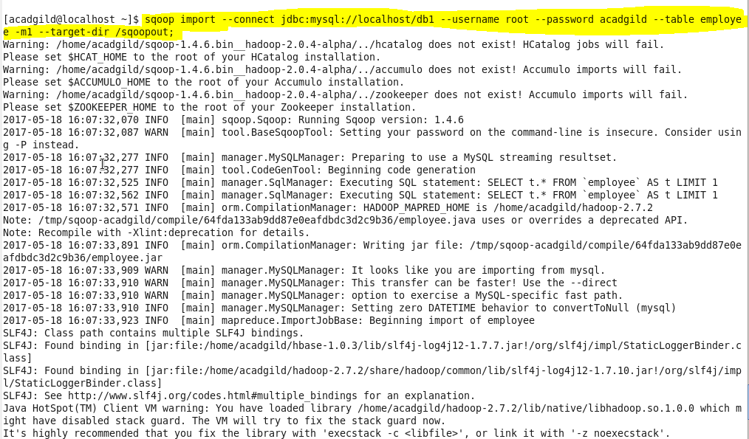

COMMAND EXPLANATION

--connect:It is used to give the JDBC Url of database

--Username:user name of database

--password:password of database

--table : give the table you want to copy from MySql

--target-dir: directory used by Sqoop Under which the data will be stored in Hdfs

The below screenshot shows the successful import of data:

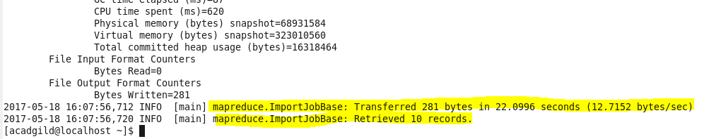

Here is the output directory where the data is stored on HDFS

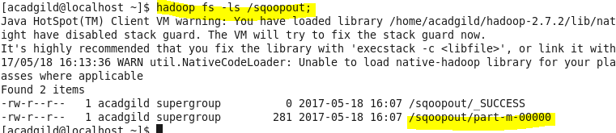

Output:

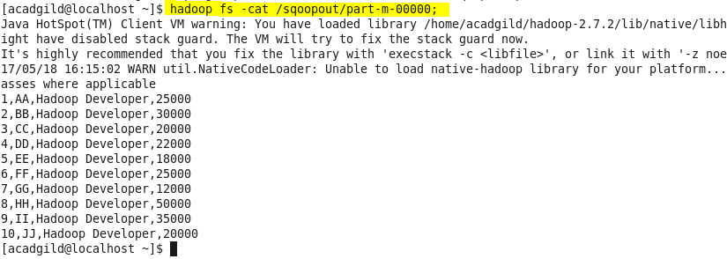

* **Create a employee2 table in Mysql and Export employee details file from HDFS directory to Mysql table employee2 using Sqoop.**

Creating table employee2 in database db1 to store the data back into the table

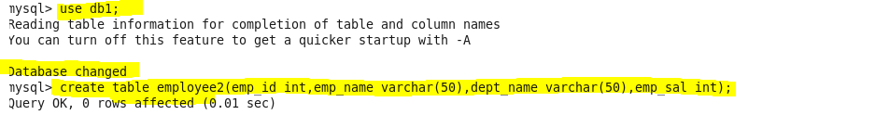

**Command for exporting the data into a mysql table**

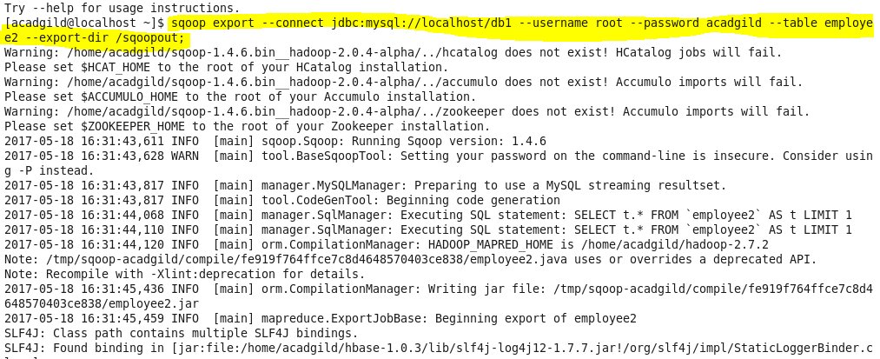

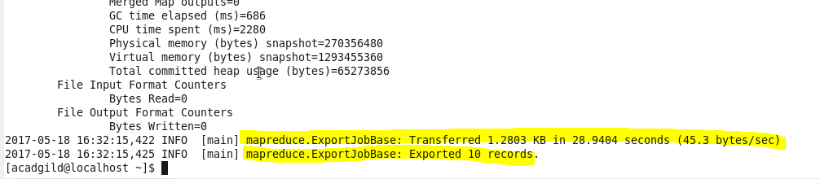

**This shows that the job is complete and the records have been exported from hdfs to mysql table.**

