**ASSIGNMENT 35.2**

We start by creating a database in mysql and the table employee inside it.

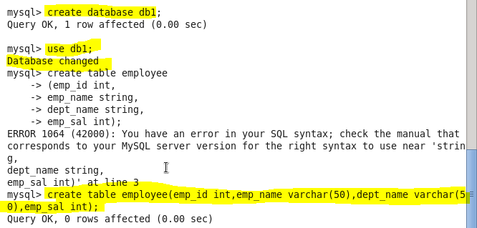

Inserting data in the MySql table:

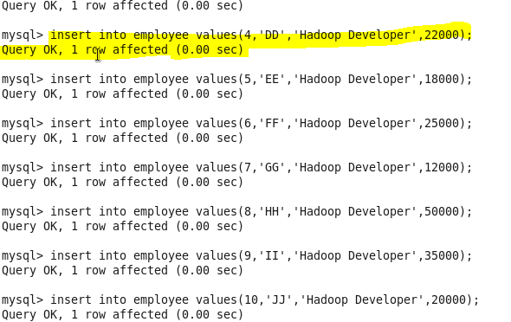

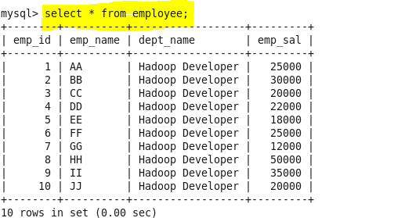

**● Import the employee table contents into the HDFS directory using Sqoop**.

Sqoop tool ‘import’ is used to import table data from the table to the Hadoop file system as a text file or a binary file.

We first create our own directory in hdfs to store the data named sqoopoutput:

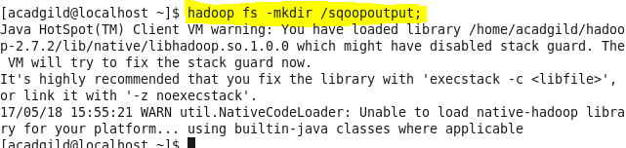

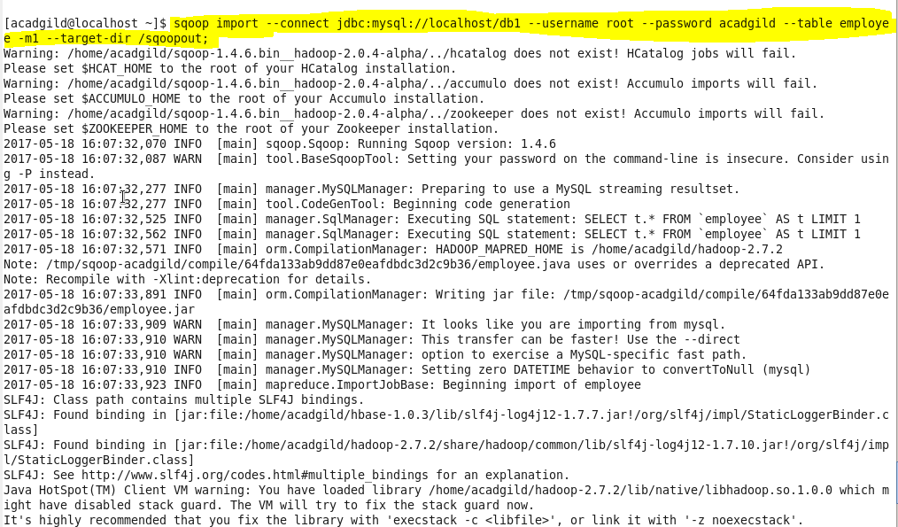

COMMAND EXPLANATION

--connect:It is used to give the JDBC Url of database

--Username:user name of database

--password:password of database

--table : give the table you want to copy from MySql

--target-dir: directory used by Sqoop Under which the data will be stored in Hdfs

The below screenshot shows the successful import of data:

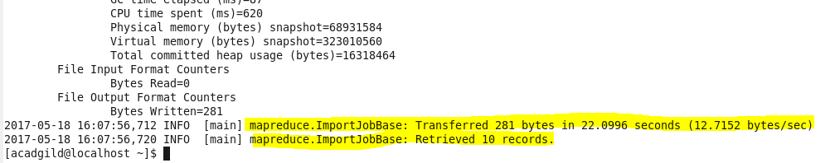

Here is the output directory where the data is stored on HDFS

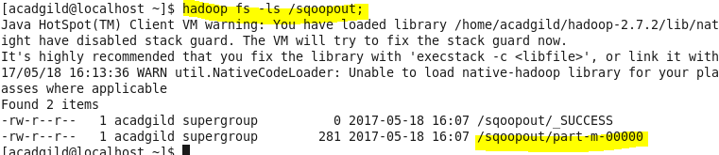

Output:

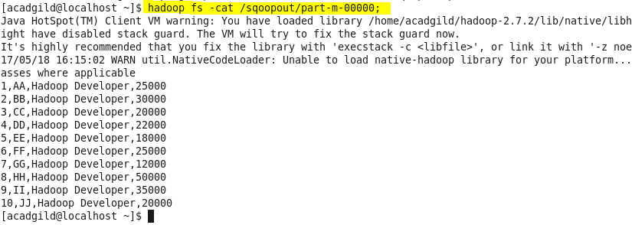

* **Explain and perform Importing table contents from Mysql to Hive using Sqoop.**

We now import data into hive:

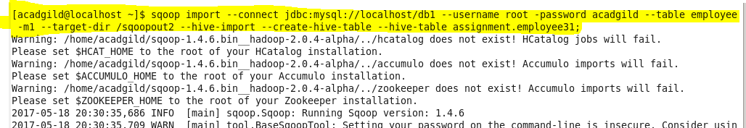

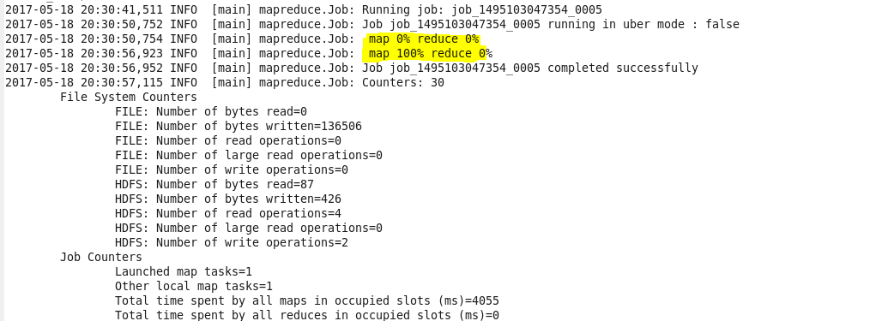

Output:

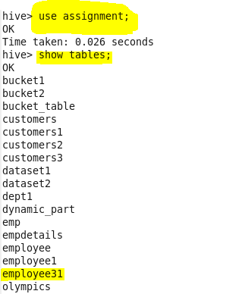

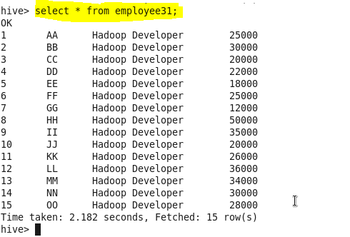

* **Explain and perform Importing table contents from Mysql to HBase using Sqoop.**

**We need to create a new table in Hbase to import table contents from Mysql database.**

**Start the hbase shell:**

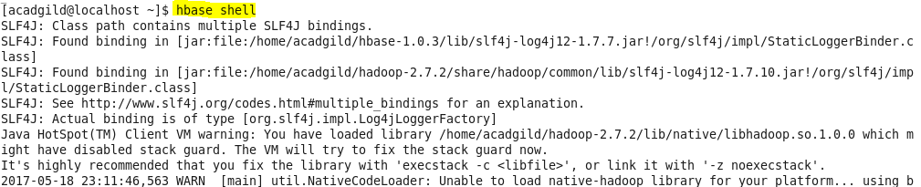

**Creating table:**



**We can use scan command to see a table contents in Hbase**.

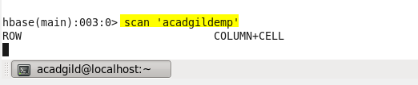

Now use below command to import Mysql **employee31** table to HBase **acadgildemp** table.

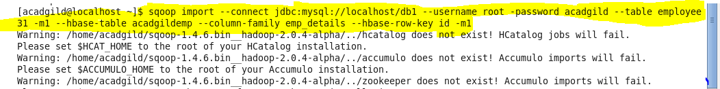

**Thus the contents are transferred from mysql to hbase using sqoop**