**ASSIGNMENT8.1**

* **Write a mapreduce program to find the total amount of petrol in volume sold by every distributor.**

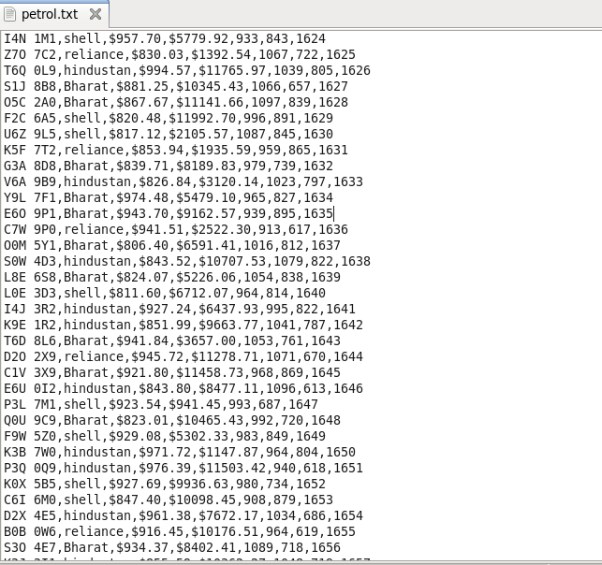

**DRIVER CLASS**

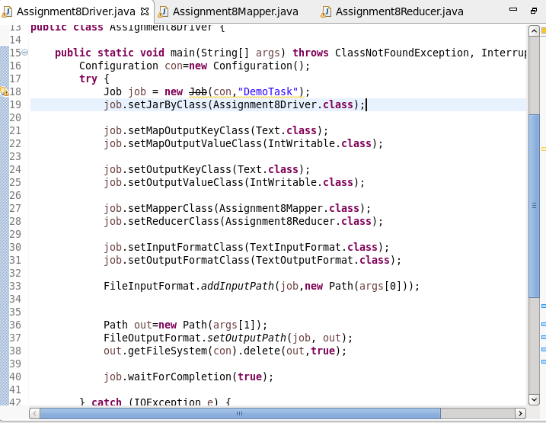

**MAPPER**

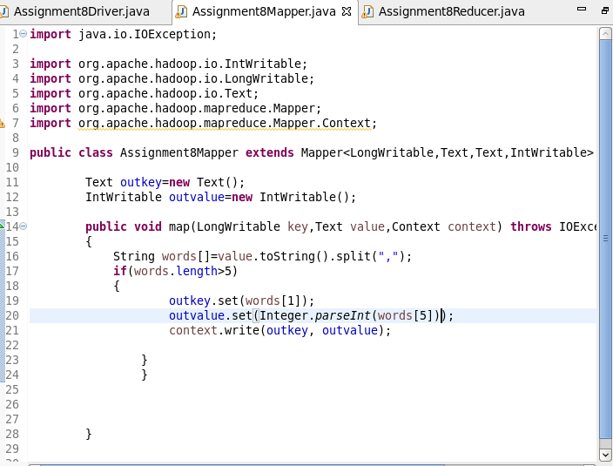

**REDUCER**

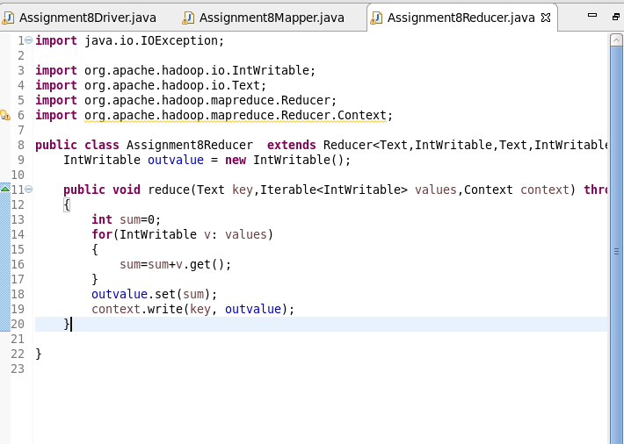

**OUTPUT**

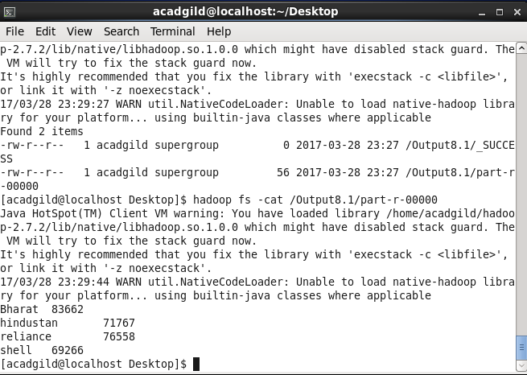

* **Write a mapreduce program to find which are the top 10 distributors ID's for selling petrol and also display the amount of petrol sold in volume.**

**DRIVER**

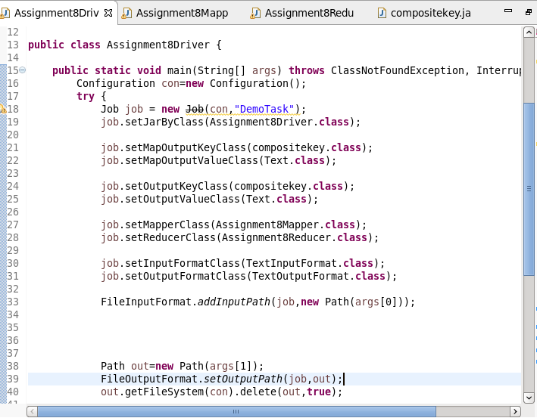

**MAPPER**

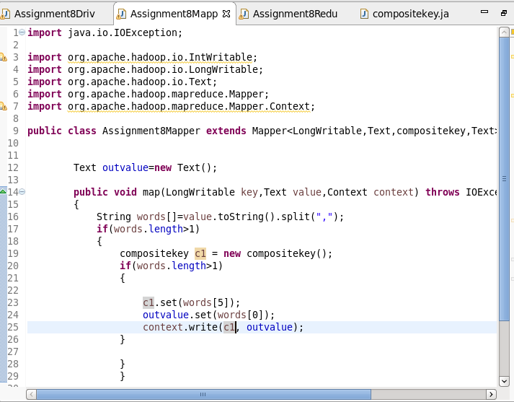

**REDUCER**

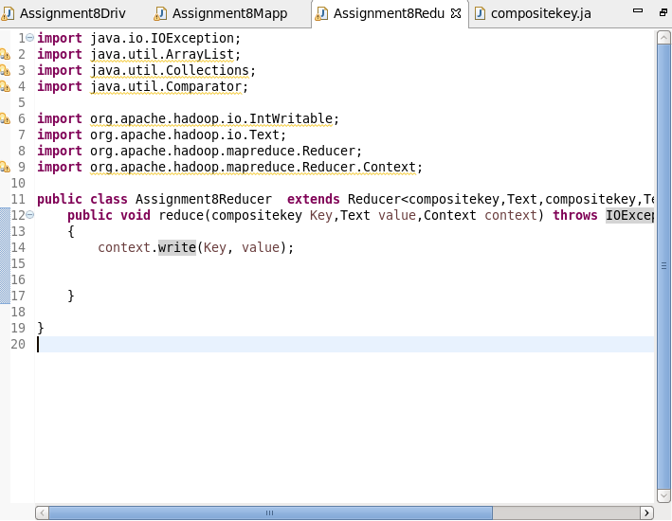

**COMPOSITE KEY**

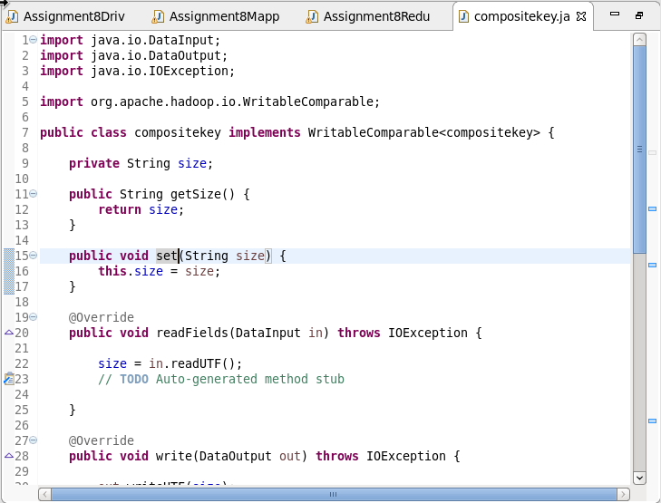

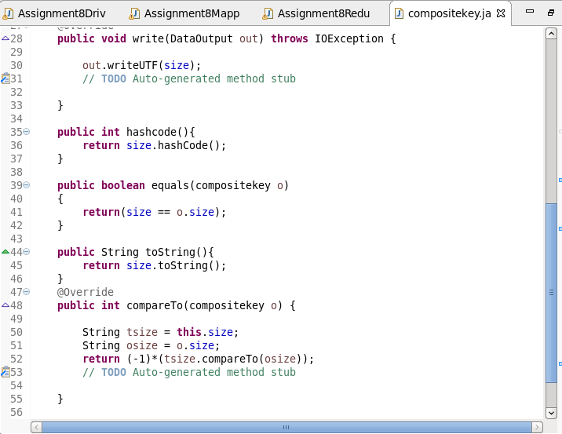

**RUNNING JAR**

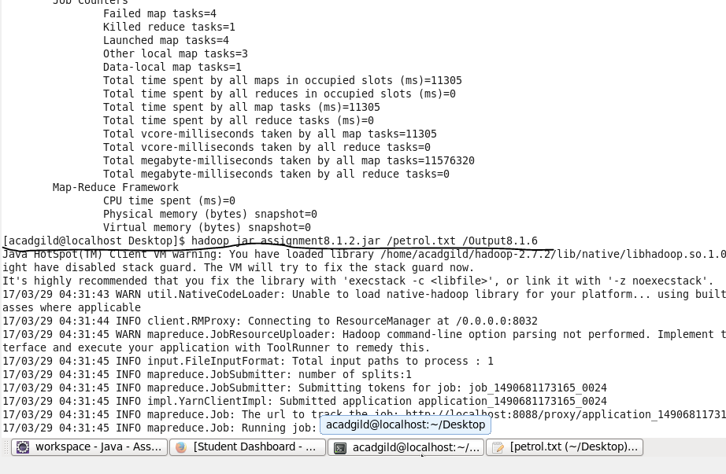

**OTPT**

