Working of pig script commands with example :

* LOAD

To Load the data from the file system (local/HDFS) into a relation.

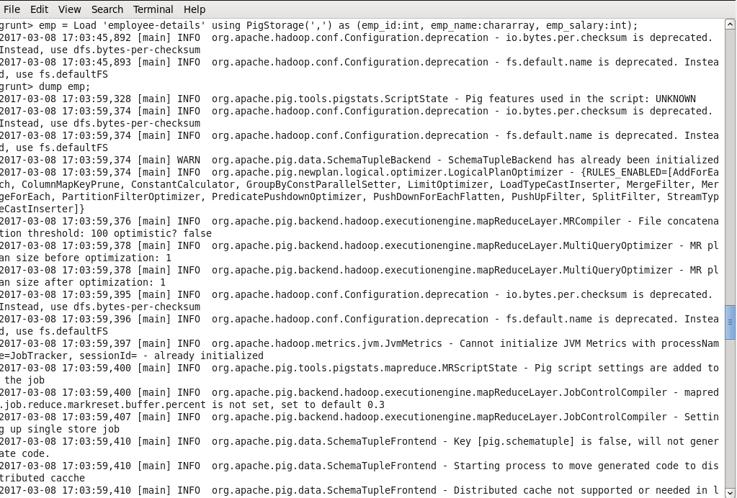

* STORE

To save a relation to the file system (local/HDFS).

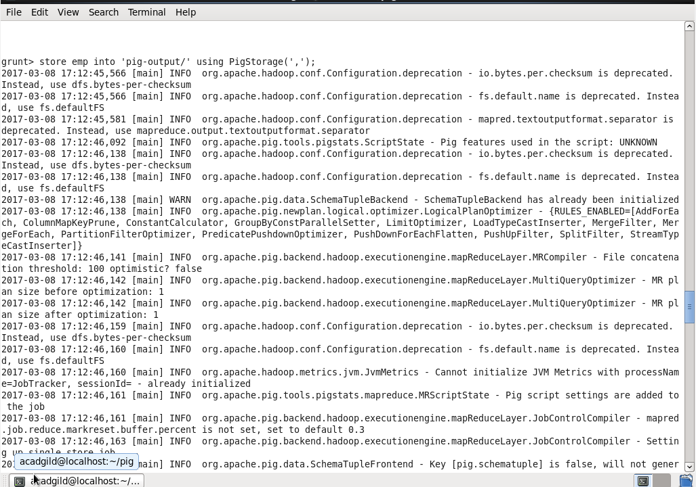

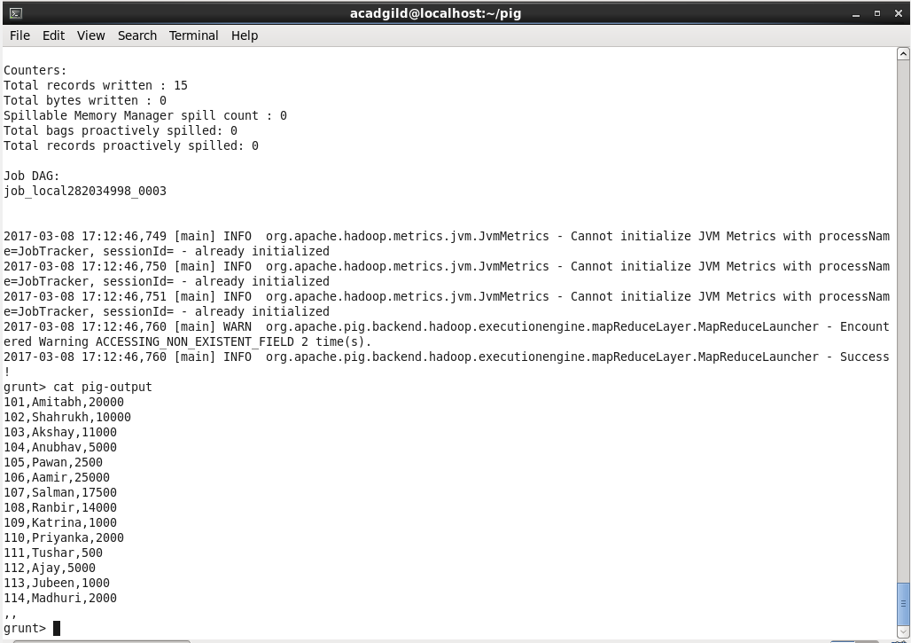

* DUMP

To print the contents of a relation on the console.

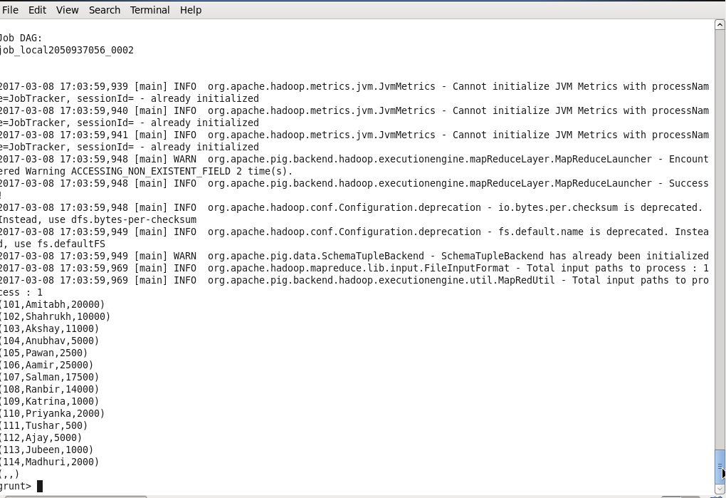

* FOREACH

The **FOREACH** operator is used to generate specified data transformations based on the column data.

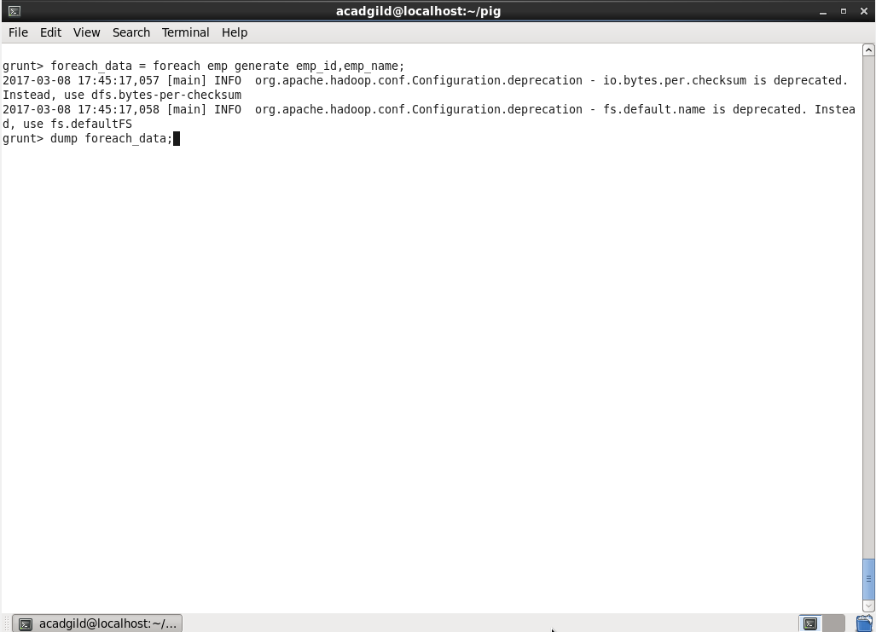

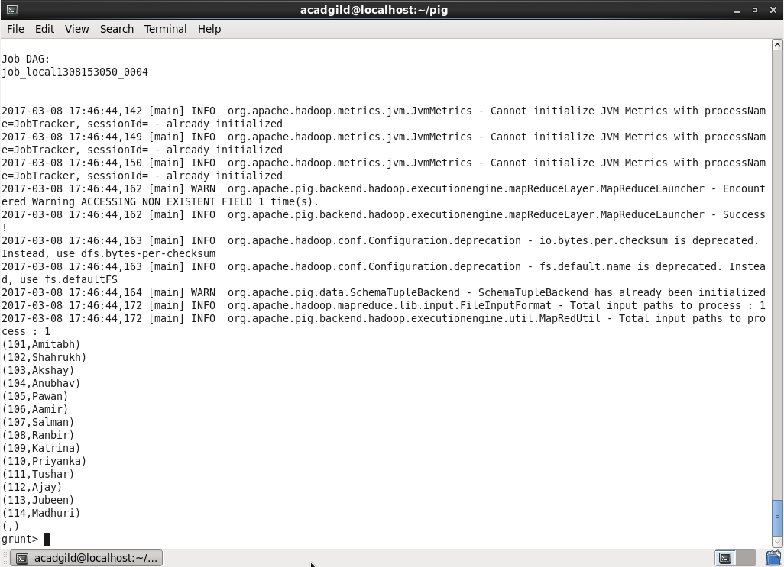

* FILTER

The **FILTER** operator is used to select the required tuples from a relation based on a condition.

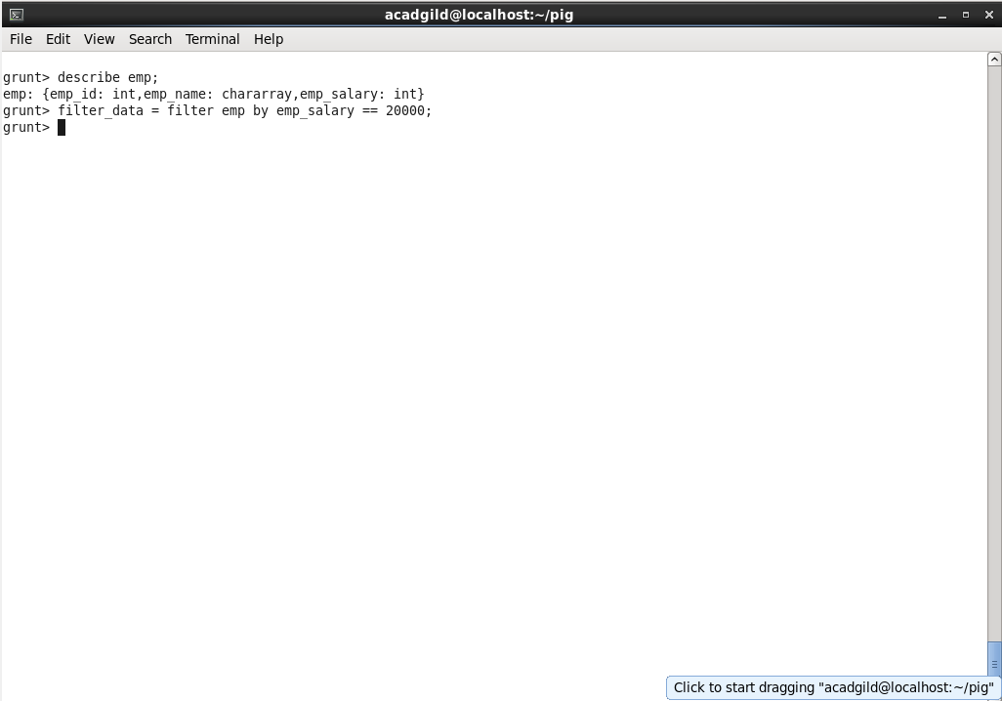

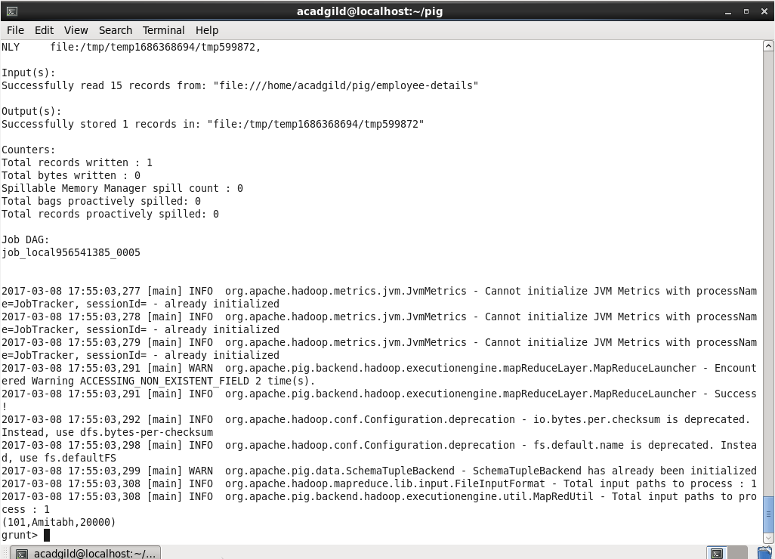

* GROUP BY

The **GROUP** operator is used to group the data in one or more relations. It collects the data having the same key.

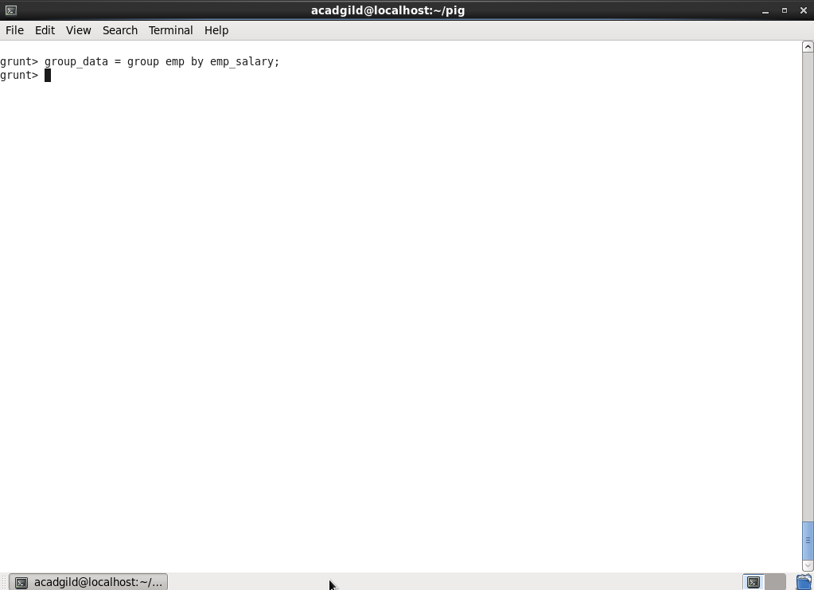

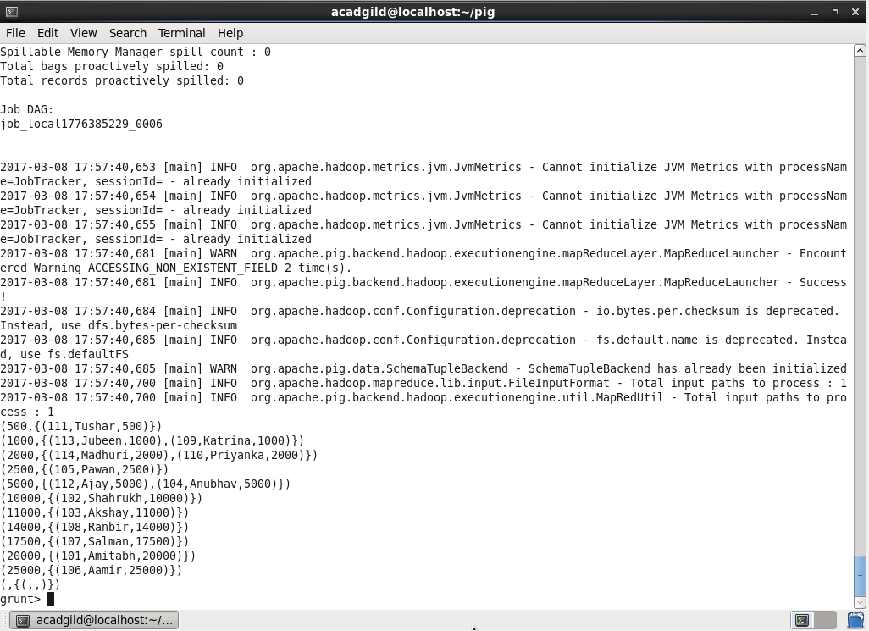

* ORDER BY

The **ORDER BY** operator is used to display the contents of a relation in a sorted order based on one or more fields.

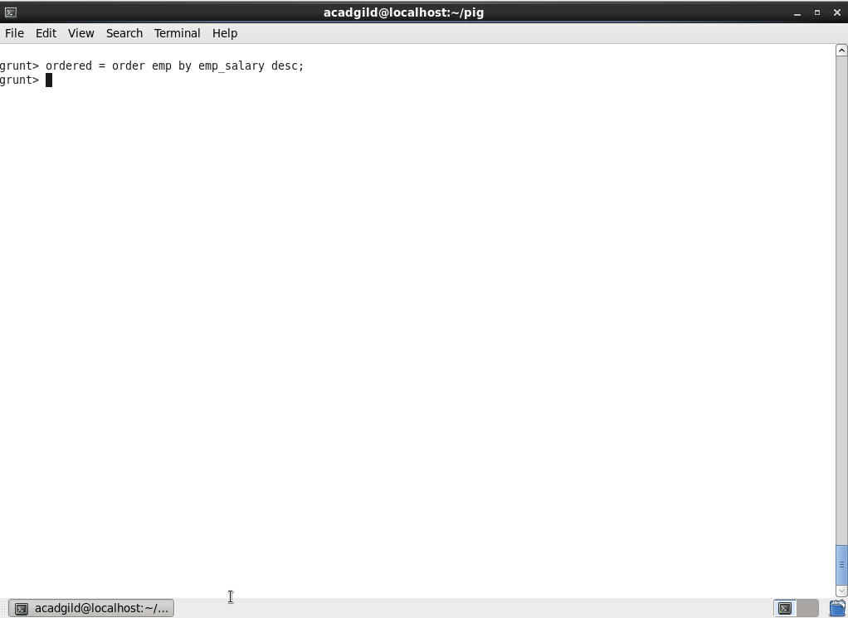

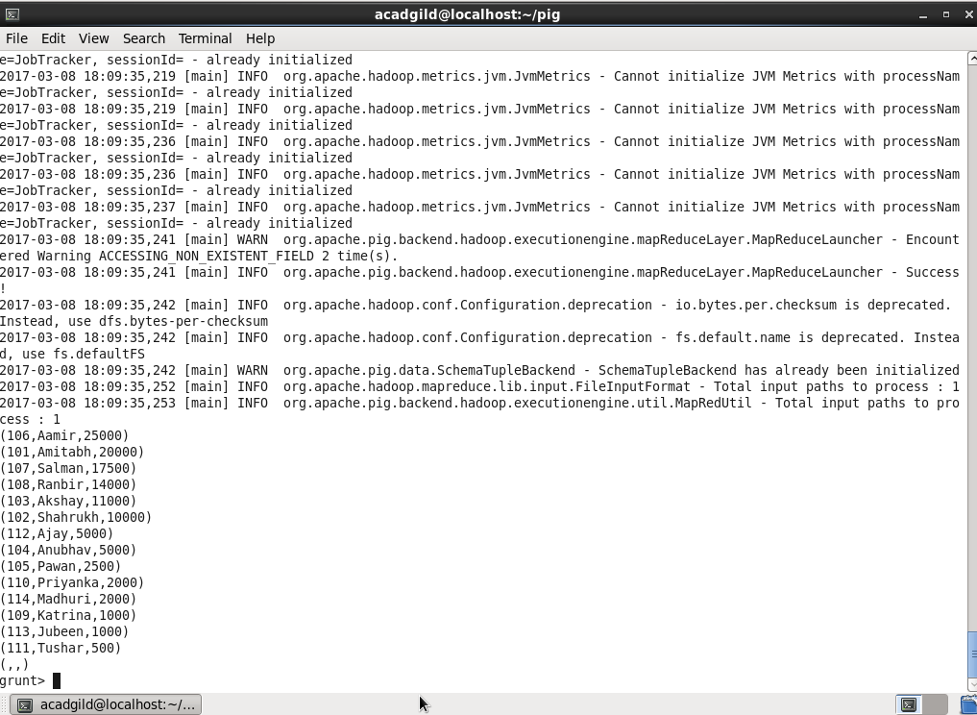

* DESCRIBE

The **describe** operator is used to view the schema of a relation.

