**PIG**

**1. Write a pig script to find no of complaints which got timely response**

**INPUT**

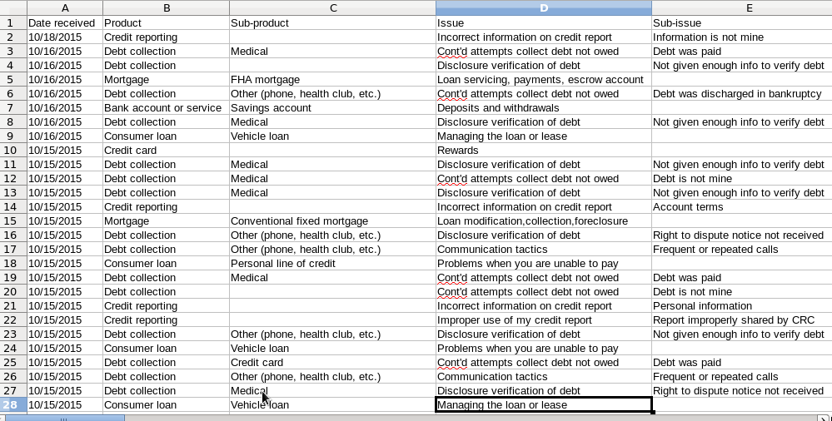

**LOAD THE DATA**

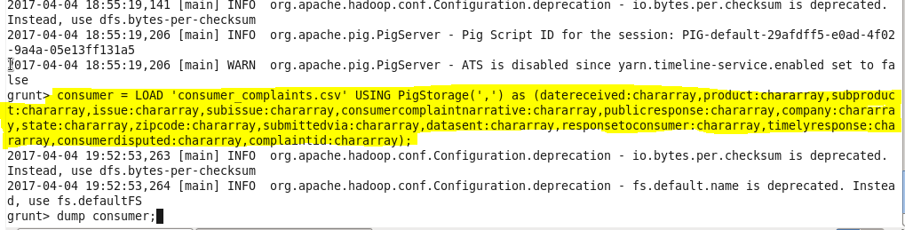

**FILTER DATA BY TIMELY RESPONSE**

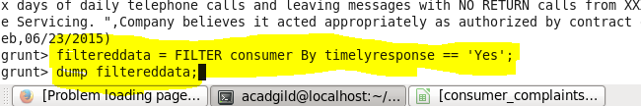

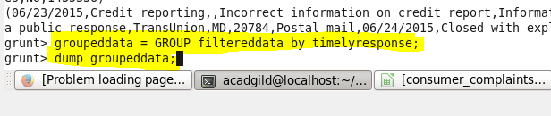

**OUTPUT**

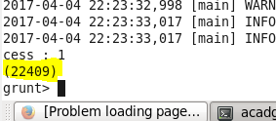

**2. Write a pig script to find no of complaints where consumer forum forwarded the complaint same day they received to respective company**

**FILTER DATA BY RECEIVED DATE = SENT DATE**

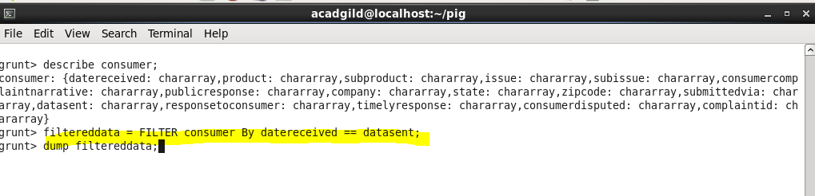

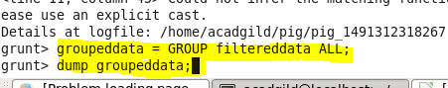

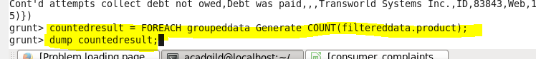

**OUTPUT**

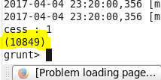

**3. Write a pig script to find list of companies topping in complaint chart (companies with maximum number of complaints)**

**GROUP DATASET BY COMPANY NAMES**

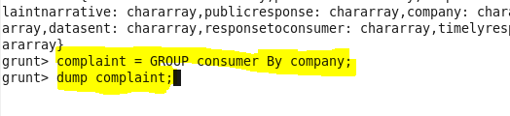

**COUNTING NO. OF COMPLAINTS FOR EACH COMPANY**

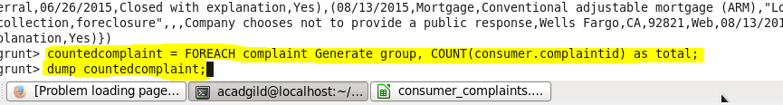

**ORDERING IN DESCENDING ORDER**

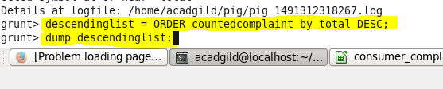

**LIMIT DATA TO 20 ITEMS**

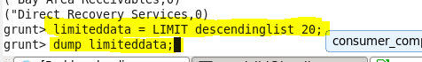

**OUTPUT**

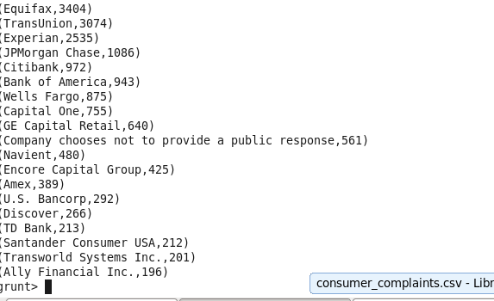

**4. Write a pig script to find no of complaints filed with product type has "Debt collection" for the year 2015**

**FILTER DATA BY PRODUCT = DEBT COLLECTION AND YEAR =2015**

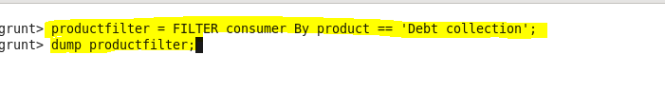

**D:\project2\4.2command.PNG**

**GROUP DATA BY PRODUCT AND COUNT THE NUMBER OF COMPLAINTS**

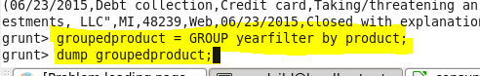



**OUTPUT**

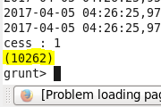

**MAP REDUCE**

**1. Write a mapreduce program to remove commas present inside the double quotes.**



