ML & DATA SCIENCE
Complete EDA & Data Preprocessing Handbook
From Raw Data to Model-Ready Features

Topics Covered
✦ Statistical Measures: Mean, Median, Variance, Std Dev, Covariance & Spread
✦ Data Assessing — Understanding What You Have
✦ Data Cleaning — Fixing Dirty, Inconsistent Data
✦ Handling Missing Values — Every Strategy Explained
✦ Exploratory Data Analysis (EDA) — Full Coverage
✦ Normalization (Min-Max Scaling) — When & How
✦ Standardization (Z-Score Scaling) — When & How
✦ Encoding Techniques — Label, One-Hot, Ordinal, Target
✦ PCA — Dimensionality Reduction in Depth

Dataset Used: Employee Performance Dataset (200 records, synthetically generated)

Chapter 1: Statistical Measures
Before we can explore, clean, or model data, we must understand the mathematical tools that describe it. These measures summarise an entire column of numbers into meaningful single values.

1.1 Mean (Average)
The mean is the sum of all values divided by the count of values. It represents the "centre of gravity" of the data.
Mean (μ) = (x₁ + x₂ + ... + xₙ) / n
📌 Example using our Salary column:
Salaries: [45000, 62000, 38000, 71000, 55000]
Mean = (45000+62000+38000+71000+55000) / 5 = 54200

⚠ Sensitivity: Mean is very sensitive to outliers.
If one salary is 500,000, it pulls the mean upward significantly.

1.2 Median
The median is the middle value when data is sorted. If n is even, it is the average of the two middle values. Unlike the mean, median is robust to outliers.
Median: Sort data → pick middle value (or avg of two middle values)
📌 Example:
Sorted salaries: [38000, 45000, 55000, 62000, 71000]
Median = 55000 (middle value)

With outlier: [38000, 45000, 55000, 62000, 500000]
Mean = 140000 (distorted!) Median = 55000 (unchanged)

✅ Use Median when your data has outliers or is skewed.

1.3 Variance
Variance measures how spread out the data is from the mean. It is the average of the squared differences from the mean.
Variance (σ²) = Σ(xᵢ − μ)² / n [Population]
Variance (s²) = Σ(xᵢ − x̄)² / (n−1) [Sample — use this for datasets]
📌 Example (simplified):
Values: [2, 4, 4, 4, 5, 5, 7, 9] Mean = 5
Differences from mean: [-3,-1,-1,-1,0,0,2,4]
Squared differences: [9,1,1,1,0,0,4,16]
Variance = (9+1+1+1+0+0+4+16)/8 = 4.0

⚠ Variance is in squared units (e.g., if salary is in ₹, variance is in ₹²).
That is why we use Standard Deviation (square root of variance) more often.

1.4 Standard Deviation (Std)
Standard deviation is the square root of variance. It brings the measure back to the original units, making it interpretable.
Std Dev (σ) = √Variance = √[Σ(xᵢ − μ)² / n]
📌 Interpretation — The 68-95-99.7 Rule (Normal Distribution):
• 68% of data falls within μ ± 1σ
• 95% of data falls within μ ± 2σ
• 99.7% of data falls within μ ± 3σ

📌 Employee Salary Example:
Mean Salary = ₹54,000 Std Dev = ₹18,000
→ ~68% of employees earn between ₹36,000 and ₹72,000
→ Values beyond 3σ are likely outliers.

1.5 Spread, Range & IQR
Spread refers to how wide or narrow the distribution of data is. Multiple measures describe spread:
- Range = Max − Min (simplest, but very sensitive to outliers)
- Interquartile Range (IQR) = Q3 − Q1 (robust spread measure)
- Variance / Std Dev (statistical spread measures explained above)

IQR = Q3 (75th percentile) − Q1 (25th percentile)
📌 Example — Salary IQR:
Q1 = ₹38,000 Q3 = ₹68,000 IQR = ₹30,000
Outlier Fences: Lower = Q1 − 1.5×IQR Upper = Q3 + 1.5×IQR
Any value outside these fences is flagged as an outlier.

1.6 Covariance
Covariance measures how two variables change together. A positive covariance means both increase together; negative means one goes up as the other goes down.
Cov(X,Y) = Σ[(xᵢ − x̄)(yᵢ − ȳ)] / (n−1)
📌 Interpretation:
Cov(Age, Salary) = large positive number
→ Older employees tend to have higher salaries (positive relationship)

Problem: Covariance depends on units. Age is in years, Salary in ₹.
So covariance values are hard to compare across different variable pairs.
Solution → Correlation (normalised covariance, always between −1 and +1).

Correlation (r) = Cov(X,Y) / (σₓ × σᵧ) [Range: −1 to +1]

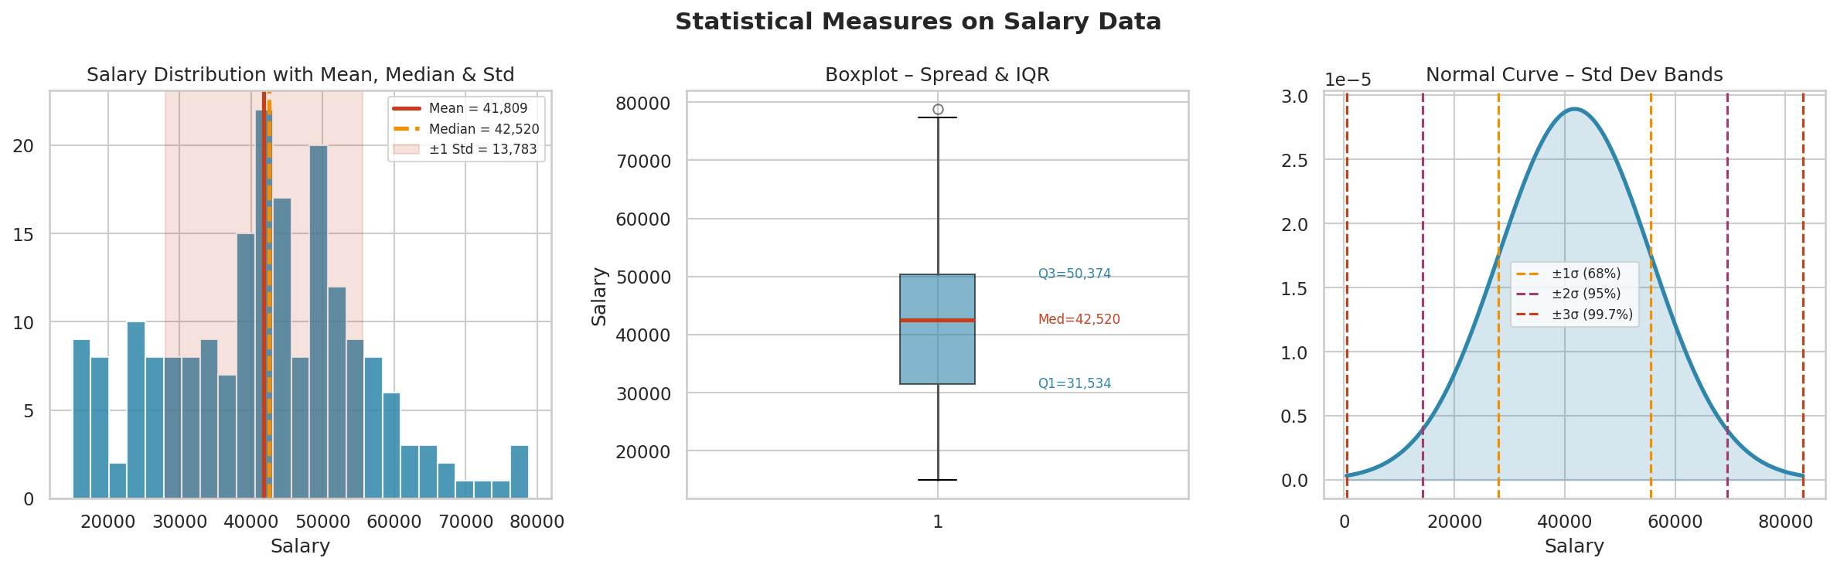
Figure 1.1 — Salary distribution showing mean, median, std dev bands, boxplot, and normal curve.

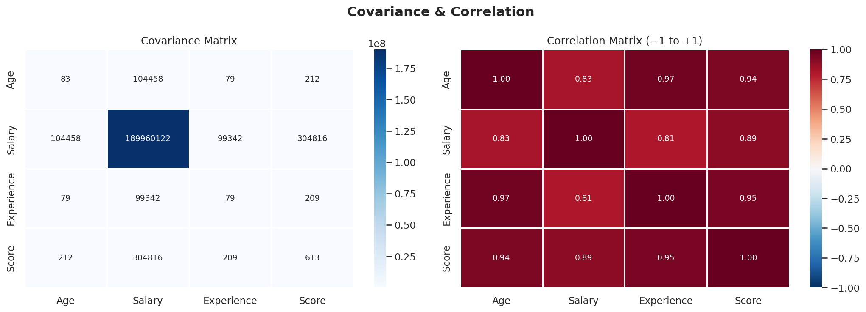
Figure 1.2 — Covariance matrix (raw values) and correlation matrix (normalised −1 to +1). Notice Age-Experience correlation is very high (~0.97) since experience grows with age.

Chapter 2: Data Assessing
Before touching a single value, you must understand what data you have. Data assessing is the process of examining a dataset to understand its structure, quality, completeness, and characteristics. Think of it as a doctor's initial examination before diagnosis.

2.1 First Look at Data
Always start with these basic commands when you receive a new dataset:
import pandas as pd
import numpy as np

df = pd.read_csv("employee_data.csv")

# 1. Shape — how many rows and columns?
print(df.shape) # (200, 7)

# 2. First few rows
print(df.head(5))

# 3. Column names & data types
print(df.dtypes)

# 4. Summary statistics for numeric columns
print(df.describe())

# 5. Info — non-null counts, dtypes, memory
print(df.info())

2.2 What to Look For During Assessment

2.2.1 Data Types
Each column should have the correct data type. Mismatched types are a common issue:
Column | Expected Type | Wrong Type Example | Problem
Age | int64 | object (string) | Cannot compute mean/median
Salary | float64 | object | Contains strings like "N/A"
Education | category/object | int64 | Encoded incorrectly
Date | datetime64 | object | Cannot do date arithmetic

# Check data types
print(df.dtypes)

# Fix wrong types
df["Age"] = pd.to_numeric(df["Age"], errors="coerce") # converts bad vals to NaN
df["Date"] = pd.to_datetime(df["Date"], errors="coerce")
df["Salary"] = df["Salary"].astype(float)

2.2.2 Missing Values
Understanding where data is missing and how much:
# Count missing per column
print(df.isnull().sum())

# Missing percentage
print((df.isnull().sum() / len(df)) * 100)

# Visual heatmap of missing values
import seaborn as sns
import matplotlib.pyplot as plt
sns.heatmap(df.isnull(), cbar=False, yticklabels=False)
plt.title("Missing Value Map")
plt.show()

2.2.3 Duplicates
# Count duplicate rows
print(df.duplicated().sum())

# See which rows are duplicated
print(df[df.duplicated()])

# Check duplicates based on a specific column
print(df.duplicated(subset=["EmployeeID"]).sum())

2.2.4 Value Counts for Categorical Columns
# Frequency of each category
print(df["Education"].value_counts())

# Percentage
print(df["Education"].value_counts(normalize=True) * 100)

# Unique values
print(df["Education"].unique())
print(df["Education"].nunique()) # number of unique values

2.2.5 Outlier Check at Assessment Stage
# Quick range check
print(df["Salary"].describe())
# Watch for: min too low, max too high, large gap between 75% and max

# Negative values check
print((df["Salary"] < 0).sum()) # should be 0

# Impossible values
print((df["Age"] > 100).sum()) # should be 0
print((df["Age"] < 0).sum()) # should be 0

2.3 Data Assessment Checklist
✅ DATA ASSESSMENT CHECKLIST

□ 1. Shape and column names understood
□ 2. All data types are correct
□ 3. Missing values counted per column
□ 4. Duplicate rows identified
□ 5. Numeric ranges make sense (no impossible values)
□ 6. Categorical columns have expected categories
□ 7. Date columns parsed correctly
□ 8. Summary statistics reviewed (describe())
□ 9. Unique value counts for categoricals
□ 10. Memory usage acceptable for the system

Chapter 3: Data Cleaning
Data cleaning is the process of fixing or removing incorrect, corrupted, duplicate, or incomplete data. Real-world data is messy — studies show data scientists spend 60-80% of their time cleaning data.

3.1 Why Clean Data Matters
Dirty data leads to:
- Wrong insights — models learn wrong patterns from corrupted data
- Biased results — missing data in certain groups skews analysis
- Model errors — algorithms crash or give NaN outputs with dirty input
- Misleading visualisations — outliers distort charts

3.2 Types of Data Quality Issues
Issue | Example | Impact
Missing Values | Age = NaN, Salary = None | Breaks computations, models
Duplicates | Same employee row appears twice | Inflates counts, biases model
Wrong Data Type | Age stored as string "32" | Cannot do arithmetic
Outliers | Salary = -9999 or 9999999 | Distorts statistics & model
Inconsistent Formatting | "New York" vs "new york" vs "NY" | Creates extra fake categories
Incorrect Values | Experience=50 for Age=22 | Logically impossible data
Extra Whitespace | " Engineer " vs "Engineer" | String comparison fails

3.3 Method 1: Removing Duplicates
Duplicate rows occur when the same record is entered more than once. They inflate frequency counts and bias model training.
import pandas as pd

df = pd.read_csv("employee_data.csv")

# Check before
print("Before:", df.shape) # (215, 7) — 15 duplicates injected
print("Duplicates:", df.duplicated().sum()) # 15

# Remove ALL duplicate rows
df = df.drop_duplicates()
print("After:", df.shape) # (200, 7)

# Remove duplicates based on specific column(s)
df = df.drop_duplicates(subset=["EmployeeID"]) # keep first occurrence
df = df.drop_duplicates(subset=["EmployeeID"], keep="last") # keep last
df = df.drop_duplicates(subset=["EmployeeID"], keep=False) # drop ALL copies

3.4 Method 2: Fixing Data Types
# Common type conversion issues

# String numbers → numeric (coerce turns unparseable values to NaN)
df["Age"] = pd.to_numeric(df["Age"], errors="coerce")
df["Salary"] = pd.to_numeric(df["Salary"].str.replace(",",""), errors="coerce")

# Object → category (saves memory for repeated string values)
df["Department"] = df["Department"].astype("category")

# Parse date strings
df["JoinDate"] = pd.to_datetime(df["JoinDate"], format="%Y-%m-%d", errors="coerce")

# Extract features from date
df["JoinYear"] = df["JoinDate"].dt.year
df["JoinMonth"] = df["JoinDate"].dt.month

# Verify types after fix
print(df.dtypes)

3.5 Method 3: Handling Inconsistent Text
# Standardise text columns

# Trim whitespace
df["Department"] = df["Department"].str.strip()

# Lowercase everything
df["Education"] = df["Education"].str.lower()

# Fix capitalisation
df["Education"] = df["Education"].str.title() # "high school" → "High School"

# Replace inconsistent values
df["Department"] = df["Department"].replace({
"Eng": "Engineering",
"eng": "Engineering",
"ENGINEERING": "Engineering",
"HR/Admin": "HR"
})

# Check unique values after fix
print(df["Department"].unique())

3.6 Method 4: Removing / Fixing Impossible Values
# Identify logically impossible values

# Negative salary → impossible
print(df[df["Salary"] < 0]) # show offending rows

# Option A: Drop those rows
df = df[df["Salary"] > 0]

# Option B: Replace with NaN (then impute later)
df.loc[df["Salary"] < 0, "Salary"] = np.nan

# Experience cannot be more than (Age - 16)
invalid_exp = df["Experience"] > (df["Age"] - 16)
print(f"Invalid experience rows: {invalid_exp.sum()}")
df.loc[invalid_exp, "Experience"] = np.nan # flag for imputation

# Age cannot be < 18 in this employment dataset
df = df[df["Age"] >= 18]

3.7 Method 5: Outlier Treatment
Outliers are data points that are far from the rest of the distribution. They can be legitimate extreme values or data entry errors.

Method A: IQR-based Capping (Winsorisation)
# IQR Capping — clips outliers to boundary, does not remove rows
Q1 = df["Salary"].quantile(0.25)
Q3 = df["Salary"].quantile(0.75)
IQR = Q3 - Q1

lower_fence = Q1 - 1.5 * IQR
upper_fence = Q3 + 1.5 * IQR

print(f"Lower: {lower_fence:.0f} Upper: {upper_fence:.0f}")

# Count outliers
outliers = df[(df["Salary"] < lower_fence) | (df["Salary"] > upper_fence)]
print(f"Outliers found: {len(outliers)}")

# Cap (clip) values at the fences
df["Salary"] = df["Salary"].clip(lower=lower_fence, upper=upper_fence)

Method B: Z-Score Removal
from scipy import stats

# Remove rows where any numeric column has |Z| > 3
z_scores = np.abs(stats.zscore(df[["Salary", "Age", "Experience"]]))
df_clean = df[(z_scores < 3).all(axis=1)]
print(f"Removed {len(df) - len(df_clean)} outlier rows")

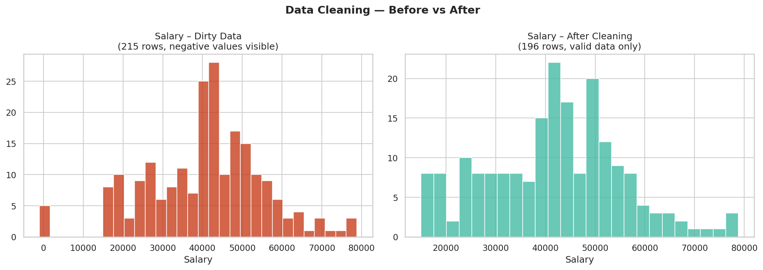
Figure 3.1 — Effect of removing duplicate rows and filtering impossible negative salary values.

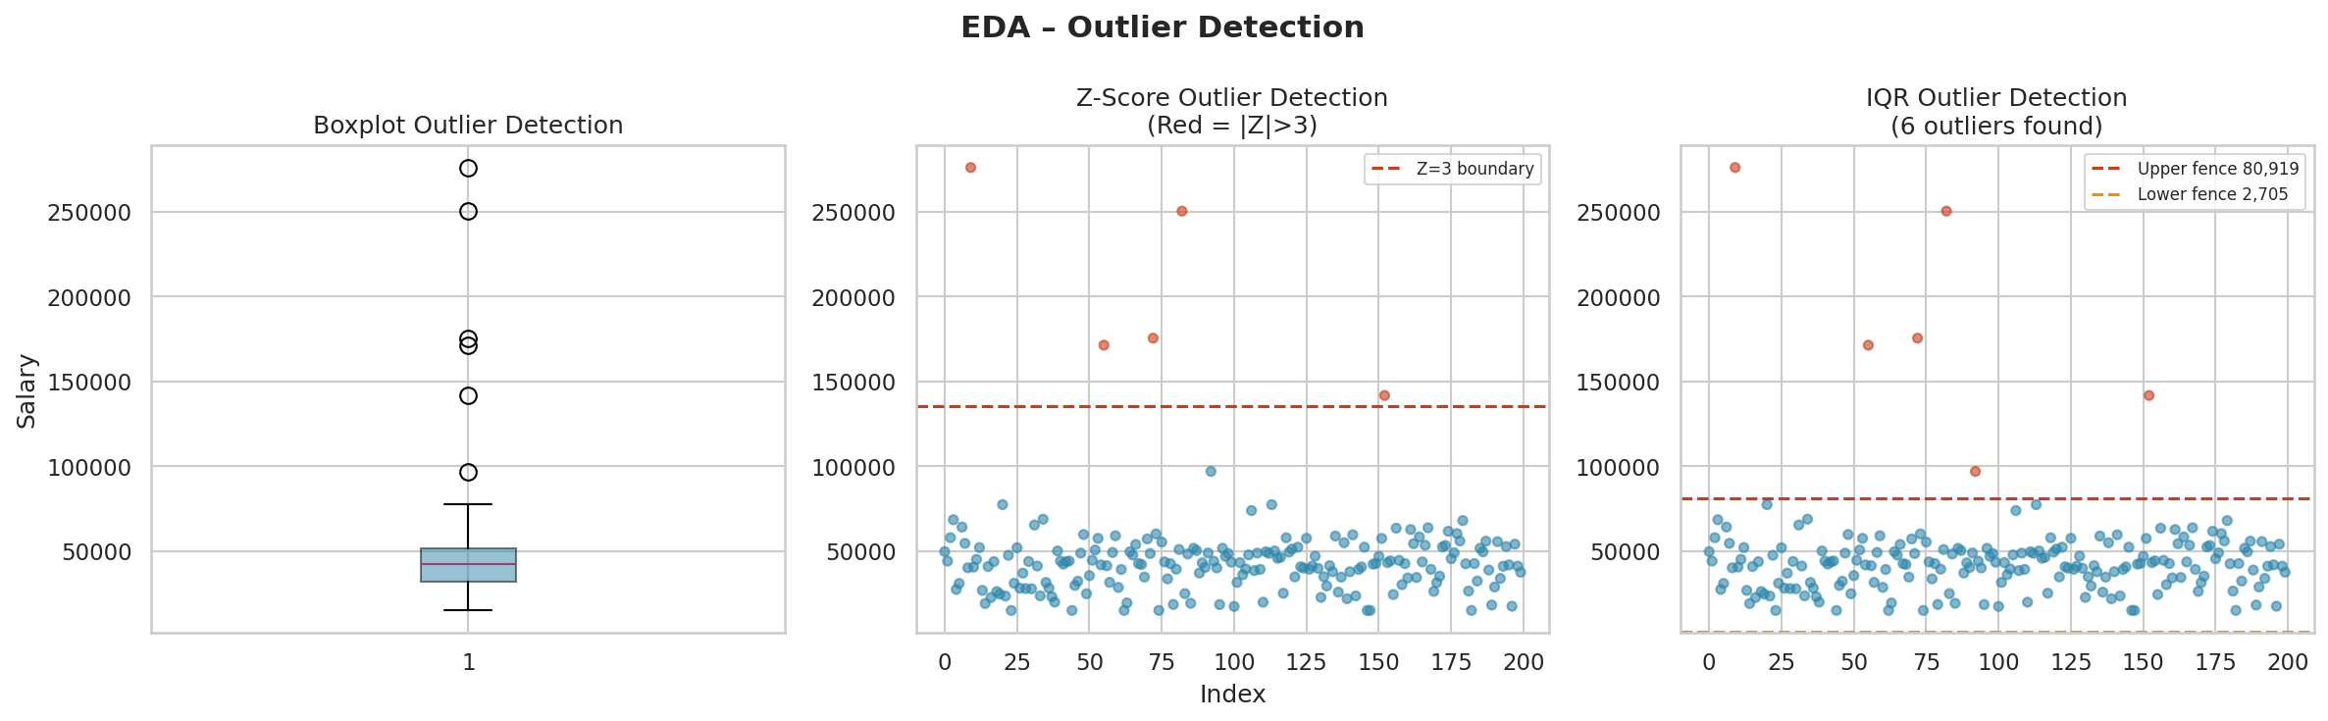
Figure 3.2 — Three outlier detection methods: Boxplot, Z-Score (|Z|>3 highlighted), and IQR fences.

Chapter 4: Handling Missing Values
Missing values are one of the most common data quality issues. How you handle them dramatically changes your analysis and model performance. There is no single "correct" approach — the right strategy depends on why the data is missing and how much is missing.

4.1 Types of Missingness
Type | Full Name | Meaning | Example
MCAR | Missing Completely At Random | Missingness is unrelated to any data | Random sensor dropout
MAR | Missing At Random | Missingness depends on other observed columns | Senior employees skip salary field more often
MNAR | Missing Not At Random | Missingness depends on the missing value itself | Low earners skip salary field to hide it

💡 Why does type matter?
MCAR → Any strategy is safe. Drop or impute freely.
MAR → Impute using other correlated columns (group-wise mean, KNN, etc.)
MNAR → Simple imputation introduces bias. Consider domain-specific solutions.
Sometimes create a flag column: "Salary_was_missing = 1/0"

4.2 Visualise Missing Values First
import missingno as msno # pip install missingno

# Matrix plot (shows pattern of missingness)
msno.matrix(df)

# Bar chart of non-null counts
msno.bar(df)

# Manual approach
missing_info = pd.DataFrame({
"Count": df.isnull().sum(),
"Percent": (df.isnull().sum() / len(df) * 100).round(2)
})
print(missing_info[missing_info["Count"] > 0])

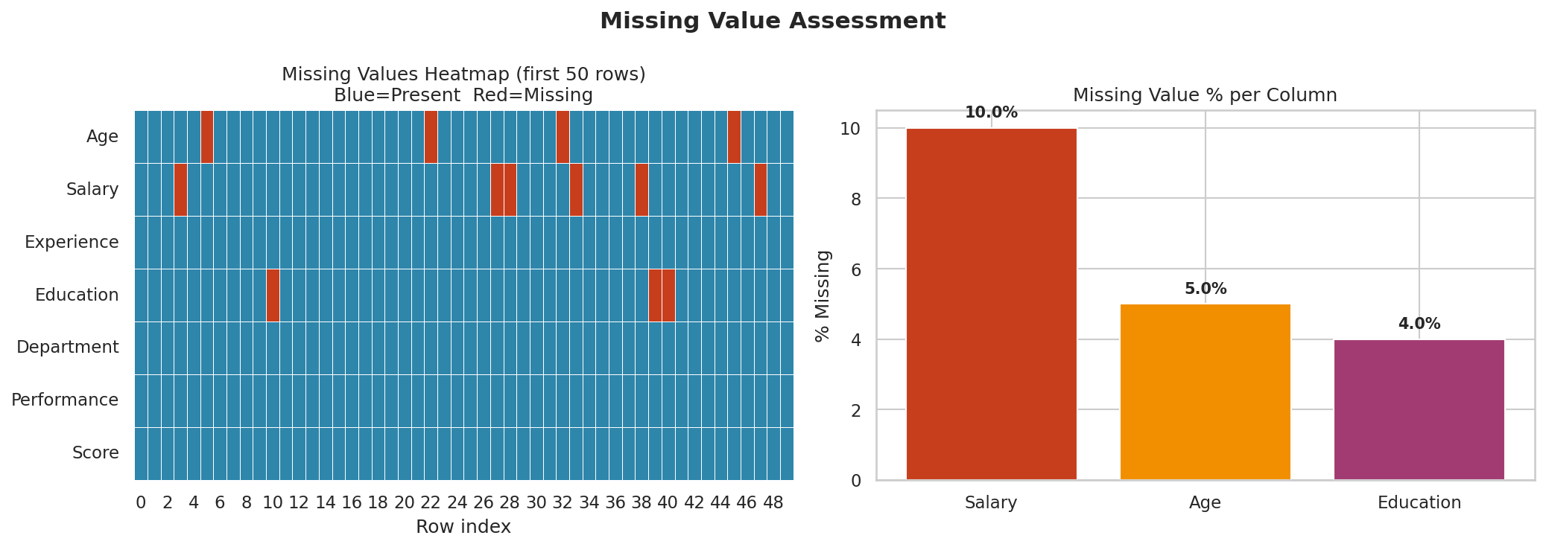
Figure 4.1 — Left: Heatmap showing exactly which rows/columns have missing data. Right: % missing per column.

4.3 Strategy 1: Drop Missing Values
The simplest approach: remove rows or columns with missing data. Only safe when missingness is MCAR and the proportion is small (< 5%).
# Drop rows where ANY column has a missing value
df_dropped = df.dropna()

# Drop rows only if SPECIFIC column is missing
df_dropped = df.dropna(subset=["Salary"])

# Drop a column if > 40% values are missing
threshold = 0.4
df = df.loc[:, df.isnull().mean() < threshold]

# Drop rows where at least 3 values are missing
df = df.dropna(thresh=len(df.columns) - 2)

# When to use:
# ✅ < 5% missing in that column
# ✅ MCAR assumption holds
# ❌ Do NOT use when > 20% missing — you lose too much data

4.4 Strategy 2: Fill with Mean / Median / Mode

Mean Imputation — for normally distributed numeric columns
# Fill Salary NaN with mean salary
mean_salary = df["Salary"].mean()
df["Salary"] = df["Salary"].fillna(mean_salary)

# Or inline
df["Salary"].fillna(df["Salary"].mean(), inplace=True)

# ✅ Good when: data is symmetric, no outliers, MCAR
# ❌ Bad when: data is skewed, has outliers (mean gets pulled)

Median Imputation — better for skewed / outlier-prone data
# Median is robust to outliers
df["Salary"].fillna(df["Salary"].median(), inplace=True)

# ✅ Good when: data is skewed (right-tailed salary data)
# ✅ Preferred over mean when outliers are present

Mode Imputation — for categorical columns
# Fill missing Education with the most frequent value
mode_edu = df["Education"].mode()[0] # mode() returns a Series
df["Education"].fillna(mode_edu, inplace=True)

# ✅ Good for: categorical columns (Department, Education)
# ❌ Bad when: many categories with similar frequency

4.5 Strategy 3: Forward Fill / Backward Fill
Useful for time series data where values are expected to carry over between time steps.
# Forward fill: propagate last valid value forward
df["Salary"] = df["Salary"].ffill()

# Backward fill: propagate next valid value backward
df["Salary"] = df["Salary"].bfill()

# Combine both (fill from front, then back for any remaining at start)
df["Salary"] = df["Salary"].ffill().bfill()

# ✅ Good for: time-series (sensor readings, stock prices, attendance)
# ❌ Bad for: cross-sectional tabular data (employee records, surveys)

4.6 Strategy 4: Group-Wise Imputation
Instead of filling with the global mean, fill with the mean of the subgroup. This is more accurate because salary within "Engineering" is different from "HR".
# Fill missing Salary with the mean salary of the same Department
df["Salary"] = df.groupby("Department")["Salary"].transform(
lambda x: x.fillna(x.mean())
)

# Fill Age with median age per Education level
df["Age"] = df.groupby("Education")["Age"].transform(
lambda x: x.fillna(x.median())
)

# ✅ Much better than global mean — respects subgroup patterns
# ✅ Use when you have correlated categorical columns

4.7 Strategy 5: KNN Imputation
K-Nearest Neighbors Imputation finds the k rows most similar to the row with the missing value and fills it with the average of those neighbours. This is one of the most powerful imputation strategies.
from sklearn.impute import KNNImputer

# Only works on numeric columns
num_cols = ["Age", "Salary", "Experience", "Score"]

imputer = KNNImputer(n_neighbors=5) # use 5 nearest rows
df[num_cols] = imputer.fit_transform(df[num_cols])

# How it works:
# For a row with missing Salary:
# 1. Find 5 rows with similar Age, Experience, Score
# 2. Fill Salary = average of those 5 rows' Salary

# ✅ Best for MAR — uses other columns to estimate missing value
# ✅ Preserves relationships between columns
# ❌ Slow on very large datasets (>100k rows)

4.8 Strategy 6: Add a "Was Missing" Flag
When missingness is informative (MNAR), preserve the information about what was missing by creating a binary flag column.
# Create indicator BEFORE imputing
df["Salary_was_missing"] = df["Salary"].isnull().astype(int)

# Then impute normally
df["Salary"].fillna(df["Salary"].median(), inplace=True)

# Now your model can learn:
# "When Salary_was_missing=1, it might mean the person preferred not to share"

# ✅ Essential for MNAR data
# ✅ Lets the model use missingness as a feature signal

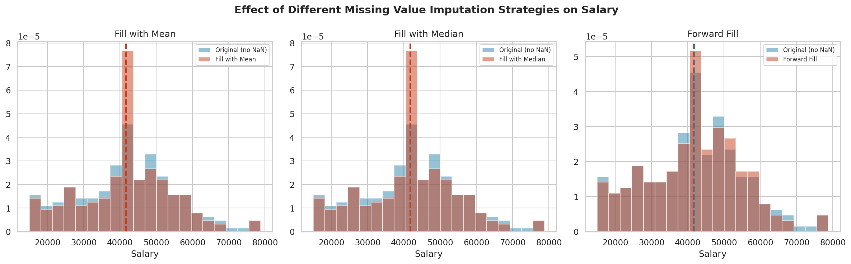
Figure 4.2 — Comparison of Mean, Median, and Forward Fill imputation strategies on Salary. The shape of the distribution changes slightly with each approach.

4.9 Choosing the Right Strategy
Situation | Recommended Strategy
< 5% missing, MCAR | Drop rows
> 40% of column missing | Drop the entire column
Numeric, symmetric distribution | Mean imputation
Numeric, skewed or has outliers | Median imputation
Categorical column | Mode imputation
Time series / sequential data | Forward Fill / Backward Fill
Correlated with other columns | Group-wise mean / KNN imputation
Missingness is informative (MNAR) | Flag + impute
Best accuracy required | KNN or ML-based imputation

Chapter 5: Exploratory Data Analysis (EDA)
EDA is the process of analysing datasets to summarise their main characteristics, using visual methods. The goal is to understand the data deeply BEFORE modelling — find patterns, spot anomalies, test assumptions, and check relationships between variables.

5.1 EDA Framework
📋 EDA Structured Approach:

Step 1: Univariate Analysis — Examine each column individually
Step 2: Bivariate Analysis — Examine pairs of columns
Step 3: Multivariate Analysis — Examine many columns together
Step 4: Temporal Analysis — If time column exists
Step 5: Segmented Analysis — Analyse subgroups
Step 6: Anomaly Investigation — Deep dive into outliers

5.2 Univariate Analysis
Analyse each column in isolation. The goal is to understand the distribution, central tendency, and spread of each variable.

For Numeric Columns
# Full numeric EDA on a single column
col = df["Salary"]

# Basic stats
print(col.describe())
print(f"Skewness: {col.skew():.3f}") # 0=symmetric, >1=right skewed
print(f"Kurtosis: {col.kurtosis():.3f}") # 3=normal, >3=heavy tails

# Visualise
fig, axes = plt.subplots(1, 3, figsize=(15,4))

# Histogram
axes[0].hist(col, bins=30, color="#2E86AB", edgecolor="white")
axes[0].axvline(col.mean(), color="red", label="Mean")
axes[0].axvline(col.median(), color="orange", linestyle="--", label="Median")
axes[0].legend(); axes[0].set_title("Histogram")

# KDE (Kernel Density Estimate)
col.plot(kind="kde", ax=axes[1], color="#2E86AB")
axes[1].set_title("KDE Plot")

# Boxplot
axes[2].boxplot(col, vert=True, patch_artist=True)
axes[2].set_title("Boxplot")

plt.tight_layout()
plt.show()

For Categorical Columns
# Categorical univariate EDA
col = df["Education"]

# Frequency table
print(col.value_counts())
print(col.value_counts(normalize=True) * 100) # percentages

# Bar chart
col.value_counts().plot(kind="bar", color=["#2E86AB","#A23B72","#F18F01","#44BBA4"])
plt.title("Education Level Distribution")
plt.xticks(rotation=30)
plt.show()

# Pie chart
col.value_counts().plot(kind="pie", autopct="%1.1f%%")
plt.title("Education Split")
plt.show()

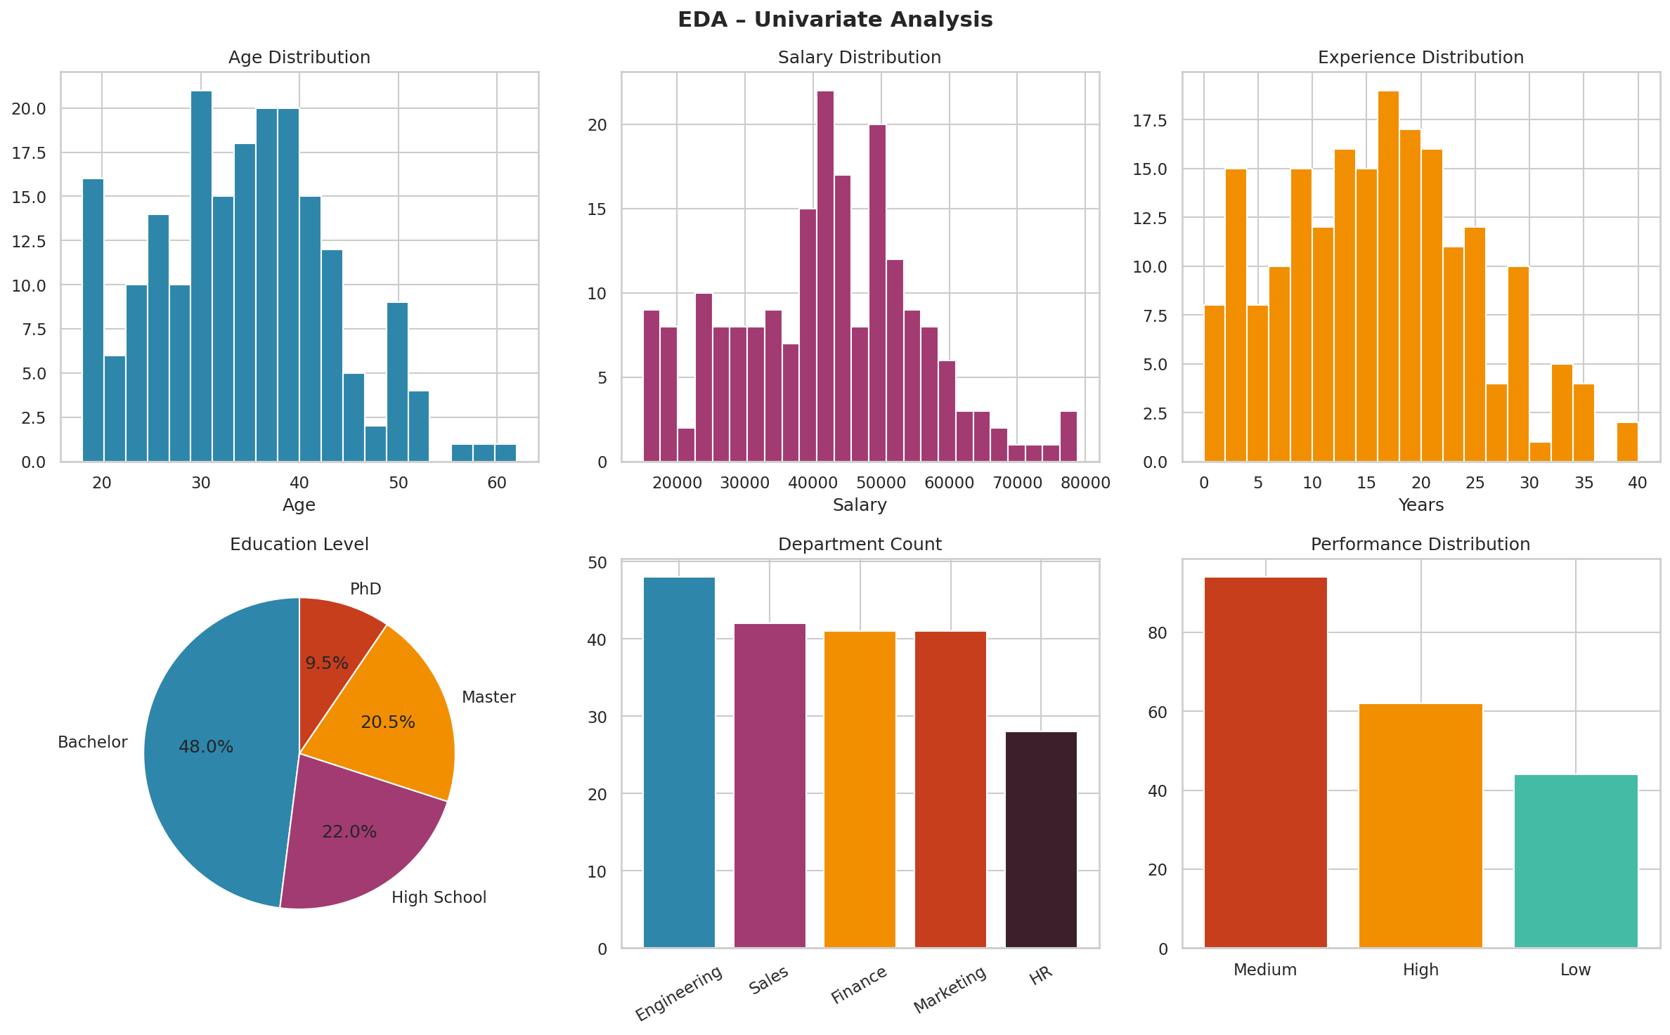
Figure 5.1 — Univariate analysis across all columns: histograms for numeric columns (Age, Salary, Experience), pie chart for Education, bar charts for Department and Performance.

5.3 Understanding Skewness
Skewness Value | Shape | Interpretation | Implication
≈ 0 | Symmetric | Mean ≈ Median | Normal; use mean for stats
> 1 (Right-skewed) | Long tail right | Mean > Median | Use median; consider log transform
< −1 (Left-skewed) | Long tail left | Mean < Median | Use median; consider reflection + log

📌 Real Example — Salary is typically Right-Skewed:
Most employees earn moderate salaries, but a few executives earn very high salaries.
This creates a long right tail.
→ Mean salary = ₹62,000 (pulled up by high earners)
→ Median salary = ₹54,000 (better representative of typical employee)
→ Use log transformation: df["Log_Salary"] = np.log1p(df["Salary"])

5.4 Bivariate Analysis
Examine relationships between pairs of variables.

Numeric vs Numeric — Scatter Plots & Correlation
# Scatter plot with regression line
import seaborn as sns

sns.regplot(x="Age", y="Salary", data=df, scatter_kws={"alpha":0.5})
plt.title(f'Age vs Salary (r = {df["Age"].corr(df["Salary"]):.2f})')
plt.show()

# Correlation matrix heatmap
corr = df[["Age","Salary","Experience","Score"]].corr()
sns.heatmap(corr, annot=True, cmap="RdBu_r", vmin=-1, vmax=1)
plt.title("Correlation Matrix")
plt.show()

Categorical vs Numeric — Box / Violin Plots
# How does salary differ across departments?
sns.boxplot(x="Department", y="Salary", data=df)
plt.title("Salary by Department")
plt.xticks(rotation=30)
plt.show()

# Violin plot shows distribution shape too
sns.violinplot(x="Education", y="Salary", data=df,
order=["High School","Bachelor","Master","PhD"])
plt.title("Salary Distribution by Education Level")
plt.show()

# Group mean comparison
print(df.groupby("Department")["Salary"].agg(["mean","median","std"]))

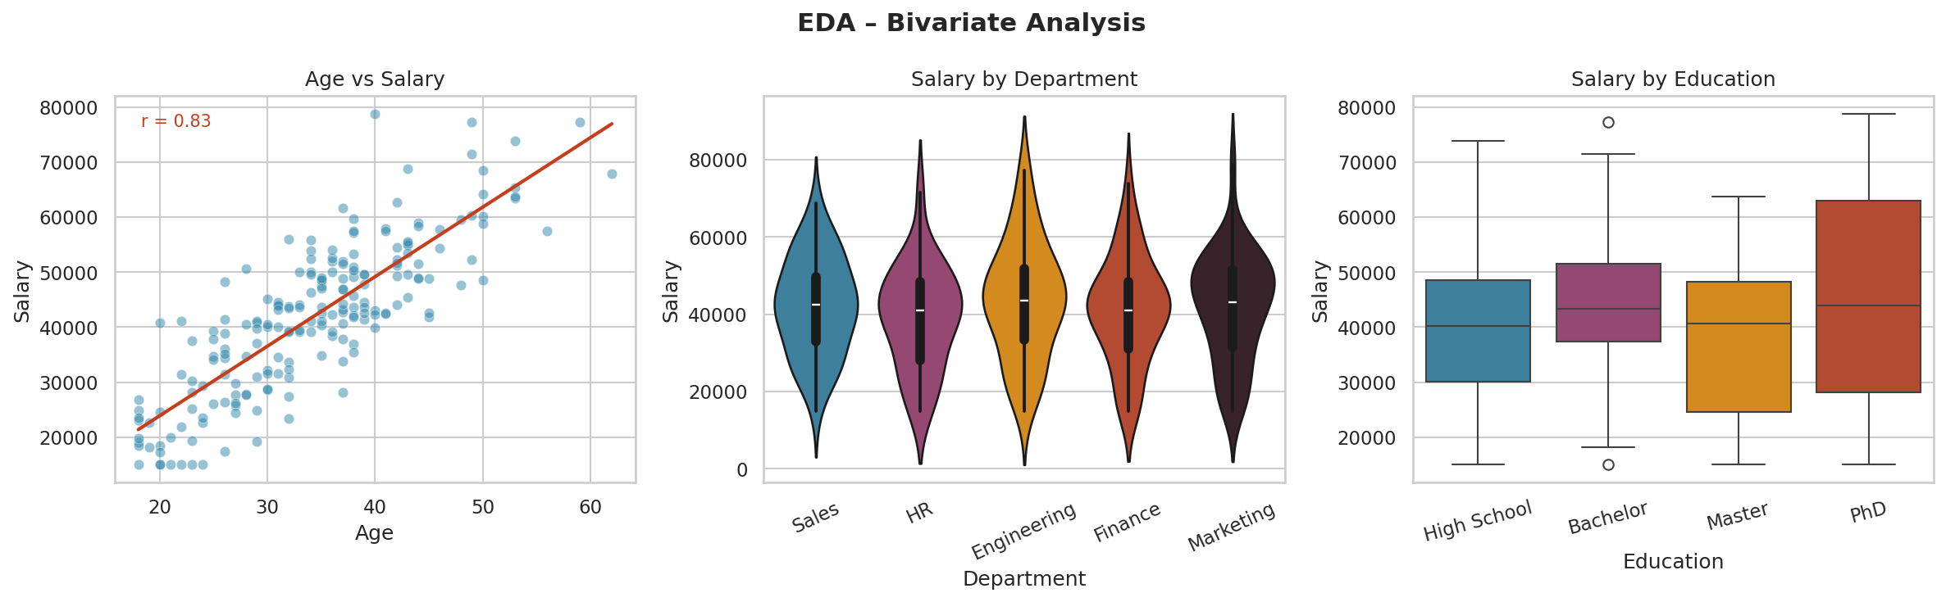
Figure 5.2 — Bivariate: Age vs Salary scatter (positive correlation r shown), Salary by Department (violin), and Salary by Education level (boxplot showing PhD highest).

5.5 Multivariate Analysis

Pair Plot
# Pair plot — all numeric pairs at once, coloured by category
sns.pairplot(df[["Age","Salary","Experience","Score","Performance"]],
hue="Performance",
plot_kws={"alpha": 0.5},
diag_kind="kde")
plt.suptitle("Pair Plot — Multi-Variable EDA", y=1.02)
plt.show()

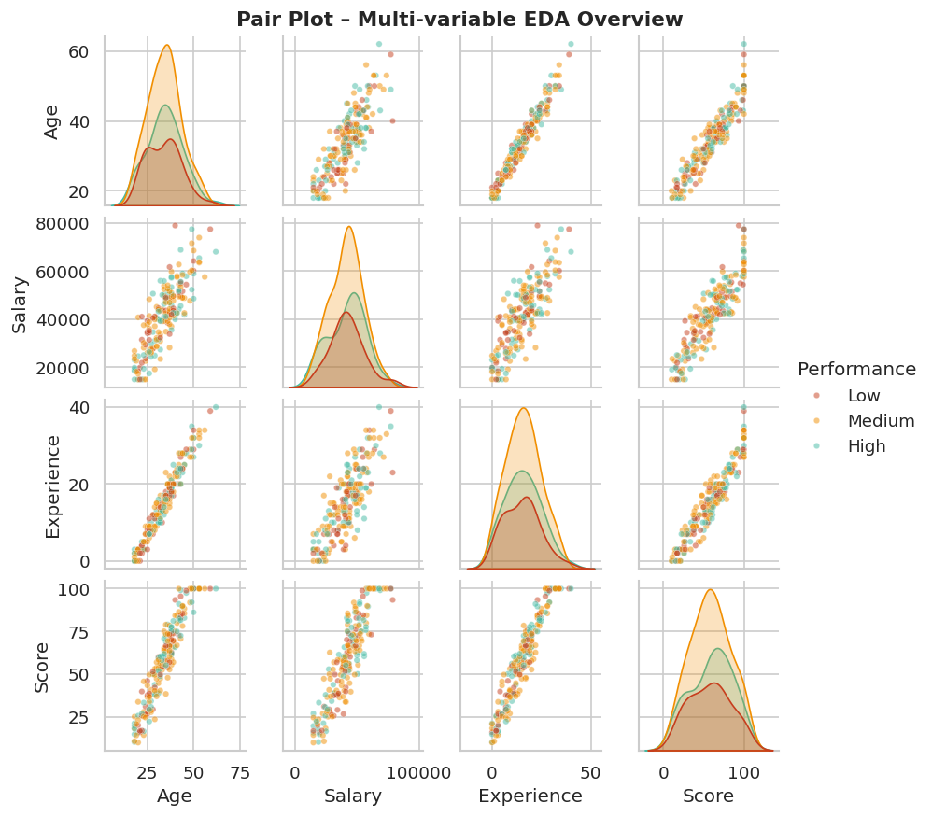
Figure 5.3 — Pair plot showing pairwise relationships coloured by Performance level. Diagonal shows KDE distributions. Notice Experience-Salary and Age-Experience are strongly correlated.

5.6 Temporal Analysis (if Date column exists)
# Monthly salary trend
df["JoinDate"] = pd.to_datetime(df["JoinDate"])
df.set_index("JoinDate")["Salary"].resample("M").mean().plot()
plt.title("Average Monthly Salary Trend")

# Year-over-year growth
yearly = df.groupby(df["JoinDate"].dt.year)["Salary"].mean()
print(yearly.pct_change() * 100) # % change year over year

5.7 EDA Summary Checklist
✅ COMPLETE EDA CHECKLIST

□ Checked all column distributions (histograms, KDE)
□ Identified skewness and kurtosis
□ Found and documented outliers
□ Examined correlations between numeric variables
□ Visualised categorical distributions (bar, pie)
□ Compared numeric variables across categories (boxplot, violin)
□ Created correlation heatmap
□ Ran pair plot for multivariate overview
□ Checked data after cleaning for verification
□ Documented key findings and anomalies

Chapter 6: Normalization (Min-Max Scaling)
Normalization rescales features so that all values fall within a fixed range, typically [0, 1]. It preserves the original shape of the distribution but changes the scale.

6.1 The Formula
x_normalized = (x − x_min) / (x_max − x_min)
📌 What this does:
• The minimum value becomes exactly 0
• The maximum value becomes exactly 1
• All other values are proportionally scaled between 0 and 1

📌 Example — Age column: [22, 35, 28, 65, 18]
x_min = 18, x_max = 65
Age=22 → (22−18)/(65−18) = 4/47 = 0.085
Age=65 → (65−18)/(65−18) = 1.000
Age=18 → 0.000

6.2 Python Implementation
import pandas as pd
import numpy as np
from sklearn.preprocessing import MinMaxScaler

df = pd.DataFrame({
"Age": [22, 35, 28, 65, 18],
"Salary": [25000, 55000, 38000, 95000, 20000],
"Experience": [2, 12, 7, 40, 0]
})

print("Before normalization:")
print(df)

# Apply Min-Max Normalization
scaler = MinMaxScaler() # range [0,1] by default
df_norm = pd.DataFrame(
scaler.fit_transform(df),
columns=df.columns
)

print("\nAfter normalization (all values between 0 and 1):")
print(df_norm.round(3))

# Custom range [0, 100]
scaler_100 = MinMaxScaler(feature_range=(0, 100))
df_0_100 = pd.DataFrame(scaler_100.fit_transform(df), columns=df.columns)

# Inverse transform (get original values back)
df_original = pd.DataFrame(
scaler.inverse_transform(df_norm),
columns=df.columns
)

6.3 What Happens to the Data?
🔍 WHAT NORMALIZATION DOES TO YOUR DATA:

✅ Shape preserved: If your data was right-skewed before, it stays right-skewed.
✅ Relative relationships preserved: a 2x higher value stays 2x.
✅ Units removed: Age in "years" and Salary in "₹" both become dimensionless [0,1].
✅ No negative values after transformation (range is 0 to 1).

⚠ Sensitive to outliers: One extreme value (e.g., Salary=500,000)
squishes ALL other values into a tiny range near 0.
⚠ Breaks when new data exceeds original min/max (at inference time).

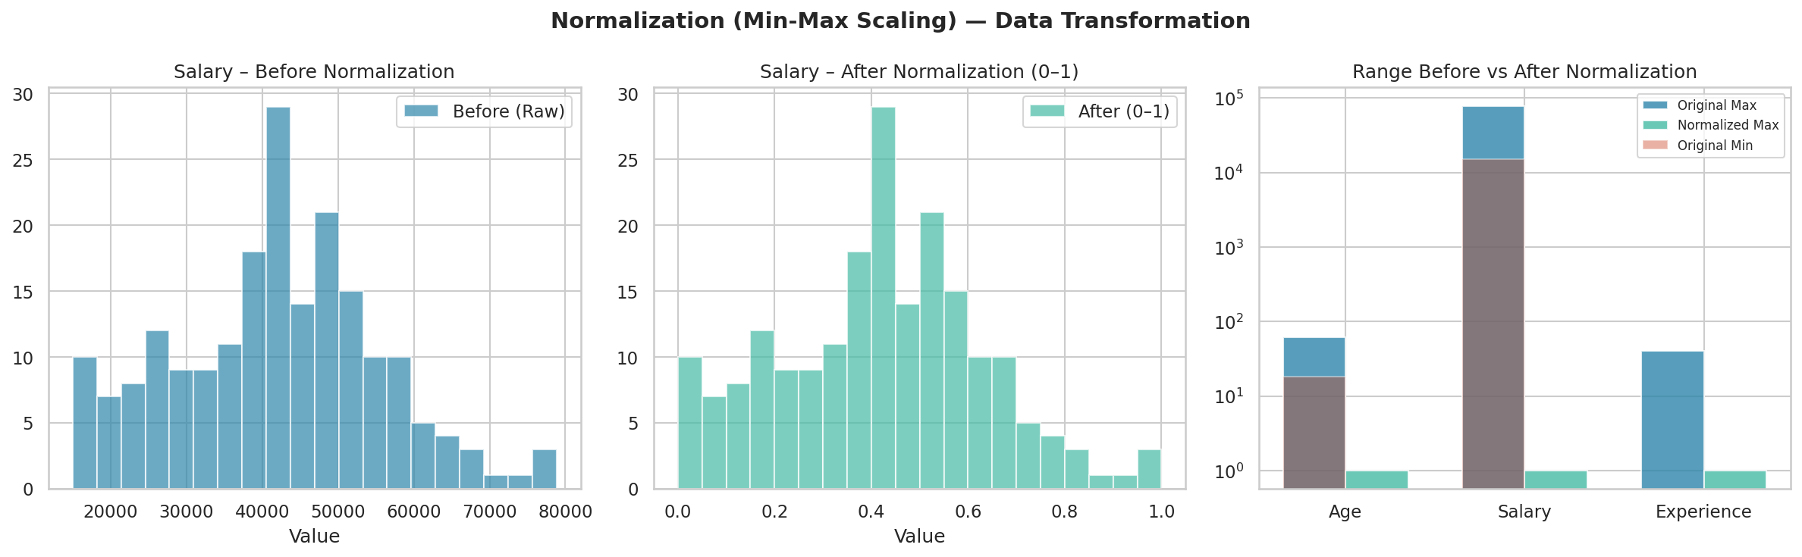
Figure 6.1 — Salary before normalization (thousands), after normalization (0–1 range), and range comparison across columns.

6.4 When to Use Normalization
Use Normalization When... | Do NOT Use When...
Algorithm uses distance (KNN, K-Means) | Data has heavy outliers
Algorithm uses dot products (Neural Nets) | Data is normally distributed already
Features need to be in a bounded range | Using tree-based models (RF, XGBoost)
Image pixel values (0–255 → 0–1) | Standardization is more appropriate

Chapter 7: Standardization (Z-Score Scaling)
Standardization transforms data so that each feature has a mean of 0 and a standard deviation of 1. Unlike normalization, it does not bound values to a specific range — values can be negative and can exceed ±1.

7.1 The Formula
z = (x − μ) / σ
📌 What this does:
• The column mean becomes exactly 0
• The column standard deviation becomes exactly 1
• Values are expressed as "how many standard deviations from the mean"

📌 Example — Salary: [25000, 55000, 38000, 95000]
μ = 53,250 σ = 27,886
Salary=25000 → (25000−53250)/27886 = −1.013 (about 1 std below average)
Salary=95000 → (95000−53250)/27886 = +1.497 (about 1.5 std above average)

7.2 Python Implementation
from sklearn.preprocessing import StandardScaler
import pandas as pd

df = pd.DataFrame({
"Age": [22, 35, 28, 65, 18],
"Salary": [25000, 55000, 38000, 95000, 20000],
"Experience": [2, 12, 7, 40, 0]
})

scaler = StandardScaler()
df_std = pd.DataFrame(
scaler.fit_transform(df),
columns=df.columns
)

print("After standardization:")
print(df_std.round(3))

# Verify: mean ≈ 0, std ≈ 1
print("\nMean of each column:", df_std.mean().round(6))
print("Std of each column:", df_std.std().round(6))

# Access the learned parameters
print("Original means:", scaler.mean_)
print("Original stds:", scaler.scale_)

# Inverse transform
df_back = pd.DataFrame(
scaler.inverse_transform(df_std),
columns=df.columns
)

7.3 What Happens to the Data?
🔍 WHAT STANDARDIZATION DOES TO YOUR DATA:

✅ Distribution shape preserved: skewness and kurtosis unchanged.
✅ More robust to outliers than normalization.
(Outlier shifts mean/std slightly, but does not squish all other values.)
✅ Values can be negative (below mean gets negative Z-score).
✅ No fixed upper/lower bound — can go beyond ±3 for extreme values.
✅ Preferred for models that assume normal distribution (Linear/Logistic Reg, SVM).

⚠ Does not guarantee values in [0,1] — use normalization for that.
⚠ Assumes data is approximately normally distributed for best results.

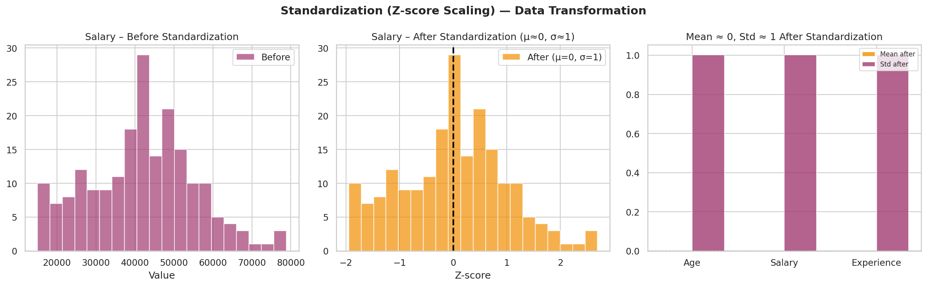
Figure 7.1 — Salary before and after standardization. After scaling, the distribution is centred at 0 with std=1. Bar chart confirms mean≈0 and std≈1 for all columns.

7.4 Normalization vs Standardization — The Big Comparison
This is one of the most confusing topics. Here is a definitive breakdown:
Aspect | Normalization (Min-Max) | Standardization (Z-Score)
Output range | 0 to 1 (or custom) | No fixed range (typically −3 to +3)
Mean after | Not necessarily 0 | ≈ 0
Std after | Not necessarily 1 | ≈ 1
Outlier effect | Very sensitive — squishes data | Moderate — shifts mean/std slightly
Assumes normality? | No | Works best with approximately normal data
Use case | Neural nets, KNN, K-Means, pixel data | Linear/Logistic Regression, SVM, PCA
New data out of range | May go outside [0,1] | Handled gracefully

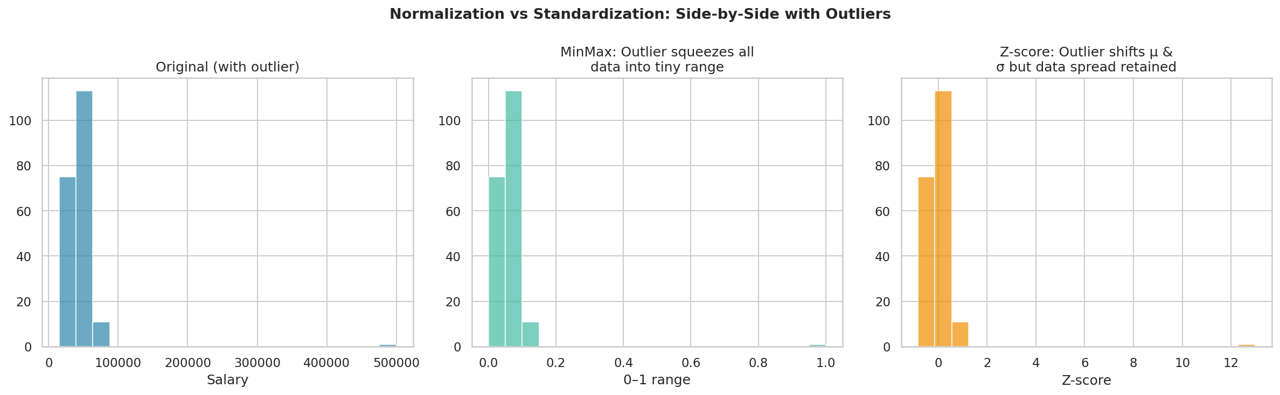
Figure 7.2 — Impact of one outlier (Salary=500,000). MinMax squishes all real data into [0, 0.02]. Standardization handles it gracefully — outlier becomes Z≈16, rest of data still usable.

7.5 Decision Guide — Which One to Use?
🎯 QUICK DECISION GUIDE:

❓ Does your algorithm use DISTANCE (KNN, K-Means, SVM with RBF)?
→ Use StandardScaler (or MinMax if no outliers)

❓ Are you building a NEURAL NETWORK?
→ Use MinMaxScaler (input in [0,1] trains faster)
→ Or StandardScaler (also works well)

❓ Does your data have HEAVY OUTLIERS?
→ Use StandardScaler (outliers skew MinMax badly)

❓ Are you using PCA?
→ ALWAYS use StandardScaler first

❓ Are you using TREE-BASED models (Random Forest, XGBoost, LightGBM)?
→ Neither is needed — trees are scale-invariant

❓ Is your data bounded by nature (age, percentages)?
→ MinMaxScaler is natural

Chapter 8: Encoding Techniques
Machine learning models work with numbers, not text. Encoding converts categorical variables (like "High School", "Engineering", "Male") into numerical representations. Choosing the wrong encoding method can introduce false ordinal relationships or explode feature dimensionality.

8.1 Types of Categorical Variables
Type | Definition | Example | Best Encoding
Nominal | No natural order | Department: Eng, HR, Finance | One-Hot Encoding
Ordinal | Has a natural order | Education: HS < BSc < MSc < PhD | Ordinal / Label Encoding
Binary | Only 2 categories | Gender: Male/Female | Label Encoding (0/1)
High Cardinality | Many unique categories | City: 500 unique cities | Target / Frequency Encoding

8.2 Label Encoding
Assigns an integer to each category. Simple, but introduces false ordinal relationships for nominal data.
High School → 0, Bachelor → 1, Master → 2, PhD → 3
from sklearn.preprocessing import LabelEncoder

le = LabelEncoder()
df["Education_Encoded"] = le.fit_transform(df["Education"])

# See the mapping
mapping = dict(zip(le.classes_, le.transform(le.classes_)))
print(mapping)
# {'Bachelor': 0, 'High School': 1, 'Master': 2, 'PhD': 3}
# Note: alphabetical order, not natural order!

# Decode back to original
df["Education_Decoded"] = le.inverse_transform(df["Education_Encoded"])

# ✅ Use for: ordinal data or binary categories
# ❌ WARNING: Do NOT use for nominal data with 3+ categories.
# The model may think PhD(3) - Master(2) = Master(2) - Bachelor(1),
# which is a false assumption.

8.3 Ordinal Encoding
Like label encoding, but you manually specify the order. This is the correct approach for ordinal variables.
from sklearn.preprocessing import OrdinalEncoder

# Manual mapping (preserves your intended order)
edu_order = {"High School": 1, "Bachelor": 2, "Master": 3, "PhD": 4}
df["Education_Ordinal"] = df["Education"].map(edu_order)

# Using OrdinalEncoder with explicit category order
enc = OrdinalEncoder(categories=[["High School","Bachelor","Master","PhD"]])
df["Education_Ordinal2"] = enc.fit_transform(df[["Education"]])

# Result: High School=0, Bachelor=1, Master=2, PhD=3
# (0-indexed in OrdinalEncoder, or custom 1-4 with manual mapping)

# ✅ Correct for ordinal data — preserves meaningful rank

8.4 One-Hot Encoding
Creates a new binary column for each unique category. The correct choice for nominal data with no natural order.
import pandas as pd

# Using pandas get_dummies
df_encoded = pd.get_dummies(df, columns=["Department"], prefix="Dept")
# Adds: Dept_Engineering, Dept_Finance, Dept_HR, Dept_Marketing, Dept_Sales

# Drop first to avoid multicollinearity (dummy variable trap)
df_encoded = pd.get_dummies(df, columns=["Department"], prefix="Dept", drop_first=True)
# Now only 4 columns — 5th is implied when all 4 are 0

# Using sklearn
from sklearn.preprocessing import OneHotEncoder

ohe = OneHotEncoder(sparse_output=False, drop="first")
encoded = ohe.fit_transform(df[["Department"]])
ohe_df = pd.DataFrame(encoded, columns=ohe.get_feature_names_out())

# ✅ Correct for nominal categories (Department, City, Colour)
# ❌ Bad for high cardinality — 500 cities = 500 columns

8.5 Target Encoding (Mean Encoding)
Replace each category with the mean of the target variable for that category. Useful for high-cardinality columns. Must be done carefully to avoid data leakage.
# Target Encoding — encode Department with mean Salary

# ⚠ IMPORTANT: Use training data only to compute means
# Then apply the same map to test data

target_mean = df.groupby("Department")["Salary"].mean()
print(target_mean)
# Engineering 68000
# Finance 61000
# HR 47000
# Marketing 54000
# Sales 52000

df["Dept_Target_Encoded"] = df["Department"].map(target_mean)

# ✅ Great for high-cardinality columns
# ⚠ Risk of data leakage — use cross-validation target encoding

# Safe version using category_encoders library
# pip install category_encoders
import category_encoders as ce
enc = ce.TargetEncoder(cols=["Department"])
df["Dept_TE"] = enc.fit_transform(df["Department"], df["Salary"])

8.6 Frequency Encoding
Replace each category with how often it appears in the dataset. Simple and effective for high-cardinality nominal columns.
# Frequency encoding
freq_map = df["Department"].value_counts(normalize=True)
df["Dept_Freq"] = df["Department"].map(freq_map)

# Result: Engineering appears in 25% of rows → 0.25
# HR appears in 15% of rows → 0.15

# ✅ Simple, no data leakage, works for any cardinality
# ✅ Encodes popularity/frequency as a signal

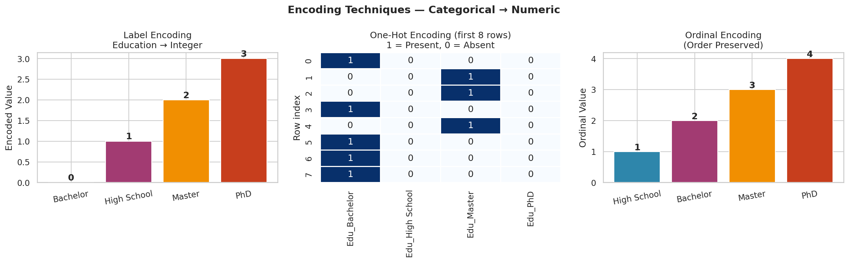
Figure 8.1 — Three encoding techniques on Education: Label Encoding (integers assigned alphabetically), One-Hot Encoding (binary columns for first 8 rows), and Ordinal Encoding (1–4 preserving natural order).

8.7 Encoding Decision Guide
🎯 ENCODING DECISION GUIDE:

❓ Is the variable BINARY (2 categories only)?
→ Label Encoding: Male=0, Female=1

❓ Is the variable ORDINAL (has a natural rank)?
→ Ordinal Encoding (map manually to preserve order)

❓ Is the variable NOMINAL with few categories (<15)?
→ One-Hot Encoding (get_dummies with drop_first=True)

❓ Is the variable NOMINAL with many categories (>15)?
→ Target Encoding or Frequency Encoding

❓ Are you using a TREE model (RF, XGBoost)?
→ Label or Ordinal encoding often sufficient
→ Trees can learn non-linear splits regardless of order

❓ Are you using LINEAR models or NEURAL NETS?
→ One-Hot for nominal (avoids false ordinal assumption)

Chapter 9: Principal Component Analysis (PCA)
PCA is a dimensionality reduction technique. It takes a dataset with many correlated features and transforms it into a smaller set of uncorrelated components that capture most of the variance (information) in the original data.

9.1 The Problem PCA Solves
💡 Why do we need PCA?

Problem 1 — Too many features:
You have 100 features. Many are correlated. The model overfits.

Problem 2 — Curse of Dimensionality:
In high dimensions, all data points become equidistant.
Distance-based models (KNN, K-Means) break down.

Problem 3 — Visualisation:
You cannot visualise 50-dimensional data.
PCA compresses it to 2–3 dimensions for plotting.

Solution: PCA finds new axes (Principal Components) in the data
that capture the most variance, then projects the data onto them.

9.2 How PCA Works — Step by Step
- Standardize the data — PCA is sensitive to scale. ALWAYS standardize first.
- Compute the Covariance Matrix — Measures how features co-vary.
- Compute Eigenvectors & Eigenvalues — Eigenvectors = directions of maximum variance. Eigenvalues = amount of variance in each direction.
- Sort Eigenvectors by Eigenvalue — The eigenvector with the highest eigenvalue is PC1 (most variance), next is PC2, etc.
- Project data onto new axes — Multiply original data by selected eigenvectors.

9.3 Mathematical Foundation
Covariance Matrix: C = (1/(n−1)) × Xᵀ × X (where X is standardized)
Eigendecomposition: C × v = λ × v
Where: v = eigenvector (direction / principal component)
λ = eigenvalue (variance explained by that component)
Projection: Z = X × V (V = matrix of selected eigenvectors)

9.4 Python Implementation — Full Walkthrough
import pandas as pd
import numpy as np
from sklearn.preprocessing import StandardScaler
from sklearn.decomposition import PCA
import matplotlib.pyplot as plt

# Step 1: Prepare data (numeric only)
X = df[["Age", "Salary", "Experience", "Score"]].copy()

# Step 2: Standardize FIRST (critical!)
scaler = StandardScaler()
X_scaled = scaler.fit_transform(X)

# Step 3: Fit PCA — start with all components
pca = PCA() # or PCA(n_components=2) for 2D
pca.fit(X_scaled)

# Step 4: Examine explained variance
ev = pca.explained_variance_ratio_
cum_ev = np.cumsum(ev)

print("Variance explained per component:")
for i, (e, c) in enumerate(zip(ev, cum_ev), 1):
print(f" PC{i}: {e*100:.1f}% (Cumulative: {c*100:.1f}%)")

# Output:
# PC1: 72.3% (Cumulative: 72.3%)
# PC2: 18.1% (Cumulative: 90.4%)
# PC3: 7.2% (Cumulative: 97.6%)
# PC4: 2.4% (Cumulative: 100%)

# Step 5: Choose n_components to retain ~95% variance
n_comp = np.argmax(cum_ev >= 0.95) + 1
print(f"\nComponents needed for 95% variance: {n_comp}")

# Step 6: Transform the data
pca_final = PCA(n_components=n_comp)
X_pca = pca_final.fit_transform(X_scaled)

print(f"\nOriginal shape: {X_scaled.shape}") # (200, 4)
print(f"Reduced shape: {X_pca.shape}") # (200, 2)

9.5 Scree Plot & Explained Variance
The scree plot is essential for choosing the number of components to keep. Look for the "elbow" point where adding more components gives diminishing returns.
# Scree Plot
fig, ax = plt.subplots(figsize=(8, 4))

ax.bar(range(1, len(ev)+1), ev*100, color="#2E86AB", alpha=0.8, label="Individual")
ax.plot(range(1, len(ev)+1), cum_ev*100, "o-", color="#C73E1D", lw=2, label="Cumulative")
ax.axhline(95, color="#F18F01", linestyle="--", lw=1.5, label="95% threshold")

ax.set_xlabel("Principal Component")
ax.set_ylabel("Variance Explained (%)")
ax.set_title("Scree Plot")
ax.legend()
plt.show()

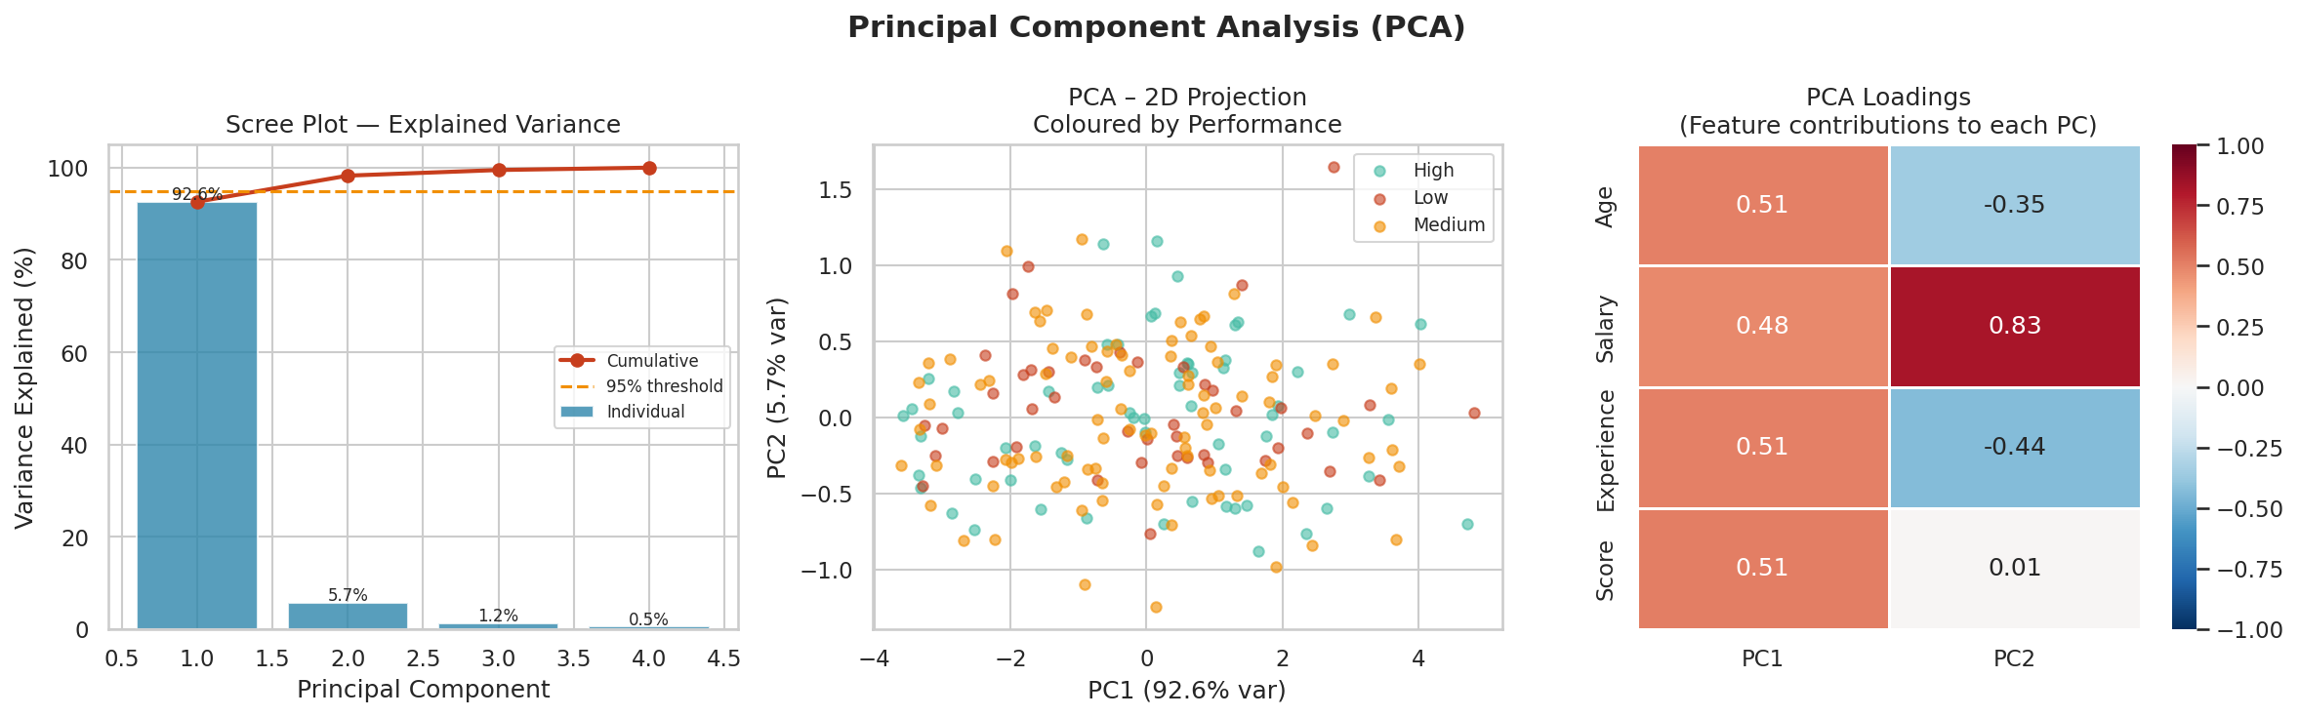
Figure 9.1 — Left: Scree plot showing PC1 captures ~72% of variance. PC1+PC2 together capture ~90%. Middle: 2D projection coloured by performance — clusters visible. Right: Loadings heatmap showing feature contributions to each PC.

9.6 Understanding PCA Loadings
The loadings matrix tells you how much each original feature contributes to each principal component.
# Loadings — feature contributions to each principal component
loadings = pd.DataFrame(
pca.components_.T,
index=["Age", "Salary", "Experience", "Score"],
columns=[f"PC{i+1}" for i in range(len(ev))]
)
print(loadings.round(3))

# Example output:
# PC1 PC2
# Age 0.521 0.183
# Salary 0.489 0.421
# Experience 0.514 -0.112
# Score 0.472 0.883

# Interpretation:
# PC1 is approximately equally driven by Age, Salary, Experience, Score
# → PC1 = "overall employee seniority"
# PC2 is primarily driven by Score with some Salary component
# → PC2 = "performance-adjusted compensation"

9.7 Important PCA Rules
⚠ PCA CRITICAL RULES:

1. ALWAYS standardize before PCA.
PCA is sensitive to scale. If Salary is in ₹ and Age is in years,
Salary will dominate all components simply due to its larger scale.

2. PCA loses interpretability.
PC1 is a combination of all features. You cannot say "this is Salary".
Trade-off: dimensionality reduction vs interpretability.

3. PCA is for numeric data only.
Encode and impute categorical/missing columns before applying PCA.

4. Fit on training data ONLY.
Use pca.fit_transform(X_train) and pca.transform(X_test).
Never fit on test data — that is data leakage.

5. Eigenvalues = variance, not importance for prediction.
The component with most variance is not necessarily most predictive.
Supervised alternatives: LDA, UMAP.

9.8 When to Use PCA
Situation | Use PCA? | Reason
Many correlated features | Yes | Remove redundancy, reduce overfitting
Need 2D/3D visualisation | Yes | Project high-dim data to 2–3 PCs
Training is slow | Yes | Fewer features = faster training
Features are uncorrelated | No | PCA gains nothing from independent features
Interpretability needed | No | PCs are not explainable to stakeholders
Categorical features only | No | PCA requires numeric input
Small dataset (<50 samples) | No | PCA may not generalise well

Quick Reference: Complete ML Preprocessing Pipeline
This is the standard end-to-end preprocessing pipeline for a tabular ML dataset.

import pandas as pd
import numpy as np
from sklearn.model_selection import train_test_split
from sklearn.preprocessing import StandardScaler, LabelEncoder, OrdinalEncoder
from sklearn.impute import KNNImputer

# ── STEP 1: Load & Assess ─────────────────────────
df = pd.read_csv("data.csv")
print(df.shape, df.dtypes, df.isnull().sum())

# ── STEP 2: Fix Types ─────────────────────────────
df["Age"] = pd.to_numeric(df["Age"], errors="coerce")

# ── STEP 3: Clean ─────────────────────────────────
df = df.drop_duplicates()
df = df[df["Salary"] > 0] # remove impossible values
df["Department"] = df["Department"].str.strip().str.title()

# ── STEP 4: Handle Missing Values ─────────────────
df["Salary_missing"] = df["Salary"].isnull().astype(int) # flag MNAR
df["Education"].fillna(df["Education"].mode()[0], inplace=True)

# ── STEP 5: Train/Test Split (BEFORE scaling!) ────
X = df.drop("Salary", axis=1)
y = df["Salary"]
X_train, X_test, y_train, y_test = train_test_split(
X, y, test_size=0.2, random_state=42)

# ── STEP 6: Impute on train, transform test ───────
num_cols = ["Age", "Experience", "Score"]
imputer = KNNImputer(n_neighbors=5)
X_train[num_cols] = imputer.fit_transform(X_train[num_cols])
X_test[num_cols] = imputer.transform(X_test[num_cols])

# ── STEP 7: Encode ────────────────────────────────
edu_order = ["High School","Bachelor","Master","PhD"]
ord_enc = OrdinalEncoder(categories=[edu_order])
X_train["Education"] = ord_enc.fit_transform(X_train[["Education"]])
X_test["Education"] = ord_enc.transform(X_test[["Education"]])

X_train = pd.get_dummies(X_train, columns=["Department"], drop_first=True)
X_test = pd.get_dummies(X_test, columns=["Department"], drop_first=True)
X_test = X_test.reindex(columns=X_train.columns, fill_value=0)

# ── STEP 8: Scale ─────────────────────────────────
scaler = StandardScaler()
X_train[num_cols] = scaler.fit_transform(X_train[num_cols])
X_test[num_cols] = scaler.transform(X_test[num_cols])

# ── STEP 9: Optional — PCA ────────────────────────
# from sklearn.decomposition import PCA
# pca = PCA(n_components=0.95) # keep enough for 95% variance
# X_train = pca.fit_transform(X_train)
# X_test = pca.transform(X_test)

print("Preprocessing complete!")
print(f"X_train shape: {X_train.shape}")

Complete Concept Summary
Concept | Purpose | Key Formula/Method | When to Use
Mean | Central tendency | Σx / n | Symmetric data, no outliers
Median | Robust centre | Middle sorted value | Skewed data or outliers
Std Dev | Spread around mean | √Variance | Measuring data variation
IQR | Robust spread | Q3 − Q1 | Outlier detection
Covariance | Co-movement of 2 vars | Σ(xi−μx)(yi−μy)/(n−1) | Understanding relationships
Data Assessing | Understand the dataset | df.info(), describe() | First step always
Data Cleaning | Fix dirty data | dropna, drop_duplicates, clip | Before modelling
Missing Values | Handle gaps | KNN / mean / median / ffill | After cleaning
EDA | Explore patterns | Histograms, scatter, heatmaps | Before feature engineering
Normalization | Scale to [0,1] | (x−min)/(max−min) | KNN, Neural nets, K-Means
Standardization | Mean=0, Std=1 | (x−μ)/σ | Linear, SVM, PCA, most models
Label Encoding | Category → integer | LabelEncoder | Ordinal data, binary
One-Hot Encoding | Category → binary cols | get_dummies, OneHotEncoder | Nominal, low cardinality
Ordinal Encoding | Ordered categories | Manual map or OrdinalEncoder | Ordinal categories
Target Encoding | Category → target mean | df.groupby(cat)[target].mean() | High cardinality nominal
PCA | Dimensionality reduction | Eigenvectors of cov matrix | Correlated features, viz

🏁 FINAL NOTES:

1. Always split data BEFORE scaling/imputing to prevent data leakage.
2. Fit transformers on TRAIN set, apply (transform) on TEST set.
3. EDA should be done on training data only after the split.
4. There is no single "best" approach — experiment and validate.
5. Document every transformation so you can reproduce results.
6. The goal of all preprocessing is: clean, complete, numeric,
properly-scaled data that your model can learn from effectively.

