WHAT IS NETWORKING
Task 1 – What is Networking?
I learned the basic concept of networking and understood that a network is formed when two or more devices are connected to communicate with each other. I also learned how networks are used in everyday life and in computing. I answered the question about the key term for connected devices, which is “Network.”
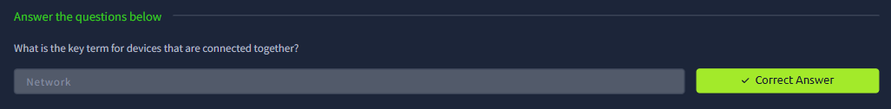
Task 2 – The Internet
I learned how the Internet is made up of many smaller networks connected together. I also understood the difference between private and public networks and got an overview of how the Internet developed. I learned about the ARPANET project and the role of Tim Berners-Lee in creating the World Wide Web. I completed the question asking who invented the World Wide Web.
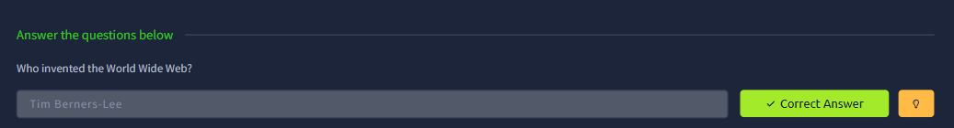
Task 3 – IP & MAC Addressing
I learned about IP and MAC addresses and how they are used to identify devices on a network. I understood that IP stands for Internet Protocol, an IPv4 address has four sections called octets, and MAC stands for Media Access Control. I also completed the interactive lab related to MAC addressing and answered the questions successfully.

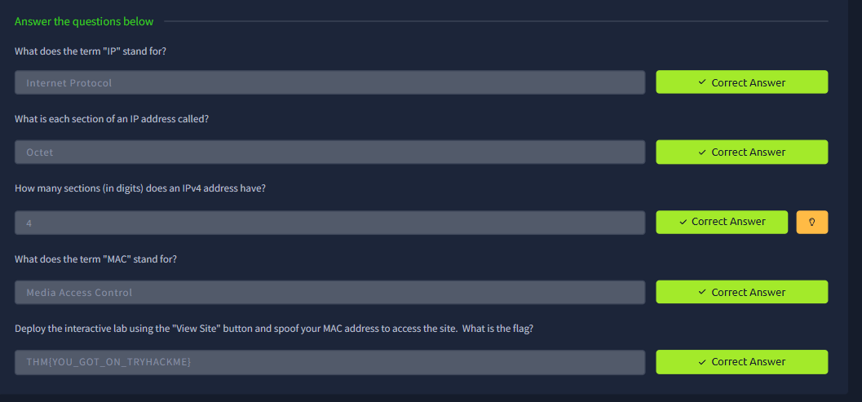
Task 4 – Ping Basics
I learned the basics of using ping to test network connectivity. I understood that ping uses the ICMP protocol and practiced the correct command for pinging an IP address. I also completed the ping activity and obtained the required flag.
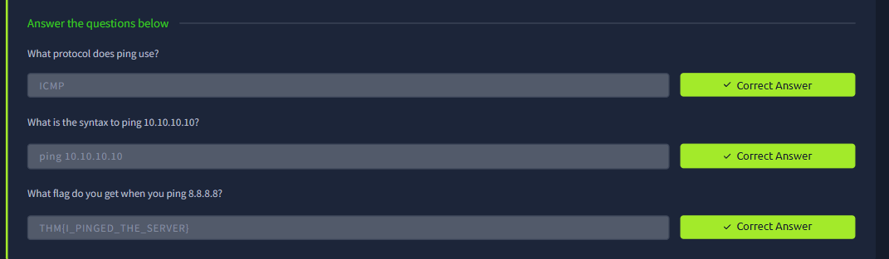

What I Learned
Overall, I gained a basic understanding of computer networking and how devices communicate with each other. I learned about the OSI Model, TCP/IP, encapsulation and de-encapsulation, IP and MAC addressing, private and public networks, and the Internet. I also got familiar with basic networking concepts like ICMP and the ping command through practical activities. These tasks helped me understand how data is transferred between devices and gave me a better foundation in networking and cybersecurity

INTRODUCTION TO NETWORKING
ROOM1:
Task 1 – Offensive Security

In this task I was asked which term describes simulating a hackers actions to find weaknesses in a system. I answered Offensive Security.

I chose this because Offensive Security is basically about thinking like an attacker and trying to find weaknesses before a real attacker can take advantage of them. It helps identify security problems. Fix them before they become a bigger issue.
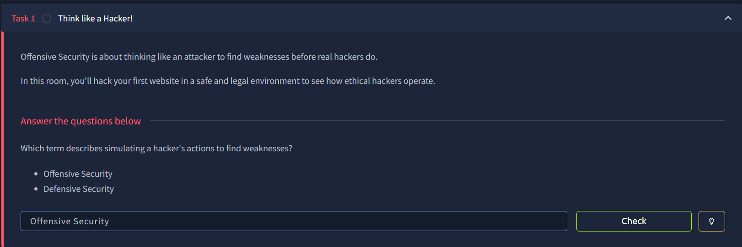
Task 2 – Finding the Bank Account Number

In this task I had to find the bank account number to use in the Fake Bank application.

I clicked on "View Site" which opened the bank website. I looked through the information on the website and found the account number I needed. The account number was 8881. I entered it into the application.
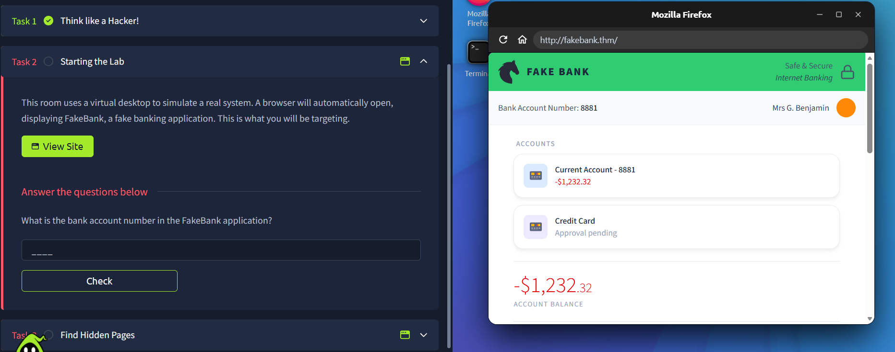
Task 3 – Finding Hidden Pages

In this task I had to find a page on the Fake Bank website.

I used the Dirb tool to scan the website and look for directories and pages. The scan showed a results, including /images and /bank-transfer.

The page I needed was:

http://fakebank.thm/bank-transfer

I entered this as my answer and clicked Check, which confirmed that it was correct.
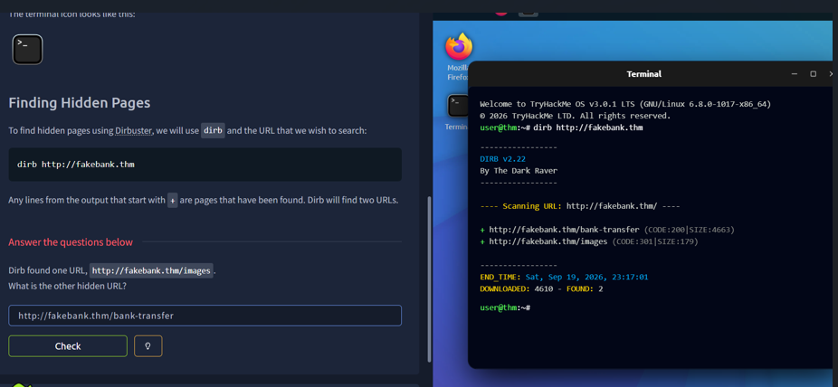

Task 4 – Attacking the Admin Page

For the task I had to access the hidden bank-transfer page and complete the given instructions.

I opened the /bank-transfer page in the browser. Used the account number 8881. I then deposited $2000 into the account as instructed. After the deposit the account balance became positive. A message appeared showing "BANK-HACKED".

I entered BANK-HACKED as the answer. Submitted it successfully.
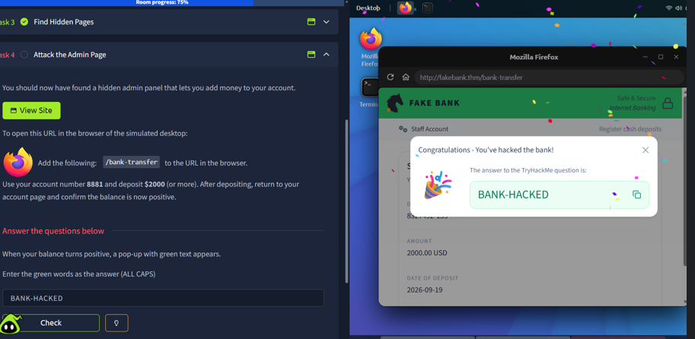

What I Learned

From these tasks I learned how attackers can look for weaknesses in websites and applications by exploring the information and hidden pages. I also got to use Dirb to find directories, which helped me understand how directory enumeration works. Overall the tasks helped me understand the basics of thinking like an attacker and finding vulnerabilities, in a controlled environment.

ROOM2

Task 1 – Introduction
I went through the introduction to basic networking and learned about the OSI Model, TCP/IP Model, and some basic networking tools. I also got a basic idea of how these networking models are used in real-world communication.

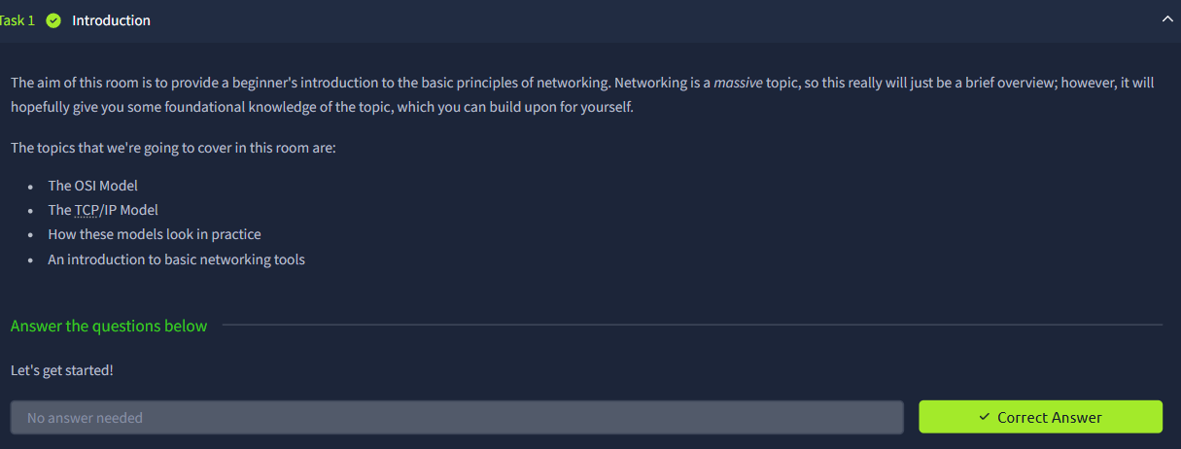
Task 2 – OSI Model
I learned about the 7 layers of the OSI Model and understood the basic function of each layer. I learned which layers are involved in data transmission, TCP/UDP, data checking, formatting, encryption, and compression. I then completed the questions based on the OSI Model and got the answers correct.
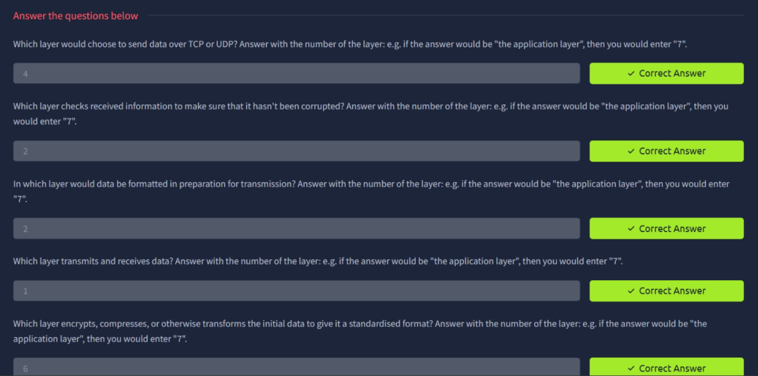
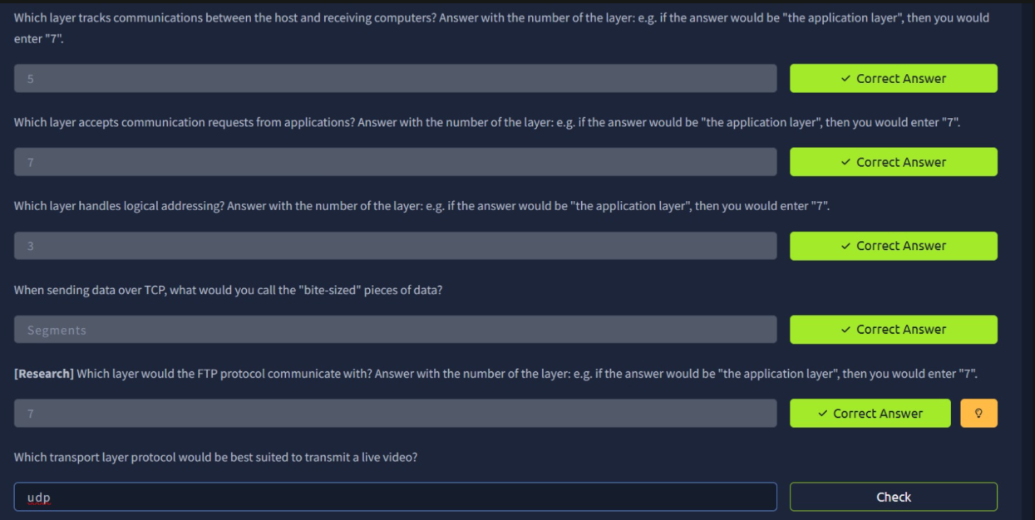

Task 3 – Encapsulation and De-encapsulation

I learned how encapsulation and de-encapsulation work in the OSI model. I understood how data is changed into forms as it goes through the layers like frames at the Data Link Layer and datagrams when UDP is used at the Transport Layer. I also learned how the device that receives the data takes off the information through the process of de-encapsulation. Along with this I understood the role of the Data Link Layer trailer during encapsulation. How encapsulation is mainly used for correct data transmission instead of being an extra security layer.

Task 4-Understanding the TCP/IP Model

In this task I learned about the TCP/IP model and how its layers relate to the OSI model.

I learned that the TCP/IP model was introduced before the OSI model. The Transport layer in TCP/IP is the same as the Transport layer in the OSI model while the Application layer covers the functions of the Session layer in the OSI model. I also learned that the Network Interface layer covers the Data Link and Physical layers in the OSI model while the Internet layer handles the functions of the Network layer in the OSI model.

I also learned that TCP is a connection-based protocol and that SYN stands for Synchronise. While learning about the three-way handshake I found that the second step is SYN/ACK, followed by an ACK (Acknowledgement).

This task helped me understand how the TCP/IP and OSI models are related and gave me an understanding of how TCP starts a connection.
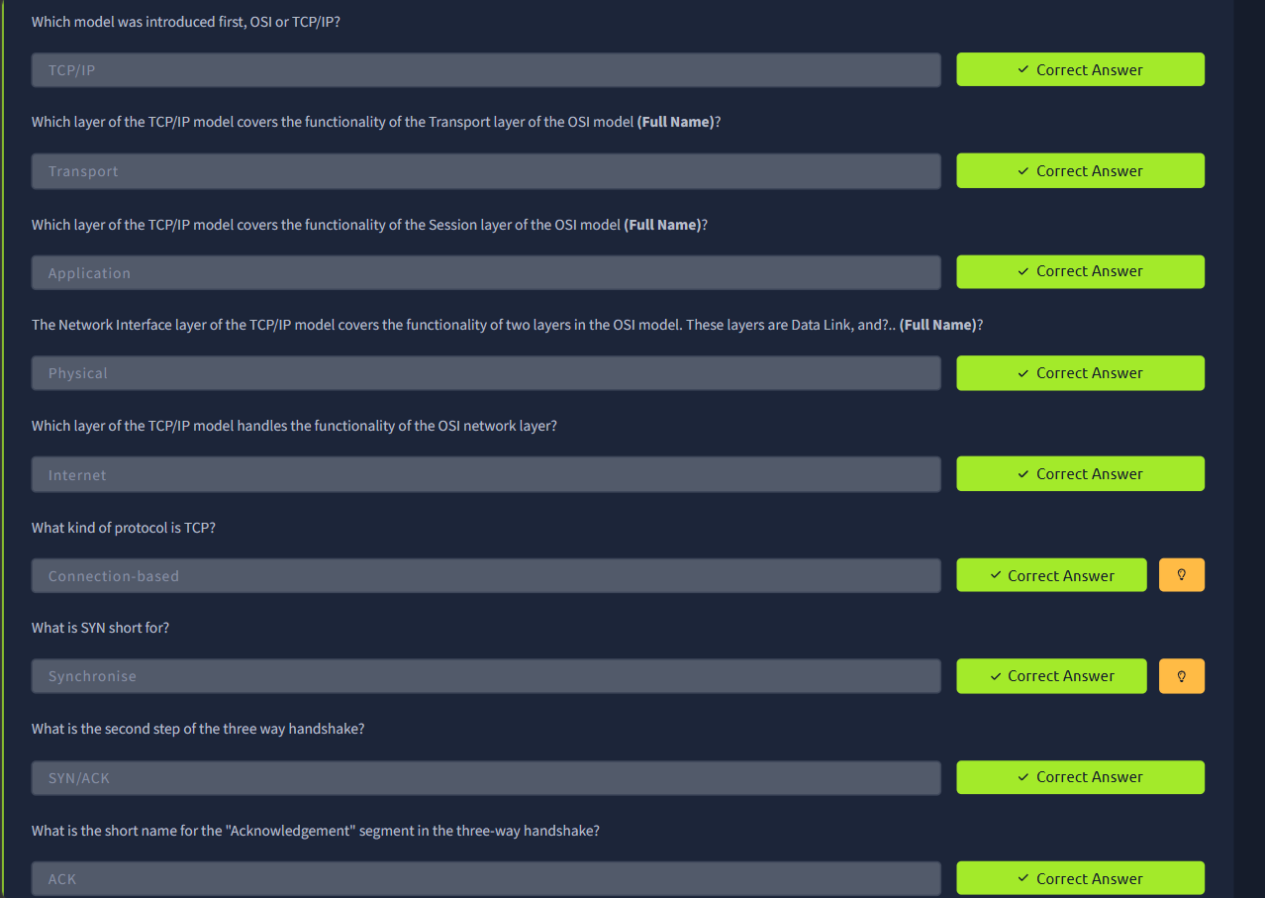

Task 5- Using Ping

In this task I learned how to use the ping command to test if my system can connect to a website.

I used the command:

ping bbc.co.uk

I also found that the IPv4 address of muirlandoracle.co.uk was 217.160.0.152.

The task also introduced me to some ping options. The -i switch changes the time between ping requests the -4 switch limits the requests to IPv4 and the -v switch shows detailed results.

This helped me understand how the ping command can be used to test network connectivity and how different options can change the way it works.
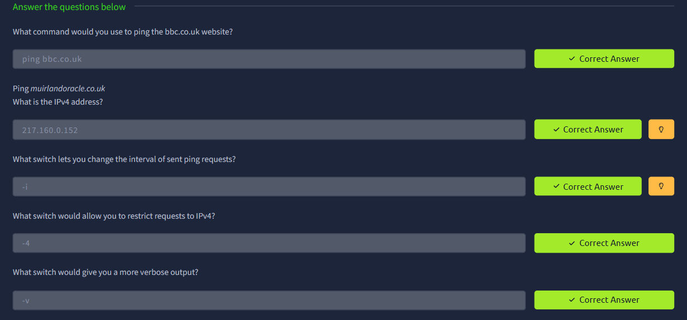

Task 6-Traceroute

In this task I learned how traceroute can be used to look at the path taken by network traffic when talking to a website.

I used traceroute with tryhackme.com. Learned about the different options available with the command. The -i switch is used to choose a network interface while the -T can be used to send TCP SYN requests while tracing the route.

I also learned that on Windows traceroute works at the Internet layer of the TCP/IP model.

This task helped me understand how network paths can be checked and how traceroute can be helpful when looking into network connections.
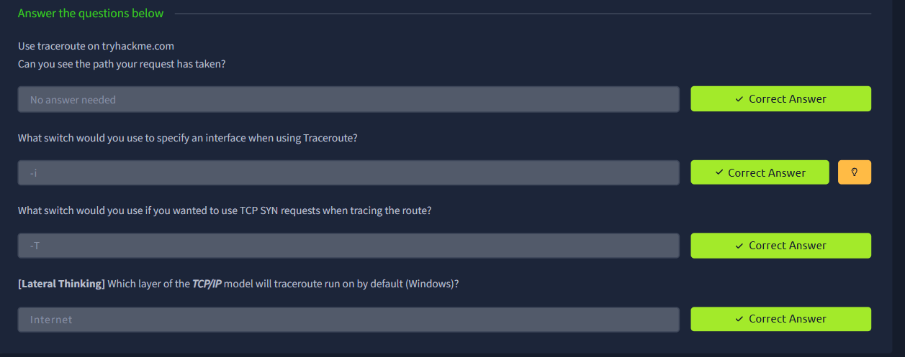

Task 7-Whois Lookups

In this task I learned how to use a Whois lookup to find details about a domain that is registered.

I did a Whois search for facebook.com. Looked at the registration details from the lookup. From the results I found that the postal code of the person who registered the domain was 94025 and that the domain was first registered on 29/03/1997.

This task helped me understand how Whois can be used to find information about domain registrations.
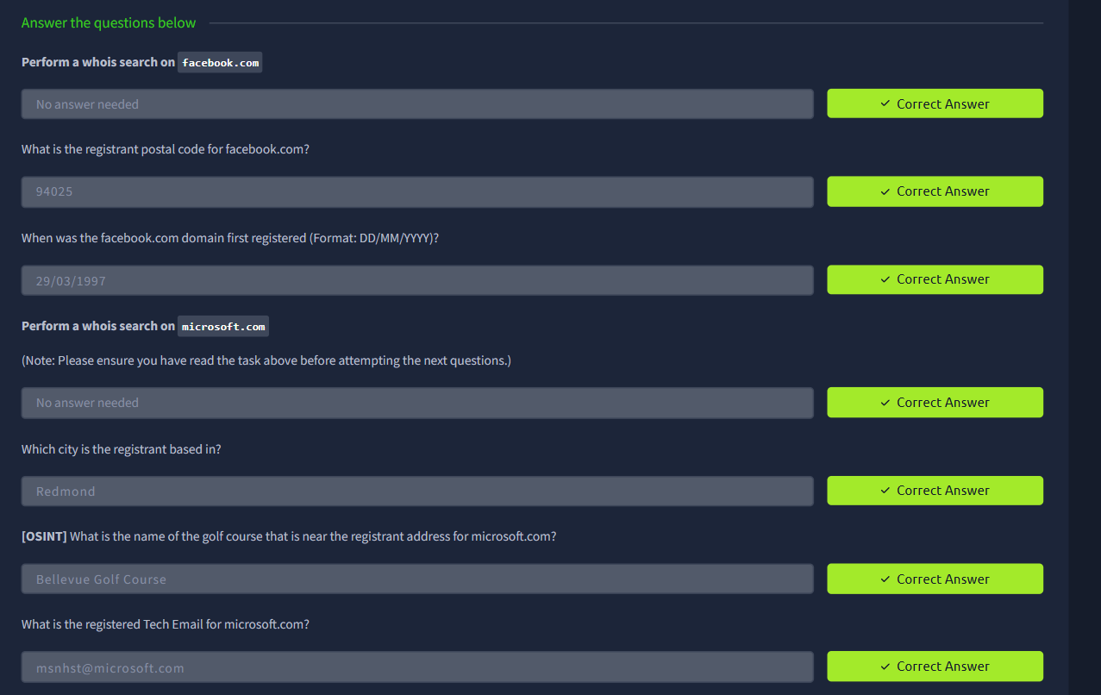

Task 8- DNS

In this task I learned about DNS (Domain Name System) and how it helps turn domain names into IP addresses.

I learned that the first type of DNS server my computer contacts is a DNS server. I also learned about Top-Level Domain (TLD) servers, which have information about domain extensions.

The task also showed me that before making a DNS request a computer first looks at its Hosts File to see if it already has an IP address for the domain.

As part of the research question I found that another public DNS server, from Google besides 8.8.8.8 is 8.8.4.4.

I also learned about TTL (Time To Live) in DNS. A TTL of 24 hours equals 86,400 seconds, which's the number that `dig` would show.

This task helped me understand how DNS works in the background and how domain names are turned into IP addresses.

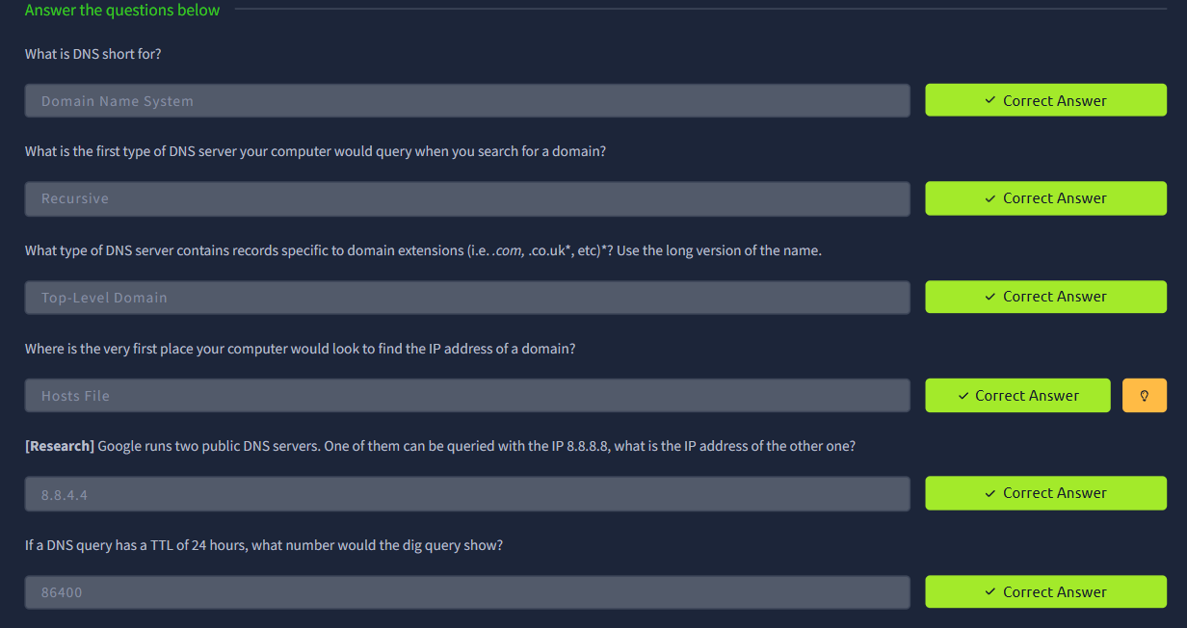
What I learned
Overall, I learned the basics of the OSI Model and how the different layers work together during data communication. I understood the functions of all seven layers and learned how protocols like TCP and UDP are involved in communication. I also learned about encapsulation and de-encapsulation, including how data changes as it moves through the layers, such as becoming segments, packets, and frames. This helped me understand how data is prepared, transmitted, and received between devices in a network.

LINK: https://tryhackme.com/p/prakthukshavijayabala

