
School of Computer Science and Engineering
CSE(IOT and Cybersecurity including Blockchain Technology)
Object Oriented Programming with Java Lab Mini Project Report
Course Code: B24EI0303  Academic Year: 2025-26 |  | Semester: 3rd  Batch: CSE(IoT)
Project Details
Project Title: | The Student Attendance Management System is a desktop-based application
Place of Project: | REVA UNIVERSITY, BENGALURU
Student Details:
Name | SRN |  | Sign:
Prakul P Shetty | R24EI043
Dhanush Ram R | R24EI015
Ramesh | R24EI048
Guide and Lab Faculty Member Details
Name of the Faculty |  |  | Sign: Date:
Marks by Lab Faculty(10M)

CONTENT
1 | Abstract |  | Page No.1
2 | Introduction |  | Page No.2
3 | Objective of the project |  | Page No.3
4 | Software Components |  | Page No.3
5 | Implementation |  | Page No.4-7
6 | Screenshots and Output | Page No.8-10
5 | Conclusion |  | Page No.11
6 | References |  | Page No.11

Abstract
The Student Attendance Management System is a desktop-based application developed using Core Java and Java Swing to simplify and automate the process of managing student attendance in an academic environment. In traditional attendance systems, maintaining records manually is time-consuming, error-prone, and difficult to organize. This project aims to provide a simple, efficient, and user-friendly solution for lecturers to record, view, and manage attendance digitally.
The application allows lecturers to register and log in securely using file-based authentication. Students can be added with unique IDs along with their department and semester details. Attendance can be marked on a daily basis by selecting present or absent status for each student, and the records are stored persistently using text files. The system also provides functionality to view attendance for a selected date along with attendance statistics such as total students, present count, and absent count.
The project is implemented using Java Swing for the graphical user interface and text files for data storage, without using any external frameworks or databases. Object-oriented principles such as modularity, encapsulation, and reusability are followed throughout the application design. This system is suitable for small educational institutions and serves as an excellent academic project to demonstrate Java GUI programming, file handling, and event-driven programming concepts.

Introduction:

1.1 Overview of the Project
Attendance management is an essential task in educational institutions to track student participation and ensure academic discipline. Many institutions still rely on manual registers or spreadsheets, which can lead to data inconsistency and difficulty in maintaining historical records. The Student Attendance Management System addresses these issues by providing a desktop-based solution that enables lecturers to manage attendance efficiently using a graphical interface.
This application is developed using Java Swing, which provides a platform-independent GUI. The system stores data in text files, making it lightweight and easy to deploy without requiring database configuration. The application is designed with multiple modules such as login, student management, attendance marking, and attendance viewing, each implemented using separate JFrame classes.

1.2 Problem Statement
Manual attendance systems are inefficient, time-consuming, and prone to errors such as incorrect entries and data loss. There is a need for a simple digital system that allows lecturers to easily manage student records and attendance without relying on complex software or external databases.

Objectives of the Project:
The main objectives of the project are:
- To develop a desktop-based attendance management system using Core Java.
- To provide a secure login and registration system for lecturers.
- To enable easy addition and management of student records.
- To allow lecturers to mark daily attendance efficiently.
- To store attendance data persistently using text files.
- To provide attendance viewing and statistical analysis by date.
- To demonstrate object-oriented programming concepts in Java.

Software Components
3.1 Frontend
Technologies Used:
- Java Swing (JFrame, JLabel, JButton, JTextField, JTable, JComboBox)
User Interface Description:
The user interface is clean, professional, and text-based. It consists of multiple windows for login, signup, dashboard, student management, attendance marking, and attendance viewing. The layout ensures ease of navigation and proper alignment of components.

3.2 Backend
Technologies Used:
- Core Java
- File Handling (FileReader, BufferedReader, FileWriter)
Database Design (Text Files):
- lecturers.txt: Stores lecturer credentials
  - Fields: name, email, password
- students.txt: Stores student details
  - Fields: studentId, name, department, semester
- attendance.txt: Stores attendance records
  - Fields: date, studentId, status

Implementation

Main.java – Application Entry Point
public class Main {
public static void main(String[] args) {
javax.swing.SwingUtilities.invokeLater(() -> {
new LoginFrame().setVisible(true);
});
}
}

LoginFrame.java – Authentication Logic
Reading Lecturer Credentials from File
try (BufferedReader br = new BufferedReader(new FileReader("data/lecturers.txt"))) {
String line;
while ((line = br.readLine()) != null) {
String[] parts = line.split(",");
String storedEmail = parts[1].trim();
String storedPassword = parts[2].trim();

if (storedEmail.equals(email) && storedPassword.equals(password)) {
return true;
}
}
} catch (IOException e) {
e.printStackTrace();
}
return false;
SignupFrame.java – Lecturer Registration
Writing Lecturer Data to File
try (FileWriter writer = new FileWriter("data/lecturers.txt", true)) {
writer.write(name + "," + email + "," + password + "\n");
} catch (IOException e) {
e.printStackTrace();
}
Duplicate Email Check
private boolean emailExists(String email) {
try (BufferedReader br = new BufferedReader(new FileReader("data/lecturers.txt"))) {
String line;
while ((line = br.readLine()) != null) {
String[] parts = line.split(",");
if (parts[1].trim().equals(email)) {
return true;
}
}
} catch (IOException e) {
e.printStackTrace();
}
return false;
}
AddStudentFrame.java – Student Management
Semester Validation (Exception Handling)
try {
Integer.parseInt(semester);
} catch (NumberFormatException e) {
JOptionPane.showMessageDialog(this, "Semester must be a number");
return;
}
Save Student Details
try (FileWriter writer = new FileWriter("data/students.txt", true)) {
writer.write(id + "," + name + "," + department + "," + semester + "\n");
} catch (IOException e) {
e.printStackTrace();
}

MarkAttendanceFrame.java – Attendance Storage
Auto-Fill Today’s Date
String today = new java.text.SimpleDateFormat("yyyy-MM-dd")
.format(new java.util.Date());
dateField.setText(today);

Save Attendance Records
try (FileWriter writer = new FileWriter("data/attendance.txt", true)) {
for (int i = 0; i < tableModel.getRowCount(); i++) {
String studentId = tableModel.getValueAt(i, 0).toString();
String status = tableModel.getValueAt(i, 4).toString();
writer.write(date + "," + studentId + "," + status + "\n");
}
} catch (IOException e) {
e.printStackTrace();
}
ViewAttendanceFrame.java – Attendance Retrieval
Load Student Names Using HashMap
Map<String, String> studentMap = new HashMap<>();

try (BufferedReader br = new BufferedReader(new FileReader("data/students.txt"))) {
String line;
while ((line = br.readLine()) != null) {
String[] parts = line.split(",");
studentMap.put(parts[0].trim(), parts[1].trim());
}
}
Filter Attendance by Date
try (BufferedReader br = new BufferedReader(new FileReader("data/attendance.txt"))) {
String line;
while ((line = br.readLine()) != null) {
String[] parts = line.split(",");
if (parts[0].equals(date)) {
String name = studentMap.getOrDefault(parts[1], "Unknown");
tableModel.addRow(new Object[]{parts[1], name, parts[2]});
}
}
}

Count Present & Absent
int present = 0, absent = 0;

for (int i = 0; i < tableModel.getRowCount(); i++) {
String status = tableModel.getValueAt(i, 2).toString();
if (status.equalsIgnoreCase("Present")) {
present++;
} else {
absent++;
}
}

Screenshots and Output
  - Login Screen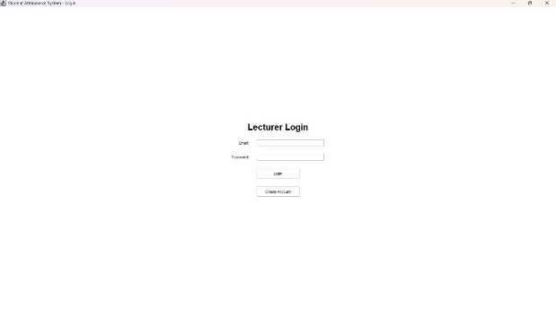
  - Signup Screen
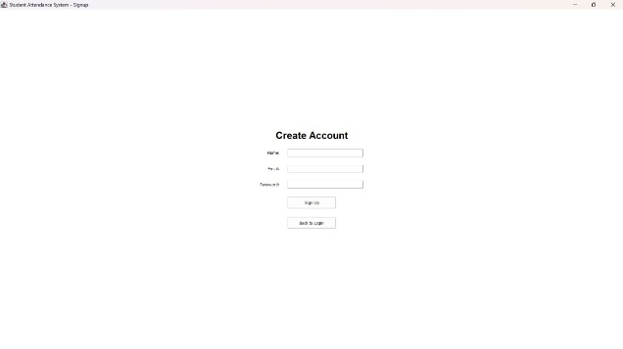

  - Main Dashboard
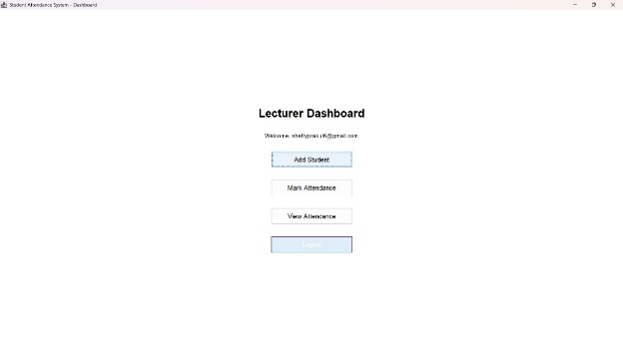
5.4 Add Students
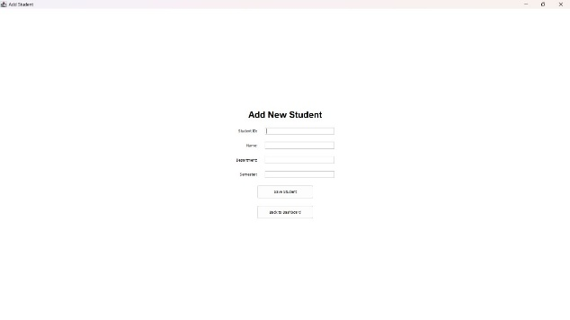

  - Mark attendance Screens
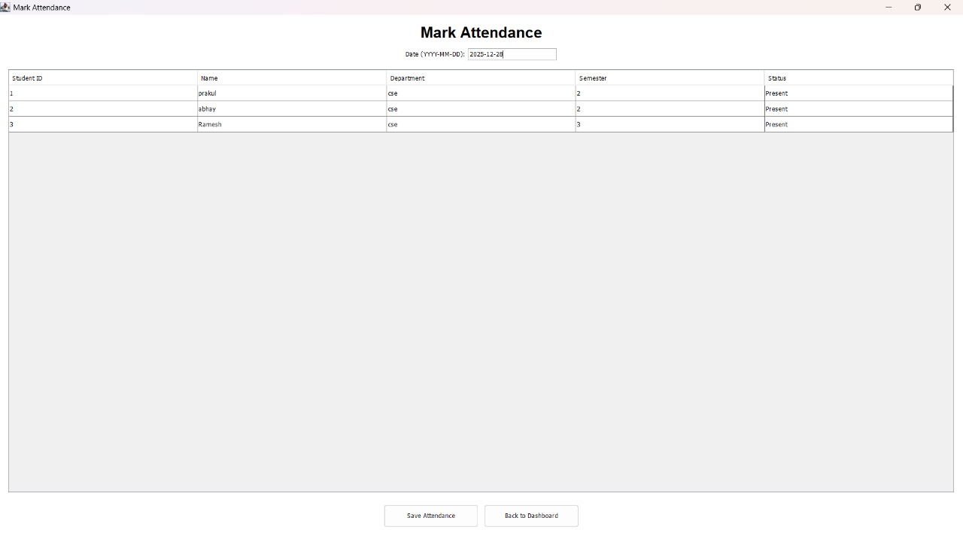

  - View Attendence Screen
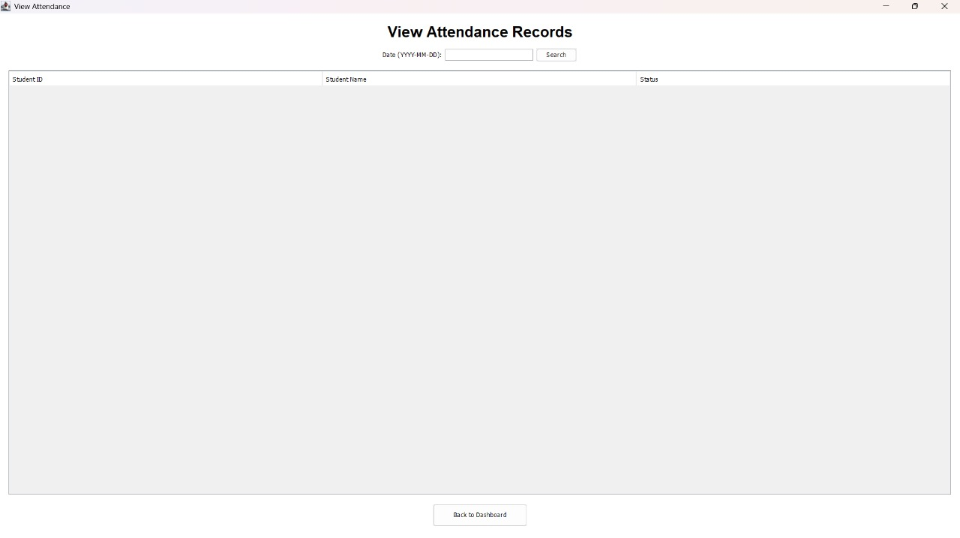

Conclusion
The Student Attendance Management System successfully provides a simple and effective solution for managing student attendance using Java Swing. The system reduces manual effort, minimizes errors, and ensures proper data storage through file handling. The project demonstrates the practical application of object-oriented programming, GUI development, and file management in Java. It is suitable for small institutions and serves as an excellent academic project for understanding real-world software development concepts.

References
Learning Resources
Books:
- Cay S. Horstmann, Core Java® SE 9 for the Impatient, Addison Wesley, Second Edition, 2018.
- Herbert Schildt, Java™: The Complete Reference, McGraw-Hill, Tenth Edition, 2018.
Online Resources:
- Oracle Java Documentation
- Java Swing Tutorials (Oracle & GeeksforGeeks)

