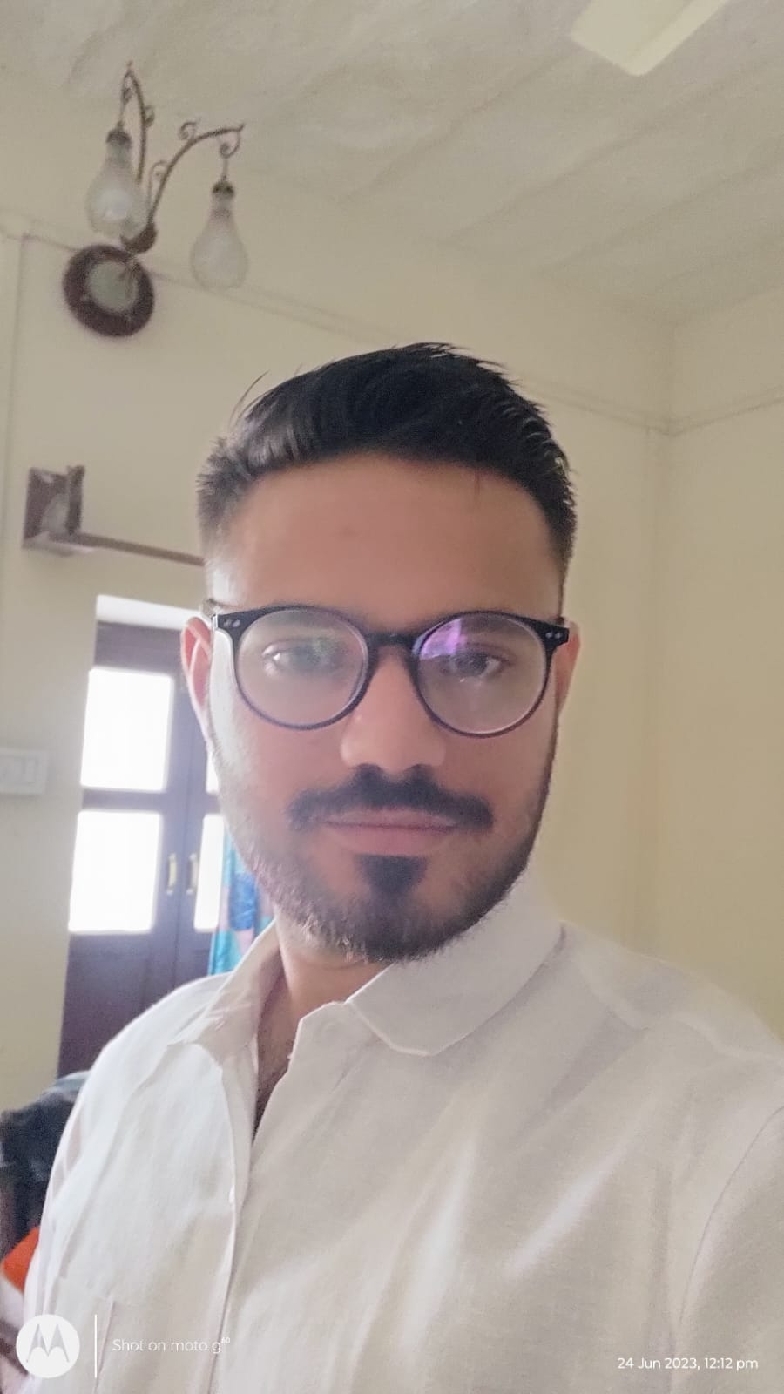
Prakul Soni
📍 Bhumkar Chowk Road, Tathawade, Pune – 411012
📞 +91 80000 81310 | ✉️ prakulsoni26@gmail.com
🔗 LinkedIn: https://www.linkedin.com/in/prakul-soni-b683892a7

Objective
Aspiring AI Engineer eager to leverage strong foundational knowledge in machine learning, data analysis, and programming to contribute to innovative AI solutions and drive impactful business outcomes. Passionate programmer seeking an entry-level opportunity in the AI and ML field.

Skills
• Proficient in Python and Java, with experience in AI/ML libraries such as Scikit-learn.
• Familiar with development tools and platforms including Jupyter Lab, Google Gemini, and Git for collaborative AI projects.
• Strong ability to analyze large datasets, extract insights, and support data-driven decision-making.
• Excellent problem-solving skills with a passion for continuous learning in emerging AI technologies.

Hobbies
Professional & Skill-Oriented Hobbies
- Coding side projects
- Hackathons & Coding Competitions (teamwork + problem-solving)
Personal Development & Balance
- Fitness & Sports (Cricket/Badminton/Gym) (discipline + teamwork)
- Travel & Exploring Cultures (adaptability + curiosity)

Education
Master of Computer Applications (MCA) – Pursuing (2025 – 2027)
Dr. D. Y. Patil School of Science & Technology, Pune
Bachelor of Computer Applications (BCA) – Graduated 2024
Maharishi Dayanand Saraswati University, Ajmer

