**Experiment No.8**

**A.1 Aim:** To analyze IEEE/Springer/ACM paper on AI applications.

**A.2 Prerequisite:** Concepts of AI, Expert system

**A.3 Outcome:**

**After successful completion of this experiment students will be able to**

* To implement the concept of AI or expert system for any application.

**Tools Required:** Internet

**A.4 Theory:**

In [artificial intelligence](https://en.wikipedia.org/wiki/Artificial_intelligence), an **expert system** is a computer system that emulates the decision-making ability of a human expert. Expert systems are designed to solve complex problems by [reasoning](https://en.wikipedia.org/wiki/Automated_reasoning) through bodies of knowledge, represented mainly as [if–then rules](https://en.wikipedia.org/wiki/Rule-based_system) rather than through conventional [procedural code](https://en.wikipedia.org/wiki/Procedural_programming). The first expert systems were created in the 1970s and then proliferated in the 1980s.Expert systems were among the first truly successful forms of [artificial intelligence](https://en.wikipedia.org/wiki/Artificial_intelligence) (AI) software. An expert system is divided into two subsystems: the [inference engine](https://en.wikipedia.org/wiki/Inference_engine) and the [knowledge base](https://en.wikipedia.org/wiki/Knowledge_base). The knowledge base represents facts and rules. The inference engine applies the rules to the known facts to deduce new facts. Inference engines can also include explanation and debugging abilities.

Architecture of Expert System:

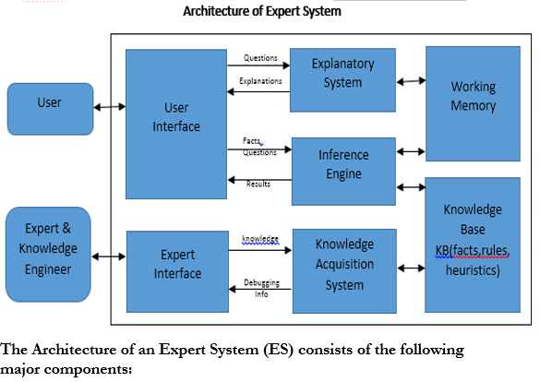

* **Knowledge Base (KB):** repository of special heuristics or rules that direct the use of knowledge, facts (productions). It contains the knowledge necessary for understanding, formulating, & problem solving.
* **Working Memory(Blackboard):** if forward chaining used

It describes the current problem & record intermediate results

Records Intermediate Hypothesis & Decisions: 1. Plan, 2. Agenda, 3. Solution

* **Inference Engine:** the deduction system used to infer results from user input & KB

It is the brain of the ES, the control structure(rule interpreter)

It provides methodology for reasoning

* **Explanation Subsystem (Justifier):** Traces responsibility & explains the ES behaviour by interactively answering question: Why?, How?, What?, Where?, When?, Who?
* **User Interface:** interfaces with user through Natural Language Processing (NLP), or menus & graphics. Acts as Language Processor for friendly, problem-oriented communication

PART B

(PART B : TO BE COMPLETED BY STUDENTS)

|  |  |
| --- | --- |
| Roll. No. | Name: |
| Class | Batch: |
| Date of Experiment: | Date of Submission: |
| Grade: | |

**B.1** Write down Title Abstract and Introduction of your research paper on Expert System

Title: VER-Net: a hybrid transfer learning model for lung cancer detection using CT scan images

Abstract:

Background Lung cancer is the second most common cancer worldwide, with over two million new cases per year. Early identification would allow healthcare practitioners to handle it more effectively. The advancement of computer aided detection systems significantly impacted clinical analysis and decision-making on human disease. Towards this, machine learning and deep learning techniques are successfully being applied. Due to several advantages, transfer learning has become popular for disease detection based on image data.

Methods In this work, we build a novel transfer learning model (VER-Net) by stacking three different transfer learning models to detect lung cancer using lung CT scan images. The model is trained to map the CT scan images with four lung cancer classes. Various measures, such as image preprocessing, data augmentation, and hyperparameter tuning, are taken to improve the efficacy of VER-Net. All the models are trained and evaluated using multiclass classifications chest CT images.

Results The experimental results confirm that VER-Net outperformed the other eight transfer learning models compared with. VER-Net scored 91%, 92%, 91%, and 91.3% when tested for accuracy, precision, recall, and F1-score, respectively. Compared to the state-of-the-art, VER-Net has better accuracy.

Conclusion VER-Net is not only effectively used for lung cancer detection but may also be useful for other diseases for which CT scan images are available.

Keywords Lung cancer detection, CT scan, Transfer learning, Image processing, Stacking, VGG19, EfficientNetB0, ResNet101

Introduction:

Lung cancer is one of the leading causes of cancer-related deaths globally. It is broadly classified as small and non small-cell lung cancer [1]. Lung cancer is a significant contributor to cancer-related deaths worldwide, with the highest mortality rate among all types of cancer.

According to the World Health Organization1, cancer is a significant contributor to global mortality, result ing in approximately 10 million fatalities in 2020, which accounts for roughly one out of every six deaths. WHO estimated that one in 16 people would be diagnosed with lung cancer worldwide by 2022. Amongst all cancers, lung cancer has a significantly higher mortality rate. Additionally, when considering the number of incident cases, lung cancer ranks second among all types of cancer.

As artificial intelligence (AI) has advanced, deep learning has become increasingly popular in analyzing medical images. Deep learning is a technique that can automatically discover high dimensionality, as compared to the more intuitive visual assessment of images that is often performed by skilled clinicians. Convolutional neural networks (CNNs) are promising for extracting more powerful and deeper features from these images [13]. Significant improvements have been achieved in the potential to identify images and extract features inside images due to the development of CNN.

Advanced CNNs have been shown to improve the accuracy of predictions significantly. In recent years, the development of computer-aided detection (CAD) has shown promising results in medical image analysis. Deep learning techniques, particularly transfer learning, have emerged as a powerful technique for leveraging pre-trained models and improving the performance of deep learning models. Transfer learning has gained significant attention and success in various fields of AI, including medical image diagnosis, computer vision, natural language processing, speech recognition, and many more. Transfer learning involves using pre-trained neu ral networks to take the knowledge gained from one task (source task) and apply it to a different but related task (target task).

In transfer learning, a model pre trained on a large dataset for a specific task can be fine tuned on similar datasets for different tasks. Transfer learning has recently shown much promise in making it easier to detect lung cancer from medical imagIng data.

It offers a practical and effective way to leverage existing knowledge and resources to develop accurate and efficient models for lung cancer detection. It starts with a pre-trained CNN model and f ine-tunes its layers on a dataset of lung images. This allows the model to quickly learn to identify relevant features associated with lung cancer without requiring extensive labelled lung cancer images.

**B.2** Explain and Draw proposed methodology framework for expert system using hybrid approach for your paper.

The proposed model follows seven phases of structure. After acquiring the chest CT scan images, they were preprocessed and augmented to make the experiment suitable. The processed dataset is divided into training, validation, and testing sets. Eight popular transfer learning models were executed based on this data. Among them, the top three were selected and stacked to build a new prediction model. The model was fine-tuned repeatedly to improve the classification accuracy while reducing the required training time. The model was trained and validated to classify three cancer classes and a normal class. Finally, the model was tested.

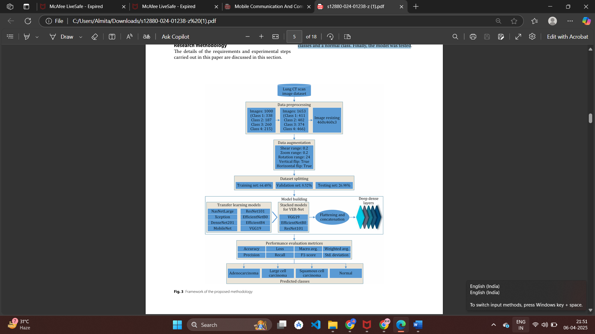

Dataset description -The chest CT images utilized in this study were obtained from Kaggle3. The dataset contains CT scan images of three types of lung cancers: Adenocarcinoma, Large cell carcinoma, and Squamous cell carcinoma.

Data preprocessing -To develop a robust and reliable automated system, data preprocessing plays a crucial role in the model building process. Preprocessing is an essential step to eliminate the distortions from the images. In this study, data preprocessing, image resizing, and data augmentation were used for better classification and detection of lung cancer, as discussed in the subsections below.

Image resizing -The loaded images are standardized and normalized using a standard scaler and min-max scaler as the nor malization functions. The files are resized from 224 × 224 to 460 × 460 using a resize function.

Data augmentation- Random oversampling was applied afterwards to add randomly duplicate examples in the minority class by adding additional images to the classes containing fewer samples in the dataset. Initially, the dataset comprised 1000 images, with each class containing 338, 187, 260 and 215 images. The final dataset after oversampling con tains 1653 images, with each class containing 411, 402, 374 and 466 images.

Transfer learning models- Transfer learning models play a significant role in health care for medical image processing.Medical imaging technologies, such as X-rays, CT scans, MRI scans, and histopathology slides, generate vast amounts of visual data that require accurate and efficient analysis. Transfer learning enables the utilization of pre-trained models trained on large datasets from various domains, such as natural images, to tackle medical image process ing tasks. The transfer learning models that are con sidered in this experiment are described in this section.

Proposed VER-Net model To find out the best-performing models among the ones discussed in the previous section, we ran them and assessed their performance individually. Among them, VGG19 and EfficientNetB0 were the best per formers in all metrics. However, EfficientNetB4 and ResNet101 competed with each other to take the third spot. In some metrics, EfficientNetB4 did better, while in some, ResNet101 was better. Nevertheless, we picked ResNet101 over EfficientNetB4 because it has better test ing accuracy and precision, which is crucial for detect ing life-threatening diseases like cancer. Therefore, we stacked VGG19, EfficientNetB0, and ResNet101 in our proposed VER-Net model.

**B.3 Observations and learning:**

Write down Advantages of Proposed system and disadvantages of Existing system in terms of observation and learning

**Advantages of the Proposed System (VER-Net):**

1. **Enhanced Accuracy:** VER-Net achieved a classification accuracy of 91%, surpassing the performance of eight other transfer learning models evaluated in the study.
2. **Improved Precision and Recall:** The model demonstrated a precision of 92% and a recall of 91%, indicating its effectiveness in correctly identifying lung cancer cases and minimizing false negatives.
3. **Robustness through Hybrid Architecture:** By integrating three different transfer learning models, VER-Net leverages diverse feature extraction capabilities, enhancing its robustness and generalization across varying CT scan images.

**Disadvantages of Existing Systems:**

1. **Lower Performance Metrics:** The existing transfer learning models evaluated in the study exhibited lower accuracy, precision, and recall compared to VER-Net, indicating less reliable performance in lung cancer detection.
2. **Limited Generalization:** Traditional models may not generalize well across different datasets or imaging conditions, potentially leading to decreased performance when applied to diverse clinical scenarios.​
3. **Single Model Limitations:** Relying on a single transfer learning model may not capture the complex patterns in CT images as effectively as a hybrid approach like VER-Net, which combines multiple models to enhance feature extraction and classification.​

These observations highlight the potential of VER-Net to improve lung cancer detection through its hybrid transfer learning approach, addressing some limitations inherent in existing systems.

**B.4 Conclusion:**

Conclusion and references

**Conclusion**

The proposed VER-Net model demonstrates significant improvements in lung cancer detection using CT scan images through its hybrid transfer learning architecture. By integrating features from multiple pre-trained models, VER-Net enhances both the learning capability and the observation accuracy compared to existing single-model approaches. This results in better classification performance, higher precision, and more robust generalization across datasets. In contrast, existing models show limitations in learning complex features, generalization ability, and often suffer from lower diagnostic accuracy. Overall, VER-Net establishes a promising direction for computer-aided diagnosis systems in medical imaging.

**References**

1. R. L. Siegel, K. D. Miller, H. E. Fuchs, and A. Jemal, “Cancer statistics, 2021,” *CA Cancer J Clin.*, vol. 71, no. 1, pp. 7–33, Jan. 2021, doi: [10.3322/caac.21654](https://doi.org/10.3322/caac.21654).
2. C. S. Dela Cruz, L. T. Tanoue, and R. A. Matthay, “Lung cancer: Epidemiology, etiology, and prevention,” *Clin Chest Med.*, vol. 32, no. 4, pp. 605–644, Dec. 2011, doi: 10.1016/j.ccm.2011.09.001.
3. S. Wankhade, “A novel hybrid deep learning method for early detection of lung cancer using neural networks,” *Healthc. Anal.*, vol. 3, p. 100195, 2023, doi: [10.1016/j.health.2023.100195](https://doi.org/10.1016/j.health.2023.100195).
4. A. Ruano-Raviña et al., “Lung cancer symptoms at diagnosis: Results of a nationwide registry study,” *ESMO Open*, vol. 5, no. 6, p. e001021, 2020, doi: 10.1136/esmoopen-2020-001021.
5. C. Zappa and S. A. Mousa, “Non-small cell lung cancer: Current treatment and future advances,” *Transl. Lung Cancer Res.*, vol. 5, no. 3, pp. 288–300, Jun. 2016, doi: 10.21037/tlcr.2016.06.07.
6. Z. Otty, A. Brown, S. Sabesan, R. Evans, and S. Larkins, “Optimal care pathways for people with lung cancer—a scoping review of the literature,” *Int. J. Integr. Care*, vol. 20, no. 3, pp. 1–9, 2020, doi: [10.5334/ijic.5438](https://doi.org/10.5334/ijic.5438).
7. D. Xiang et al., “Lung cancer screening: From imaging to biomarker,” *Biomark. Res.*, vol. 1, no. 1, 2013, doi: 10.1186/2050-7771-1-4.
8. N. Woznitza, K. Piper, S. Rowe, and A. Bhowmik, “Immediate reporting of chest X-rays referred from general practice by reporting radiographers: A single centre feasibility study,” *Clin. Radiol.*, vol. 73, no. 5, pp. 507.e1–507.e8, 2018, doi: 10.1016/j.crad.2017.11.016.
9. M. J. McAuliffe et al., “Medical image processing, analysis and visualization in clinical research,” in *Proc. 14th IEEE Symp. Computer-Based Medical Systems*, 2001, pp. 381–386, doi: [10.1109/CBMS.2001.941749](https://doi.org/10.1109/CBMS.2001.941749).
10. M. Puttagunta and S. Ravi, “Medical image analysis based on deep learning approach,” *Multimed. Tools Appl.*, vol. 80, no. 16, pp. 24365–24398, 2021, doi: 10.1007/s11042-021-10707-4.
11. D. Shen, G. Wu, and H. I. Suk, “Deep learning in medical image analysis,” *Annu. Rev. Biomed. Eng.*, vol. 19, pp. 221–248, Jun. 2017, doi: 10.1146/annurev-bioeng-071516-044442.
12. M. Tsuneki, “Deep learning models in medical image analysis,” *J. Oral Biosci.*, vol. 64, no. 3, pp. 312–320, 2022, doi: [10.1016/j.job.2022.03.003](https://doi.org/10.1016/j.job.2022.03.003).
13. S. Dara, P. Tumma, N. R. Eluri, and G. R. Kancharla, “Feature extraction in medical images by using deep learning approach.” [Online]. Available: <http://www.acadpubl.eu/hub/>
14. F. H. Kuwil, “A new feature extraction approach of medical image based on data distribution skew,” *Neurosci. Inf.*, vol. 2, no. 3, p. 100097, 2022, doi: 10.1016/j.neuri.2022.100097.
15. Y. Bar et al., “Chest pathology identification using deep feature selection with non-medical training,” *Comput. Methods Biomech. Biomed. Eng. Imaging Vis.*, vol. 6, no. 3, pp. 259–263, May 2018, doi: [10.1080/21681163.2016.1138324](https://doi.org/10.1080/21681163.2016.1138324).

**B.5 Question of Curiosity**

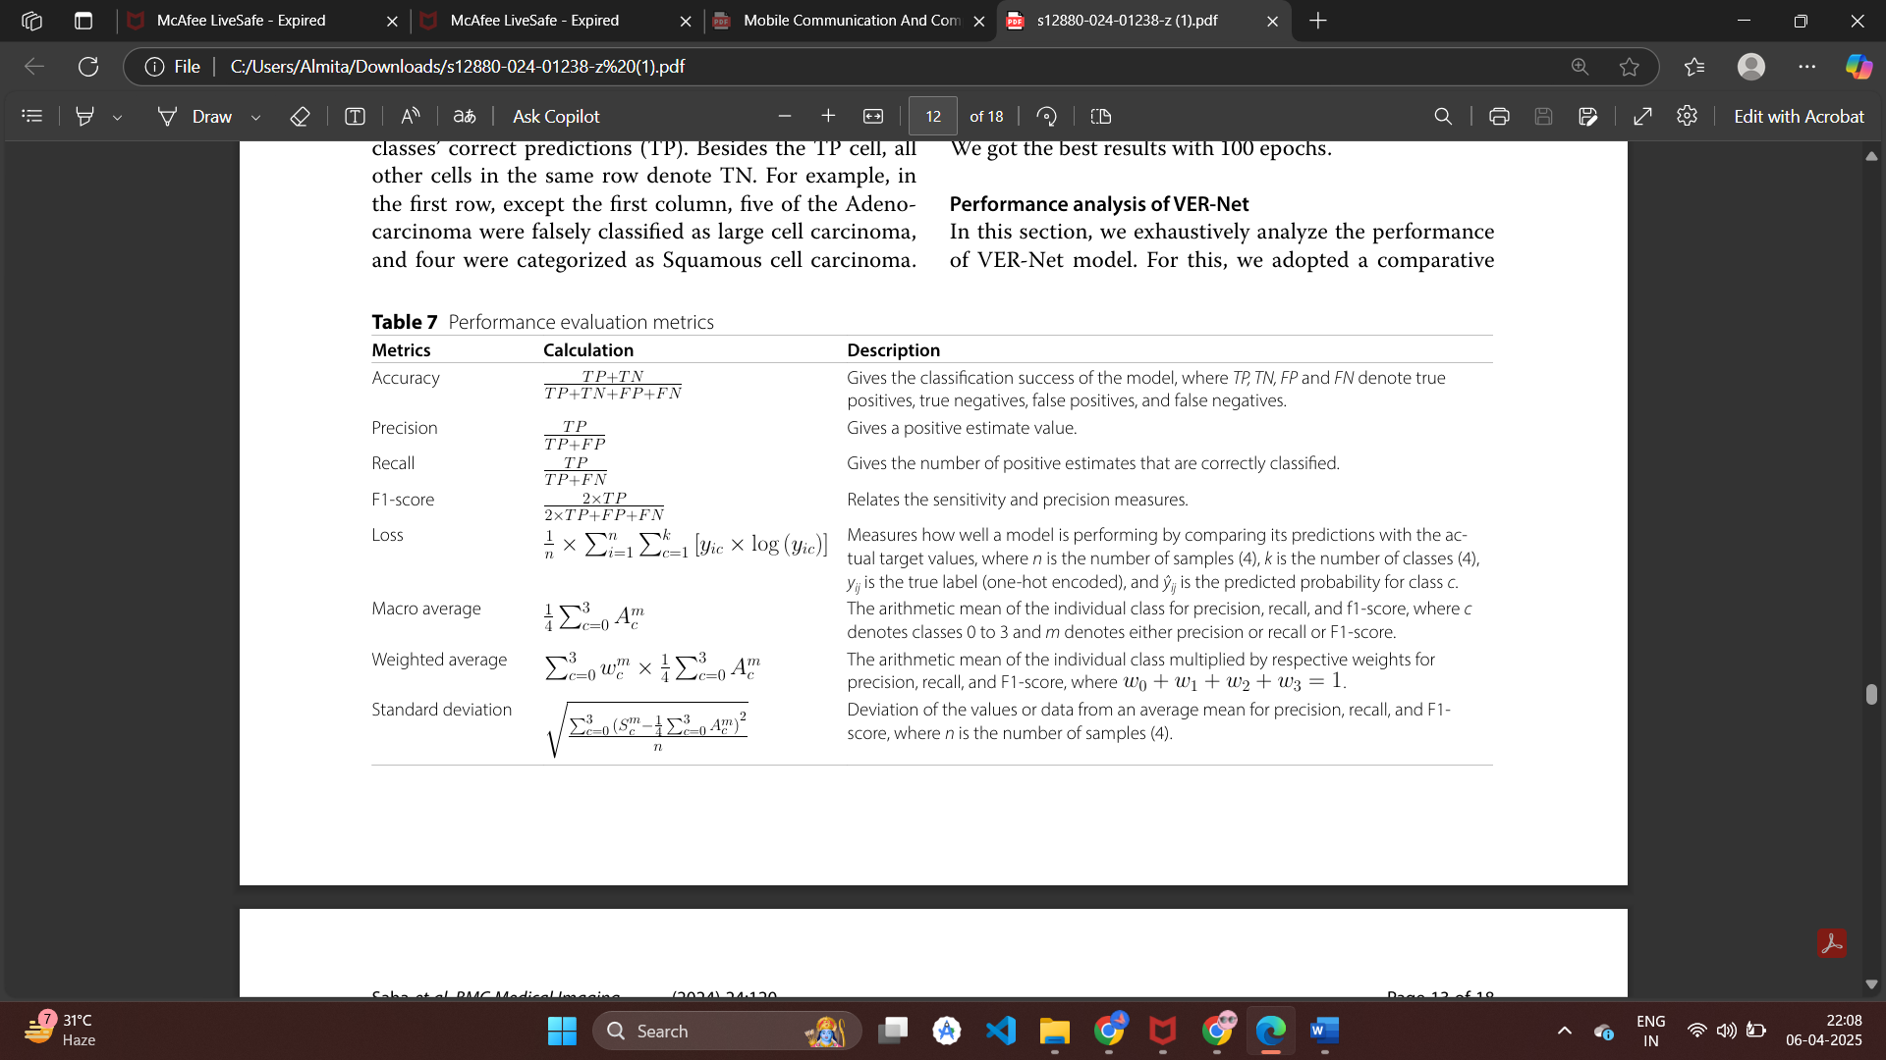1] Explain performance parameters that will be used to evaluate your proposed system.

To thoroughly evaluate the effectiveness of the proposed VER-Net model for lung cancer detection using CT scan images, several statistical and performance-based metrics are employed. These metrics provide insights into how accurately and reliably the model performs across different categories.

**Accuracy** is the most straightforward metric that gives an overall measure of correct classifications by comparing all true positives and true negatives with the total number of predictions. However, in medical imaging tasks, especially with imbalanced datasets, accuracy alone may not provide a complete performance picture.

**Precision** focuses on the quality of positive predictions — how many of the predicted positive cases are actually positive — which is essential in clinical diagnosis to reduce false positives and avoid unnecessary treatments.

**Recall**, or sensitivity, measures the model’s ability to detect all relevant cases (true positives), making it critical in minimizing the risk of missing actual cancer cases.

**F1-score** provides a balance between precision and recall, especially useful when there is an uneven class distribution. It gives a single measure that accounts for both false positives and false negatives.

**Loss** function quantifies the difference between the predicted output and the actual target values during training. It helps guide the optimization process to improve the model’s learning.

To ensure fair evaluation across multiple classes (in this case, multiple types of lung conditions or cancer stages), **macro average**, **weighted average**, and **standard deviation** are calculated. Macro averaging treats all classes equally, giving insight into performance consistency, while weighted averaging accounts for class imbalances. **Standard deviation** indicates the variation in performance across different classes and helps assess the model’s robustness.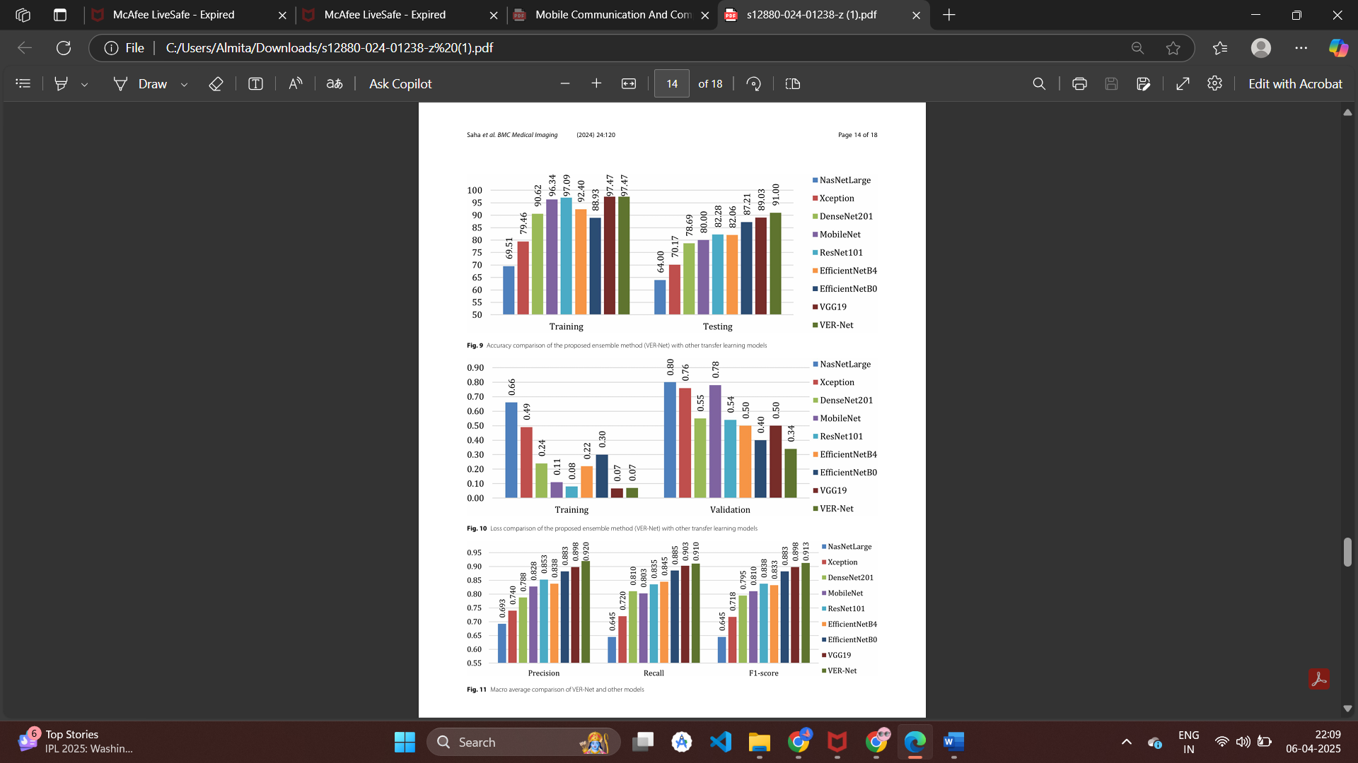These metrics together provide a comprehensive and balanced evaluation of the proposed system, highlighting its strength in accurate prediction, sensitivity to real cases, and consistency across categories.