ABSTRACT

Although Internet has become such a handy thing for people having access to Internet that they roam about with it in their pockets, but this has been possible for those countries that can afford fibre optic cables for connectivity and therefore the bitter truth remains that nearly two-thirds of the world population do not yet have Internet access. The Google[X] team has therefore taken an initiative to bridge this gap and make the world actually connected to one another by introducing Google’s Project Loon.

Project Loon – a network of balloons traveling on the edge of space, designed to provide Internet connectivity free of terrestrial constrains and with an affordable rate worldwide.This project has come along a long way with successful Pilot Test and also surpassing many environmental, engineering , political challenges(relating to use of airspace and radio frequencies)

TABLE OF CONTENTS

- INTRODUCTION

- DESIGN OF LOONS

- HOW LOON MOVES?

- WORKING

- PRACTICAL PARAMETERS

- PILOT TEST

- ADVANTAGES

- DISADVANTAGES

- FUTURE ASPECTS

10. CONCLUSION

11. REFERENCES

1. INTRODUCTION

Today only 4.5 billion people – a little more than one third of the world’s population—have Internet access. This fact can be attributed to many reasons, but the most important factor is the scarcity revolution in data services. Even though there are more than 36% smartphone subscribers in the world, the majority of them still don’t have data access due to the costly data plan in many countries. On the other hand, the vast majority of the prices people pay for data plans go directly towards covering the tens of billions of dollars spent each year building the infrastructure to deliver the connections. Unless the infrastructure expansion becomes more efficient, the industry cannot sustainably serve everyone. Bring majority of the global population into Internet community is one of the greatest challenges of our generation, and now we see hope from the Google Project Loon – a network of balloons travelling on the edge of space, designed to provide ubiquitous Internet connectivity free of terrestrial constrains and with an affordable rate worldwide.In 2015, the Google Project Loon finally matured in technology. The novel system is ready to enter the market to provide Broadband Internet connectivity. However, this industry is highly competitive and prospers with various Broadband technologies of intensive capital necessary for Internet infrastructure implementation in many developing areas.



1.2 Concept of Loon

Project loon is a research and development project being developed by Google. It is a network of balloons travelling on the edge of space, designed to provide ubiquitous Internet connectivity. The balloons float in the stratosphere, twice as high as airplanes and the weather. They are carried around the Earth by winds and they can be steered by rising or descending to an altitude with winds moving in the desired direction. People connect to the balloon network using a special Internet antenna attached to their building. The signal bounces from balloon to balloon, then to the global Internet back on Earth.

1.3 Loon Overview

Project Loon balloons travel around 20 km above the Earth’s surface in the stratosphere. Winds in the stratosphere are generally steady and slow-moving at between 5 and 20 mph, and each layer of wind varies in direction and magnitude. Project Loon uses software algorithms to determine where its balloons need to go, then moves each one into a layer of wind blowing in the right direction. By moving with the wind, the balloons can be arranged to form one large communications network situated between 10 km and 60 km altitude on the edge of space, the stratosphere is named after the different strata, or layers, of wind within it.But the extreme altitude also presents unique engineering challenges:

1. air pressure is 1% of that at sea level,
2. temperatures hover around -50°C, and
3. a thinner atmosphere offers less protection from the UV radiation and temperature
swings caused by the sun’s rays.

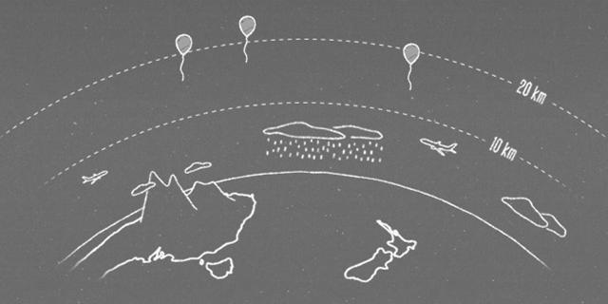
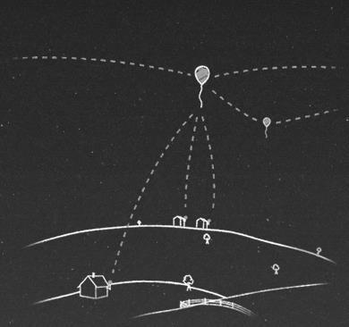

2. DESIGN OF LOONS

2.1 Architecture of Loon

The loon is comprised of three parts: an envelope, solar panels and equipment.

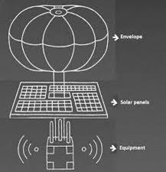

2.2 Envelope

The balloon envelope is the name for the inflatable part of the balloon. Project Loon’s balloon envelopes are made from sheets of polyethylene plastic and stand fifteen meters wide by twelve meters tall when fully inflated. The balloon powers itself by two renewable energies, sunlight and wind.

They are specially constructed for use in Super pressure balloons, which are resistant to UV radiation, and is capable to function at temperature as low as -58 °F, and at pressure as low as
1/100 atm.

Its envelope is made from sheets of Mylar which is a brand for a thin strong polyester film about 0.076 mm thick. Such super pressure balloons require Mylar since it strongly keeps from stretching and popping at even high altitude. It is built to resist higher pressures than a normal weather balloon which reaches usually at an altitude of 40 km (25 mi). Inside envelope, there is another chamber, called bladder. To have the balloon descended, a fan powered by the solar energy fills the bladder with air to make it heavier. Likewise, the fan vents air in the bladder, which causes it to rise. The balloon can move up or down a 1.7 km (1 mi) range through the bladder system. This system can help to choose suitable wind currents in stratosphere. It also releases some air inside out of the envelope to relieve pressure. When being out of the service, it releases gas from the envelope and descends slowly to the ground. It rarely happens, but when the balloon drops quickly, it uses the parachute on the top of the envelope.

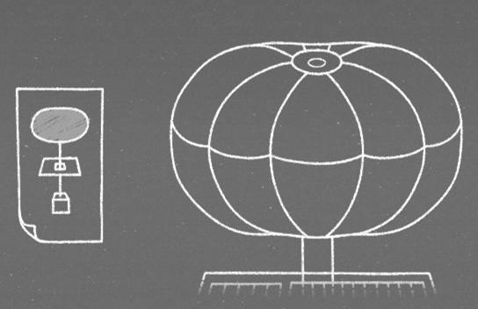

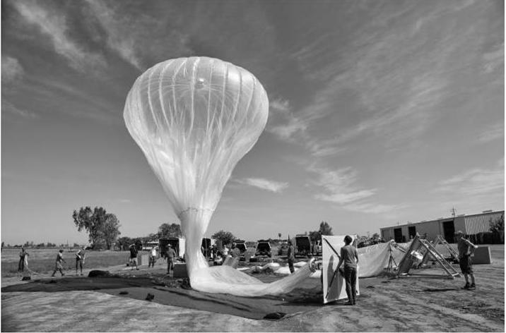

Balloons filled with Helium and air mixture are launched, recycled and re-launched at a designated collecting point. After 100 days from the launching, the balloon is ready to be 8www.studymafia.org taken out of service and the gas is released from the envelope to bring down the balloon in a controlled descent to the ground. Each balloon includes a parachute to ensure a more controlled landing. The balloons and equipment on board can be re-used and each loon has an
approximately 2-years life time.

2.3 Solar Panel

Each unit’s electronics are powered by an array of solar panels that sits between the envelope and the hardware. In full sun, these panels produce 100 Watts of power - enough to keep the unit running while also charging a battery for use at night. By moving with the wind and charging in the sun, Project Loon is able to power itself using only renewable energy sources.

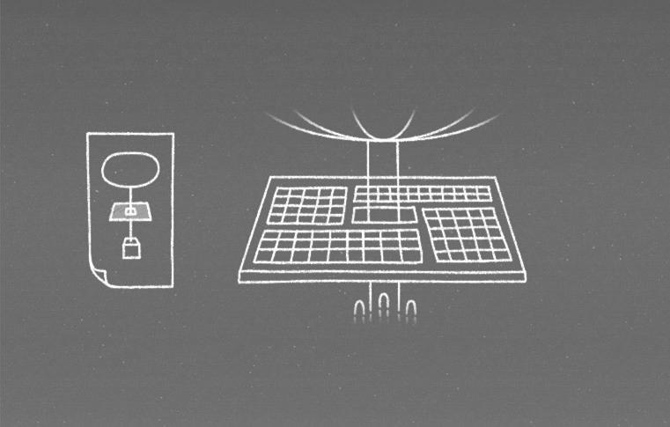
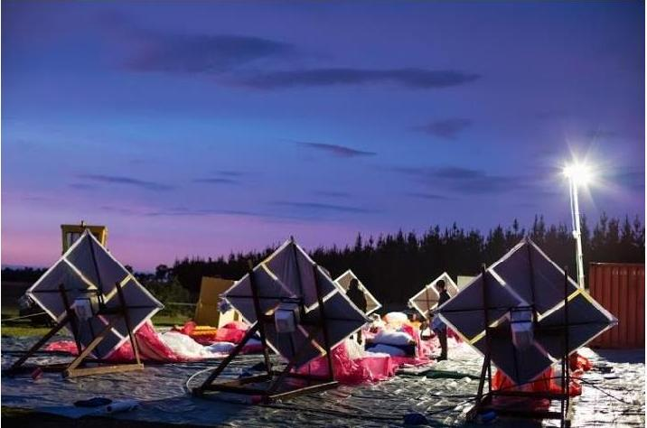

2.4 Equipments

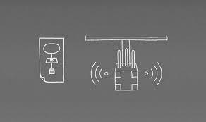

A small box containing the balloon’s electronic equipment hangs underneath the inflated envelope, like the basket that is carried by a hot air balloon. It contains circuit boards that control the system, radio antennas to communicate with other balloons and with Internet antennas on the ground, batteries to store solar power so the balloons can operate during the night, and weather instruments to monitor the weather and the conditions around them.

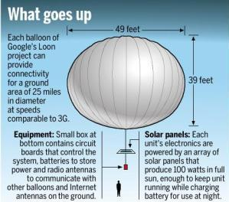

3. HOW LOON MOVES?

Project Loon balloons travel around 65,000 feet above the Earth’s surface in the stratosphere. Winds in the stratosphere are generally steady and slow-moving at between 5 and 20 mph, and each layer of wind varies in direction and magnitude. Due to the wind properties, balloons can travel along latitude line with a ± 5 o latitude range. Project Loon uses software algorithms to determine where its balloons need to go, then moves each one into a layer of wind blowing in the right direction. By moving with the wind, the balloons can be arranged to form one large communications network. The Loon team can access the web-based control system from any computer or tablet.

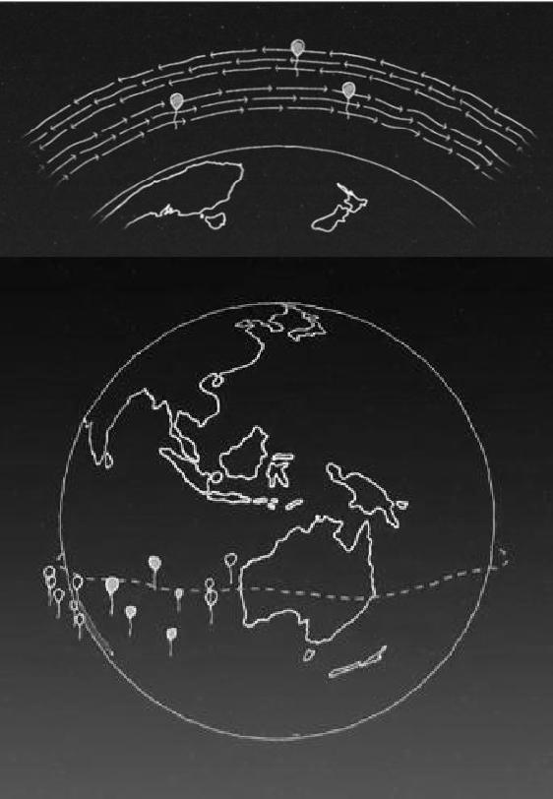

4. WORKING

4.1 Connections

Far below the loons, ground stations providing connectivity to backbone Internet can transmit signals to the balloons up to 65 miles far. The signals would hop forward, from one balloon to the next, along a chain of up to 5 balloons. Each balloon is networked to one another within 30 miles with a radio transceiver as in a mesh, designed to ensure signal reliability. A second transceiver keeps the balloon in contact hundreds of antennas on ground area about 25 miles in diameter at speeds comparable to 3G. The specialized antennas can be placed on homes, much like a very small satellite TV receiver. Project Loon currently uses ISM bands (specifically 2.4 and 5.8 GHz bands) that are available for anyone to use. There is also a back-up transceiver and a GPS on each balloon, so Google can monitor each balloon's location
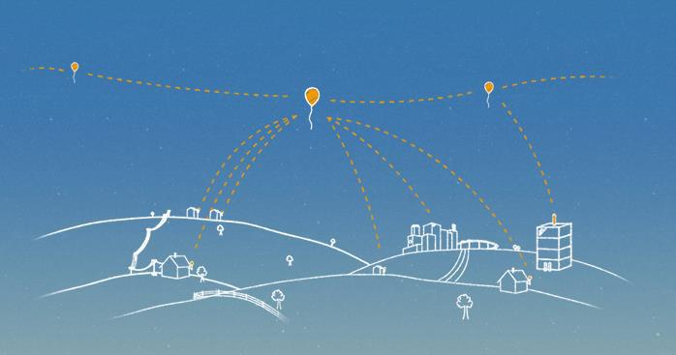

4.2 Reception(antenna)

It can provide wireless Internet connectivity to ground areas at up to 10Mbps (3G speed). There are two kinds of communications: balloon-to-balloon network and balloon-to-ground station or subscribers network. It has specialized radio antennas to support two networks. It currently uses ISM bands specifically 2.4 and 5.8 Ghz 12 some bands because they are typically unlicensed radio frequencies around the world, which means Google is able to avoid negotiating with local governments to purchase specific radio frequencies. Additionally, these also avoids interferences and reaches much further distances. Because it does not support Wi-Fi, smart phones such as iPhone are not able to establish connections directly to balloons. it requires users to install a specialized antenna the outside of their home to receive the signal from a balloon near their home and to decrypt the signal. This way is very similar to the usage of satellites.

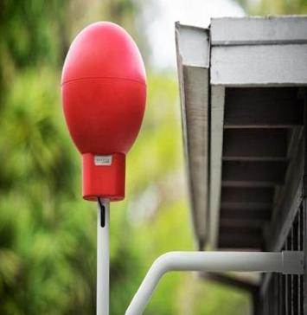
4.3 How actually it works?

A user with the specialized antenna sends signals via a radio frequency over ISM bands to a balloon close to him/her. The balloon sends the signals to neighbouring balloons. Eventually, the signals reach the balloon which is connected to the local Internet. The wireless mesh network is constantly adjusting as balloons move. Any balloon is able to connect the Internet to a base station which has Internet connectivity and then receives Internet data and forwards them via balloons in the sky to the destination. Finally, the balloon close to the request user broadcasts the data to the grounds via a radio frequency over ISM bands. The special antenna installed the outside of home receives data and decrypt the data. The wireless mesh network should be constantly adjusting as balloons move.
It covers an area of an around 40 km (28 mi) diameter circle which is twice the area of New York City. Thousands of balloons can cover the whole world. Currently, its lifetime is only a few weeks, but Google anticipates that they can be in the sky hundreds of days in future.

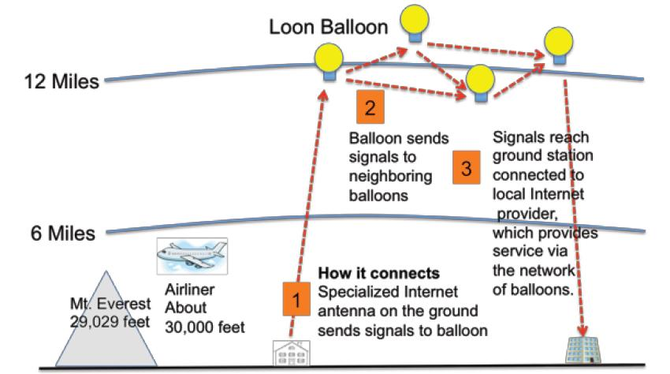

5. PRACTICAL PARAMETERS

5.1. Balloon:

- Polyethylene plastic envelops manufactured by Raven Aerostat: $4,000

- Helium gas per loon per flight: $2,000

- 100W solar panels (5ft × 5ft): $500

- Navigation control system: $1000

- Equipment box (circuit boards, radio antennae, GPS, weather instruments and batteries): $12,000

- Re-launch fee for a used balloon: $3,000

5.2 Antenna for user:

- Antenna: $500

- Assume it could be installed easily so no extra labour fee.

6. PILOT TEST

In 2008, Google had considered contracting with or acquiring Space Data Corp., a company that sends balloons carrying small base stations about 20 miles (32 km) up in the air for providing connectivity to truckers and oil companies in the southern United States, but didn't do so. Unofficial development on the project began in 2011 under incubation in Google X with a series of trial runs in California's Central Valley. The project was officially announced as a Google project on 14 June 2013.

On 16 June 2013, Google began a pilot experiment in New Zealand where about 30 balloons were launched in coordination with the Civil Aviation Authority from the Tekapo area in the South Island. About 50 local users in and around Christchurch and the Canterbury Region tested connections to the aerial network using special antennas. After this initial trial, Google plans on sending up 300 balloons around the world at the 40th parallel south that would provide coverage to New Zealand, Australia, Chile, and Argentina. Google hopes to eventually have thousands of balloons flying in the stratosphere.

The technology designed in the project could allow countries to avoid using expensive fibre cable that would have to be installed underground to allow users to connect to the Internet. Google feels this will greatly increase Internet usage in developing countries in regions such as Africa and Southeast Asia that can't afford to lay underground fibre cable.

The high-altitude polyethylene balloons fly around the world on the prevailing winds (mostly in a direction parallel with lines of latitude, i.e. east or west). Solar panels about the size of a card table that are just below the free-flying balloons generate enough electricity in four hours to power the transmitter for a day and beam down the Internet signal to ground stations. These ground stations are spaced about 100 km (62 mi) apart, or two balloon hops, and bounce the signal to other relay balloons that send the signal back down.

This makes Internet access available to anyone in the world who has a receiver and is within range of a balloon. Currently, the balloons communicate using unlicensed 2.4 and 5.8 GHz ISM bands, and Google claims that the setup allows it to deliver "speeds comparable to 3G" to users. It is unclear how technologies that rely on short communications times (low latency pings), such as VoIP, might need to be modified to work in an environment similar to mobile phones where the signal may have to relay through multiple balloons before reaching the wider Internet.

The first person to connect to the "Google Balloon Internet" after the initial test balloons were launched into the stratosphere was a farmer in the town of Leeston, New Zealand, who was one of 50 people in the area around Christchurch who agreed to be a pilot tester for Project Loon. The New Zealand farmer lived in a rural location that couldn't get broadband access to the Internet, and had used a satellite Internet service in 2009, but found 16 that he sometimes had to pay over $1000 per month for the service. The locals knew nothing about the secret project other than its ability to deliver Internet connectivity; but allowed project workers to attach a basketball-sized receiver resembling a giant bright-red party balloon to an outside wall of their property in order to connect to the network.

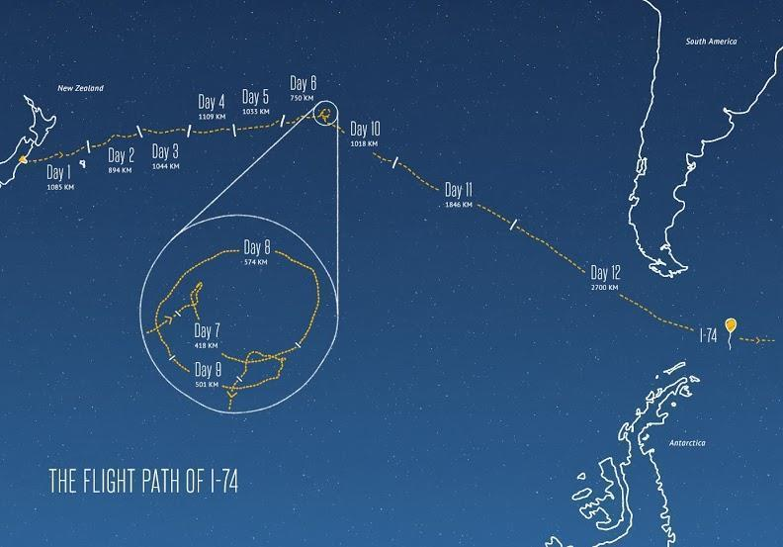

7.ADVANTAGES

- The price of Internet data in many parts of the world continues to be unaffordable for the majority of global citizens.

- “Project Loon” will offer worldwide access to information to everyone, including those who today are beyond the geographic reach of the internet or can’t afford it.

- Project Loon will guarantee this right by taking a practical approach to information delivery.

- Project Loon‘s near-term goal is to provide the entire world with broadcast data, Internet access for everyone.

- Wireless connection to the Web available for free to every person in the world.

- Project Loon will also offer a humanitarian communications system, relaying public service transmissions during emergencies in places where there is no access to conventional communications networks due to natural disasters or man-made restrictions on the free-flow of information.

- Project Loon will use a network of balloons to transmit selected internet data – audio, video, text and applications – to any Wi-Fi-enabled device, including mobile phones, anywhere in the world.

8. DISADVANTAGES

- “Cost” was high as we have to take permission, buy antenna and fix it in home.

- “Maintenance” cost will be very high as the total equipment is very costly and complicated.

- “Balloons” must be replaced for every two to three weeks. As they must be refilled the gas and should correct the balloon’s equipment if any damages occurs when they are moving at stratosphere.

9. FUTURE ASPECTS

MDIF plans to formally request NASA to use the International Space Station to test their technology in September 2014. Manufacturing and launching of satellites would begin in early 2015, and Outer net is planned to begin broadcasting in June 2015. Indian company Specify Inc. Is the first private non-profit company which is working with outernet to provide global free Wi-Fi access. Forget the Internet - soon there will be the OUTERNET: Company plans to beam free Wi-Fi to every person on Earth from space.

The New York Company plans to ask NASA to test their Outernet technology on the International Space. An ambitious project known as Outernet is aiming to launch hundreds of miniature satellites into low Earth orbit by June 2015. Each satellite will broadcast the Internet to phones and computers giving billions of people across the globe free online access. Citizens of countries like China and North Korea that have censored online ctivity could be given free and unrestricted cyberspace. You might think you have to pay through the nose at the moment to access the Internet. But one ambitious organisation called the Media Development Investment Fund (MDIF) is planning to turn the age of online computing on its head by giving free web access to every person on Earth. Known as Outernet, MDIF plans to launch hundreds of satellites into orbit by 2015. And they say the project could provide unrestricted Internet access to countries where their web access is censored, including China and North Korea.

The Outernet team claim that only 60% of the world's population currently have access to the wealth of knowledge that can be found on the Internet. This is because, despite a wide spread of Wi-Fi devices across the globe, many countries are unable or unwilling to provide people with the infrastructure needed to access the web. The company's plan is to launch hundreds of low-cost miniature satellites, known as cubesats, into low Earth orbit. Here, each satellite will receive data from a network of ground stations across the globe. Using a technique known as User Datagram Protocol (UDP) multitasking, which is the sharing of data between users on a network, Outernet will beam information to users. Much like how you receive a signal on your television and flick through channels, Outernet will broadcast the Internet to you and allow you to flick through certain websites. THE OUTERNET PROJECT TIMELINE By June of this year the Outernet project aims to begin deploying prototype satellites to test their technology. In September 2014 they will make a request to NASA to test their technology on the International Space Station.

By early 2015 they intend to begin manufacturing and launching their satellites. And in June 2015 the company says they will begin broadcasting the Outernet from space. 'We have a very solid understand of the costs involved, as well as experience working on numerous spacecraft,' said Project Lead of Outernet Syed Karim, who fielded some questions on Reddit. 'There isn't a lot of raw research that is being done here; much of what is being described has already been proven by other small satellite programs and experiments. "There's really nothing that is technically impossible to this" But at the prospect of telecoms operators trying to shut the project down before it gets off the ground, Karim said: 'We will 19 fight... and win.' If everything goes to plan, the Outernet project aims to ask NASA for permission to test the technology on the International Space Station. And their ultimate goal will be to beginning deploying the Outernet satellites into Earth orbit, which they say can begin in June 2015.

10. CONCLUSION

Although internet has become such a handy thing for people having access to internet that they roam about with it in their pockets, but this has been possible for those countries that can afford fibre optic cables for connectivity and therefore the bitter truth remains that nearly two-thirds of the world population do not yet have internet access. The Google[X] team has therefore taken an initiative to bridge this gap and make the world actually connected to one another by introducing Google’s Project Loon. This project has come along a long way with successful Pilot Test and also surpassing many environmental, engineering , political challenges(relating to use of airspace and radio frequencies) and now is seeking NASA’s intervention for its success worldwide. The project aims at : “Forget the Internet, soon there will be OUTERNET” The success of this project would thereby make us talk about Outernet , may be, in the next one year and we would put one step forward in connecting the world into one by our technology.

11. REFERENCES

