EXP11

Change Hardware compatibility of a VM (Either by clone/create new one) which is already created and configured.

The procedural steps are :

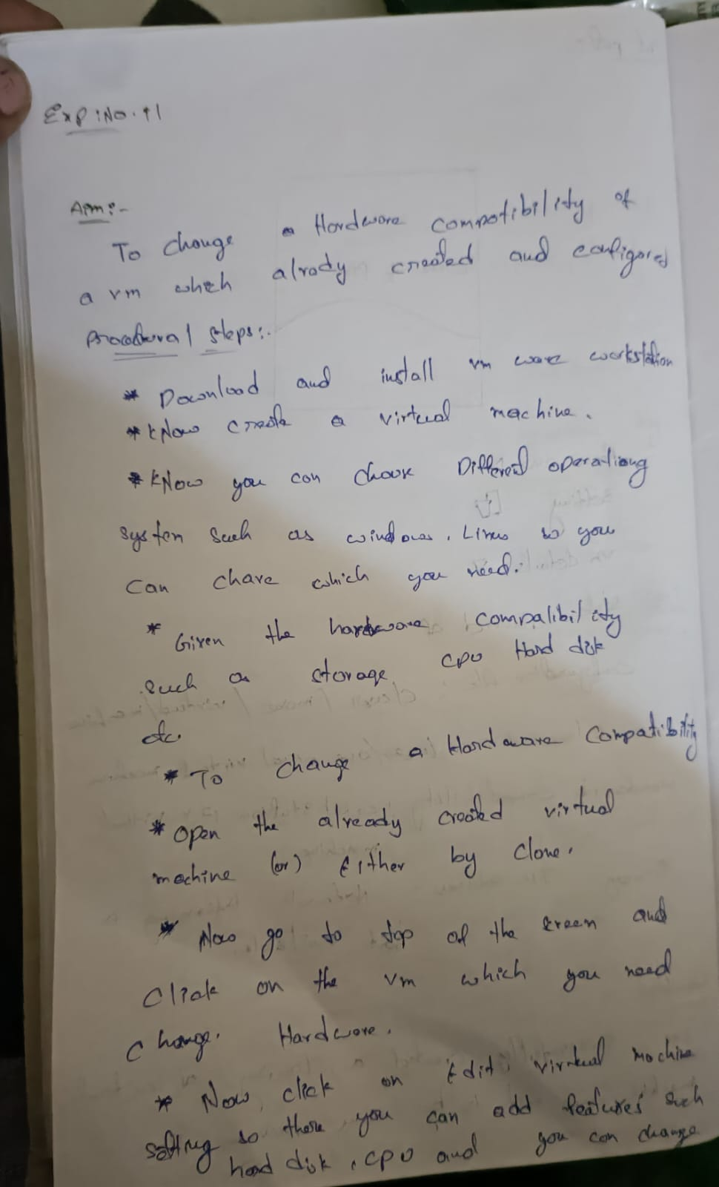

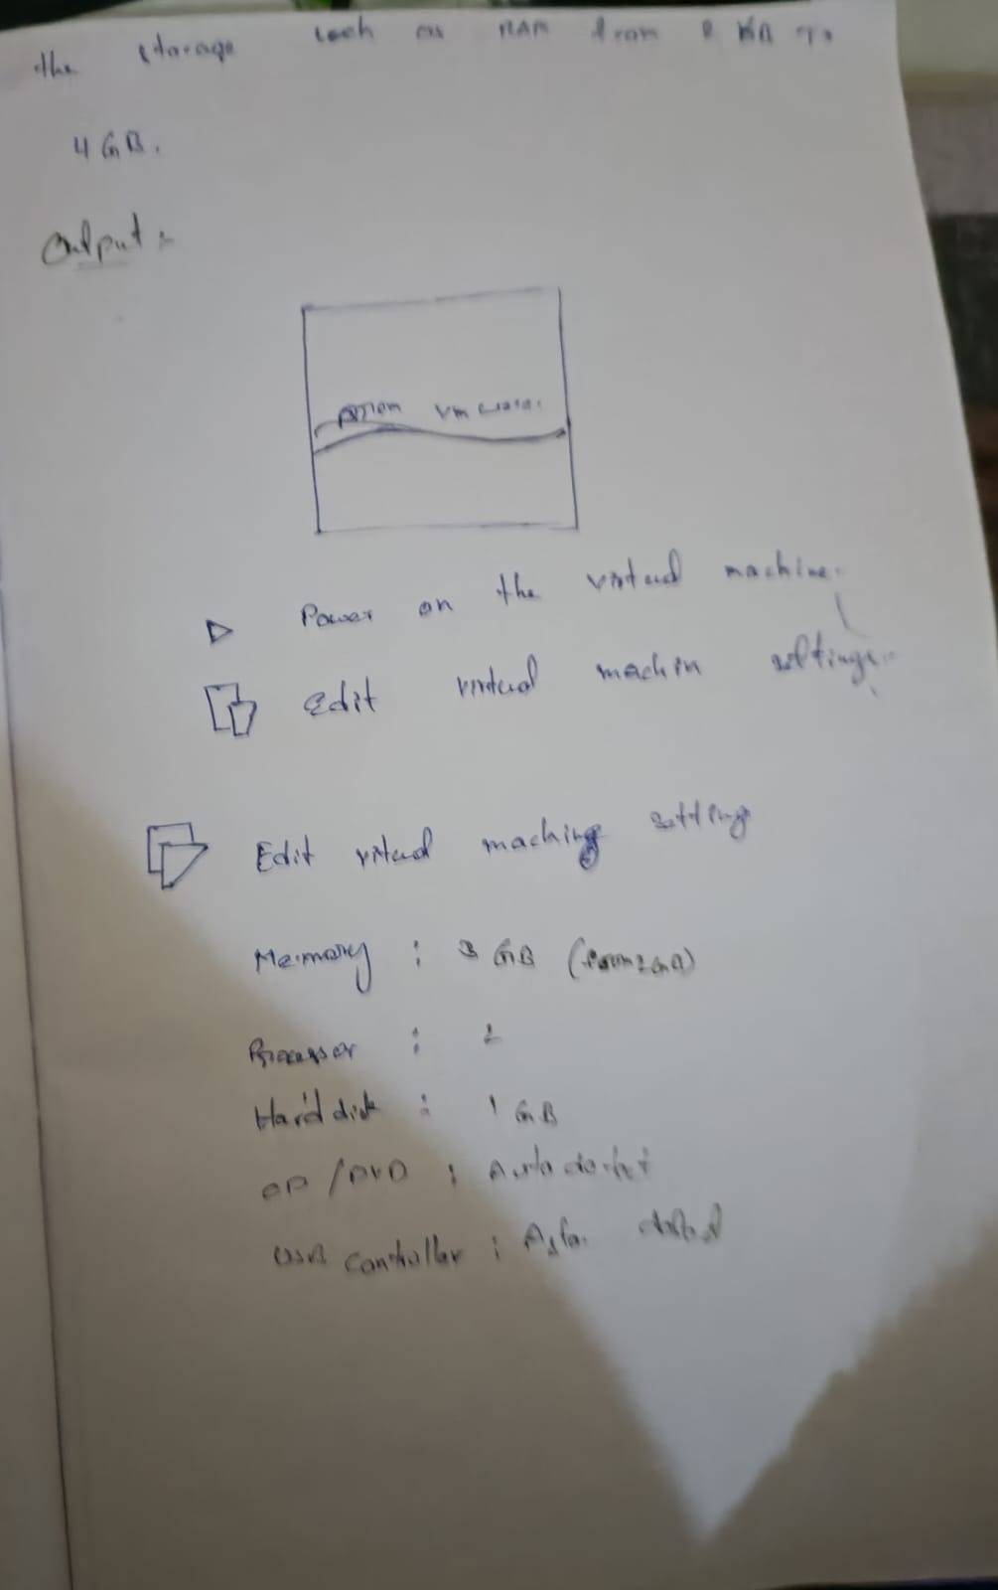

Out put :

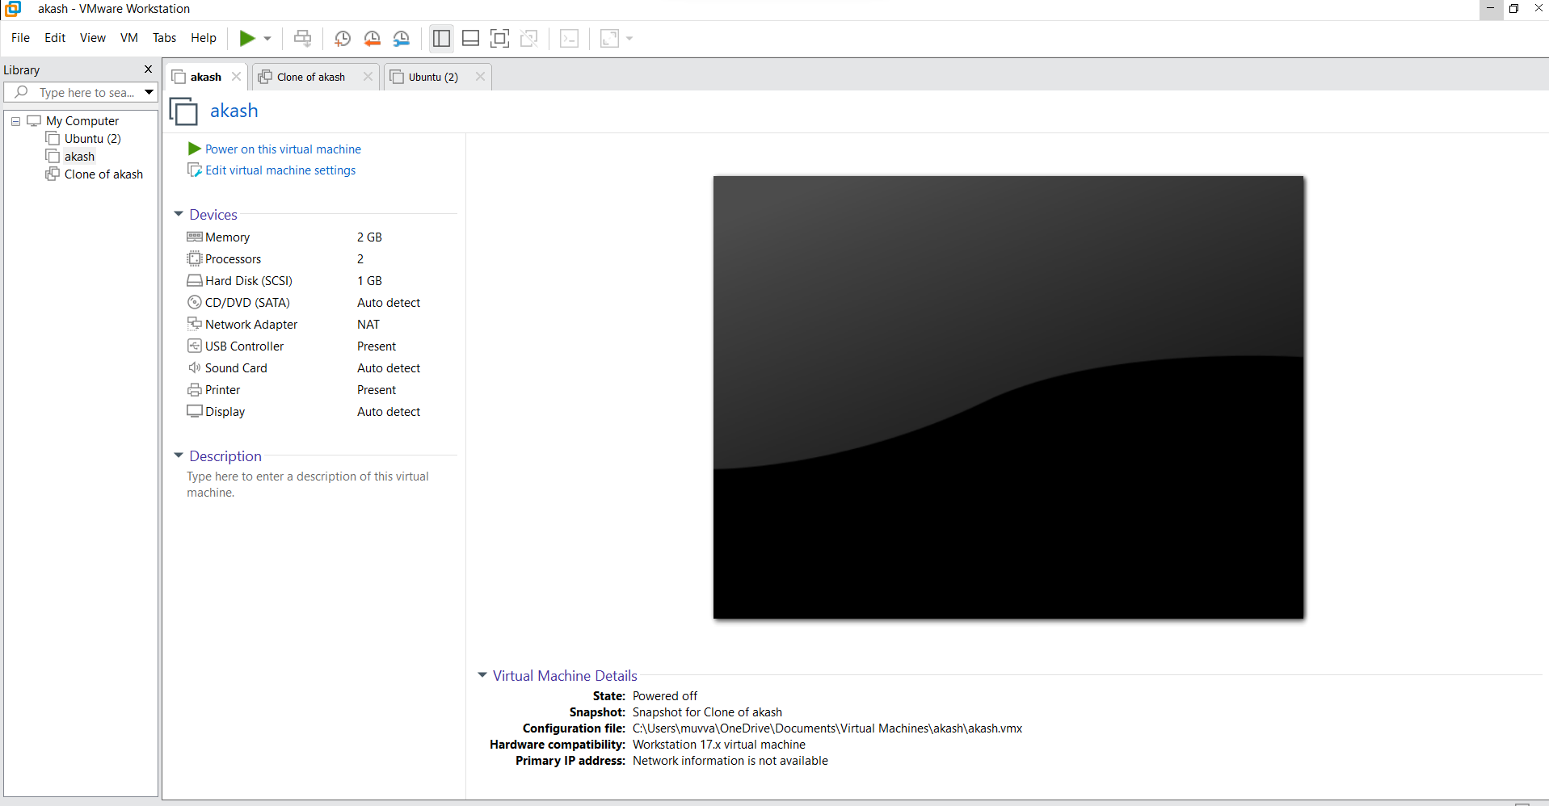

Changing hardware

