EXP-2

1. Create a simple cloud software application for Property Buying & Rental process (In Chennai city) using any Cloud Service Provider to demonstrate SaaS
2. 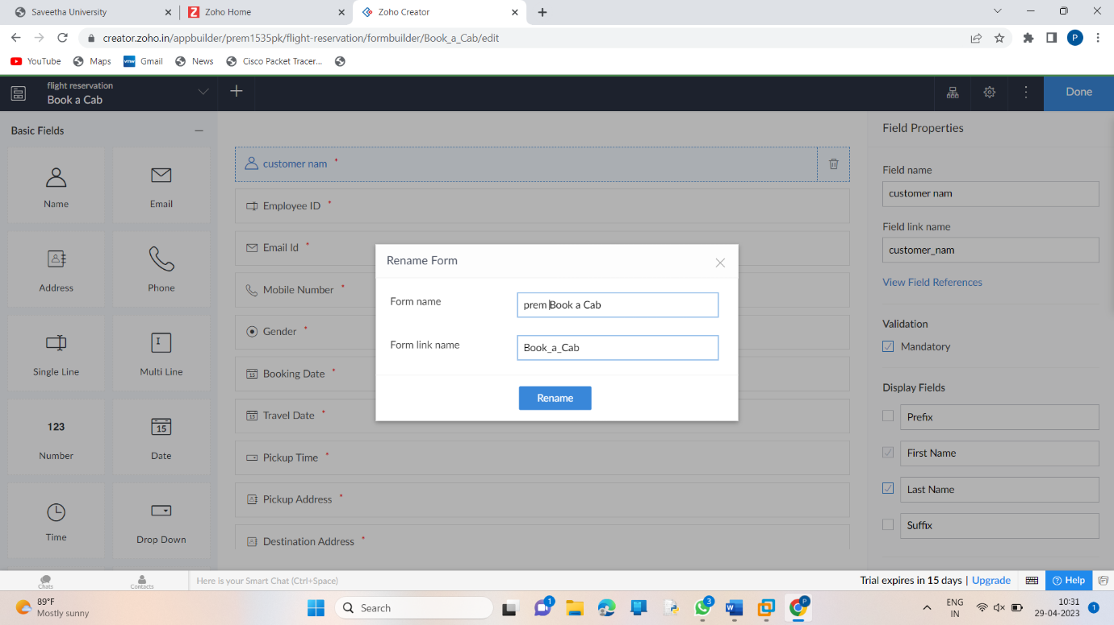
3. 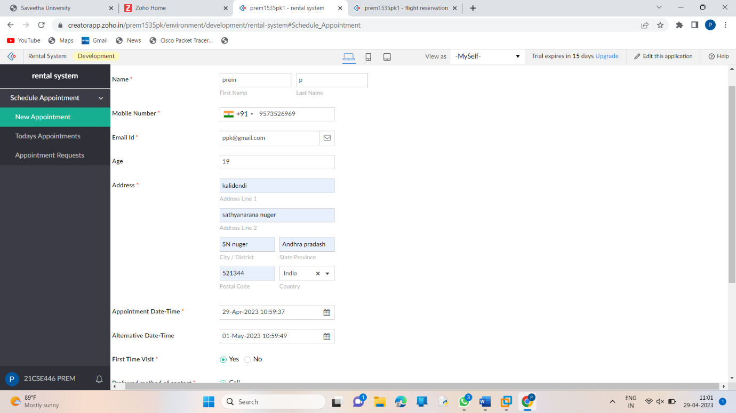
4. 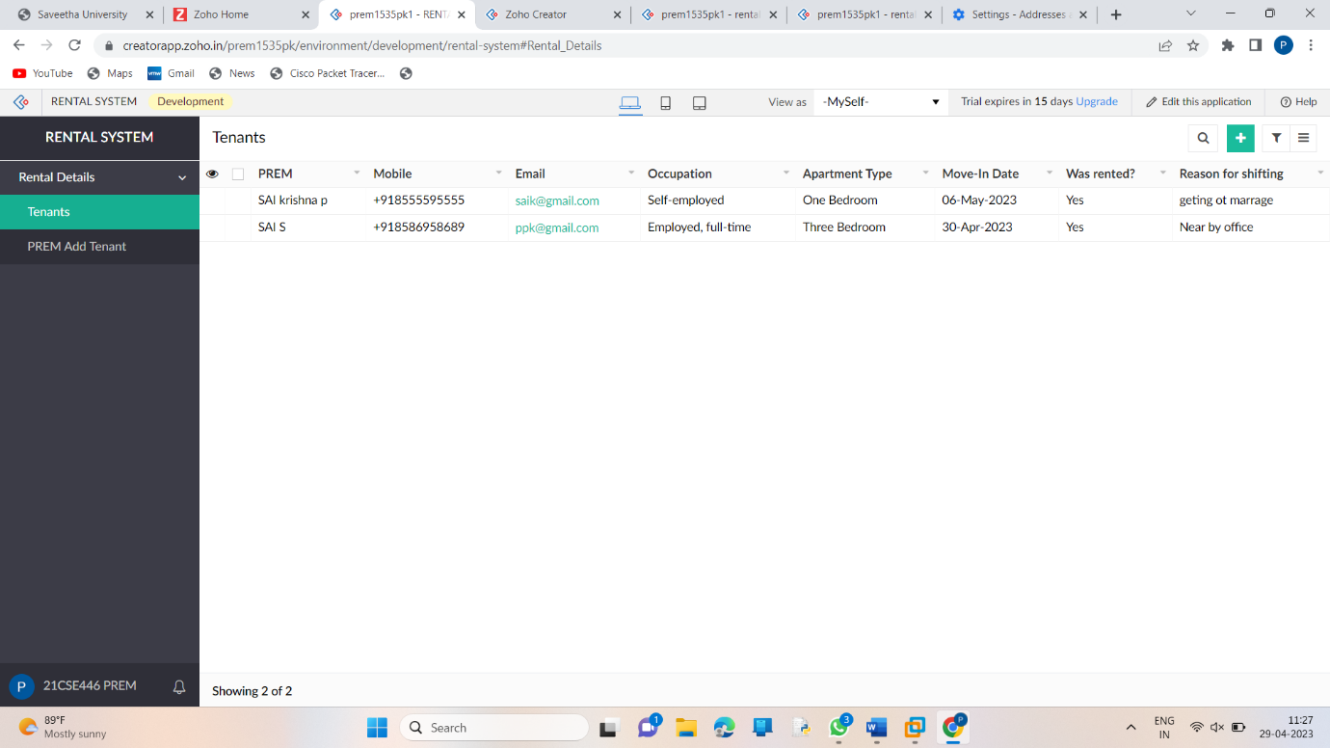
5. 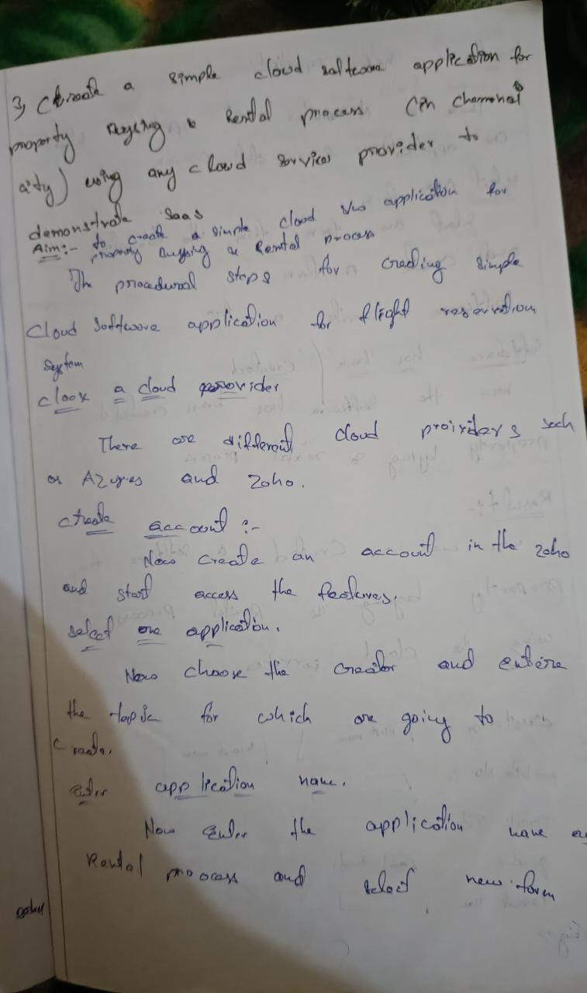
6. 