|  |
| --- |
| Credit Card Processing |

— Umbrello UML Modeller

Code Settings Help

|  |  |  |  |  |  |
| --- | --- | --- | --- | --- | --- |
| Stereotypes | |  | | Credit Card Processing |  |
| Name | Usage |  | Cardholder  system | | |
| folder |  |
| datatype | 11 |
|  | |
| Tree View | |
| @ Credit card Management Credit Card Processing credit records  E -Reservation System  @ Login Detalis members managment Passanqer | |
| Debug | |
| Class Name |  |
| umlwidgets umbrello cppparser dialogs codeimport rpfartnrinr' |
| Documentation | |
| e Credit Card Processi |  |

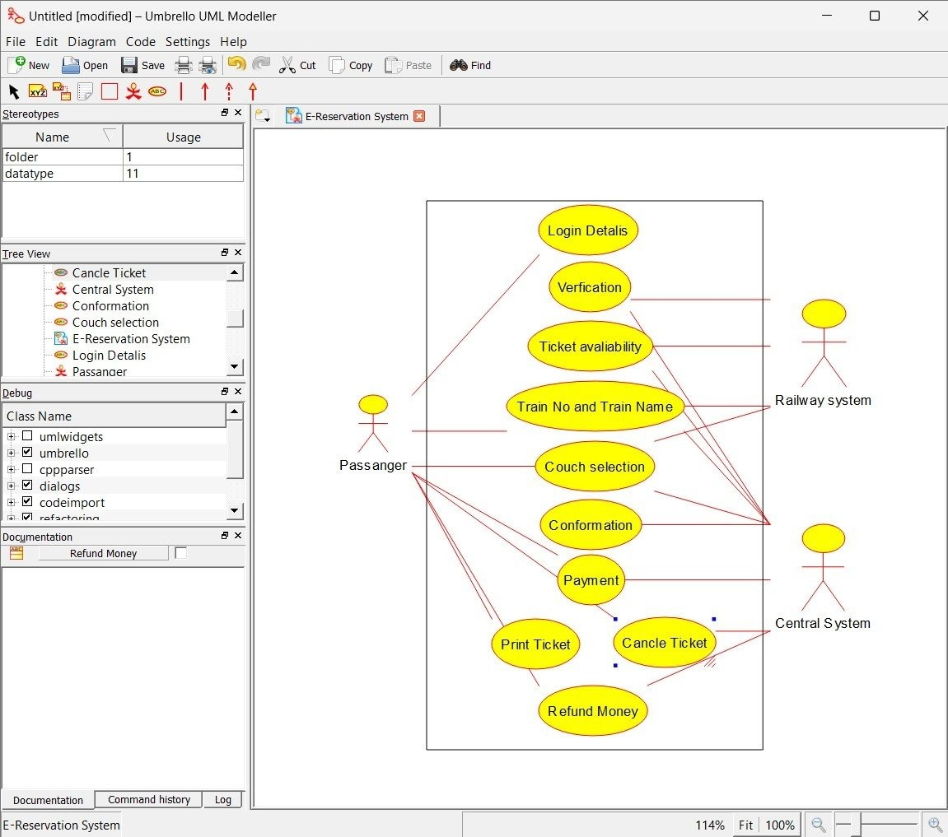

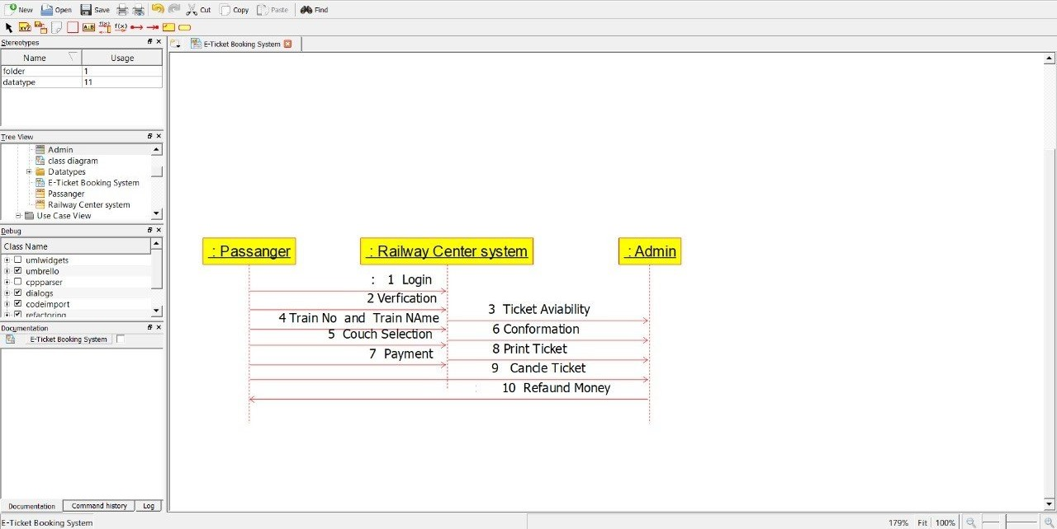— Umbrello UML Mcdeller

Code Settings Help