1.Develop a system using UML for Personal Loan Management System. The admin should add new customers and view the customer's records. The admin should check the defaulters. The customer can see his/her account detail and apply for a new loan by providing  
the required documents, and payslip. The admin should verify the document submitted and approve the loan after verifying the payback potential of the customer.

Class Diagram:

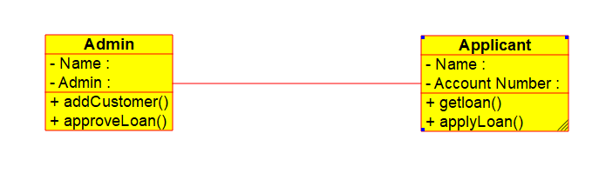

Use Case Diagram:

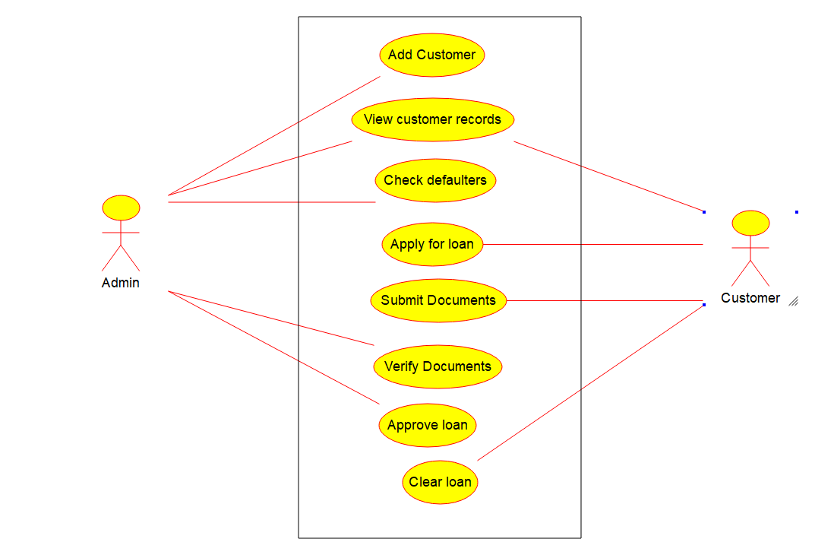

State diagram:

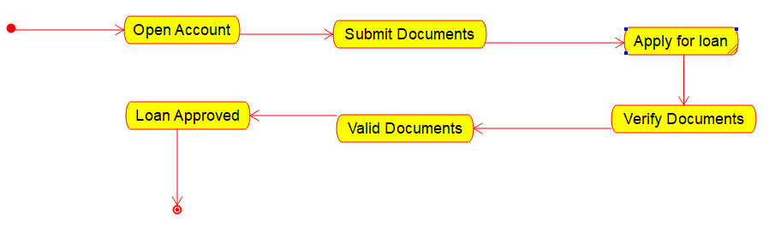

Component Diagram:

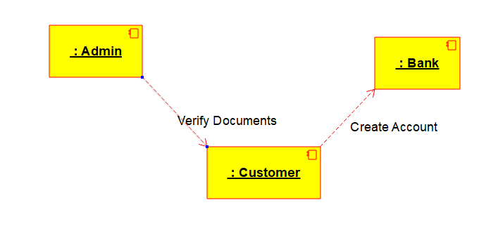

Collaboration Diagram:

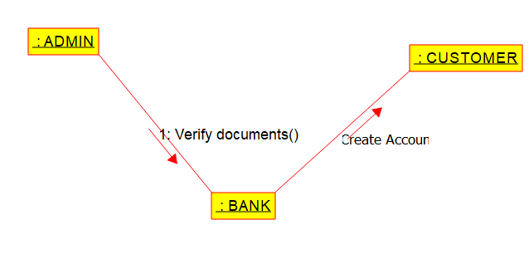

2.Develop a system using UML for Car/Bike Vehicle Booking System. The system should support the renting  
of different automobiles by the customer. Each vehicle should have a unique  
access detail. The system should be  
able to send a notification whenever the reservation is approaching the pick- up date, as well as when the vehicle is  
nearing the due date. The system  
should maintain a vehicle log to track all events related to the vehicles.

Use Case Diagram:

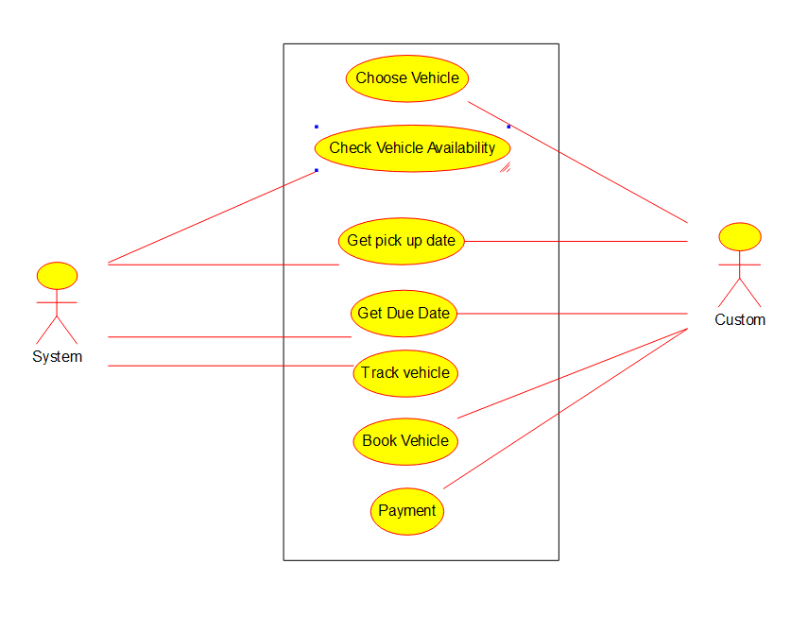

Class Diagram:

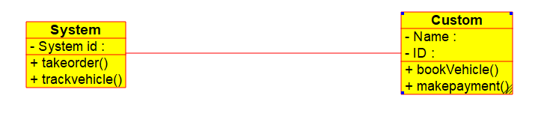

Deployment Diagram:

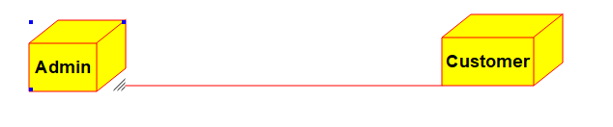

Collaboration Diagram:

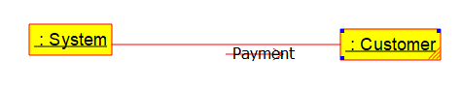

Component Diagram:

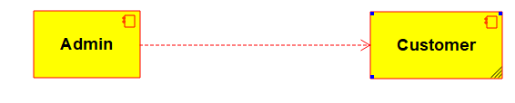

3. Develop a system

using UML for Doctor Appointment System. The central system  
should manage doctors’ availability and appointments for the given date. The patient can book the doctor’s appointment based on the doctor’s availability. When the booking  
is confirmed, it should be updated with the patient  
and doctor.

Class Diagram:

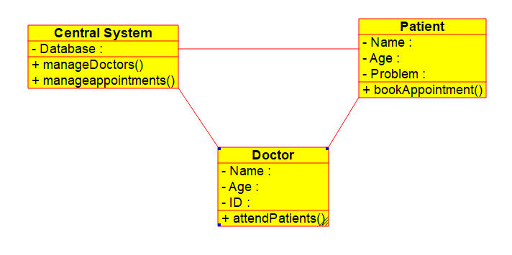

Use Case diagram:

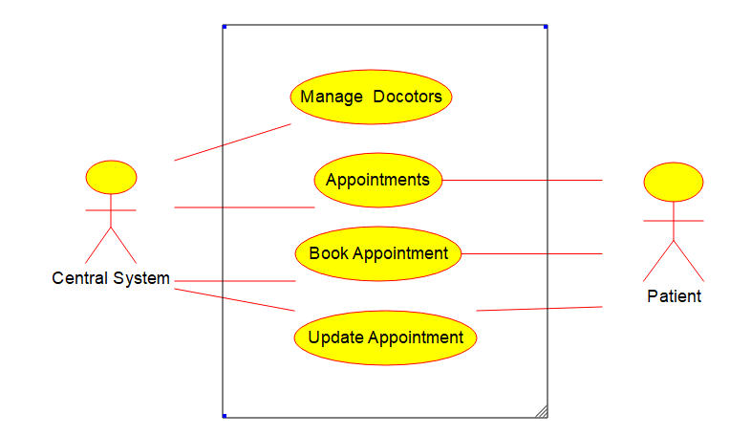

State Machine diagram:

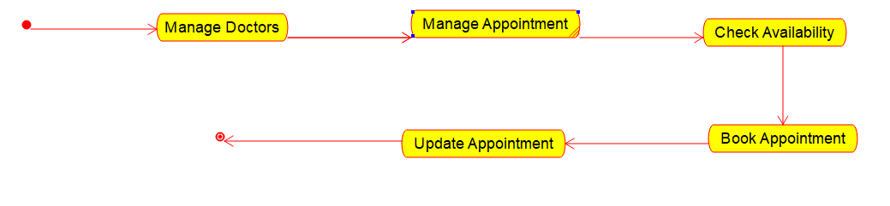

Collaboration Diagram:

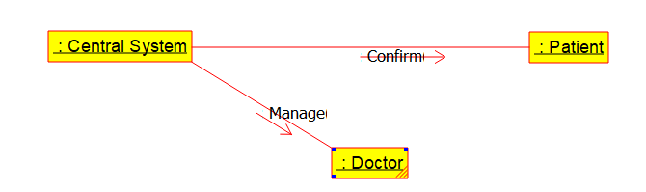

Deployment Diagram:

