PL/ SQL EXERCISES

Assumptions
Since the database schema was not provided in the assignment, the following tables were created to implement and test the PL/SQL solutions.
Accounts Table
CREATE TABLE Accounts (
AccountID NUMBER,
CustomerName VARCHAR2(50),
Balance NUMBER,
AccountType VARCHAR2(20)
);
Employees Table
CREATE TABLE Employees (
EmployeeID NUMBER,
EmployeeName VARCHAR2(50),
Department VARCHAR2(30),
Salary NUMBER
);
Sample Data:
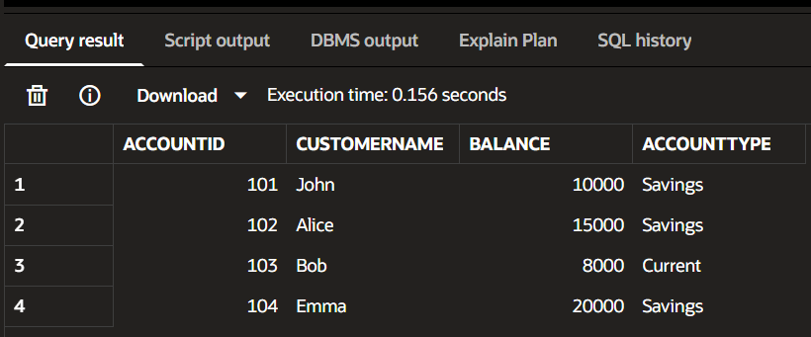

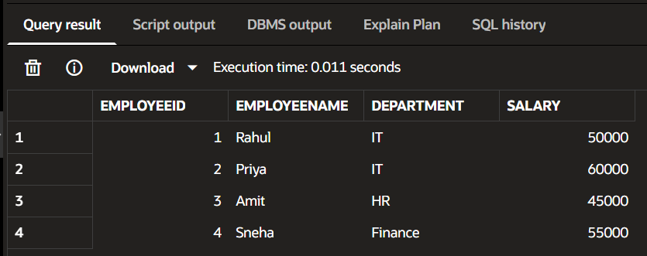

Exercise 3: Stored Procedures
Scenario 1: The bank needs to process monthly interest for all savings accounts.
  - Question: Write a stored procedure ProcessMonthlyInterest that calculates and updates the balance of all savings accounts by applying an interest rate of 1% to the current balance.
PROCEDURE:

CREATE OR REPLACE PROCEDURE ProcessMonthlyInterest
IS
BEGIN
UPDATE Accounts
SET Balance = Balance + (Balance * 0.01)
WHERE AccountType = 'Savings';
COMMIT;
END;
/

EXECUTE PROCEDURE:
BEGIN
ProcessMonthlyInterest;
END;
/

VERIFICATION:
SELECT * FROM Accounts;

OUTPUT:

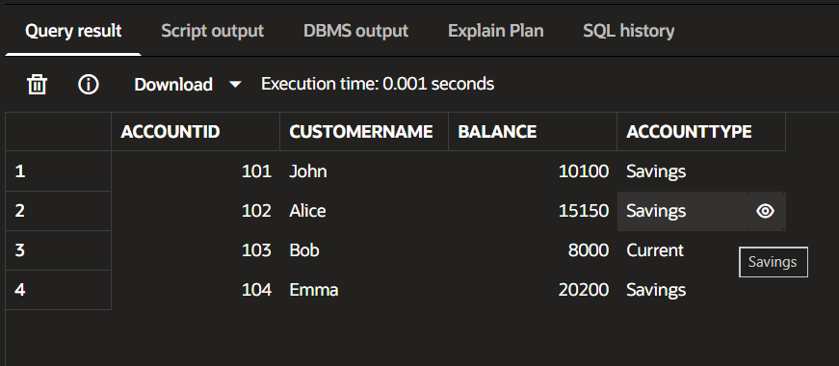

Scenario 2: The bank wants to implement a bonus scheme for employees based on their performance.
- Question: Write a stored procedure UpdateEmployeeBonus that updates the salary of employees in a given department by adding a bonus percentage passed as a parameter.

PROCEDURE:
CREATE OR REPLACE PROCEDURE UpdateEmployeeBonus
(
p_department IN VARCHAR2,
p_bonus_percent IN NUMBER
)
IS
BEGIN
UPDATE Employees
SET Salary = Salary + (Salary * p_bonus_percent / 100)
WHERE Department = p_department;
COMMIT;
END;
/

EXECUTE PROCEDURE:
BEGIN
UpdateEmployeeBonus('IT', 10);
END;
/

VERIFICATION:
SELECT * FROM Employees;

OUTPUT:
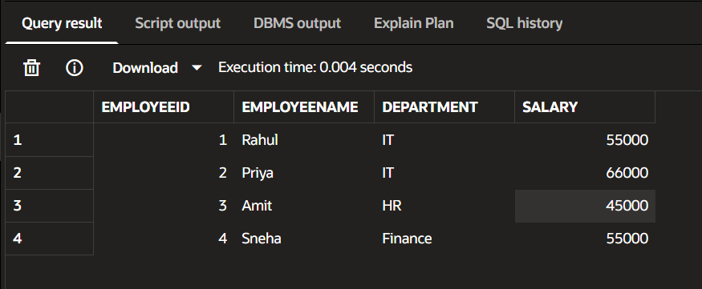

Scenario 3: Customers should be able to transfer funds between their accounts.
- Question: Write a stored procedure TransferFunds that transfers a specified amount from one account to another, checking that the source account has sufficient balance before making the transfer.

PROCEDURE:
CREATE OR REPLACE PROCEDURE TransferFunds
(
p_from_account IN NUMBER,
p_to_account IN NUMBER,
p_amount IN NUMBER
)
IS
v_balance NUMBER;
BEGIN
SELECT Balance
INTO v_balance
FROM Accounts
WHERE AccountID = p_from_account;
IF v_balance >= p_amount THEN
UPDATE Accounts
SET Balance = Balance - p_amount
WHERE AccountID = p_from_account;
UPDATE Accounts
SET Balance = Balance + p_amount
WHERE AccountID = p_to_account;
COMMIT;
DBMS_OUTPUT.PUT_LINE('Transfer Successful');
ELSE
DBMS_OUTPUT.PUT_LINE('Insufficient Balance');
END IF;
END;
/

EXECUTE PROCEDURE:
BEGIN
TransferFunds(101, 102, 2000);
END;
/

VERIFICATION:
SELECT * FROM Accounts;

OUTPUT: 