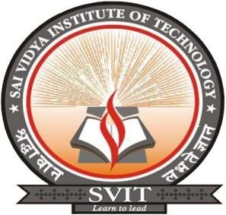
VISVESVARAYA TECHNOLOGICAL UNIVERSITY

“JNANA SANGAMA” ,BELAGAVI-590018

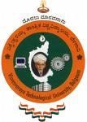

A Mini Project Report On

S “ONLINE EXAMINATION SYSTEM”

Submitted in the partial fulfillment of the requirement for the award of degree of

BACHELOR OF ENGINEERING
IN
COMPUTER SCIENCE AND ENGINEERING

Submitted By

RAKESH M R B G VINAYAK HARSHITA T
1VA17CS040 1VA17CS010 1VA17CS015

Under the Guidance of

Prof. Sunil G L Prof. Deeksha Hegde B Prof. Nagamahesh B S
Assistant Professor, Assistant Professor, Assistant Professor,
Dept., of IS&E Dept., of CS&E Dept., of CS&E

DEPARTMENT OF COMPUTER SCIENCE AND ENGINEERING

SAI VIDYA INSTITUTE OF TECHNOLOGY
(Affiliated to Visvesvaraya Technological University, Belagavi | Recognized by Govt. of Karnataka |Approved
by AICTE, New Delhi)

RAJANUKUNTE, BENGALURU – 560 064
2018-19
S


SAI VIDYA INSTITUTE OF TECHNOLOGY

(
Affiliated to Visvesvaraya Technological University, Belagavi | Recognized by Govt.

o
f Karnataka | Approved
by AICTE, New Delhi)

Rajanukunte, Bengaluru
-

560 064

DEPARTMENT OF COMPUTER SCIENCE AND ENGINEERING

CERTIFICATE

Project
Mini
that
Certified
the
work
entitled
“
ONLINE EEXAMINATION
SYSTEM
”

carried out by
Mr.
RAKESH M R (1VA17CS040) Mr. B G VINAYAK (1VA17CS040)

HARSHITHA T (1VA17CS016) ,

bonafide students of
SAI VIDYA INSTITUTE OF
TECHNOLOGY
, Bengaluru, in partial fulfillment for the award of Bachelor of Engineering in
Computer Science & Engineering of
VISVESVARAYA TECHNOLOGICAL

UN
I
VERSITY
,
Belagavi during the year
2019
-
20
.
It is certified that all corrections/suggestions indicated for
Internal Assessment have been incorporated in the report deposited in the departmental library.
The mini project report has been approved as it satisfies
the academic requirements in respect of
mini project work prescribed for the said Degree.

Name of External Examiners

Signature
with

Date

1.

___________________________

__________________________

2.

___________________________

_____________
__
_
__________

Prof. Sunil G L

Assistant Professor,

Dept., of IS&
E

Prof
.
Deeksha Hegde

B

Assistant Professor,

Dept., of CS&E

Prof. K Ananthapadmanabha

Professor & Head,

Dept., of CS&E

Dr. H S Ramesh Babu

Principal

