Like other advertising media, online advertising frequently involves the following entities

* A publisher, who integrates advertisements into its online content.
* An advertiser, who provides the advertisements to be displayed on the publisher’s content.
* Advertising agencies that help execute the online ad campaigns for advertisers by placing them on websites through their publisher channels.

The 'ad_campaign' database has the AGENCY, CAMPAIGN & PUBLISHER tables to represent the above. AD_IMPRESSION_DATA contains information about how the ad campaigns are doing on a daily basis - how many online advertisements were served, to which websites and through which publisher. Logins are provided to agencies to view reports on their campaigns, and this information is stored in the USER table. The following ER diagram represents this relationship:

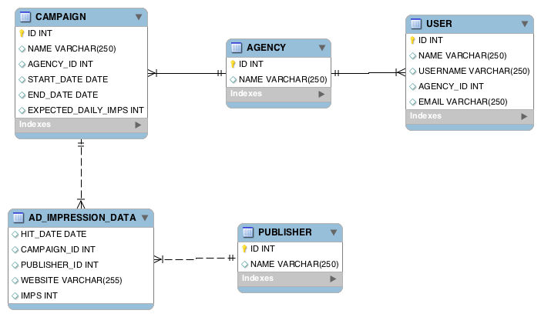

Derive answers for the following questions, using not more than one SQL statement per question. You can use the Sequel Pro client installed on this computer to try out your SQL statements. Provide your answers below each question.

1. List agencies for whom user logins have not been created
2. List the top 5 campaigns by volume, along with campaign name for the month of July
3. List publishers who have served ads to more than 115 sites in the month of June
4. List campaigns that have ads being served beyond their end dates
5. List all the sites that were served ads between '2013-04-01' and '2013-04-30'
6. Which agency is running the least number of ad campaigns
7. Which users should get the reports emailed for campaign 572?
8. What is wrong with the following SQL statement?

SELECT HIT_DATE, CAMPAIGN_ID, SUM(IMPS)

FROM AD_IMPRESSION_DATA

WHERE HIT_DATE>='2013-03-01' and HIT_DATE<='2013-03-30'

GROUP BY CAMPAIGN_ID;