**Let's Get Started, Coder!!**

**Fill the following Document**

**__________________________________________________________________________**

1. Which one of the following is an Imperative Language?

1. HTML
2. CSS
3. Java Script

Answer: The Imperative Language Is Java Script.

2. Which one of the following is a Declarative Language?

1. HTML
2. CSS
3. Java Script

Answer: HTML is a declarative language.

3. Name two uses of a DIV tag?

Answer:

DIV tag is known as Division tag

The two uses of DIV tag are as follows: -

1. defines a division or a section in HTML

2. Group of various tags of HTML

3. Make divisions of content in the web page

4. What is the difference between relative positioning and absolute positioning in HTML?

Answer: In relative positioning the element is positioned relative to its normal position.

In absolute positioning the element is positioned absolutely to its first positioned

5. What is the use of opacity in CSS?

Answer: The opacity CSS property sets the opacity of an element and controls the level of transparency of the body.

6. Which is the programming language used in the React Native Framework?

Answer: We use two languages in React Native Framework are JAVA SCRIPT and HTML together known as JSX.

7. Which online editor are we using for creating our apps in React Native Framework?

Answer: snack expo

8. Write the steps to test your first designed app in the online editor on mobile.

Answer: If we have to test online editor on mobile the steps to be followed are-

* Download the application expo Go in mobile.
* Scan the code which is available of top right corner of the online editor named my device on left of web.

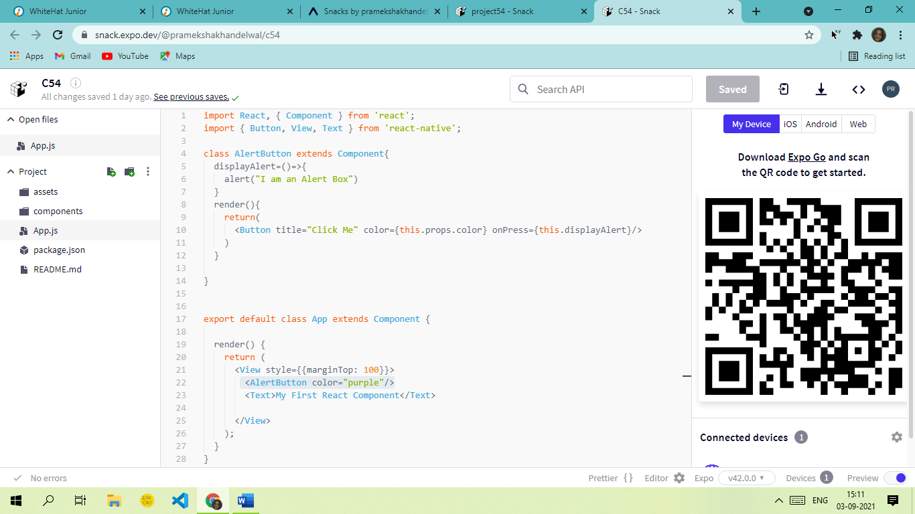

* **Alternate Method-** We can also see the view of mobile in online editor itself. We can go on the portion of android to see the same.

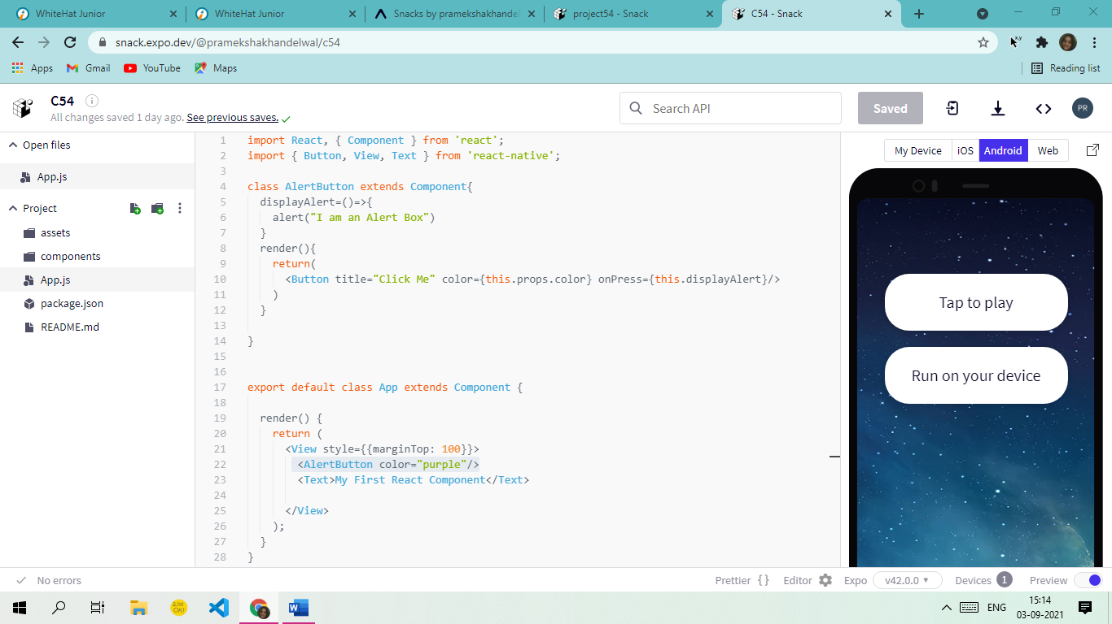

9. What is the use of the render function in React Native Framework?

Answer: Render function displays whatever components are returned by it.

10. What is the use of the return function in the React Native Framework?

Answer: Return is written when we want to display.

11. What are the various components in your first app that you designed?

Answer: The components used in first app are Button, Text and View.