**PEMROGRAMAN BERORIENTASI OBJEK**

**(Tugas 4)**



**Disusun Oleh:**

Prames Ray Lapian – 140810210059

**PROGRAM STUDI S-1 TEKNIK INFORMATIKA**

**FAKULTAS MATEMATIKA DAN ILMU PENGETAHUAN ALAM**

**UNIVERSITAS PADJADJARAN**

**JATINANGOR**

**2022**

1. Tugas4_1:

*/\**

*Program : Tugas 1*

*Nama    : Prames Ray Lapian*

*NPM     : 140810210059*

*Kelas   : A*

*Tanggal : 24 September  2022*

*Desc    : pertemuan 4*

*\*/*

import java.util.Scanner;

*/\*\**

*\**

*\* @author prame*

*\*/*

class Penilaian{

    Scanner scan = *new* Scanner(System.in);

*//Variable*

*private* String nama, npm;

*private* int num1, num2, num3;

*//Constructor #1*

*public* Penilaian(){

        this.num1 = 0;

        this.num2 = 0;

        this.num3 = 0;

        this.nama = "";

        this.npm = "";

    }

*//Constructor #2*

*public* Penilaian(String *nama*, String *npm*){

        this.nama = *nama*;

        this.npm = *npm*;

    }

*//Setter Nama*

*public* void setNama(String *nama*){

        this.nama = *nama*;

    }

*//Setter NPM*

*public* void setNPM(String *npm*){

        this.npm = *npm*;

    }

*//Setter Angka*

*public* void setAngka(int *num1*, int *num2*, int *num3*){

        this.num1 = *num1*;

        this.num2 = *num2*;

        this.num3 = *num3*;

    }

*//Getter Nama*

*public* String getNama(){

*return* this.nama;

    }

*//Getter NPM*

*public* String getNPM(){

*return* this.npm;

    }

*//Getter num1*

*public* int getNum1(){

*return* this.num1;

    }

*//Getter num2*

*public* int getNum2(){

*return* this.num2;

    }

*//Getter num3*

*public* int getNum3(){

*return* this.num3;

    }

*//Method Input*

*public* void inputAll(){

        System.out.print("Nama\t\t: ");

        this.nama = scan.nextLine();

        System.out.print("NPM\t\t: ");

        this.npm = scan.nextLine();

        System.out.print("Nilai ke-1\t: ");

        this.num1 = scan.nextInt();

        System.out.print("Nilai ke-2\t: ");

        this.num2 = scan.nextInt();

        System.out.print("Nilai ke-3\t: ");

        this.num3 = scan.nextInt();

    }

*//Method Operasi*

*public* float cariRata(int *num1*, int *num2*, int *num3*){

        float hasil = ((this.num1+this.num2+this.num3)/3);

*return* hasil;

    }

*//Method Pencari Nilai Mutu*

*public* String nilaiMutu(float *hasil*){

        String mutu = "";

*if* (100>=*hasil* && *hasil*>=80){

            mutu = "A";

        } *else* *if* (80>*hasil* && *hasil*>=68){

            mutu = "B";

        } *else* *if* (68>*hasil* && *hasil*>=55){

            mutu = "C";

        } *else* *if* (55>*hasil* && *hasil*>=45){

            mutu = "D";

        } *else* *if* (45>*hasil* && *hasil*>=0){

            mutu = "E";

        }

*return* mutu;

    }

*//Method Penentu Status Kelulusan*

*public* String kelulusan(float *hasil*){

        String lulus = "";

*if* (100>=*hasil* && *hasil*>=55){

            lulus = "Selamat Anda Dinyatakan Lulus";

        } *else* *if* (55>*hasil* && *hasil*>=0){

            lulus = "Maaf Anda Dinyatakan Gagal";

        }

*return* lulus;

    }

*//Method Print Identyty*

*public* void printId(String *nama*, String *npm*){

        System.out.println("Nama\t\t: " + *nama*);

        System.out.println("NPM\t\t: " + *npm*);

    }

*//Method Print Hasil*

*public* void  printNilai(String *mutu*, String *lulus*){

        System.out.println("Nilai Mutu\t: " + *mutu* + " (" + *lulus* + ")");

    }

}

*//---------------------------------------------------------------------------------------*

*public* class Tugas21 {

*public* *static* void main(String *args*[]){

        Scanner scan = *new* Scanner(System.in);

        Penilaian angkaUser = *new* Penilaian(); *//Test Constructor #1*

        Penilaian angkaSystem = *new* Penilaian("Prames Ray Lapian", "140810210059"); *//Test Constructor #2*

*//System Input : Angka di input langsung didalam codingan*

        System.out.println("[System Input]");

        angkaSystem.setAngka(85, 70, 90);

        float rataangkaSystem = angkaSystem.cariRata(angkaSystem.getNum1(), angkaSystem.getNum2(), angkaSystem.getNum3()); *//Variable ini dipakai untuk mempermudah pemanggilan variable hasil pada fungsi nilaiMutu dan kelulusan*

        angkaSystem.printId(angkaSystem.getNama(), angkaSystem.getNPM());

        angkaSystem.printNilai(angkaSystem.nilaiMutu(rataangkaSystem), angkaSystem.kelulusan(rataangkaSystem));

        System.out.println();

*//User Input : Angka di input manual oleh User*

        System.out.println("[User Input]");

        angkaUser.inputAll();

        float rataangkaUser = angkaUser.cariRata(angkaUser.getNum1(), angkaUser.getNum2(), angkaUser.getNum3()); *//Variable ini dipakai untuk mempermudah pemanggilan variable hasil pada fungsi nilaiMutu dan kelulusan*

        angkaUser.printNilai(angkaUser.nilaiMutu(rataangkaUser), angkaUser.kelulusan(rataangkaUser));

        scan.close();

    }

}

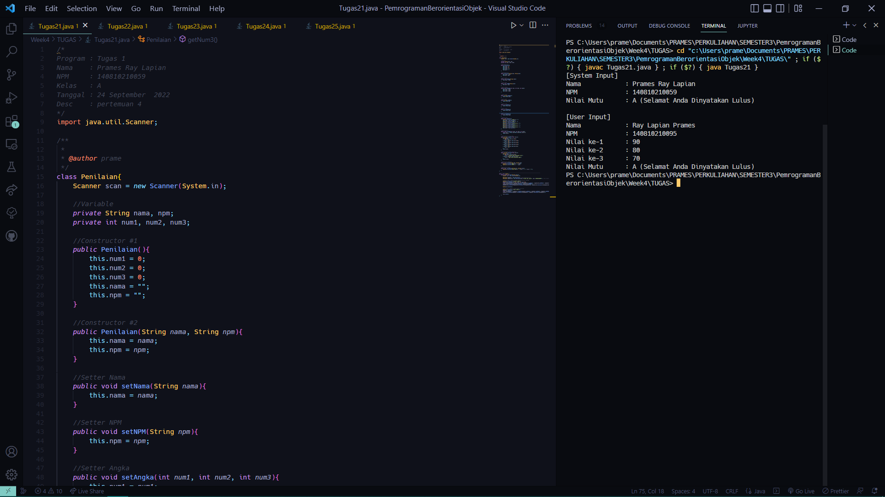

1. Tugas4_2:

*/\**

*Program : Tugas 2*

*Nama    : Prames Ray Lapian*

*NPM     : 140810210059*

*Kelas   : A*

*Tanggal : 24 September  2022*

*Desc    : pertemuan 4*

*\*/*

import java.util.Scanner;

*/\*\**

*\**

*\* @author prame*

*\*/*

class convert{

    Scanner sc = *new* Scanner(System.in);

*//Variable*

*private* int num;

*//Constructor #1*

*public* convert(){

        this.num = 0;

    }

*//Constructor 2*

*public* convert(int *num*){

        this.num = *num*;

    }

*//Setter Angka*

*public* void setAngka(int *num*){

        this.num = *num*;

    }

*//Getter Angka*

*public* int getAngka(){

*return* this.num;

    }

*//Input*

*public* void inputAngka(){

        System.out.print("Masukkan bilangan 1-10 : ");

        this.num = sc.nextInt();

    }

*//IfCase Proses*

*public* void ifCase(int *num*){

        String str = "";

        System.out.print("Menggunakan If\t\t: ");

*if*(*num* == 1)

            str = "Satu";

*else* *if*(*num* == 2)

            str = "Dua";

*else* *if*(*num* == 3)

            str = "Tiga";

*else* *if*(*num* == 4)

            str = "Empat";

*else* *if*(*num* == 5)

            str = "Lima";

*else* *if*(*num* == 6)

            str = "Enam";

*else* *if*(*num* == 7)

            str = "Tujuh";

*else* *if*(*num* == 8)

            str = "Delapan";

*else* *if*(*num* == 9)

            str = "Sembilan";

*else* *if*(*num* == 10)

            str = "Sepuluh";

*else*

            str = "Invalid Number";

        System.out.println(*num* + " dibaca '" + str + "'");

    }

*//SwitchCase Proses*

*public* void switchCase(int *num*){

        String str = "";

        System.out.print("Menggunakan Switch\t: ");

*switch*(*num*) {

*case* 1*:*

                str = "Satu";

*break*;

*case* 2*:*

                str = "Dua";

*break*;

*case* 3*:*

                str = "Tiga";

*break*;

*case* 4*:*

                str = "Empat";

*break*;

*case* 5*:*

                str = "Lima";

*break*;

*case* 6*:*

                str = "Enam";

*break*;

*case* 7*:*

                str = "Tujuh";

*break*;

*case* 8*:*

                str = "Delapan";

*break*;

*case* 9*:*

                str = "Sembilan";

*break*;

*case* 10*:*

                str = "Sepuluh";

*break*;

*default:*

                str = "Invalid Number";

*break*;

        }

        System.out.println(*num* + " dibaca '" + str + "'");

    }

}

*//---------------------------------------------------------------------------------------*

*public* class Tugas22 {

*public* *static* void main(String[] *args*) {

        Scanner sc= *new* Scanner(System.in);

        convert angkaUser = *new* convert(); *//Test Constructor #1*

        convert angkaSystem = *new* convert(5); *//Test Constructor #2*

*//System Input : Angka di input langsung didalam codingan*

        System.out.println("[Input Sistem]");

        angkaSystem.ifCase(angkaSystem.getAngka());

        angkaSystem.switchCase(angkaSystem.getAngka());

        System.out.println();

*//User Input : Angka di input manual oleh User*

        System.out.println("\n[Input Manual]");

        angkaUser.inputAngka();

        angkaUser.ifCase(angkaUser.getAngka());

        angkaUser.switchCase(angkaUser.getAngka());

        sc.close();

    }

}

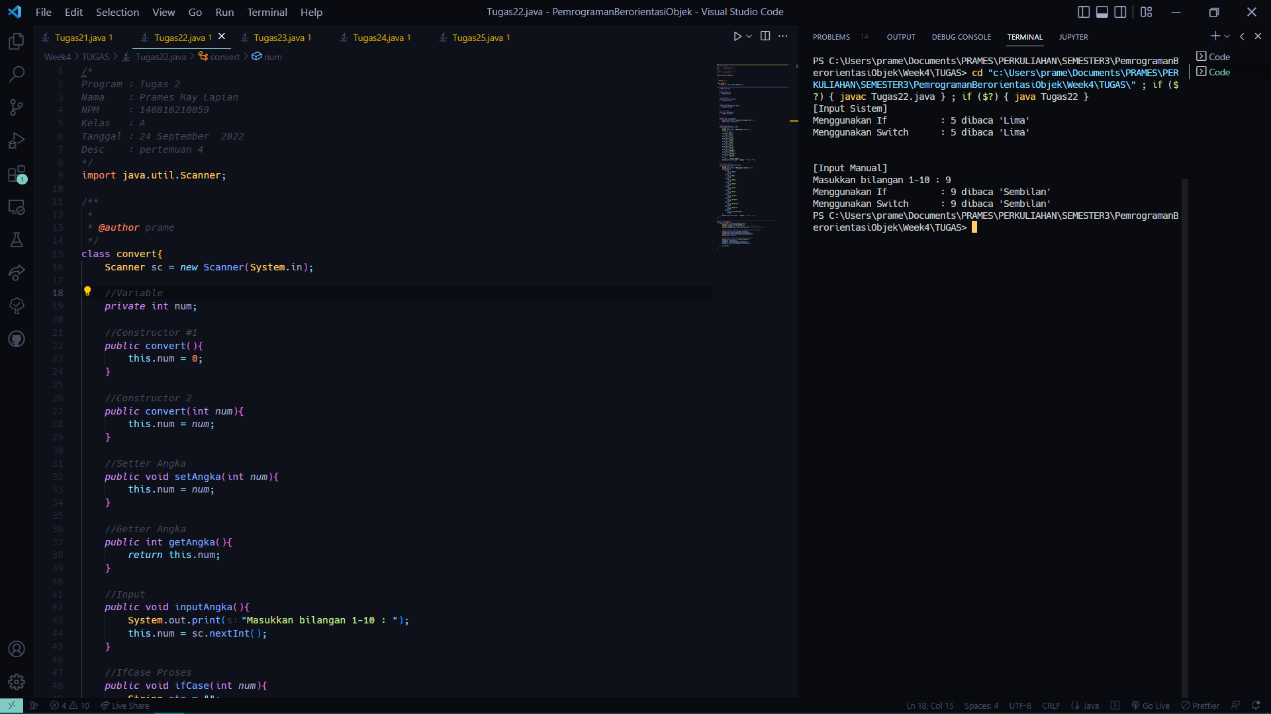

1. Tugas4_3:

*/\**

*Program : Tugas 3*

*Nama    : Prames Ray Lapian*

*NPM     : 140810210059*

*Kelas   : A*

*Tanggal : 24 September  2022*

*Desc    : pertemuan 4*

*\*/*

import java.util.Scanner;

*/\*\**

*\**

*\* @author prame*

*\*/*

class WorkerInfo{

    Scanner sc = *new* Scanner(System.in);

*//Variable*

*private* String nama;

*private* int gol;

*//Constructor #1*

*public* WorkerInfo(){

        this.nama = "";

        this.gol = 0;

    }

*//Constructor #2*

*public* WorkerInfo(String *nama*, int *gol*){

        this.nama = *nama*;

        this.gol = *gol*;

    }

*//Setter Nama*

*public* void setNama(String *nama*){

        this.nama = *nama*;

    }

*//Setter Golongan*

*public* void setGol(int *gol*){

        this.gol = *gol*;

    }

*//Getter Nama*

*public* String getNama(){

*return* this.nama;

    }

*//Getter Golongan*

*public* int getGol(){

*return* this.gol;

    }

*//Method Input*

*public* void input(){

        System.out.print("Nama\t\t: ");

        this.nama = sc.nextLine();

        System.out.print("Golongan\t: ");

        this.gol = sc.nextInt();

    }

*//Method Pencari Gaji Pokok*

*public* long gajiPokok(int *gol*){

        long gapok = 0;

*switch* (*gol*){

*case* 1*:*

                gapok = 1500000;

*break*;

*case* 2*:*

                gapok = 2000000;

*break*;

*case* 3*:*

                gapok = 3000000;

*break*;

*case* 4*:*

                gapok = 5000000;

*break*;

        }

*return* gapok;

    }

*//Method Pencari Tunjangan*

*public* float golTunjangan(int *gol*){

        float tunjangan = 0;

*switch* (*gol*){

*case* 1*:*

                tunjangan = 0.1f;

*break*;

*case* 2*:*

                tunjangan = 0.12f;

*break*;

*case* 3*:*

                tunjangan = 0.12f;

*break*;

*case* 4*:*

                tunjangan = 0.14f;

*break*;

        }

*return* tunjangan;

    }

*//Method Pencari Potongan*

*public* float golPotongan(int *gol*){

        float potongan = 0;

*switch* (*gol*){

*case* 1*:*

                potongan = 0.01f;

*break*;

*case* 2*:*

                potongan = 0.02f;

*break*;

*case* 3*:*

                potongan = 0.02f;

*break*;

*case* 4*:*

                potongan = 0.04f;

*break*;

        }

*return* potongan;

    }

*//Method Pencari Gaji Total*

*public* long gajiTotal(long *gp*, float *tj*, float *pt*){

*return* ((long)((*gp*)+(*tj*\**gp*)-(*pt*\**gp*)));

    }

*//Print Identyty*

*public* void printId(String *nama*, int *gol*){

        System.out.println("Nama\t\t: " + *nama*);

        System.out.println("Golongan\t: " + *gol*);

    }

*//Print Gaji and the detail*

*public* void printGaji(long *a*, float *b*, float *c*){

        System.out.println("Gaji Pokok\t: " + *a*);

        System.out.println("Tunjangan\t: " + (*b*\*100) + "%");

        System.out.println("Potongan\t: " + (*c*\*100) + "%");

    }

*//Print Gaji Total*

*public* void printgajiTotal(long *a*){

        System.out.println("Gaji Total\t: " + *a*);

    }

}

*//---------------------------------------------------------------------------------------*

*public* class Tugas23 {

*public* *static* void main(String[] *args*) {

        Scanner sc = *new* Scanner(System.in);

        WorkerInfo inputUser = *new* WorkerInfo(); *//Test Constructor #1*

        WorkerInfo inputSystem = *new* WorkerInfo("Prames Ray Lapian", 3); *//Test Constructor #2*

*//System Input : Angka di input langsung didalam codingan*

        System.out.println("[Input System]");

        long gapok1 = inputSystem.gajiPokok(inputSystem.getGol());

        float tunjanganSystem = inputSystem.golTunjangan(inputSystem.getGol()); *//Variable ini dipakai untuk mempermudah pemanggilan fungsi printGaji dan printGajiTotal*

        float potongan1 = inputSystem.golPotongan(inputSystem.getGol()); *//Variable ini dipakai untuk mempermudah pemanggilan fungsi printGaji dan printGajiTotal*

        inputSystem.printId(inputSystem.getNama(), inputSystem.getGol());

        inputSystem.printGaji(gapok1, tunjanganSystem, potongan1);

        inputSystem.printgajiTotal(inputSystem.gajiTotal(gapok1, tunjanganSystem, potongan1));

*//User Input : Angka di input manual oleh User*

        System.out.println("\n[Input User]");

        inputUser.input();

        long gapok2 = inputUser.gajiPokok(inputUser.getGol());

        float tunjanganUser = inputUser.golTunjangan(inputUser.getGol()); *//Variable ini dipakai untuk mempermudah pemanggilan fungsi printGaji dan printGajiTotal*

        float potongan2 = inputUser.golPotongan(inputUser.getGol()); *//Variable ini dipakai untuk mempermudah pemanggilan fungsi printGaji dan printGajiTotal*

        inputUser.printGaji(gapok2, tunjanganUser, potongan2);

        inputUser.printgajiTotal(inputUser.gajiTotal(gapok2, tunjanganUser, potongan2));

        sc.close();

    }

}

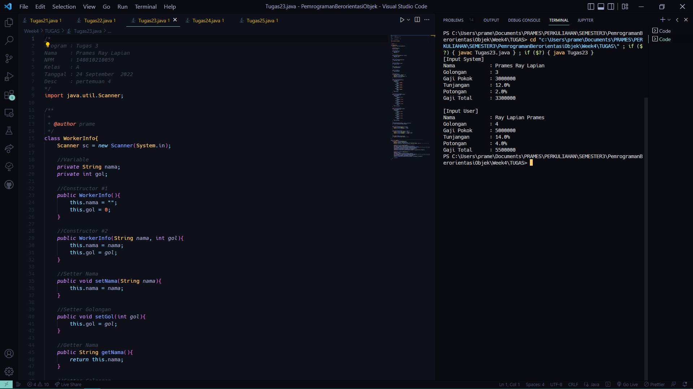

1. Tugas4_4:

*/\**

*Program : Tugas 4*

*Nama    : Prames Ray Lapian*

*NPM     : 140810210059*

*Kelas   : A*

*Tanggal : 24 September  2022*

*Desc    : pertemuan 4*

*\*/*

import java.util.Scanner;

*/\*\**

*\**

*\* @author prame*

*\*/*

class Asterisk {

    Scanner sc = *new* Scanner(System.in);

*//Variable*

*private* int angka;

*//Constructor #1*

*public* Asterisk(){

        this.angka = 0;

    }

*//Constructor #2*

*public* Asterisk(int *angka*){

        this.angka = *angka*;

    }

*//Setter Angka*

*public* void setAngka(int *angka*){

        this.angka = *angka*;

    }

*//Getter Angka*

*public* int getAngka(){

*return* this.angka;

    }

*//Method Input*

*public* void inputAngka(){

        sc = *new* Scanner(System.in);

        System.out.print("Masukkan Angka : ");

        this.angka = sc.nextInt();

    }

*//Method Pencari Hasil dengan For*

*public* void cariHasilDenganFor(){

*for*(int i = this.angka; i >= 1; i--){

            System.out.print((this.angka - i + 1) + ".");

*for*(int j = i; j >= 1; j--){

                System.out.print(" *");

            }

            System.out.println();

        }

    }

*//Method Pencari Hasil dengan While*

*public* void cariHasilDenganWhile(){

        int i = 1, j;

*while*(i <= this.angka){

            System.out.print(i + ".");

            j = 1;

*while*(j <= i){

                System.out.print(" *");

                j++;

            }

            i++;

            System.out.println();

        }

    }

*//Method Print*

*public* void printHasil(){

        System.out.println("---For Loop---");

        cariHasilDenganFor();

        System.out.println("---While Loop---");

        cariHasilDenganWhile();

    }

}

*//---------------------------------------------------------------------------------------*

*public* class Tugas24 {

*public* *static* void main(String[] *args*) {

        Scanner sc = *new* Scanner(System.in);

        Asterisk angkaUser = *new* Asterisk(); *//Tes Constructor#1*

        Asterisk angkaSystem = *new* Asterisk(5); *//Tes Constructor#2*

*//System Input : Angka di input langsung didalam codingan*

        System.out.println("[System Input]");

        angkaSystem.printHasil();

        System.out.println();

*//User Input : Angka di input manual oleh User*

        System.out.println("[User Input]");

        angkaUser.inputAngka();

        angkaUser.printHasil();

        sc.close();

    }

}

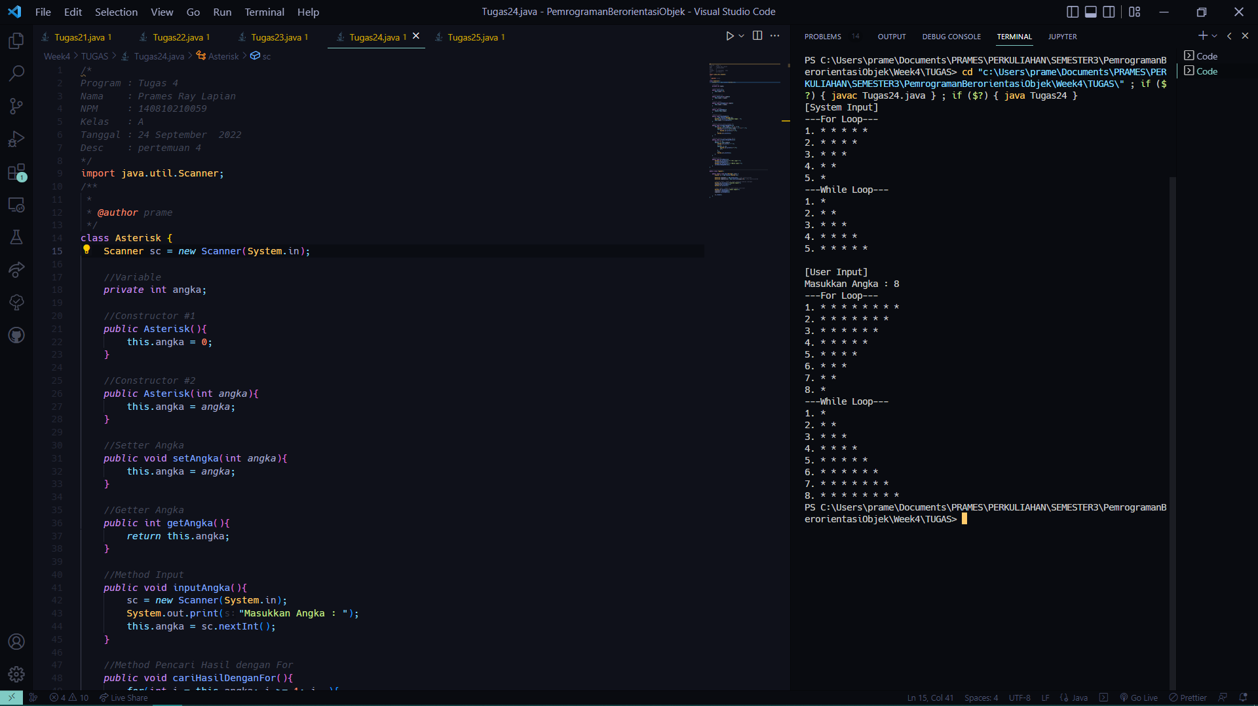

1. Tugas4_5:

*/\**

*Program : Tugas 5*

*Nama    : Prames Ray Lapian*

*NPM     : 140810210059*

*Kelas   : A*

*Tanggal : 24 September  2022*

*Desc    : pertemuan 4*

*\*/*

import java.util.Scanner;

*/\*\**

*\**

*\* @author prame*

*\*/*

class Perpangkatan{

    Scanner sc = *new* Scanner(System.in);

*//Variable*

*private* int angka, pangkat;

*//Constructor #1*

*public* Perpangkatan(){

        this.angka = 0;

        this.pangkat = 0;

    }

*//Constructor #2*

*public* Perpangkatan(int *angka*, int *pangkat*){

        this.angka = *angka*;

        this.pangkat = *pangkat*;

    }

*//Setter All Atribute*

*public* void setBilangan(int *angka*, int *pangkat*){

        this.angka = *angka*;

        this.pangkat = *pangkat*;

    }

*//Setter Angka*

*public* void setAngka(int *angka*){

        this.angka = *angka*;

    }

*//Setter Pangkat*

*public* void setPangkat(int *pangkat*){

        this.pangkat = *pangkat*;

    }

*//Getter Angka*

*public* int getAngka(){

*return* this.angka;

    }

*//Getter Pangkat*

*public* int getpangkat(){

*return* this.pangkat;

    }

*//Method Input*

*public* void inputBilangan(){

        sc = *new* Scanner(System.in);

        System.out.print("Masukkan Angka\t\t\t: ");

        this.angka = sc.nextInt();

        System.out.print("Masukkan Pangkat\t\t: ");

        this.pangkat = sc.nextInt();

    }

*//Method Pencari Hasil dengan While*

*public* int cariHasilDenganWhile(){

        int i = 1, hasil = this.angka;

*while*(i < this.pangkat){

            hasil *= this.angka;

            i++;

        }

*return* hasil;

    }

*//Method Pencari Hasil dengan Do-While*

*public* int cariHasilDenganDoWhile(){

        int i = 1, hasil = this.angka;

*do*{

*if*(this.pangkat == 1){

                hasil = this.angka;

                i++;

            } *else* {

                hasil *= this.angka;

                i++;

            }

        } *while*(i < this.pangkat);

*return* hasil;

    }

*//Method Pencari Hasil dengan For*

*public* int cariHasilDenganFor(){

        int i = 1, hasil = this.angka;

*for*(i = 1; i < this.pangkat; i++){

            hasil *= this.angka;

        }

*return* hasil;

    }

*//Method Print*

*public* void printHasil(){

        System.out.println("Hasil dengan While Loop\t\t: " + cariHasilDenganWhile());

        System.out.println("Hasil dengan Do-While Loop\t: " + cariHasilDenganDoWhile());

        System.out.println("Hasil dengan For Loop\t\t: " + cariHasilDenganFor());

    }

}

*//---------------------------------------------------------------------------------------*

*public* class Tugas25 {

*public* *static* void main(String[] *args*) {

        Scanner sc = *new* Scanner(System.in);

        Perpangkatan bilanganUser = *new* Perpangkatan(); *//Tes Constructor#1*

        Perpangkatan bilanganSystem = *new* Perpangkatan(2, 4); *//Tes Constructor#2*

*//System Input : Angka dan Pangkat di input langsung didalam codingan*

        System.out.println("---System Input---");

        bilanganSystem.printHasil();

        System.out.println();

*//User Input : Angka dan Pangkat di input manual oleh User*

        System.out.println("---User Input---");

        bilanganUser.inputBilangan();

        bilanganUser.printHasil();

        sc.close();

    }

}

