**PEMROGRAMAN BERBASIS OBJEK**

**(Tugas 5)**



**Disusun Oleh:**

Prames Ray Lapian - 140810210059

**PROGRAM STUDI S-1 TEKNIK INFORMATIKA**

**FAKULTAS MATEMATIKA DAN ILMU PENGETAHUAN ALAM**

**UNIVERSITAS PADJADJARAN**

**JATINANGOR**

**2022**

1. Soal 1:

*/\**

*Program : Tugas 1*

*Nama    : Prames Ray Lapian*

*NPM     : 140810210059*

*Kelas   : A*

*Tanggal : 5 Oktobrer  2022*

*Desc    : Tugas Pertemuan 5*

*\*/*

import java.util.Scanner;

*/\*\**

*\**

*\* @author prame*

*\*/*

class Identity {

  Scanner sc = *new* Scanner(System.in);

*//Variable*

  private String nama, npm, waktuMulai, waktuSelesai;

  private int nilai;

*//Constructor #1*

  public Identity(){

      this.nilai = 0;

      this.nama = "";

      this.npm = "";

      this.waktuMulai = "";

      this.waktuSelesai = "";

  }

*//Constructor #2*

  public Identity(String *nama*, String *npm*){

      this.nama = nama;

      this.npm = npm;

  }

*//Setter Nama*

  public void setNama(String *nama*){

      this.nama = nama;

  }

*//Setter NPM*

  public void setNPM(String *npm*){

      this.npm = npm;

  }

*//Setter Angka*

  public void setAngka(int *nilai*){

      this.nilai = nilai;

  }

*//Setter Waktu*

  public void setWaktu(String *waktuMulai*, String *waktuSelesai*){

    this.waktuMulai = waktuMulai;

    this.waktuSelesai = waktuSelesai;

  }

*//Getter Nama*

  public String getNama(){

*return* this.nama;

  }

*//Getter NPM*

  public String getNPM(){

*return* this.npm;

  }

*//Getter Nilai*

  public int getNilai(){

*return* this.nilai;

  }

*//Getter Waktu Mulai*

  public String getWaktuMulai(){

*return* this.waktuMulai;

  }

*//Getter Waktu Selesai*

  public String getWaktuSelesai(){

*return* this.waktuSelesai;

  }

*//Method Input*

  public void inputData(){

      System.out.print("Nama\t\t: ");

      this.nama = sc.nextLine();

      System.out.print("NPM\t\t: ");

      this.npm = sc.nextLine();

      System.out.print("Waktu Mulai\t: ");

      this.waktuMulai = sc.nextLine();

      System.out.print("Waktu Selesai\t: ");

      this.waktuSelesai = sc.nextLine();

      System.out.print("Nilai\t\t: ");

      this.nilai = sc.nextInt();

  }

*//Method Pencari + Output Durasi*

  public void durasi(){

    String strArrMulai[]= this.waktuMulai.split(":");

    int jamMulai = Integer.parseInt(strArrMulai[0]) ;

    int menitMulai = Integer.parseInt(strArrMulai[1]) ;

    int detikMulai = Integer.parseInt(strArrMulai[2]) ;

    String strArrSelesai[]= this.waktuSelesai.split(":");

    int jamSelesai = Integer.parseInt(strArrSelesai[0]);

    int menitSelesai = Integer.parseInt(strArrSelesai[1]);

    int detikSelesai = Integer.parseInt(strArrSelesai[2]);

*if* (detikMulai > detikSelesai){

      detikSelesai = detikSelesai + 60;

      menitSelesai--;

    }

*if* (menitMulai > menitSelesai){

      menitSelesai = menitSelesai + 60;

      jamSelesai--;

    }

    int durasiMenit = menitSelesai - menitMulai;

    int durasiDetik = detikSelesai - detikMulai;

    int durasiJam = jamSelesai - jamMulai;

    System.out.println("Durasi\t\t: " + durasiJam + " jam " + durasiMenit + " menit " + durasiDetik + " detik ");

  }

*//Method Pencari Nilai Mutu*

  public String nilaiMutu(){

      String mutu = "";

*if* (100>=this.nilai && this.nilai>=80){

          mutu = "A";

      } *else* *if* (80>this.nilai && this.nilai>=68){

          mutu = "B";

      } *else* *if* (68>this.nilai && this.nilai>=55){

          mutu = "C";

      } *else* *if* (55>this.nilai && this.nilai>=45){

          mutu = "D";

      } *else* *if* (45>this.nilai && this.nilai>=0){

          mutu = "E";

      }

*return* mutu;

  }

*//Method Penentu Status Kelulusan*

  public String kelulusan(){

      String lulus = "";

*if* (100>=this.nilai && this.nilai>=55){

          lulus = "Selamat Anda Dinyatakan Lulus";

      } *else* *if* (55>this.nilai && this.nilai>=0){

          lulus = "Maaf Anda Dinyatakan Gagal";

      }

*return* lulus;

  }

*//Method Print Identyty*

  public void printId(String *nama*, String *npm*){

      System.out.println("Nama\t\t: " + nama);

      System.out.println("NPM\t\t: " + npm);

  }

*//Method Print Hasil*

  public void printNilai(String *mutu*, String *lulus*){

      System.out.println("Nilai Mutu\t: " + mutu + " (" + lulus + ")");

  }

}

*//=======================================================================================================================================*

public class Tugas51 {

  public static void main(String *args*[]){

    Scanner sc = *new* Scanner(System.in);

    Identity angkaSystem = *new* Identity("Prames Ray Lapian", "140810210059"); *//Test Constructor #2*

    Identity angkaUser = *new* Identity(); *//Test Constructor #1*

*//System Input : Angka di input langsung didalam codingan*

    System.out.println("[System Input]");

    angkaSystem.setAngka(85);

    angkaSystem.setWaktu("08:00:00", "10:00:00");

    angkaSystem.printId(angkaSystem.getNama(),

                        angkaSystem.getNPM());

    System.out.println("Waktu Mulai\t: " + angkaSystem.getWaktuMulai());

    System.out.println("Waktu Selesai\t: " + angkaSystem.getWaktuSelesai());

    System.out.println("Nilai\t\t: " + angkaSystem.getNilai());

    angkaSystem.printNilai(angkaSystem.nilaiMutu(),

                           angkaSystem.kelulusan());

    angkaSystem.durasi();

    System.out.println();

*//User Input Parent Class: Angka di input manual oleh User melalui fungsi yang ada di Class Parent*

    System.out.println("[User Input]");

    angkaUser.inputData();

    angkaUser.printNilai( angkaUser.nilaiMutu(),

                          angkaUser.kelulusan());

    angkaUser.durasi();

    System.out.println();

    sc.close();

  }

  static String inputString(String *pesan*) {

      Scanner sc = *new* Scanner(System.in);

      System.out.print(pesan);

      String str = sc.nextLine();

*return* (str);

  }

  static int inputInt(String *pesan*) {

      Scanner sc = *new* Scanner(System.in);

      System.out.print(pesan);

      int num = sc.nextInt();

*return* (num);

  }

}

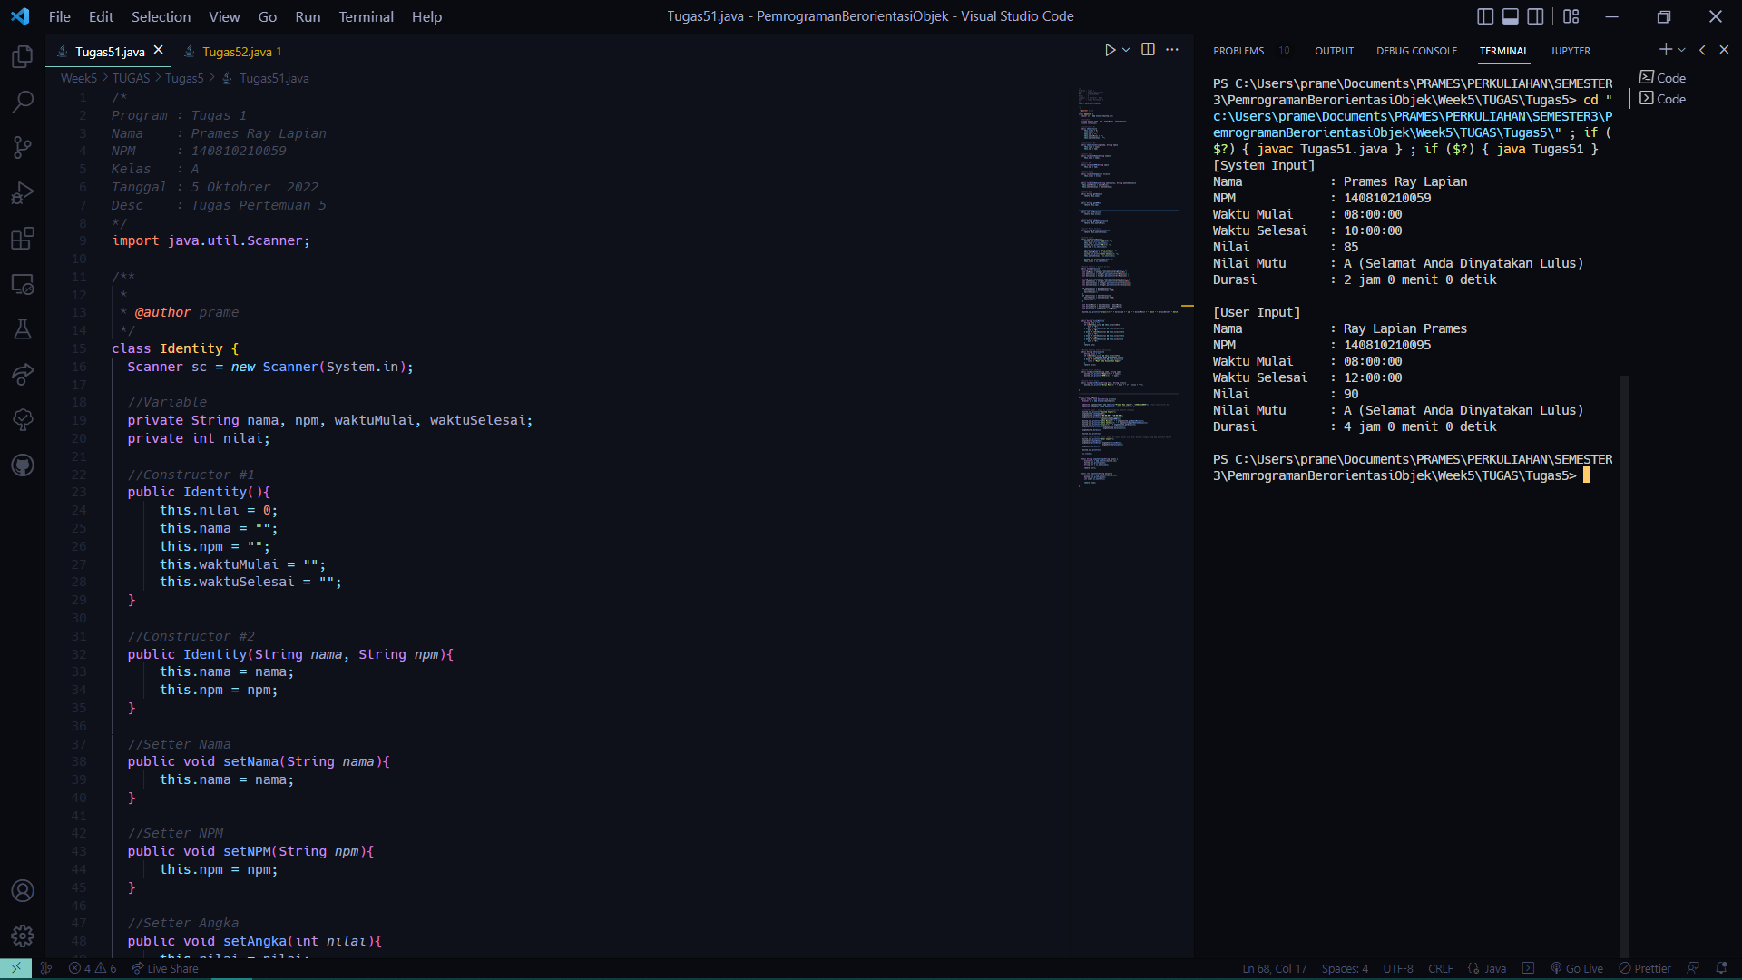

1. Soal 2:

*/\**

*Program : Tugas 2*

*Nama    : Prames Ray Lapian*

*NPM     : 140810210059*

*Kelas   : A*

*Tanggal : 5 Oktober  2022*

*Desc    : pertemuan 5*

*\*/*

import java.util.Scanner;

*/\*\**

*\**

*\* @author prame*

*\*/*

class WorkerInfo{

    Scanner sc = *new* Scanner(System.in);

*//Variable*

*private* String nama;

*private* int gol;

*//Constructor #1*

*public* WorkerInfo(){

        this.nama = "";

        this.gol = 0;

    }

*//Constructor #2*

*public* WorkerInfo(String *nama*, int *gol*){

        this.nama = *nama*;

        this.gol = *gol*;

    }

*//Setter Nama*

*public* void setNama(String *nama*){

        this.nama = *nama*;

    }

*//Setter Golongan*

*public* void setGol(int *gol*){

        this.gol = *gol*;

    }

*//Getter Nama*

*public* String getNama(){

*return* this.nama;

    }

*//Getter Golongan*

*public* int getGol(){

*return* this.gol;

    }

*//Method Input*

*public* void input(){

        System.out.print("Nama\t\t: ");

        this.nama = sc.nextLine();

        System.out.print("Golongan\t: ");

        this.gol = sc.nextInt();

    }

*//Method Pencari Gaji Pokok*

*public* long gajiPokok(int *gol*){

        long gapok = 0;

*switch* (*gol*){

*case* 1*:*

                gapok = 150000;

*break*;

*case* 2*:*

                gapok = 200000;

*break*;

*case* 3*:*

                gapok = 300000;

*break*;

*case* 4*:*

                gapok = 500000;

*break*;

        }

*return* gapok;

    }

*//Method Pencari Gaji Lembur*

*public* long gajiLembur(int *gol*, int *lembur*){

      long biaya = 0;

*switch* (*gol*) {

*case* 1*:*

              biaya = 50000;

*break*;

*case* 2*:*

              biaya = 70000;

*break*;

*case* 3*:*

              biaya = 150000;

*break*;

*case* 4*:*

              biaya = 200000;

*break*;

*default:*

*break*;

      }

*return* (biaya * *lembur*);

    }

*//Method Pencari Gaji Harian*

*public* long gajiHarian(long *gapok*, long *gajiLembur*){

*return* *gapok*+*gajiLembur*;

    }

*//Print Identyty*

*public* void printId(String *nama*, int *gol*){

        System.out.println("Nama\t\t: " + *nama*);

        System.out.println("Golongan\t: " + *gol*);

    }

*//Print Gaji Total*

*public* void printgajiTotal(long *a*){

        System.out.println("Gaji Total\t: " + *a*);

    }

}

*//---------------------------------------------------------------------------------------*

class Waktu {

  Scanner sc = *new* Scanner(System.in);

*private* String waktuDatang, waktuPulang;

*//Constructor Waktu #1*

*public* Waktu(){

    this.waktuDatang = "";

    this.waktuPulang = "";

  }

*//Constructor Waktu #2*

*public* Waktu(String *waktuDatang*, String *waktuPulang*){

    this.waktuDatang = *waktuDatang*;

    this.waktuPulang = *waktuPulang*;

  }

*//Setter Waktu*

*public* void setWaktu(String *waktuDatang*, String *waktuPulang*){

    this.waktuDatang = *waktuDatang*;

    this.waktuPulang = *waktuPulang*;

  }

*//Getter Waktu Datang*

*public* String getWaktuDatang(){

*return* this.waktuDatang;

  }

*//Getter Waktu Pulang*

*public* String getWaktuPulang(){

*return* this.waktuPulang;

  }

*//Method Input*

*public* void inputDataWaktu(){

    System.out.print("Waktu Datang\t: ");

    this.waktuDatang = sc.nextLine();

    System.out.print("Waktu Pulang\t: ");

    this.waktuPulang = sc.nextLine();

  }

*//Method Pencari + Output Durasi*

*public* int durasiDalamDetik(){

    String strArrDatang[]= this.waktuDatang.split(":");

    int jamDatang = Integer.parseInt(strArrDatang[0]) ;

    int menitDatang = Integer.parseInt(strArrDatang[1]) ;

    int detikDatang = Integer.parseInt(strArrDatang[2]) ;

    String strArrPulang[]= this.waktuPulang.split(":");

    int jamPulang = Integer.parseInt(strArrPulang[0]);

    int menitPulang = Integer.parseInt(strArrPulang[1]);

    int detikPulang = Integer.parseInt(strArrPulang[2]);

    int lamadetik = (jamPulang - jamDatang) * 3600 +

                    (menitPulang - menitDatang) * 60 +

                    (detikPulang - detikDatang);

*return* lamadetik;

  }

*//Method Pencari Durasi Jam*

*public* int durasiJam(){

    int durasiJam = durasiDalamDetik() / 3600;

*return* durasiJam;

  }

*//Method Pencari Durasi Menit*

*public* int durasiMenit(){

    int lamadetik = durasiDalamDetik() % 3600;

    int durasiMenit = lamadetik / 60;

*return* durasiMenit;

  }

*//Method Pencari Durasi Detik*

*public* int durasiDetik(){

    int lamadetik = durasiDalamDetik() % 3600;

        lamadetik = durasiDalamDetik() % 60;

    int durasiDetik = lamadetik;

*return* durasiDetik;

  }

*//Method Lembur*

*public* int lembur(){

    int lembur = 0;

*if* (durasiJam() > 8)

      lembur = durasiJam() - 8;

*else*

      lembur = 0;

*return* lembur;

  }

*//Method Peringatan*

*public* void statusPeringatan(){

*if*(durasiJam() < 8)

      System.out.println("PERINGATAN!!!\t: Durasi bekerja anda kurang dari 8 jam");

  }

*//Method Print Durasi*

*public* void printDurasi(){

    System.out.println("Durasi Kerja\t: " + durasiJam() + " jam " + durasiMenit() + " menit " + durasiDetik() + " detik ");

  }

}

*//---------------------------------------------------------------------------------------*

*public* class Tugas52 {

*public* *static* void main(String[] *args*) {

      Scanner sc = *new* Scanner(System.in);

      WorkerInfo inputSystem = *new* WorkerInfo("Prames Ray Lapian", 3); *//Test Constructor #2*

      Waktu inputWaktuSystem = *new* Waktu("08:00:00", "15:00:00"); *//Test Constructor Waktu #1*

*//System Input : Angka di input langsung didalam codingan*

      System.out.println("[Input System]");

      inputSystem.printId(inputSystem.getNama(), inputSystem.getGol());

      System.out.println("Waktu Datang\t: " + inputWaktuSystem.getWaktuDatang());

      System.out.println("Waktu Pulang\t: " + inputWaktuSystem.getWaktuPulang());

      inputWaktuSystem.printDurasi();

      System.out.println("Waktu Lembur\t: " + inputWaktuSystem.lembur() + " jam");

      System.out.println("Gaji Harian\t: " + inputSystem.gajiHarian(inputSystem.gajiPokok(inputSystem.getGol()),

                                                                    inputSystem.gajiLembur(inputSystem.getGol(),

                                                                                           inputWaktuSystem.lembur())));

      inputWaktuSystem.statusPeringatan();

      WorkerInfo inputUser = *new* WorkerInfo(); *//Test Constructor #1*

      Waktu inputWaktuUser = *new* Waktu(); *//Test Constructor Waktu #1*

*//User Input : Angka di input manual oleh User*

      System.out.println("\n[Input User]");

      inputUser.input();

      inputWaktuUser.inputDataWaktu();

      inputWaktuUser.printDurasi();

      System.out.println("Waktu Lembur\t: " + inputWaktuUser.lembur() + " jam");

      System.out.println("Gaji Harian\t: " + inputUser.gajiHarian(inputUser.gajiPokok(inputUser.getGol()),

                                                                    inputUser.gajiLembur(inputUser.getGol(),

                                                                                           inputWaktuUser.lembur())));

      inputWaktuUser.statusPeringatan();

      sc.close();

  }

}

