**PEMROGRAMAN BERBASIS WEB**

**(Tugas7)**



**Disusun Oleh:**

Prames Ray Lapian - 140810210059

**PROGRAM STUDI S-1 TEKNIK INFORMATIKA**

**FAKULTAS MATEMATIKA DAN ILMU PENGETAHUAN ALAM**

**UNIVERSITAS PADJADJARAN**

**JATINANGOR**

**2022**

1. Soal 3 C++
   1. Source Code:

*// Program : Soal 3*

*// Nama    : Prames Ray Lapian*

*// NPM     : 140810210059*

*// Kelas   : A*

*// Tanggal : 23 Oktober 2022*

*#include* <iostream>

using namespace std;

class Matriks{

    private :

        int baris, kolom;

        int nilai[10][10];

    public :

        void setBaris(int *baris*){

            this->baris = *baris*;

        }

        void setKolom(int *kolom*){

            this->kolom = *kolom*;

        }

        int getBaris(){

*return* this->baris;

        }

        int getKolom(){

*return* this->kolom;

        }

        void inputSize(){

            cout << "Masukkan baris : ";

            cin >> this->baris;

            cout << "Masukkan kolom : ";

            cin >> this->kolom;

        }

        void inputMatriks(){

*for* (int i = 0; i < this->baris; i++){

*for* (int j = 0; j < this->kolom; j++){

                    cout << "Masukkan nilai ke (" << (i+1) << "," << (j+1) << ") : ";

                    cin >> this->nilai[i][j];

                }

            }

        }

        void cetakMatriks(){

*for* (int i = 0; i < this->baris; i++){

*for* (int j = 0; j < this->kolom; j++){

                    cout << this->nilai[i][j] << "\t";

                }

                cout << endl;

            }

        }

        void compareMatriks(Matriks *A*, Matriks *B*){

*for* (int i = 0; i < this->baris; i++){

*for* (int j = 0; j < this->kolom; j++){

*if*(*A*.nilai[i][j] >= *B*.nilai[i][j]){

                        this->nilai[i][j] = 1;

                    }

*else* {

                        this->nilai[i][j] = 0;

                    }

                }

            }

        }

};

main(){

    Matriks A, B, Hasil;

    cout << "[MATRIKS A]" << endl;

    A.inputSize();

    A.inputMatriks();

    A.cetakMatriks();

    cout << endl;

    cout << "[MATRIKS B]" << endl;

    B.inputSize();

    B.inputMatriks();

    B.cetakMatriks();

    cout << endl;

    cout << endl << "[HASIL]] :\n";

    Hasil.inputSize();

    Hasil.compareMatriks(A, B);

    Hasil.cetakMatriks();

}

* 1. Screenshot:

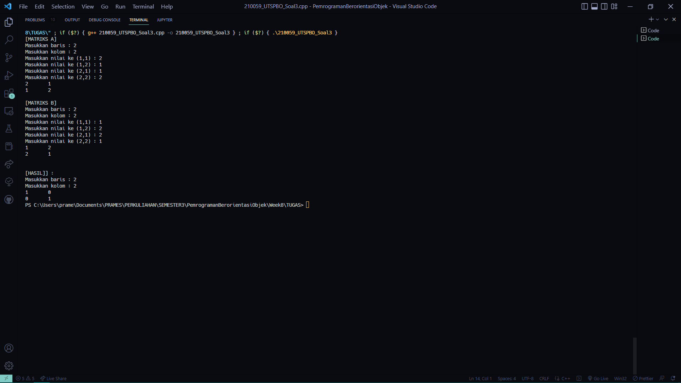

1. Soal 3 Python
   1. Source Code:

*# Program : Soal 3*

*# Nama    : Prames Ray Lapian*

*# NPM     : 140810210059*

*# Kelas   : A*

*# Tanggal : 23 Oktober 2022*

class Matriks:

    __baris = 0

    __kolom = 0

    def __init__(*self*, *baris*=0, *kolom*=0):

*self*.__baris = *baris*

*self*.__kolom = *kolom*

*self*.__nilai = [[0]\**kolom* *for* i *in* range (*baris*)]

    def setBaris(*self*, *baris*):

*self*.__baris = *baris*

    def setKolom(*self*, *kolom*):

*self*.__kolom = *kolom*

    def setNilai(*self*, *baris*, *kolom*, *nilai*):

*self*.__nilai[*baris*][*kolom*] = *nilai*

    def getBaris(*self*):

*return* *self*.__baris

    def getKolom(*self*):

*return* *self*.__kolom

    def getNilai(*self*, *baris*, *kolom*):

*return* *self*.__nilai[*baris*][*kolom*]

    def inputMatriks(*self*):

        print("Input Matriks")

*for* i *in* range(0, *self*.__baris):

            print("Baris ke -", i+1)

*for* j *in* range(0, *self*.__kolom):

*self*.__nilai[i][j] = int(input("Kolom ke-" + str(j) + " : "))

            print()

    def cetakMatriks(*self*, *text*):

        print("Matriks", *text*)

*for* i *in* range(0, *self*.__baris):

*for* j *in* range(0, *self*.__kolom):

                print(*self*.__nilai[i][j], " ", *end*='')

            print()

        print()

    def compareMatriks(*self*, *matriks2*):

        compare = Matriks(*self*.__baris, *self*.__kolom)

*for* i *in* range(0, *self*.__baris):

*for* j *in* range(0, *self*.__kolom):

*if*(*self*.__nilai[i][j] >= *matriks2*.getNilai(i, j)):

                    compare.setNilai(1, i, j)

*else*:

                    compare.setNilai(0, i, j)

*return* compare

def inputnilai(*urutan*: str) -> Matriks:

    print(*urutan*)

    baris = int(input("Input baris " + *urutan* +" : "))

    kolom = int(input("Input kolom " + *urutan* + " : "))

    X = Matriks(baris, kolom)

    X.inputMatriks()

*return* X

def output(*A* : Matriks, *B* : Matriks, *C* : Matriks):

*A*.cetakMatriks("1")

*B*.cetakMatriks("2")

*C*.cetakMatriks("Perbandingan")

*# main ------------------------------------------------------------------------------------------------*

A = Matriks()

B = Matriks()

C = Matriks()

A = inputnilai("Matriks ke-1")

print()

B = inputnilai("Matriks ke-2")

print()

C = A.compareMatriks(B)

print("Output : ")

output(A, B, C)

* 1. Screenshot:

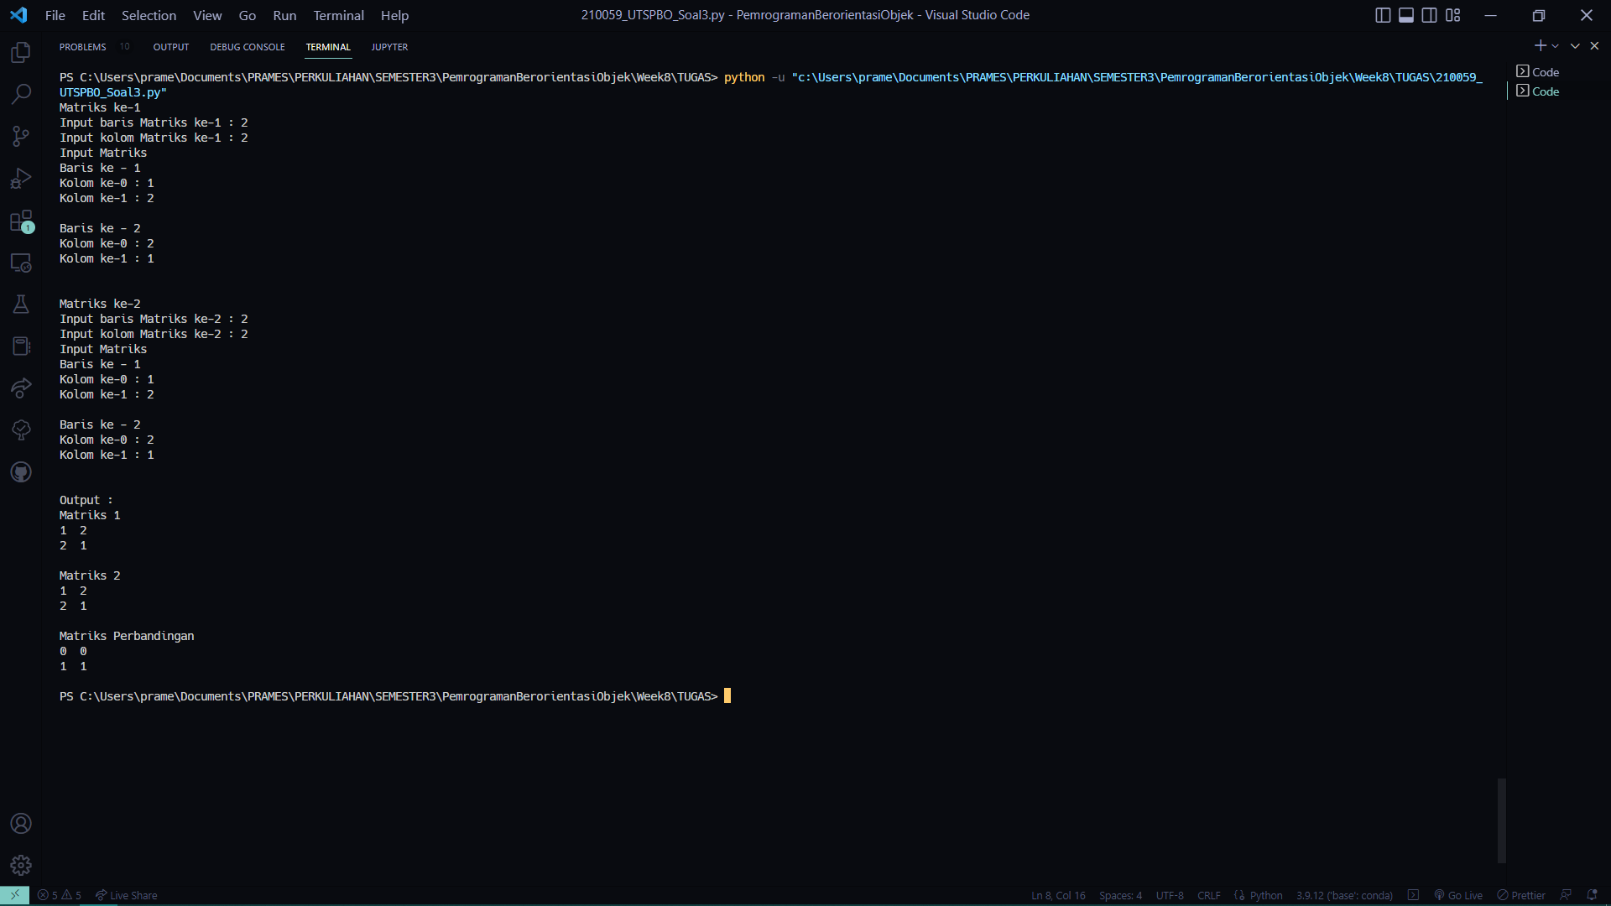

1. Soal 4 C++
   1. Source Code:

*// Program : Soal 3*

*// Nama    : Prames Ray Lapian*

*// NPM     : 140810210059*

*// Kelas   : A*

*// Tanggal : 23 Oktober 2022*

*#include* <iostream>

using namespace std;

class Waktu{

    private :

        int h, m, s;

    public :

        void setJam(int *jam*){

            h = *jam*;

        }

        void setMenit(int *mnt*){

            m = *mnt*;

        }

        void setDetik(int *dtk*){

            s = *dtk*;

        }

        int getJam(){

*return* h;

        }

        int getMenit(){

*return* m;

        }

        int getDetik(){

*return* s;

        }

        void inputWaktu(string *text*){

            cout << "Masukkan Jam " << *text* << "\t: ";

            cin >> h;

            cout << "Masukkan Menit " << *text* << "\t: ";

            cin >> m;

            cout << "Masukkan Detik " << *text* << "\t: ";

            cin >> s;

        }

        string getWaktu(){

            string jam, menit, detik;

            jam = "";

            menit = "";

            detik = "";

*if*(h<10){

                jam = "0";

            } *else*{}

*if*(m<10){

                menit = "0";

            } *else*{}

*if*(s<10){

                detik = "0";

            } *else*{}

*return* (jam + to_string(h) + ":" + menit + to_string(m) + ":" + detik + to_string(s));

        }

        int detikTotal(){

            int total = (h*3600 + m*60 + s);

*return* total;

        }

        Waktu durasi(Waktu *keluar*){

            Waktu durasi;

            int detikMasuk = this->detikTotal();

            int detikKeluar = *keluar*.detikTotal();

            int total = detikKeluar - detikMasuk;

            durasi.konversi(total);

*return* durasi;

        }

        void konversi(int *detik*){

            h = *detik*/3600;

*detik* = *detik*%3600;

            m = *detik*/60;

*detik* = *detik*%60;

            s = *detik*;

        }

};

class Kendaraan{

    private :

        string plat;

        int jenis;

        Waktu masuk;

        Waktu keluar;

    public :

        void setPlat(string *platK*){

            plat = *platK*;

        }

        void setJenis(int *jenisK*){

            jenis = *jenisK*;

        }

        string getPlat(){

*return* plat;

        }

        int getJenis(){

*return* jenis;

        }

        Waktu getMasuk(){

*return* masuk;

        }

        Waktu getKeluar(){

*return* keluar;

        }

        void inputKendaraan(){

            cout << "Masukkan No Kendaraan : ";

            cin >> plat;

            cout << "Masukkan Jenis Kendaraan" << endl

                 << "1. Mobil" << endl

                 << "2. Motor" << endl

                 << "Opsi: ";

            cin >> jenis;

            masuk.inputWaktu("Masuk");

            keluar.inputWaktu("Keluar");

        }

        int tarifParkir(){

            int tarif = 0;

*if* (jenis == 2){

                tarif = 2000;

            }

*else* *if* (jenis == 1){

                tarif = 3000;

            }

*return* tarif;

        }

        Waktu durasiParkir(){

            Waktu durpak;

            durpak = masuk.durasi(keluar);

*if* (durpak.getMenit() > 10){

                durpak.setJam(durpak.getJam()+1);

            }

*return* durpak;

        }

        int getBiaya(){

            int biaya;

*if*(durasiParkir().detikTotal() > 600){

*if* (jenis == 2){

                    biaya = (2000*durasiParkir().getJam());

                }

*else* *if* (jenis == 1){

                    biaya = (3000*durasiParkir().getJam());

                }

            }

*return* biaya;

        }

};

class Larik{

    private:

        int banyak;

        Kendaraan kendaraan[10];

    public:

        void setBanyak(int *ukuran*){

            banyak = *ukuran*;

        }

        void inputLarik(){

*for*(int i=0; i<banyak; i++){

                cout << endl << "Kendaraan ke-" << i+1 << "\n";

                kendaraan[i].inputKendaraan();

            }

        }

        int getBanyak(){

*return* banyak;

        }

        void print(){

            int no = 1;

            cout<<"\t\t\t\t\t[List Parkir Kendaraan] \n";

*if*(kendaraan[0].getPlat() == " "){

                cout<<"NULL\n";

            }

*else*{

                cout<<"----------------------------------------------------------------------------------------------------------------------\n";

                cout<<"No\tNo Kendaraan\t\tJenis\t\t Masuk\t\t Keluar\t\t Durasi\t\tLama Jam\tBiaya\t\n";

                cout<<"----------------------------------------------------------------------------------------------------------------------\n";

*for*(int i=0; i<banyak; i++){

*if*(kendaraan[i].getPlat() == " "){

*break*;

                    }

*else*{

                        cout<<

                            no << "\t" <<

*//identitas*

                            kendaraan[i].getPlat() << "\t\t" << kendaraan[i].getJenis() << "\t\t" <<

*//waktu masuk keluar*

                            kendaraan[i].getMasuk().getWaktu() << "\t" << kendaraan[i].getKeluar().getWaktu() << "\t" <<

*//waktu parkir*

                            kendaraan[i].durasiParkir().getWaktu() << "\t" << kendaraan[i].durasiParkir().getJam() << "\t\t " <<

*//tarif parkir*

                            kendaraan[i].getBiaya() << "\t\n";

                        no++;

                    }

                }

                cout<<"----------------------------------------------------------------------------------------------------------------------\n";

            }

        }

        void totalBiaya(){

            int hasil = 0;

*for*(int i=0; i<banyak; i++){

                hasil += kendaraan[i].getBiaya();

            }

            cout << "Total Biaya Parkir = " << hasil;

        }

};

main(){

    int banyak;

    cout << "Masukkan banyak kendaraan : ";

    cin >> banyak;

    cout << endl;

    Larik kendaraan;

    kendaraan.setBanyak(banyak);

    kendaraan.inputLarik();

    cout << endl;

    kendaraan.print();

    kendaraan.totalBiaya();

}

* 1. Screenshot:

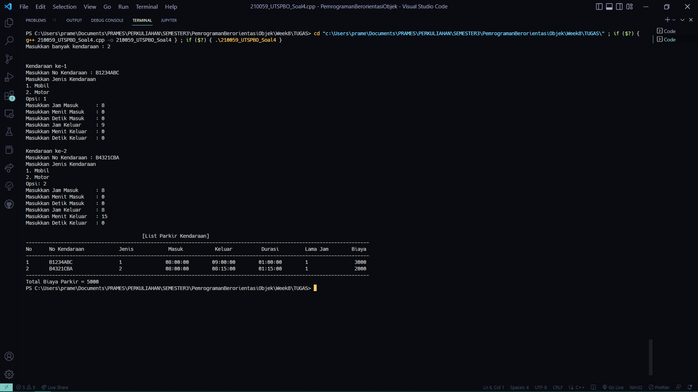

1. Soal 4 Pyton
   1. Source Code:

*# Program : Soal 3*

*# Nama    : Prames Ray Lapian*

*# NPM     : 140810210059*

*# Kelas   : A*

*# Tanggal : 23 Oktober 2022*

class Waktu:

    __h = 0

    __m = 0

    __s = 0

    def __init__(*self*, *h*, *m*, *s*):

*self*.__h = int(*h*)

*self*.__m = int(*m*)

*self*.__s = int(*s*)

    def setJam(*self*, *h*):

*self*.__h = int(*h*)

    def setMenit(*self*, *m*):

*self*.__m = int(*m*)

    def setDetik(*self*, *s*):

*self*.__s = int(*s*)

    def getJam(*self*):

*return* *self*.__h

    def getMenit(*self*):

*return* *self*.__m

    def getDetik(*self*):

*return* *self*.__s

    def inputWaktu(*self*):

*self*.__h = int(input("Masukkan jam\t: "))

*self*.__m = int(input("Masukkan menit\t: "))

*self*.__s = int(input("Masukkan detik\t: "))

    def getWaktu(*self*):

        jam = ""

        menit = ""

        detik = ""

*if*(*self*.__h<10):

            jam = "0"

*if*(*self*.__m<10):

            menit = "0"

*if*(*self*.__s<10):

            detik = "0"

*return* jam + str(*self*.__h) + ":" + menit + str(*self*.__m) + ":" + detik + str(*self*.__s)

    def detikTotal(*self*):

        total = int(*self*.__h*3600 + *self*.__m*60 + *self*.__s)

*return* total

    def durasi(*self*, *keluar*):

        durasi = Waktu(0,0,0)

        detikMasuk = int(*self*.detikTotal())

        detikKeluar = int(*keluar*.detikTotal())

        total =  detikKeluar - detikMasuk

        durasi.konversi(total)

*return* durasi

    def konversi(*self*, *detik*):

*self*.__h = int(*detik*/3600)

*detik* = *detik*%3600

*self*.__m = int(*detik*/60)

*detik* = *detik*%60

*self*.__s = int(*detik*)

class Kendaraan:

    __plat = ""

    __jenis = ""

    __masuk = Waktu(0,0,0)

    __keluar = Waktu(0,0,0)

    def __init__(*self*, *plat*, *jenis*):

*self*.__plat = str(*plat*)

*self*.__jenis = str(*jenis*)

    def setPlat(*self*, *plat*):

*self*.__plat = str(*plat*)

    def setJenis(*self*, *jenis*):

*self*.__jenis = str(*jenis*)

    def getPlat(*self*):

*return* *self*.__plat

    def getJenis(*self*):

*return* *self*.__jenis

    def getMasuk(*self*):

*return* *self*.__masuk

    def getKeluar(*self*):

*return* *self*.__keluar

    def inputKendaraan(*self*):

*self*.__plat = str(input("Masukkan Plat Kendaraan : "))

*self*.__jenis = str(input("Masukkan Jenis Kendaraan : "))

        print("Masuk")

*self*.__masuk.inputWaktu()

        print("Keluar")

*self*.__keluar.inputWaktu()

    def durasiParkir(*self*):

        temp = Waktu(0,0,0)

        temp = *self*.__masuk.durasi(*self*.__keluar)

*if* (temp.getMenit() > 10):

                temp.setJam(temp.getJam()+1)

*return* temp

    def biaya(*self*):

        biaya = int(0)

*if*(*self*.durasiParkir().detikTotal() > 600):

*match* *self*.__jenis:

*case* "Motor":

                    biaya = (2000\**self*.durasiParkir().getJam())

*case* "Mobil":

                    biaya = (3000\**self*.durasiParkir().getJam())

*return* biaya

class Larik:

    __banyak = int(0)

    __kendaraan = []

    def __init__(*self*, *banyak*):

*self*.__banyak = int(*banyak*)

    def setBanyak(*self*, *banyak*):

*self*.__banyak = int(*banyak*)

    def getBanyak(*self*):

*return* *self*.__banyak

    def inputLarik(*self*):

        i = 0

*while*(i<*self*.__banyak):

            print("Kendaraan ke -" , (i+1))

            x = Kendaraan(" ", " ")

            x.inputKendaraan()

*self*.__kendaraan.append(x)

            i = i+1

    def printLarik(*self*):

        print("~~~~~~~~~~ List Parkir Kendaraan ~~~~~~~~~~")

        no = 1

*if*(*self*.__kendaraan[0] == " "):

            print("NULL")

*else*:

            i = 0

            print("-------------------------------------------------------------------------------------------------------------------")

            print("No\tNo Kendaraan\tJenis\t\t Masuk\t\t Keluar\t\t Durasi\t\tJam Terhitung\tBiaya\t")

            print("-------------------------------------------------------------------------------------------------------------------")

*while*(i<*self*.__banyak):

*if*(*self*.__kendaraan[0].getPlat() == " "):

*break*

*else*:

                    print(

                        no , "\t" ,

*self*.__kendaraan[i].getPlat(), "\t",

*self*.__kendaraan[i].getJenis(), "\t\t",

*self*.__kendaraan[i].getMasuk().getWaktu(), "\t",

*self*.__kendaraan[i].getKeluar().getWaktu(), "\t",

*self*.__kendaraan[i].durasiParkir().getWaktu(), "\t",

*self*.__kendaraan[i].durasiParkir().getJam(), "\t\t",

*self*.__kendaraan[i].biaya()

                    )

                    no = no +1

                i = i+1

            print("-------------------------------------------------------------------------------------------------------------------")

    def totalBiaya(*self*):

        hasil = 0

        i = 0

*while* (i<*self*.__banyak):

            hasil = hasil + *self*.__kendaraan[i].biaya()

            i = i+1

        print("Total Biaya Parkir =", hasil)

*# main ------------------------------------------------------------------------------------------*

banyak = int(input("Masukkan banyak kendaraan : "))

print()

kendaraan = Larik(banyak)

kendaraan.setBanyak(banyak)

kendaraan.inputLarik()

print()

kendaraan.printLarik()

kendaraan.totalBiaya()

* 1. Screenshot:

