1. INTRODUCTION
   1. overview

A subscriber to a channel on the video sharing YouTube is a user who has chosen to receive the channel 's subscriber button.A generated channels that lack their own videos ( such a music and news) and channel that have been made effectively.

* 1. Purpose

YouTube subscribers refer to the people or account that are subscribed to your channel so whenever you upload a new videos ,subscribers will be able to see it in their feeds. This makes your subscribers more likely to watch the videos you upload.

1. Problem Definition &Design Thinking
   1. Empathy Map

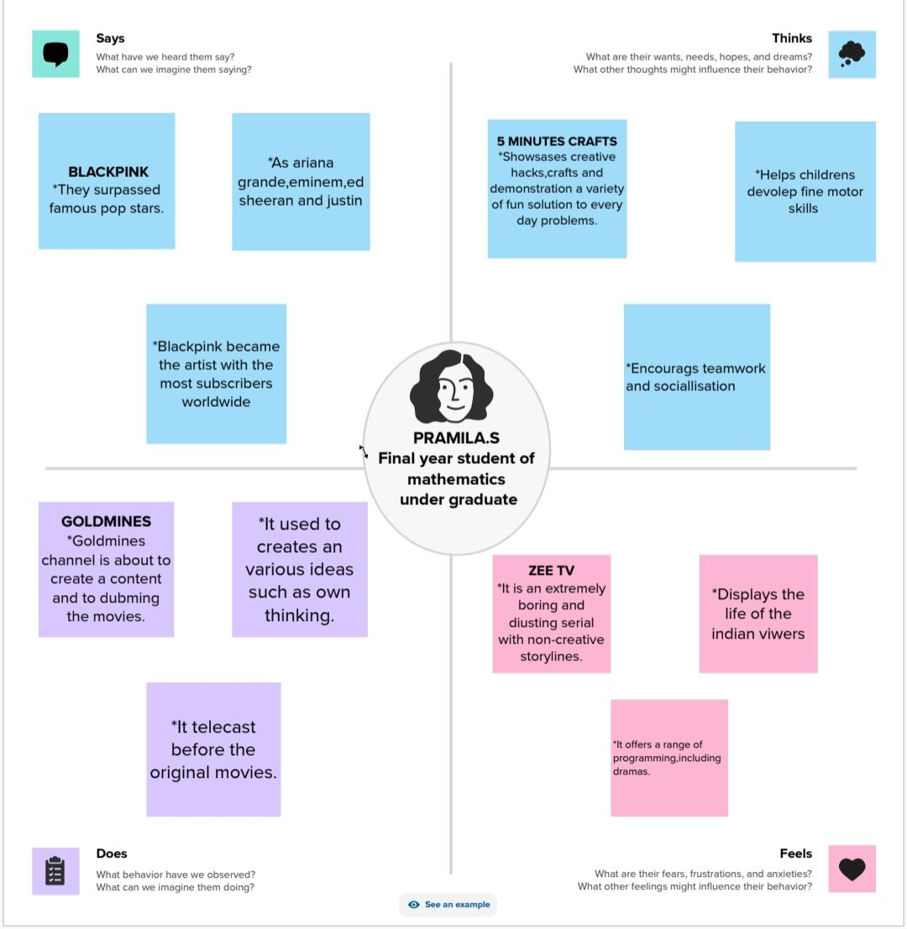 2.2 Ideation & Brainstorming Map

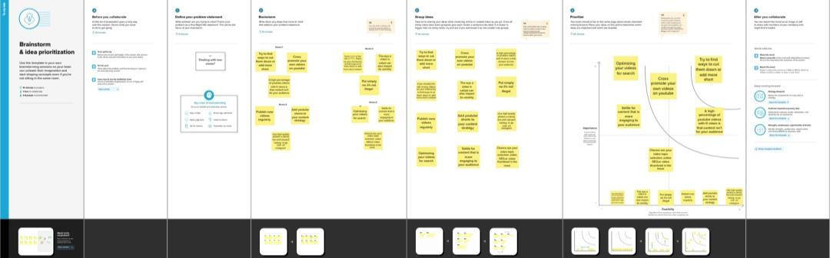3 RESULT

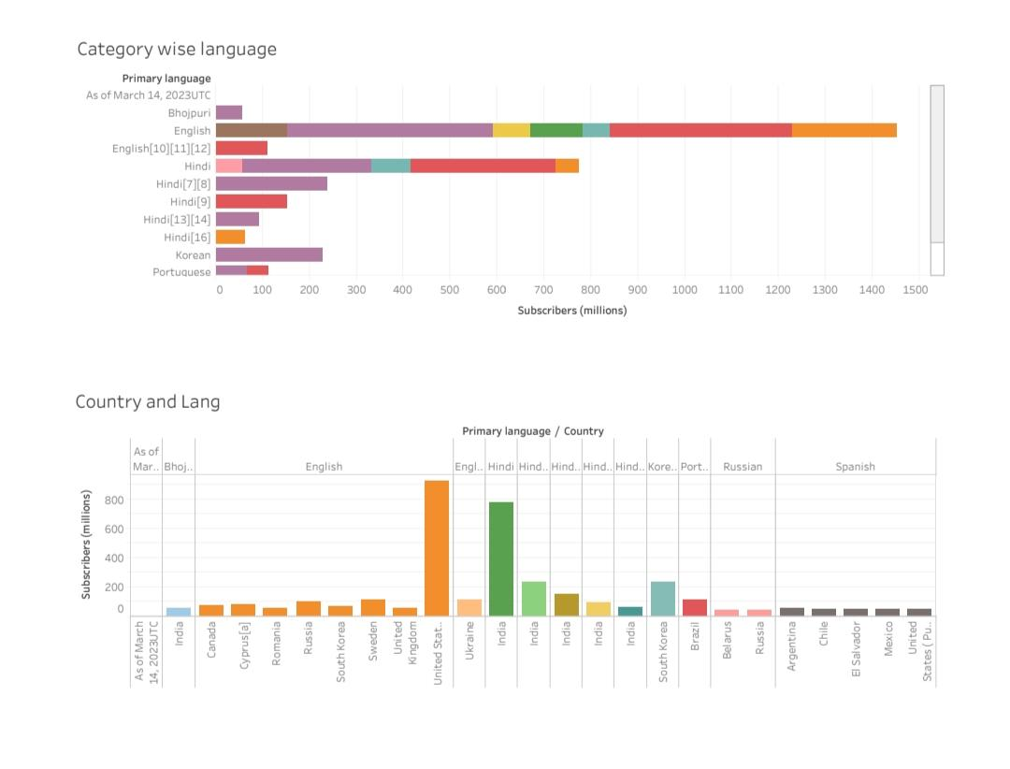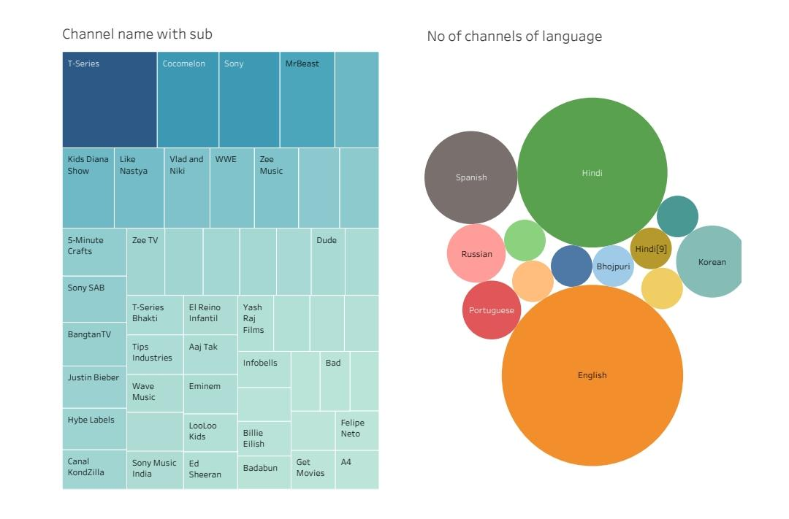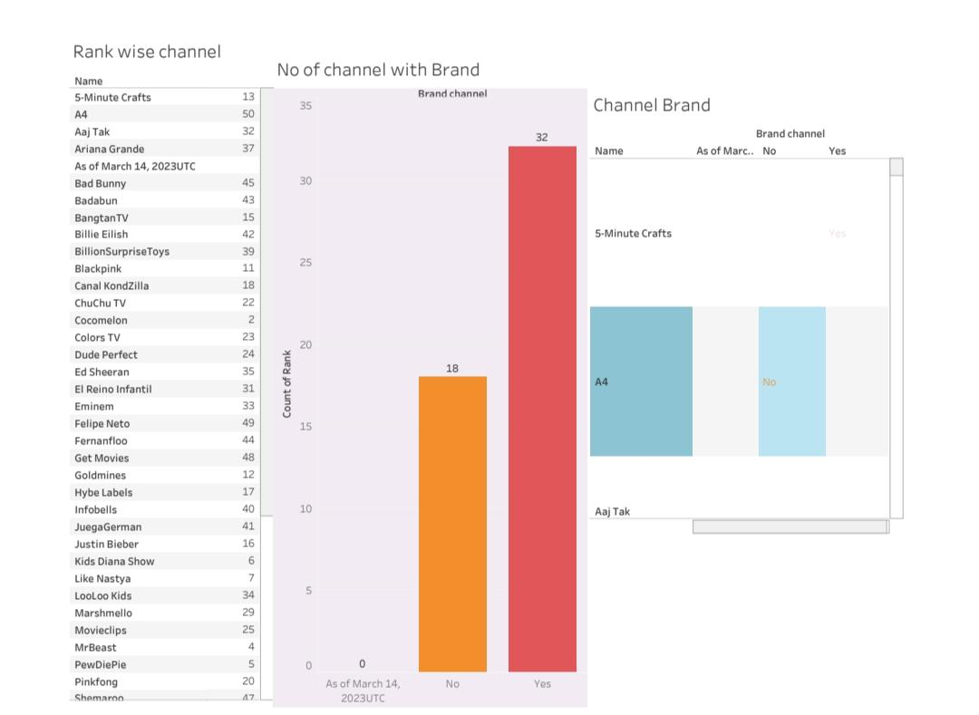

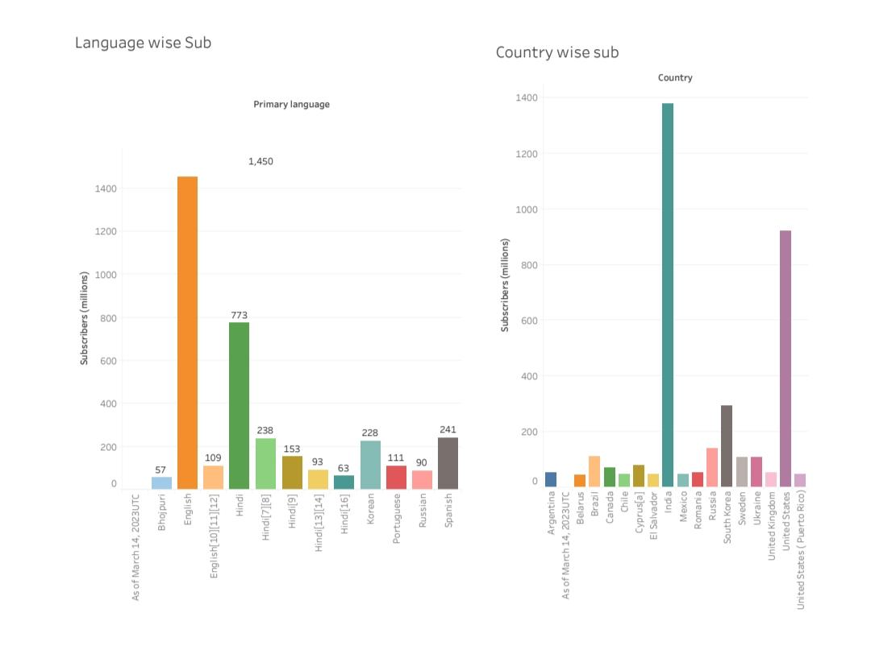 4. ADVANTAGES & DISADVANTAGES

1. ADVANTAGES
2. After parties & live chat
3. Smart device integration
4. Smart downloads
5. Co- Watch with Google Meet
6. Special offers and early access to new features.

* DISADVANTAGES

1. It may impede your preschooler’s development.
2. It can cause meltdowns.
3. It may promote unsafe behaviour.
4. Your child is targeted by ads,ads and more ads.
5. It can affect sleep

5 APPLICATIONS

Public.tableau.com

6 CONCLUISION

People are starting to record the daily lives or themselves playing video games And they ending YouTube is and the importance it has now days in this globally connected world.

7 FUTURE SCOPE

NO

8 APPENDEX

192023