

PURBANCHAL UNIVERSITY
HIMALAYAN WHITEHOUSE INTERNATIONAL COLLEGE
PUTALISADAK, KATHMANDU

Proposal
On
“Student Record Management System”

Submitted By:
Pramila Tamang
Sneha Pokharel

Submitted To:
THE DEPARTMENT OF SCIENCE & TECHNOLOGY
IN PARTIAL FULFILLMENT OF THE REQUIREMENTS FOR THE DEGREE OF
BACHELOR IN INFORMATION AND TECHNOLOGY

March, 2025
Kathmandu, Nepal

ABSTRACT
The Student Record Management System is a web-based application developed using HTML, CSS, and JavaScript for the frontend and PHP with MySQL for the backend. It is designed to help educational institutions manage student records in an organized and efficient way. The system provides secure login access for both administrators and students. Administrators can register new students, update, search, or delete records, manage attendance, publish results, and post notices. Students can log in to view their academic results, attendance status, and notices shared by the administration. The use of web technologies ensures a responsive and user-friendly interface, while the MySQL database securely stores and organizes all information for quick access and reliable data management. This system improves accuracy, saves time, and enhances communication between students and administrators, making it a practical solution for modern educational management.
Keywords: Student Record Management System, Web Application, HTML, CSS, JavaScript, PHP, MySQL, Attendance, Result Management, Notice Board, Admin Login, Student Login, Database Integration, Data Security, Frontend, Backend

LIST OF FIGURES
Figure 1: Spiral Model 10
Figure 2: Use Case Diagram 11
Figure 3: Admin-side DFD 12
Figure 4: Student-side DFD 13
Figure 5: ER-Diagram……………………………………………………………………………………………………………………..14
Figure 6: Admin Activity Diagram 15
Figure 7: Student Activity Diagram………………………………………………………………………………………………..…16

LIST OF TABLES

Table 1: Gantt Chart 7

LIST OF ABBREVIATIONS

SRMS Student Record Management System
SQL Structured Query Language
DFD Data Flow Diagram
SDLC Software Development Life Cycle
UI Graphical User Interface

TABLE OF CONTENT
ABSTRACT I
LIST OF FIGURES II
LIST OF TABLES III
LIST OF ABBREVIATIONS IV
CHAPTER 1 1
INTRODUCTION 1
1.1 Background 1
1.2 Problem Statement 1
1.3 Objective 1
1.4 Scope & limitations 2
CHAPTER 2 3
LITERATURE REVIEW 3
2.1 Study of existing system 3
2.2 Research based on similar project. 4
2.3 Requirement Analysis 5
2.4 Feasibility Analysis 6
CHAPTER 3 8
SYSTEM DESIGN 8
3.1 SDLC Model 8
3.1.1 Selected model 9
3.2 Use Case Diagram 10
3.3 DFD 12
3.4 ER-Diagram 14
3.5 Activity Diagram 15
CHAPTER 4 18
IMPLEMENTATION & TESTING 18
4.1 Implementation 18
4.2 Testing 18
CHAPTER 5 20
FINAL OUTCOME 20
5.1 Analysis of output obtained 20
CHAPTER 6: 21
CONCLUSION & FUTURE RECOMMENDATION 21
6.1 Conclusion 21
6.2 Future Enhancement 21
REFERENCES 22

CHAPTER 1

INTRODUCTION

Background
The Student Record Management System (SRMS) is a web-based application developed using HTML, CSS, JavaScript, and PHP with MySQL. It is designed for both administrators and students, providing a secure and efficient platform for managing and accessing student-related information. The system allows administrators to handle essential tasks such as registering new students, updating, searching, or deleting records, managing attendance, posting notices, and publishing results. Students can log in to view their academic results, attendance records, and notices shared by the administration. The primary goal of this project is to simplify and streamline the management of student data while ensuring security, accuracy, and easy accessibility. By integrating modern web technologies with a structured database, the SRMS offers a reliable and user-friendly solution that enhances communication and operational efficiency within educational institutions. This project aims to combine programming knowledge and problem-solving skills to create a useful tool for educational institutions.

Problem Statement
Educational institutions face challenges in managing large volumes of student data, including registration details, academic records, and result tracking. Manual record-keeping methods are time-consuming, error-prone, and inefficient, leading to data inconsistencies and security risks. Our project “Student Record Management System (SRMS)" addresses these issues by providing a secure, automated, and centralized platform for efficient student information management, ensuring accurate record maintenance and streamlined communication between administrators and students.

Objective
The project is with the main aim of meeting the following objectives:
- To develop a secure login system for both administrators and students, ensuring that only authorized users can access the system and its features.
- To enable efficient management of student records, including adding, viewing, editing, searching, and deleting details, as well as managing attendance, posting notices, and publishing results.
- To ensure data security and integrity through encryption and other measures to protect user information from unauthorized access or loss.

Scope & limitations
The "Student Record Management System (SRMS)" is designed to streamline and automate the administrative processes of educational institutions through a secure and user-friendly web platform. The primary focus is to provide a centralized system for storing, managing, and accessing student information, reducing the need for manual record-keeping methods. The scope of this project includes the following key areas:
Scope
User Authentication:
- There is secure login and signup functionality for both administrators and students to ensure that only authorized users can access the system.
- Student Registration: There are efficient entry and storage of student details, including personal, academic, and contact information in the MySQL database.
- Record Management: Search, display, update, and delete student records to maintain accurate and up-to-date information.
- Attendance Management: Recording and viewing student attendance data for better monitoring of academic participation.
- Result Management: Uploading and displaying student results, allowing students to view their academic performance online.
- Data Security: Integration with MySQL database to ensure secure data storage and retrieval.
- 7. Responsive User Interface: Developed using HTML, CSS, and JavaScript, for an intuitive and accessible design across devices.
By combining PHP, MySQL, and modern frontend technologies, the SRMS delivers a reliable and scalable solution that improves efficiency, ensures data security, and enhances communication between administrators and students.

CHAPTER 2

LITERATURE REVIEW

Study of existing system
Initially, the development of a Student Record Management System (SRMS) using web technologies aligns with ongoing efforts to enhance accessibility, scalability, and ease of maintenance in educational management software. Recent studies emphasize the benefits of web-based applications for automating administrative tasks and improving the overall management of student information.
Gupta and Sharma (2020) developed a web-based student information management system that prioritized data security and easy accessibility through internet-enabled platforms. Their project employed PHP and MySQL for backend development, demonstrating how web applications could significantly improve data handling and retrieval efficiency in educational institutions [1].
Khan et al. (2019) proposed a web-based student management system featuring modules for student registration, fee tracking, and result management. Using technologies such as HTML, CSS, JavaScript, and MySQL, their system showcased how online platforms could minimize administrative errors, reduce processing times, and facilitate remote access to student records, making the system highly adaptable for growing educational environments [2].
Patel and Desai (2021) explored the advantages of web applications in educational institutions, focusing on cross-platform compatibility, ease of deployment, and centralized data management. Their research highlighted how web-based SRMS solutions offer scalable and secure platforms that simplify maintenance and updates compared to traditional desktop applications [3].
Singh and Verma (2018) developed an online student record management system that integrated attendance monitoring, examination management, and result publishing into a single platform. Their system, built using PHP, JavaScript, and MySQL, emphasized user-friendly interfaces and real-time data processing, which enabled both administrators and students to access updated records instantly. The study demonstrated how automation could reduce paperwork and enhance transparency in academic record-keeping [4].
Rao et al. (2022) designed a cloud-based student information management system that leveraged modern frameworks such as Laravel and MySQL for backend development. Their project highlighted the benefits of cloud deployment, including scalability, multi-user accessibility, and disaster recovery support. The system also incorporated role-based access control to ensure data confidentiality, underscoring the importance of integrating security measures in web-based educational applications [5].
These studies collectively reinforce the relevance of web-based Student Record Management Systems as effective tools for modern educational administration. By using web technologies such as HTML, CSS, JavaScript, PHP, and MySQL, this project aims to build a scalable, secure, and user-friendly platform that enhances operational efficiency and ensures reliable student data management.

Research based on similar project.
The "Student Record Management System (SRMS)" is built upon core concepts and principles from web development, database management, and client-server architecture. These theoretical foundations ensure the project is functional, secure, and user-friendly for both administrators and students.
- Web Development Technologies: Our project is developed using HTML for structuring content, CSS for styling and layout, and JavaScript for client-side interactivity. These technologies collectively ensure that the system provides a responsive, interactive, and visually appealing interface accessible from any modern web browser.
- Database Management System (DBMS): The project uses MySQL as the database to store and manage records such as student details, attendance, notices, and results. MySQL allows efficient data retrieval, insertion, updating, and deletion while ensuring data integrity and security through structured queries and constraints.
- The system follows the MVC architecture, which separates the program into three parts. The Model manages data and database operations, the View manages HTML/CSS-based presentation to the user, and the Controller connects the two by processing user actions. This makes the project well-structured and easier to maintain.
- 4. Client-Server Architecture: The system follows a client-server model, where the client (web browser) sends requests to the server, and the server responds with the required data or web pages. This separation allows scalability and supports multiple users accessing the system simultaneously.
- 5. Responsive and User-Centered Interface Design: The interface is designed with simplicity and accessibility in mind. Clear navigation menus, mobile-friendly layouts, and error-handling messages improve usability for both administrators and students accessing the system from different devices.
By applying these principles, the web-based SRMS provides a scalable, secure, and efficient solution for managing student records, ensuring smooth operations for educational institutions while maintaining easy accessibility over the internet or local network.

Requirement Analysis
Requirement analysis is a crucial part of system development, as it helps in understanding the needs of the system and its users. For the "Student Record Management System (SRMS)," the requirements are categorized as user, functional, and non-functional requirements.
- User Requirements
The system includes Administrators and Students. Administrators can login to manage student records, class details, attendance, notices, and results. Students can login to view attendance, results, and notices. The system must provide secure login and session management to prevent unauthorized access. It should be simple and user-friendly, minimizing the need for technical expertise.
- Functional Requirements
- Admin Login/Signup: Admins can securely log in using PHP sessions and hashed passwords.
- Student Registration: Admins can add new students with personal, academic, and login details.
- Record Management: The system allows admins to search, display, update, and delete student records.
- Attendance Management: Admins can mark students as present/absent, and students can view their own attendance history.
- Result Management: Admins can add and update academic results; students can view results with pass/fail status and GPA.
- Student Portal: Students can log in to view attendance, results, and notices.
- Logout: Admins and students can securely exit the system to terminate sessions.

- Non-Functional Requirements
- Data Security: The system must securely store and retrieve data using SQL database integration.
- Performance: The system should handle operations efficiently without delays.
- Scalability: The system must support an increasing number of student records as the institution grows.
- Usability: The system has Responsive design using CSS to ensure accessibility from desktops, tablets, and smartphones.

Feasibility Analysis
A feasibility study is a systematic analysis to figure out the practicality and potential success of a proposed project or venture.
A. Technical Feasibility:
- The system was developed using HTML, CSS, JavaScript for the front end and PHP for the backend. It uses MySQL as the database management system.
- These technologies are open-source, well-documented, and compatible with educational systems, making development and maintenance technically feasible.
B. Operational Feasibility:
- The system simplifies administrative tasks like student registration, record updates, manages notices, and result display.
- It reduces human errors and ensures accurate data management.
- It allows multiple users to access the system simultaneously from different devices.
C. Economic Feasibility:
- The system is developed entirely using free and open-source tools (XAMPP, PHP, MySQL, HTML, CSS, JavaScript).
- The system saves time and resources by reducing manual record-keeping costs.
- It provides long-term cost savings by ensuring better record management and 8 data security.
D. Schedule Feasibility:
The project was developed within the planned timeframe using an iterative development model. Each phase, such as requirement gathering, system design, coding, testing, and deployment, was completed as scheduled. But if we get more times, we can make this project more advanced. Below is a Gantt chart showing our project timeline:

Sprint Breakdown (2-Week Sprints).

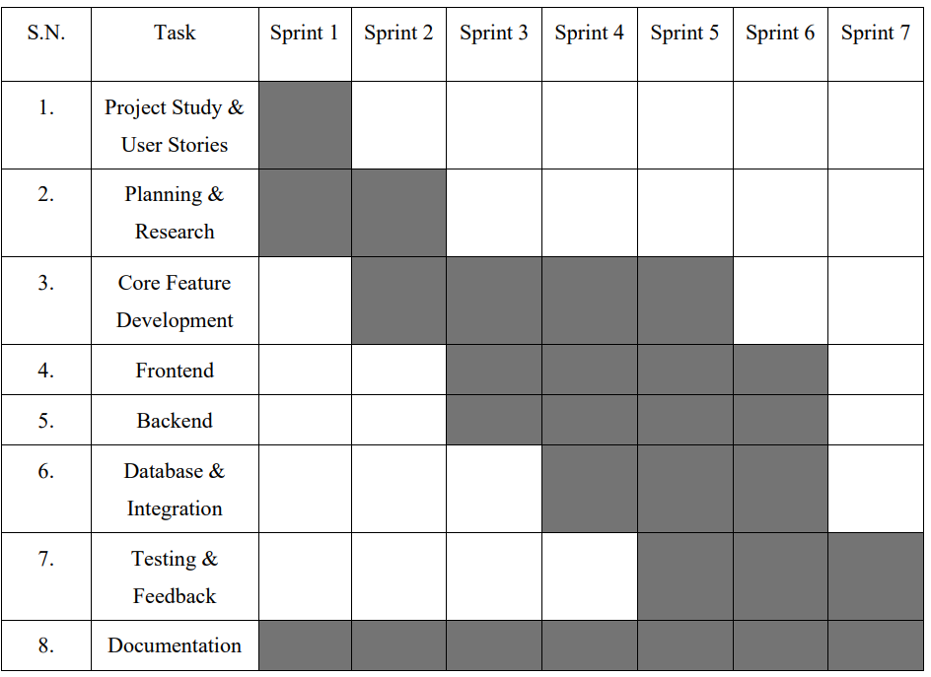

Table 1: Gantt Chart

CHAPTER 3

SYSTEM DESIGN
The System Design phase focuses on creating the architecture and structure of the Student Record Management System (SRMS). It defines how the system’s front-end, back-end, and database interact, and how data flows between them. A well-planned design ensures that the application is efficient, secure, scalable, and easy to support.

SDLC Model
The Software Development Life Cycle (SDLC) model is a structured approach used by software development teams to design, develop, test, deploy, and maintain software systems. It encompasses a series of phases or stages, each with specific activities and deliverables. Common SDLC models include Waterfall, prototype & spiral model with its own set of principles, methodologies, and best practices tailored to different project requirements and organizational needs.
The phases in the Software Development Life Cycle (SDLC) typically include:
  - Planning: This phase involves defining the project scope, objectives, timelines, and resources required. It may also include feasibility studies and risk assessments to ensure the project's viability.
  - Requirement Analysis: During this phase, the development team gathers and analyses requirements from stakeholders, such as users, customers, and business owners. The goal is to understand the needs and expectations of the software system to be developed.
  - Design: In this phase, the system architecture and design specifications are created based on the requirements gathered. This includes defining the software components, data structures, interfaces, and algorithms to be used in the system.
  - Implementation: Also known as coding or development, this phase involves translating the design specifications into actual code. Developers write, compile, and test the code to ensure it meets the requirements and design standards.
  - Testing: Once the code is developed, it undergoes rigorous testing to identify and fix defects or bugs. Testing includes various techniques such as unit testing, integration testing, system testing, and UAT.
  - Deployment: After successful testing, the software is deployed or released to the production environment. This phase involves installing the software on users' machines or servers and configuring it for use.
  - Maintenance: The final phase involves maintaining and supporting the software post-deployment. This includes addressing any issues or bugs reported by users, making enhancements or updates as needed, and ensuring the software remains functional and efficient over time.
These phases may vary slightly depending on the specific SDLC model or methodology being used, but they generally encompass the key activities involved in software development projects.

Selected model
Our project aims to develop a Calendar App with Task Planner to help users manage their schedules and tasks more effectively. After reviewing various software development life cycle (SDLC) models, we selected the Spiral Model as the best fit for this project. The Spiral Model is an iterative, risk-focused approach that combines design and prototyping in multiple stages. This allows us to continuously improve the app through repeated cycles while identifying and addressing risks early, especially those related to data security, user authentication, and system reliability. Using this approach ensures that the final product is both secure and user-friendly.
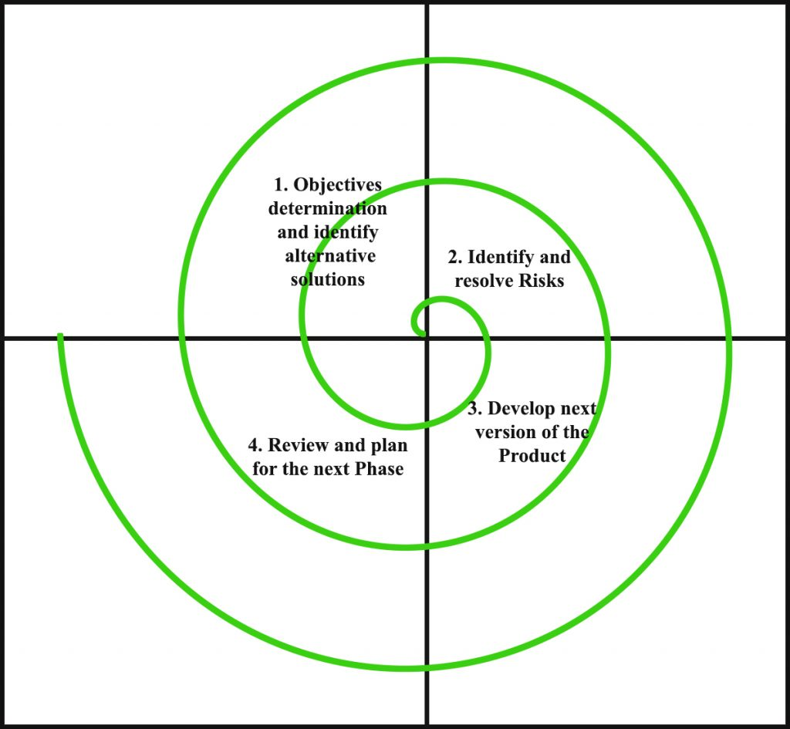

Figure 1: The Spiral Model
The Spiral Model allows us to build the system incrementally by going through multiple iterations of planning, risk assessment, design, implementation, and evaluation. Each phase is revisited with more detail and functionality, which makes it easier to manage complexities and implement core features such as calendar viewing, task creation, editing, deletion and searching, while continuously incorporating feedback and improvements. Since our student database system requires frequent testing, user interaction, and potential feature refinements, the iterative nature of the Spiral Model ensures flexibility and robustness throughout development.
Given the need for progressive development, secure data handling, and an intuitive user interface, the Spiral Model fits our project well. It allows us to address potential issues at each phase, build confidence through early prototypes, and deliver a fully functional, user-friendly, and secure Student Record Management System.

Use Case Diagram
The use case diagram is usually referred to as behavior diagram used to describe the actions of all user in a system. All user describe in use case are actors and the functionality as action of system. The Use case diagram is a collection of diagram and text together that make action on goal of a process. In our Student Record Management System there are two actors Admin and Student who can do their respective activities to run the system.

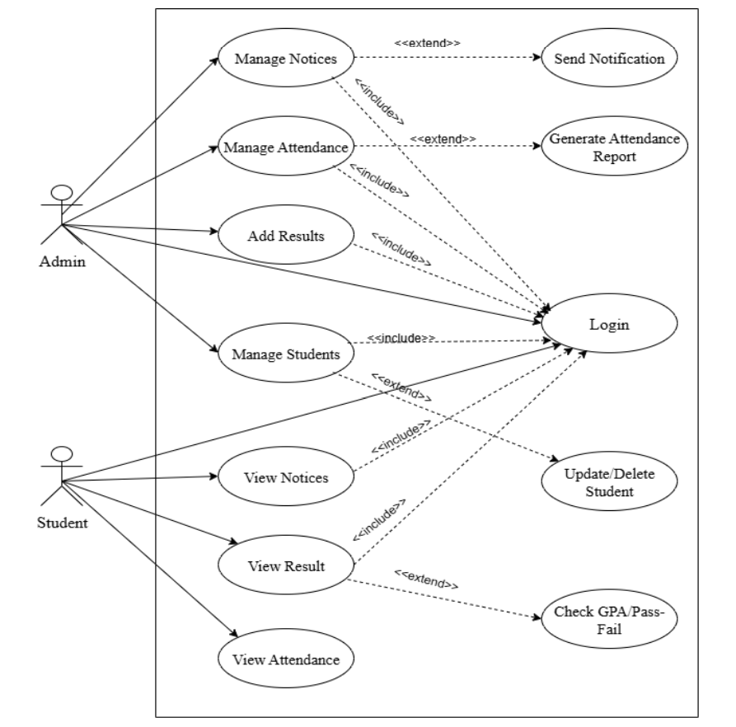

Figure 2: Use-Case Diagram

DFD
DFD stands for Data Flow Diagram. It's a graphical representation that illustrates how data flows through a system or process. DFDs consist of processes, data stores, data flows, and external entities:
I. Admin-Side DFD
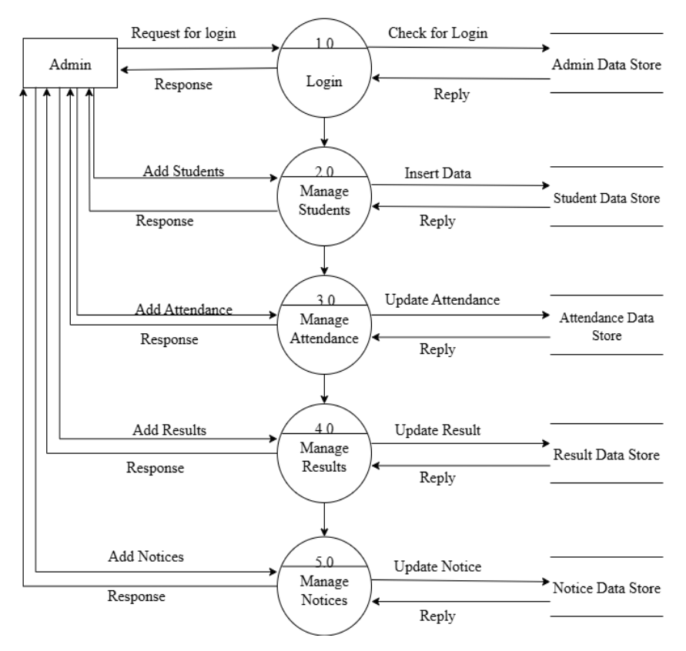
Figure 3:Admin-Side DFD

II. Student-Side DFD
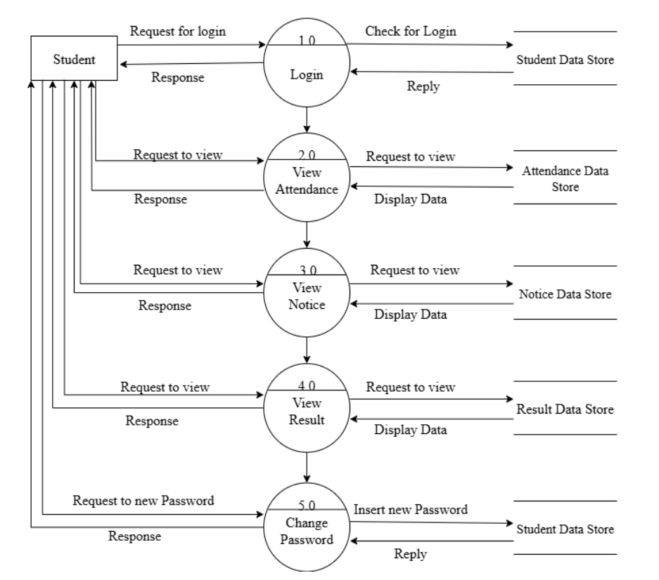
Figure 4: Student-Side One level DFD

ER-Diagram
An Entity-Relationship (ER) Diagram is a visual representation of a database structure that shows the relationships between entities. Entities are objects or concepts (like students, admin, or fees) that store data, while relationships define how these entities interact with each other.
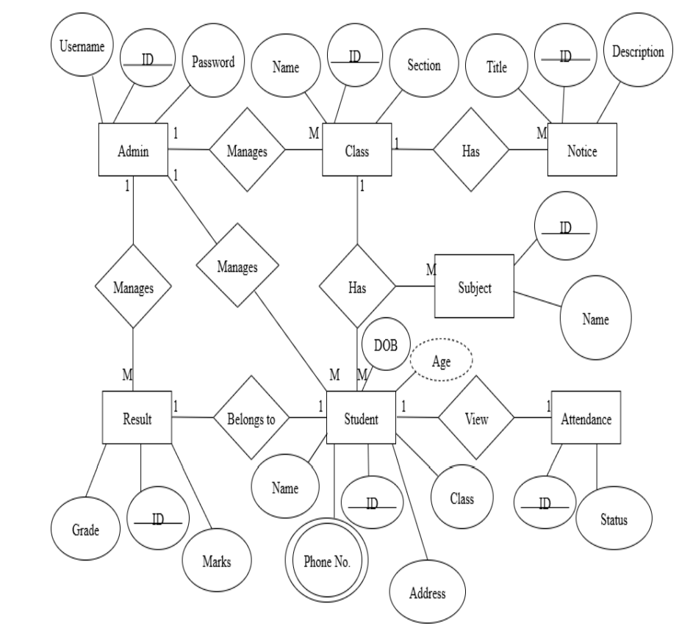

Figure 5: ER-Diagram

Activity Diagram
An activity diagram is a visual representation of the step-by-step flow of activities in a system, showing actions, decisions, and the overall process from start to end.
1. Admin Activity Diagram
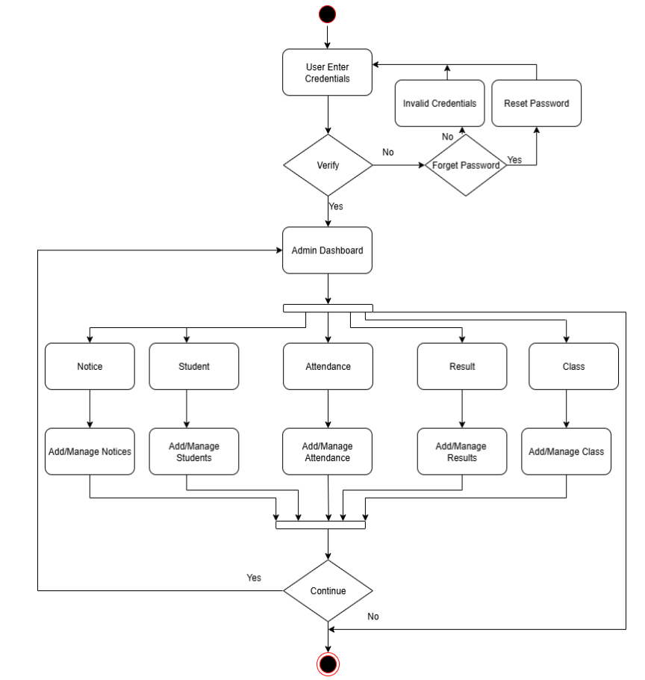
Figure 6: Admin Activity Diagram
2. Student Activity Diagram
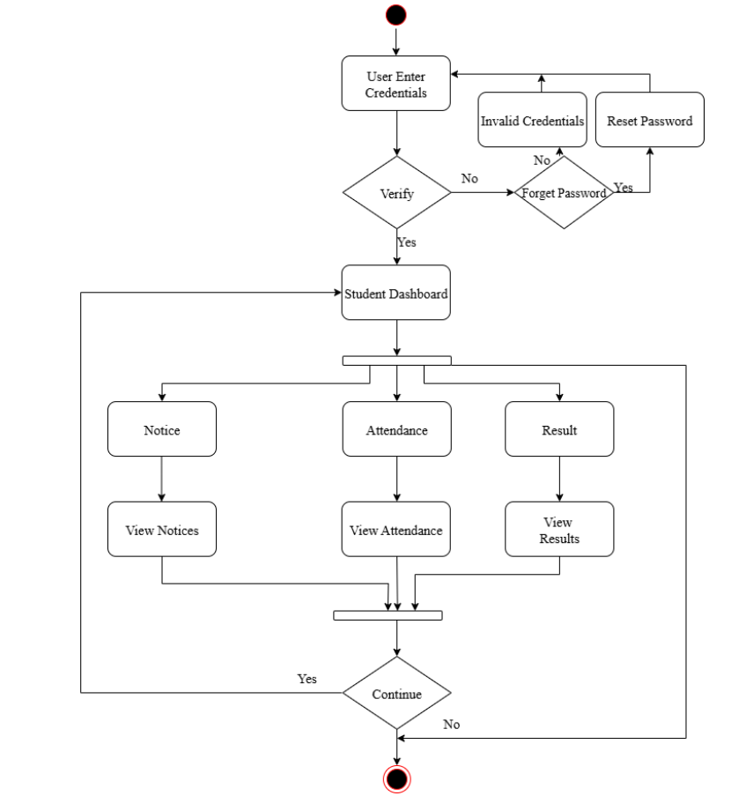
Figure 7: Student Activity Diagram

CHAPTER 4

IMPLEMENTATION & TESTING

Implementation
Implementation is the stage where the system design is converted into a functional web application. The Student Record Management System (SRMS) was implemented using HTML, CSS, JavaScript, PHP, and MySQL. The application runs on a local server environment using XAMPP for testing and deployment. Here is a key Implementation details of our project “Student Record Management System”

Testing
Testing is a critical phase in the development of the Student Record Management System (SRMS) to ensure the system functions correctly, securely, and efficiently before deployment. The application was subjected to various testing techniques to verify its reliability, accuracy, and performance.
Here are some testing details of our project:
- Functional Testing:
- It verified that each web module, including student registration, notice management, and result processing, performed as intended.
- It confirmed that student records could be accurately added, updated, displayed, and deleted through the interface.
- Usability Testing:
- It evaluated the web interface for simplicity, readability, and ease of navigation across desktop and mobile devices.
- It Checked that form layouts, buttons, and input fields were properly aligned and visually consistent. •
- It Validated that error messages and form validations provided clear guidance to users.
- Database Testing:
- It ensured data consistency and integrity between the web application and the MySQL database.
- It verified that all create, read, update, and delete (CRUD) operations reflected accurately in the database tables.
- It checked foreign key constraints and data validation rules to prevent inconsistent or duplicate records.
- Security Testing:
- It tested the login authentication system to verify proper password validation and session management. •
- It confirmed that administrative features were accessible only to authorized users. •
- It checked for vulnerabilities such as SQL injection by validating and sanitizing all user inputs.
- Performance Testing:
- It verified that the system handled multiple simultaneous user requests without delays or server crashes.
- It tested database query execution times to ensure efficiency with large volumes of student records.
The successful implementation and thorough testing of the SRMS ensured that the system operates efficiently, securely, and meets the objectives of the project.

CHAPTER 5

EXPECTED OUTCOME

Analysis of output obtained
- The system successfully allows secure login for both administrators and students using their credentials.
- Administrators can add, update, search, and delete student records efficiently.
- All student information is stored and managed properly in the MySQL database.
- The user interface created using HTML, CSS, and JavaScript is responsive and easy to use.
- The system helps reduce manual record management, improve accuracy, and save time in handling student information.

CHAPTER 6:

CONCLUSION & FUTURE RECOMMENDATION

Conclusion
The “Student Record Management System (SRMS)” was successfully developed as a web-based application using HTML, CSS, JavaScript, PHP, and MySQL. The system provides an efficient and centralized platform for managing student information, including registration, record updates, fee management, and result tracking. By replacing traditional manual processes with an online solution, the system reduces time consumption, minimizes errors, and ensures higher data accuracy. The application allows administrators to securely manage sensitive student data, generate admit cards based on fee payment status, and display academic results in a structured manner. The web interface is intuitive, responsive, and user-friendly, ensuring smooth navigation across different modules for efficient workflow. During this project development, challenges were encountered in database optimization, responsive design adjustments, and ensuring security against threats such as SQL injection. These challenges were resolved through iterative debugging, testing, and applying secure coding practices. Overall, the project achieved its objectives, delivering a functional, secure, and scalable web-based SRMS suitable for deployment in educational institutions.

Future Enhancement
Although the current version of the SDMS meets its primary objectives, several improvements can further enhance its functionality and usability. Future updates could include role-based access control to provide separate portals for administrators, teachers, and students, ensuring data privacy and relevant access. Cloud integration would allow better remote access, automatic backups, and real-time synchronization. Automated email or SMS notifications could keep users informed about fee deadlines, exam schedules, and result publications. A dedicated mobile application for Android and iOS would improve accessibility on the go. Additionally, implementing advanced security measures such as two-factor authentication and encrypted data storage would strengthen data protections.

REFERENCES
[1] Gupta, A., & Sharma, R. (2020). Web-based student information management system. Journal of Information Systems, 12(3), 123-135.
[2] Khan, M., Ali, S., & Hussain, T. (2019). Desktop-based student management system using SQL database. International Journal of Computer Science, 15(2), 45-52.
[3] Patel, H., & Desai, M. (2021). Java-based applications in educational management: A review. Educational Technology Journal, 18(4), 78-89.
[4] Singh, R., & Verma, P. (2018). Online student record management system: An integrated approach. International Journal of Web Applications, 10(1), 34-42. [5] Rao, S., Mehta, K., & Iyer, A. (2022). Cloud-based student information management system using Laravel and MySQL. Journal of Cloud Computing in Education, 7(2), 56-68.

