**B.M.S College of Engineering**

**P.O. Box No.: 1908 Bull Temple Road,**

**Bangalore-560 019**

**Department of Information Science & Engineering**



**Smart Shopping Using IOT**

Submitted to – Sindhu K

(Asst Professor)

Submitted by

Samarth M Hathwar - 1BM18IS088

Prajwal Kulkarni - 1BM18IS067

Pramila Dalavai - 1BM18IS068

ACKNOWLEDGEMENT

The satisfaction that accompanies the successful completion of this Capstone Project Phase-1 would be incomplete without the mention of the people who made it possible through constant guidance and encouragement.

We would take this opportunity to express our heart-felt gratitude to Dr. B. S. Ragini Narayan, Chairperson, Donor Trustee, Member Secretary & Chairperson, BMSET. Dr. P. Dayananda Pai, Member Life Trustee, BMSET and Dr. S. Muralidhara, Principal, B.M.S. College of Engineering for providing the necessary infrastructure to complete this Capstone Project Phase-1.

We wish to express our deepest gratitude and thanks to Dr. M. Dakshayini, Head of the Department, Information Science and Engineering and the Project Coordinator’s Prof. Yogesh N and Prof. Sindhu K for their constant support.

We wish to express sincere thanks to our guide Prof. Sindhu K, Assistant Professor, Department of Information Science and Engineering for helping us throughout and guiding us from time to time. A warm thanks to all the faculty of the Department of Information Science and Engineering, who have helped us with their views and encouraging ideas.

| NAME | USN | SIGNATURE |
| --- | --- | --- |
| PRAJWAL KULKARNI | 1BM18IS067 |  |
| PRAMILA DALVAI | 1BM18IS068 |  |
| SAMARTH M HATHWAR | 1BM18IS088 |  |

**ABSTRACT**

Smart shopping system is the project which is developed for shopping markets. This system helps the customer to bill their products on their own. The customers can reduce their time consumption in supermarkets by using this system.

This system helps the customer in many ways such as reducing time consumption, helps in estimating the bill and reduces the manpower for the owner. Till now we saw the conventional barcode scanner being used from now we can use RFID tags for scanning the products. Each bunch of products will have one unique RFID tag and the RFID reader is kept on the shopping cart so that the customer can take the RFID tag, tap on the reader and go.

There will be a display where the customer can see the total bill of the products taken. Various problems are faced by the customer and the owner so, to overcome such problems this system can be used.

**TABLE OF CONTENTS**

| Chapter No | Title | Page No |
| --- | --- | --- |
| 1 | Introduction  1.1 Background  1.2 Research motivation and Problem statement  1.2.1 Research motivation.  1.2.2 Scope of the Work  1.3 Existing system  1.4 Objectives of the work | 1-4 |
| 2 | Problem Statement | 5 |
| 3 | Literature Survey | 6-18 |
| 4 | Survey Summary | 19-23 |
| 5 | System Requirements Specification  5.1 Functional requirements  5.2 Non-functional requirements  5.3 Software requirements  5.4 Hardware requirements | 24-26 |
| 6 | System Design | 27-30 |
| 7 | Applications | 31-32 |
| 8 | Conclusions | 33-34 |
| 9 | References | 35-37 |

**List of Figures**

| Sl.no | Figure Name | Page No |
| --- | --- | --- |
| 1 | **Figure 6.1** : System Architecture | 27 |
| 2 | **Figure 6.2** : RFID Reader | 28 |
| 3 | **Figure 6.3**: RFID tag | 28 |
| 4 | **Figure 6.4** : Data Flow Diagram | 29 |
| 5 | **Figure 6.5** : Use case diagram | 30 |

**Chapter 1**

**INTRODUCTION**

Everyone wastes time while shopping, notably at the cashier counter, by standing in line, and time is the most valuable commodity in everyone's life. The crowds are frequently large, especially during festival season, and invoicing time will grow proportionately. As a result, the smart shopping system's primary goal is to shorten shopping time. Customers can create their own invoices, making it simple for them to estimate their bill. Smart shopping may eventually reduce the number of people working at the cash registers. This strategy can help you save money, and the money you save can be used to enhance the quality and experience of your customers. In addition, instead of counters, more products can be placed. This will be a complimentary service to the existing self-checkout system.

Because the concept was centered on technology, it was critical to obtain user feedback for which the concept was created. The goal was to look at the role of assumptions, perceptions, and expectations from retailers and their regular consumers when it came to the planned Smart Shopping System. The Smart Trolley concept is based on the most common automated self-checkout technology found in most UK stores. The proposal is based on a smaller version of an automated self-checkout system mounted on a shopping trolley with a user interface screen that allows customers to pay for things scanned and placed in the cart before exiting the store. This is done to relieve demand on the cash registers during peak hours.The Smart Trolley includes all of the standard features, such as scanning an item for price and data.

**1.1 Background**

The traditional barcode system is currently in use at supermarkets and shopping malls. The drawback of such a system is that it can only scan one product at a time. During the billing procedure, this takes a long time. As a result of our study, we have discovered improved methods that aid in effective time management and bill generation at checkout. The RFID reader will be put on each cart, and when the customer places an item in the cart, the RFID reader will begin scanning the tags on each block and display the entire bill amount on the LCD that is linked to the cart along with the RFID reader.

As a result, the people who use our smart cart get a real-time answer. 2 To analyse the project needs, which include product idea development and selection, product definition and value proposition, market research and assessment, and product function and commercial viability strategy. Technologically-oriented design will be used to design the system architecture of the product, including the modules of the system, based on the project requirements. To guarantee that the product is executed in a way that promotes business opportunity, a commercialization strategy must be developed in order to turn this project into a viable business.

**1.2 Research motivation**

**1.2.1 Research motivation.**

Supermarkets are where we find huge lines because everyone requires everyday necessities. There are instances when we have a crucial job to perform but are unable to do so on time in our professional lives. A consumer who has been in line for a long time finally has the opportunity to pay their bill. Since all products are scanned and the final bill is provided, customers may discover that the bill exceeds their budget. These types of scenarios occur in everyday life, so we can use the smart buying system to avoid them. We've seen the customer's point of view, but we haven't seen the owner's.

Using this smart shopping system, the proprietor may cut his personnel in half. Furthermore, many of them discover that their supermarkets are not profitable.

As a result, the owners can attract customers by employing such novel techniques, as few individuals visit the supermarket solely to try it. These scenarios inspired us to pursue this concept.

**1.2.2 Scope of the Work**

With the use of RFID technology, the above project intends to shorten the user's shopping time by making the billing process easier and less time consuming. A rfid reader with a display is included in the shopping cart shown above. Each product in a retail mall is divided into distinct blocks. A unique RFID tag is attached to each block carrying the same product. When you tape the RFID tag to the cart, it adds an Arduino board, LCD, RFID reader, and Zigbee module to the cart. In mobile applications, the centralized database will provide product reviews, recommendations, and information. Based on previous purchase behaviour, personalised recommendations are displayed. Mobile billing systems will be developed, allowing clients to purchase products more efficiently.

**1.3 Existing System**

* Supermarkets and shopping malls currently use the standard barcode technique.
* The disadvantage is that such a device can only scan one product at a time. This takes a long time during the billing process. This is due to the "line of sight" architecture of barcode scanners, which means that goods (barcodes) can only be scanned when they are placed in a straight line with the barcode.
* We have identified a superior solution as a result of our efforts, which aids in optimal time management and bill creation at checkout.

**1.4 Objectives of the work**

* This system provides solutions to improve the speed of purchasing of products and faster payment options.
* This offers a technology oriented, low-cost, easily scalable, and rugged system for assisting shopping in person.
* No ‘line of sight’ is required in case of RFID that reduces the labour required to scan the product.
* This system provides reviews and suggestions for the purchase of the goods in an interactive way.

**1.5 Proposed System**

* Agenda of the project is to provide an automated billing system using RFID technology.
* Eliminates “line of sight” scanning, by replacing barcode scanner with RFID reader that can detect products within a certain range, and without having to scan items individually.
* The RFID information is processed through the microcontroller and the data is sent to the server.
* The server reads the request and makes necessary updates/additions to the database.
* The bill details are broadcasted to the mobile application from the database and the checkout is processed.

**Chapter 2**

**PROBLEM STATEMENT**

A societally accepted innovative product is one that improves everyday comfort, ease, and efficiency. In metro centres, buying and shopping at large malls has become a daily pastime. On holidays and weekends, these malls will be crowded. People buy various products and place them in a cart. Payments must be made at the billing counter when purchases are completed. The receptionist prepares the bill at the billing counter using a barcode scanner, which is a time-consuming operation that results in a long line at the billing counter.Here will be building a technology called "RFID Based Shopping Cart" in this project to help people with their routine shopping.

**CHAPTER 3**

**LITERATURE SURVEY**

**Suhas B.M et al[1];**  Interactions between physical items have become a reality in the Internet of Things age. With the help of the Internet, every thing on the planet is on the approach of becoming connected. For example, this system has proposed a novel smart method to the shopping system in this study. Here, they offer a novel method of invoicing a customer's purchases without the need to queue for long periods of time. Employ RFID tags (Radio Frequency Identification Tags), which are applied to every item purchased. Overall, the tag is less expensive; nonetheless, this strategy will alleviate the problem of long lines.

The current shopping system is a time-consuming procedure that includes selecting things, waiting in lines, scanning products, and checking out. This is a time-consuming process, and may use IoT, a cutting-edge technology, to shorten the time and address the problem. The majority of time is squandered in never-ending lines and item billing, which causes mayhem at shopping malls. These are the areas where we can make time savings in the current system. As a result, by automating long waits and reducing scanning time, difficulties can be reduced. When compared to previous generations, the dynamic range of RFIDs has been greatly expanded.

Smart shopping carts are the solution to the above-mentioned problem; these carts are fitted with sophisticated microcontrollers and sensors that cut billing time by scanning items quickly as and when they are added to the cart, effectively eliminating shopping centre lines. Sensors and microcontrollers are readily available at a low cost and may be installed in each and every cart, with a security scanner installed at the exit to notify if payment has not been processed. This would help to overcome the market's current challenges.

**Purva S. Puranik et al[2],** Every shopper fantasises about being able to pay their bills quickly and easily in supermarkets. This document contains a suggestion for a smart cart that will be able to generate a bill from within the cart. For shopping and payment, the smart cart employs RFID and Zig-Bee technology. RFID (Radio frequency identification) is a type of wireless communication that allows an object, animal, or human to be individually identified. Two crucial components are the RFID tag and the RFID reader. An RFID tag has a memory device that saves data, as well as a microprocessor and an antenna. The RFID reader sends out radio frequency waves, and the tag is activated when it comes close enough to the reader. When a tag is activated, it sends data in the form of waves from its memory to an RFID reader. ZigBee, on the other hand, is based on the IEEE 802.15 standard. Through such intermediate devices, Zig-Bee devices establish a mesh network and transmit data across vast distances.

The current shopping system model heavily relies on barcode scanning. A barcode is connected to every product held at a department store. A barcode is a visual representation of data that can be scanned and decoded to obtain information. However, there are some minor drawbacks to using barcodes. Because barcodes are always visible on the outside of the goods, they are vulnerable to damage. To read a barcode, a scanner must have a straight line of sight to it. As a result, each product must be scanned separately. This shortcoming of barcodes contributes to the billing procedure in department stores being quite slow.

All of the products that are placed on the shelves are first registered and given RFID tags. At the server end, a database contains information such as pricing, location, and so on. When an item is placed in a smart cart, the RFID reader should read the tag and transfer the information to the microcontroller, which will subsequently interact with the server through Zig-Bee. The smart cart is in charge of encrypting and signing the message.

Smart cart generates two symmetric keys, sl and s2, which are then sent to the server with the request. SI is used to encrypt the information requested, and s2 is used to generate a message authentication code (MAC). The server performs symmetric decryption and MAC testing when it gets the message. The billing creation process is completed using three algorithms.

The Current system time is denoted by T..

Algorithm I: When the smart cart reads the product RFID tag, it performs validation of the HMAC present on the tag. If the verification is successful, the smart cart produces two symmetric keys, sl and s2, at random. s1 is used to encrypt data, while s2 is utilised to generate the message authentication code. The smart cart then adds its own ID I as well as a time stamp, to the tag information. The message is encrypted and sent to the server using the two session keys s2 and s3.

Algorithm 2: The server decrypts the message and confirms the signature and time stamp when it receives this request from the smart cart. If the message is genuine, the server searches the database for the desired information Info (TI), concatenates it with a new timestamp, and encrypts the message with sl acquired from the cart. The server also uses s2 to generate a message authentication code, which it delivers to the smart cart along with the encrypted message.

Algorithm 3: After getting the server's response, the smart cart uses s2 to check the MAC. If the MAC is valid, the smart cart uses sl to decrypt the message and checks the time stamp.

If the verification is successful, the billing information on the LCD display will be updated by the smart cart.

**P.T. Sivagurunathan et al[3];** Currently, we use the method in shopping malls with the aid of a barcode scanner. Vendors use a barcode scanner to scan the merchandise. Customers must wait in huge lines because this is a slow process. As a result, one of the main reasons why most people want to leave the mall after waiting in a long line to buy a few items is because of this. We wish to acquire more things to

avoid this. New types of technologies have emerged in recent years. A product must be placed in

a smart shopping cart by the customer. A product id is assigned to each and every item. The product id can be read by an RFID reader. This could have been beneficial to customers. Customers may benefit from any of these solutions.

When a client buys something, the buyer must first inspect it with the use of a standardised tag that is available in each item, which is used in conjunction with RFID per user. The newly obtained item can then be placed in the trolley. While the customer examines the item's RF tag, the cost of the purchasing item is recorded and saved in the framework's memory/Arduino.

In shopping malls, the smart shopping trolley application creates an automated central payment system. The product information is supplied immediately to the invoicing system via ZigBee. As a result, clients will not have to wait in a large line. It is dependable, trustworthy, and efficient in terms of time. The suggested smart shopping trolley technology will save users time searching for product locations. On an Android device, the customer just enters the name of the product he or she wishes to buy. The cart will autonomously direct them to the product's location.

i. Begin the procedure

ii. Set the system up

iii. Scan an object for RFID tags iv.

iv. Take a look at the RFID tags

iv. Take a look at the RFID tags

v. The data associated with the tag can be read from memory if the tag is registered or scanned.

vi. With the use of LCD displays the facts and cost.

vii. The item is automatically added, and the item cost is added as well, resulting in the total cost

viii. If any item is removed, the overall cost is reduced by the amount of the removed item, and the procedure is repeated again.

ix. send the total amount and print the bill.

x.The procedure has been completed.

**Ling Wu et al[4];** A shopping system's design mostly entails networking, database, and RFID technologies. The system provides the benefits of great efficiency and precision [10]. Self-checkout, self-purchase, a member mechanism, and anti-theft features are all part of the system. The binary search method is used to achieve the function of self-checkout, which can make it faster for consumers to check out in a given area, by solving the collisions of a plurality of electronic tags in the identification of shopping.

Self-purchase works in a similar way as self-checkout. To count the acquired products, the goods are designated in a specified location. This function can handle the clutter of small items, saving time and money by avoiding the hassle of artificial statistics.

RFID membership cards are given to clients who spend a particular amount of money in order to increase sales. As a result, it might enhance the frequency with which customers consume.

A unique sequence code (UID) depending on the identification tag, a set of prepared sequences of instructions delivered between scanner and a plurality of labels, after a specific label picked for both data interchanges, is referred to as a binary search algorithm. The reader delivers a request instruction to select a set of labels; data collision tag sequence code is precisely conveyed to the reader label channel transmission, and the collision is verified by the reader. If the reader wants to test the collision, the next search should be done in a reduced range.

Whether the signal encoding employed in the reader determines the optimal placement of the collision bit, which is critical in the binary search algorithm implementation process.

Manchester encoding provides this advantage, as has uplink baseband data encoding from the transmitter to the reader. Manchester encoding represents a certain value level on the rising or falling edge of a bit window (tBIT). A logic "0" code represents an increase, while a logic "1" code represents a decrease.

Manchester encoding transmission is frequently characterised as an error, and a "no change" condition is not permitted. When numerous transponders transmit different values at the same time, the result is offset by the rising and falling edges of the received signal. Because the reasons for this have yet to be revealed, it is being seen as a technique to investigate bit backtracking problems.

**Ravi Kumar et al[5];** A smart shopping cart system is suggested, which will use RFID to keep track of purchased products for billing. Every product in Mart will be equipped with a passive RFID tag, and every cart will be equipped with an RFID reader and a Wi-Fi module. There will be a centralised recommendation system that will be automated with the help of an AI-based bot. RFID readers will also be installed at the exit door to prevent theft. This method will not only minimise the amount of human labour needed at billing stations, but it will also remove congestion at the counters. Especially now, when social distance is a need owing to the global epidemic that will hit the world in 2020. Customers will be able to see more information about the item they are interested in, as well as the pricing. This gives the consumer the option of continuing with their current product list or changing it. This allows the user to make their own decisions before proceeding to the final billing counter. At a cost of less than 800 rupees, the proposed technology can be simply integrated into an existing regular cart commonly used in supermarkets.

In [1], the authors "Galande Jayshree, Rutuja Gholap, Preeti Yada" suggested an RFID-based automatic billing trolley. The system in this model consists of an RFID reader and RFID tags placed at the mall items. When a user places a product in the trolley, the RFID tag code is read by the RFID reader, and the product's price is saved in memory. The whole bill data is sent to the

system using wireless RF modules at the billing counter. ZigBee is used in this project, which

would be slower and more expensive than Node MCU.

In [2], An Automated Shopping Trolley with a Billing System was proposed by the authors "S.Sainath, K.Surender, V.Vikram Arvind." The autonomous shopping trolley is a smart cart with a Raspberry Pi integrated chip, two barcode scanners, and a battery pack that allows customers to self-check out at supermarkets. The usage of a Raspberry Pi and barcode scanners, however, makes it excessive and expensive, which is not ideal for practical application.

The shopping and billing system now in use in most shopping malls may be better. Due of the high cost, barcode scanners are only accessible at billing counters and cannot be included in a shopping cart. Customers must also manually check the pricing of each product to get an approximate estimate of how much they will be spending. This could be a source of frustration for budget-conscious individuals. To address this problem, each product will be equipped with a low-cost passive RFID tag. To stay alive, this tag doesn't at all require a battery. However, if we attach the tag's registration number to a database, it might carry a lot of information.

He doesn't have to complete the entire procedure at the billing counter. Table 1.1 shows a comparison of a barcode reader and an RFID reader. This eliminates bottlenecks that arise at the building's counters, especially when the retail centre is busy. This is a pretty common occurrence in India. The scanner in the cart features a processing unit as well as a connector unit The database and the central system are always connected to this unit. This Data is transferred quickly and smoothly between the smart carts and the central database. This will be accomplished with the help of a Wi-Fi module. Because we're using a database, it's not just inexpensive and effective, but it's also quick. In addition, because the bill is displayed on the Lcd display in the cart on a real - time basis, the consumer will have the opportunity to decide whether or not to keep a product.

**Vallabhuni, R.R et al[6];** Every shopping centre now uses shopping baskets and shopping vehicles to collect information about their customers. There are shopping items available in each rack. Clients must plan ahead of time for each item they will need for the truck, as well as maintain their position in the long queue for charging frameworks. It's possible that this will take a long time. As a result, while innovative achievements have been accomplished, the project's feasibility remains in question.

They will be bolstered and strengthened even more by the framework that has been created for them.RFID reader, LCD, and Wi-Fi transmitter are used in this research project's innovative mobile trolley. Those Wi-Fi recipients will be used to connect with the machine during the charging section. RFID stands for radio frequency identification tags, which are used to obtain an exciting ID number of results using radio waves. These RFID tags will be linked to other points of interest that take barcodes. Similarly, they will suffer a significant disadvantage, which will continue to be the visible road for organizational innovation. Furthermore, barcode tags will supply imperatives regarding their solidity, whilst RFID tags will be associated with a greater quantity of toughness. The authors have described the smart trolley system in the present system, but not the whole smart shopping system.

Shopping and purchasing products in malls and supermarkets have become a regular practice these days. After purchasing things at most of these malls and supermarkets, customers will proceed to the billing counter to pay the bill, where the cashier will scan the item and generate the bill using a barcode system. This is always a lengthy and time-consuming process, which results in large lines at the billing counters. In the proposed smart shopping system, RFID is used instead of a barcode to solve the above-mentioned difficulty.

RFID technology has been offered as a way to reduce billing time. Each advanced mobility vehicle will be outfitted with the following: RFID reader, Raspberry Pi 3, Arduino, and LCD are all used in this project. That perceptive those things placed under a truck can naturally be read by a truck. Through a second RFID observer, The framework is what keeps everything together. Things were brought together in order to create an RFID tag. The tag is scanned by the RFID reader ,when it is necessary to add or remove things from the database Trolley. The add items button should be clicked to add products to the cart, and the subtraction button should be pressed to remove goods from the cart. It will also read the expiration date while reading. If the item is past its expiration date, the red led will illuminate and a buzzer will sound; otherwise, the green led will illuminate. After we've completed our shopping, we'll proceed to the billing portion. The information about the things is transferred to the central billing server, which calculates the total value of the items and displays it on the webpage. It will be simple to pay the sum without having to wait.

**Athauda, T et al [7];** In this paper they have explained that various attempts to eliminate long shopping queues at retail stores have been made in the past. One of the most well-known strategies is the installation of self-checkouts, which has greatly enhanced customer convenience. Due to reduced overhead costs, self-checkouts have been popular since then; nonetheless, stealing and lower operating efficiencies are regarded as major negatives in the retail industry.

Proposed System -

UHF RFID was well-known for traceability applications, and Wal-Mart was the first retailer to introduce it to the general public. UHF RFID continues to thrive in retail applications and works well with shopping trolley applications due to the following qualities.

• Reading ability in the absence of a clear line of sight — Items in the shopping cart can be read without a clear line of sight.

• Reading distance - Because UHF RFID tags may be used in both near-field and far-field applications, they can be used to read items both close to and far away from the antenna.

• Higher data rates - this is especially useful for storing more data efficiently.

• Tag readability - UHF RFID tags can scan a large number of tags at once (300 tags/second), which improves reading efficiency.

When creating the need specification, all of the aforementioned was taken into account. When designing and developing a smart trolley application, the following requirements are taken into account.

1. Every item that enters and exits the shopping trolley should be identified - in this instance, antennas should be strategically placed so that the radiation patterns can cover the entire region inside the trolley regardless of tag orientation.
2. UHF RFID reader capability - A UHF RFID reader should be able to handle several antennas with varied configurations at the same time.

In this study, the successful use of UHF RFID technology for a smart shopping cart is demonstrated. The products can be recognised regardless of tag orientation, size, or form.

Prior shopping cart programmes had several issues, which were rectified in this application.

Monash Microwave, Antennas, RFID, and Sensor laboratories undertook unique research to produce the antenna and hybrid coupler. Finally, when shoppers benefit from coordinated technology collaboration, this application may deliver a unique experience for them.

**Li.R. Song et al[8];** As a result of ecommerce spending, more clients stock goods supplied over the internet and ecommerce platform. Clients can receive products from specific locations by selecting products that fit their needs and specifications. Theft, lack of inspection, items that do not function correctly or directly, not the same product as the pictures, a stolen credit card transaction, Phishing in consumers who believe they have purchased a respectable product to sell, a disrupted retail business, and no price negotiating are also risks. The public is pleased with the virtual alternative to traditional purchasing, and they obtain the identical thing for consumption as promised.

In today's world, vendors must contend with a number of challenging circumstances. Shopping hubs and shopping centres are places that are thought to be a market for a variety of small businesses. From time to time, many people have exhibited their attempts to revolutionise traditional purchasing. Barcode technology is used at several supermarkets.

Arduino, RFID, and wireless sensors are all used in this project.

Barcode technology has now been implemented and used in a large number of stores. The black vertical bars that store object information are known as barcodes. Every product can be scanned using ultrasonic sensors in an intelligent cart. Backend databases are connected to barcode printed bars. Employ a barcode reader in this manner, which reads the barcode as it is printed in the inspection line.

This demonstrates that RFID is more efficient than barcodes. Stock management accuracy has grown by 27%, while stock accuracy has decreased by 21% and stock has declined by 6%, according to their performance. The scanner scans 10,000 barcoded things takes 53 hours, whereas RFID reads in two hours. Supermarket running carts are ideal for transporting items by the end user. Fitting a bar code to carts allows customers to verify each product individually, which saves time and energy. The RFID provided an LCD display on the shopping pushcart in an early fashion, allowing the consumer to interact with product details.

Buyers are unable to interact with needed product details due to a non-user-friendly interface. RFID tags with microcontrollers are used to distribute items. The focus is on automating billing operations, which includes the antibilling system and online billing system. The RFID tags were read using NFC, which was added as an alternative device.

The data is transferred to backend databases to clients with an efficient purchasing procedure using RFID and ZigBee modules. The buyer can physically return the item by clicking the buttons, as well as pay for it with cash by hitting a button. The next stage is to use ZigBee to convey data to the cash payment procedure.

**Nithiavathy, R et al[9];** This research is a game-changer in the creation of a secure smart retail system. They offered a complete design as well as a detailed description of the principles and functionalities for the smart shopping system. They are the first to suggest that UHF RFID technology be used to connect smart retail systems. Their method is the first to automate the reading of items with a wide range of values. They are the first to develop a secure protocol for communicating with smart commerce systems. They did a security analysis as well as a performance evaluation in terms of computational and communication complexity to evaluate the protocol.

They thoroughly test the smart cart's reading range in this system. They discovered that the metal around the cart can block signals from the outside, meaning that an RFID reader cannot read the products in a shopping cart unless it is placed within the cart or on top of the cart. As a result, it is recommended that the RFID reader on the exit door be placed high enough to scan the products in the cart passing by below.

Proposed a safe smart shopping system based on RFID technology in this research. This is the first time UHF RFID has been used to improve shopping experiences, and security concerns have been raised in the context of a smart shopping system. Design a whole system in detail and develop a prototype to test its functionality. In addition,create a secure communication protocol and give security and performance evaluations.Believe that RFID technology will be used to cover future stores, and that our research will be a game-changer in the development of a smart retail system.

**Ballestín, F et al[10];** As part of their investigation, they performed observations and questionnaires. Observations were done in two supermarkets over a three-month period from November 2019 to January 2020. The findings of the observations are detailed in section. The investigation's main findings are queue times, which could be lowered in a number of processes. The survey's findings show that each transaction takes 10-20 minutes to complete, in addition to the time spent queuing. The number of items purchased and the long-awaited scanning process are two main factors that could influence the length of the queue.

Every item in the supermarket should be tagged with a passive RFID tag that contains the item ID information. The Arduino system will be attached to each of the supermarket's Smart Shopping Carts, where the power supply will be sufficient to boot the system up, the compiled source will be implemented in the Arduino, as well as the configuration of the supermarket's own network to be connected by WiFi. There can only be one open transaction in the cart at any given time.

When a customer scans the QR code on the cart, the app will query the server for [TransactionID]. The server will look for any open transactions for that cart, and if none exist, it will initiate a new transaction and return the transaction id. As long as the customer does not close or cancel the transaction, it will stay open.

The customer will tap the item's RFID tag to the reader in the Smart Shopping Cart during the shopping process.

Because the scanning of items to be shopped is done independently by the customer during the shopping process, this paper on the advancement of a Smart Shopping System using Smart Shopping Carts demonstrates that it can reduce queue time by eliminating the barcode scanning process during the checkout process. In terms of capability, sturdiness, and efficiency, RFID holds great promise. Although, for future use or development, the capabilities of an RFID system, such as new varieties of RFID, larger bandwidth, and longer read distances, can be investigated further.

**M. Shahroz et al[11];** In this modern age of technology most of the customers need to wait in the mall or supermarket for shopping because it is a very highly time consuming process.The barcode-based billing process causes crowds in the supermarket during discount offers and weekends, making it difficult to wait in long lines.

On the shopping cart, the RFID reader is attached to an LCD display, allowing the user to see product information and interact with it.Based on the Arduino microcontroller, the RFID reader reads the RFID tag on the product.Billing transaction automation ensures theft prevention and allows online billing transactions.By using RFID modules and ZigBee modules, users can accomplish a more efficient shopping experience. The ZigBee module transfers the information to the customer's back-end database. By pressing a button, the user can return an item and pay their bill, then the details are transferred to the billing system.

Three elements comprise an RFID system: an RFID reader, an RFID electronic tag, and a central communication device. An Arduino microcontroller allows a mobile application to communicate directly with an RFID product tag.As soon as the consumer puts the products in the shopping cart, the cart's RFID reader reads the passive RFID tags on the products. The data are displayed on the mobile application that is attached to the shopping cart and in front of the customer. Users can easily interact with the interface and use the available features.The proposed system is designed to enable customers to select the most efficient product, add it to their shopping cart, and calculate the added costs. When the shopping process is completed, the customer will make the payment and the payment information will be sent to the central server. In the proposed system, a map will show the product present in the mall along with its sectional specifications, enabling customers to make an informed decision.convenience. Customers can purchase a great number of products in a short amount of time with much less effort.

In this study, it shows the advantages of smart shopping with RFID technology. Another major use of RFID technology is to trace the products.

**P. Chandrasekar et al[12];** Using RFID and ZigBee communication, this paper presents a centralized and automated billing system.A RFID tag will be attached to each product in shopping malls and supermarkets to identify its type. A shopping cart is equipped with a Product Identification Device (PID) that contains a microcontroller, LCD, RFID reader, EEPROM, and ZigBee module. The RFID reader on the shopping cart will read the purchasing product information, while the EEPROM attached to it will store the product information, which will be transmitted to the Central Billing System through the Zigbee module.

The point of this research is to explain the concept of Central Automated Billing System.The carts are equipped with product identification devices (PID), which send their information to a central automated billing system for calculation of the net price. The device uses ZigBee communication..According to their Cart Identification Number, customers can get their billing information at the packing section.If a customer pays with debit/credit, there is no need for a cash collector.The billing system consists of a database of products.Visual Basic will be used to develop the automated billing system.VB is designed to be user friendly for beginners.

In addition to creating simple GUI applications, the VB programmer can also create complex ones. VB programming involves arranging components on a form, defining attributes and actions for those components, and adding code to expand functionality.

Because Visual Basic defines default attributes and actions for the components in a program, a programmer can create the program without having to write much code. Before faster computers and native code compiling, older versions of programs had performance issues.

A central billing system is created with PID for supermarkets and malls. By transferring their purchase product information to the billing system, customers will not need to wait at cash registers for their bill payment.

**R. Li, T. Song et al[13];** Our study is focused on an interactive smart shopping system based on Radio Frequency Identification (RFID) technology, which has been little studied in the pastAny store device that has an RFID reader, such as a smart shelf, can track every item for sale embedded with RFID tags. Smart shopping carts can be configured so that items placed in them can automatically be read by RFID tags and billing information can be generated by the smart cart.

Thus, customers are not forced to wait in long queues at checkout.2). RFID readers are fitted on smart shelves so that all items are continuously monitored.

In order to use Ultra High Frequency (UHF) RFID technology in the smart shopping system, we propose that passive UHF tags, whose range is 1 to 12 meters, be used.In previous research on smart shopping systems, low and high frequency RFID, both of which are limited in range, and required customers to manually scan items with a RFID scanner, were used.

In addition to a UHF RFID reader, the smart carts also feature a microcontroller, an LCD touchscreen, a Zig-Bee adapter, and a weight sensor. The RFID reader allows the carts to read the items that are placed inside automatically.

A microcontroller is installed on the cart for data processing, and an LCD touchscreen is used as the user interface. Zig-Bee technology was chosen as a low-power, inexpensive method of communication between the cart and the server.

Using RFID technology , they propose a secure smart shopping system that can track multiple products at once, such as large boxes full of merchandise or cabinets full of inventory.

**T. Athauda at el[14];** Shoplifting is another concern faced as a result of the lack of effectiveness in product tracing techniques used in retail super markets, such as barcodes for tracking products. The retail industry frequently seeks mechanisms to manage stock levels as well as track products efficiently and effectively throughout the supply chain..

A smart retail layout introduced by Amazon to remedy these problems, AmazonGo, was found to be inefficient because it was overly dependent on historical purchase patterns of consumers.Our study proposes a low-cost, robust, passive UHF RFID-based shopping trolley system that makes actual tracking and the processing of shopping data possible.UHF antennas are attached to the trolleys, while RFID tags with unique identification codes are attached to the shopping items..

This paper is developing a UHF RFID system inside a shopping trolley that can simultaneously use multiple antennas.RFID reader communicates with the interface to provide consumers with real-time information. As a result, the design of antennas, optimizing the antennas, configuring the RFID reader (the CSL468 UHF RFID reader from Convergence Systems Limited), validating the system using UHF RFID tags, and developing the user interfaces are extremely important. In this paper, they demonstrate the successful implementation of UHF RFID in a smart shopping trolley.Detection is possible regardless of the orientation, size, or shape of the tag.

**S. Mekruksavanich at el[15];** This research aims to present a design and use of a smart shopping system based on RFID technology.Users are able to navigate smart shopping carts connected to mobile devices, while promotional items are recommended, and billing information is calculated during the shopping session.

The smart shopping cart identifies and adds items to the bill when the items are placed inside.Shoppers can save time by not waiting in long lines at checkout points, and supermarkets will be able to monitor customers more efficiently if this system is used.

Additionally, the shopping cart's sensor will send a message to the main server updating the number of products. As a result, the client server will always be aware of which products are in the store.

The RFID reader will also enhance the efficiency of inventory management, since all items will be automatically read instead of being scanned by hand by employees.

With the help of a mobile management application, a smart shopping system is proposed.The system lets shoppers know which products are on the shelves and which items are in their carts, and uses RFID tags to provide automatic billing in conjunction with online payment.

So, consumers won't have to wait in long lines for the calculation and payment of their bills, allowing them to purchase the items they want.Customers will also enjoy the reliability and efficiency of the proposed system, in addition to offering significant savings to retailers.

The paper presents a mobile application that can manage a smart shopping system remotely. It provides automatic billing via RFID tags attached to each product and payment via an application's portal so that shoppers can know what products are on the shelf and which ones they have added to their cart.

**CHAPTER 4**

**SURVEY SUMMARY TABLE**

| **SL..NO** | **Paper Details** | **Problem Addressed** | **Author’s approach** | **Results** |
| --- | --- | --- | --- | --- |
| 1 | Applications on Secure Smart Shopping System  -Suhas B.M1, Tanu.N.Prabhu2 | The current shopping system is a time-consuming procedure that includes selecting things, waiting in lines, scanning products, and checking out. | 1)The cart is fitted with a sophisticated microprocessor and sensors that speed up the billing process by scanning things as soon as they are added to the cart.  2)This would completely eliminate the lines in shopping malls. | Sensors and microcontrollers are readily available at a low cost and may be included into any cart. It also emphasises security by confirming that payment has been handled prior to leave.. |
| 2 | IoT Application on Smart and Secure Shopping System using RFID, ZigBee and Gossamer Protocol.  -Purva S. Puranik1 , Parikshit N. Mahalle2 | Security: Any eavesdropper who actively watches the traffic should be unable to listen in on the communications between the server as well as other units of smart shopping systems. | 1)The security is implemented using cryptography.  2)Symmetric keys are generated for every request response cycle. And before processing any data, validation is performed via message authentication code(MAC).  3)The messages are encrypted using the Gossamer algorithm. | RFID technology, Zig-Bee technology, and the Gossamer protocol are all used in the proposed secure smart commerce system.  Department stores will profit from faster and more secure inventory, enhanced customer service, and other benefits as a result of this. |
| 3 | SMART SHOPPING TROLLEY USING RFID  P.T. Sivagurunathan#  -. Seema*, M. Shalini*, | The traditional barcode scanner would be able to scan only one item at a time, and it also requires the product to be placed in line of sight with the scanner. | 1)This paper shows the advantages of using RFID tags over barcodes.  2)Using an RFID reader it just has to be in the vicinity and it would be detected.  Researchers have added a feature to delete the products if it is mistakenly scanned. | Instantly the cart will enable the customers to scan their products and give the bill immediately. Eventually the checkout time is reduced for the customer. |
| 4 | The research of the application of the binary search algorithm of RFID system in the supermarket shopping information identification  Ling Wu1,2* , Sheng Liu1 , Baoling Zhao1 , Weinan Wu1,3 and Baozhong Zhu | Currently, time division multiple access is being used to overcome the problem (TDMA).  Therefore, due to the unique character of the supermarket buying system, the algorithm's efficiency is insufficient. | 1)To alleviate the problem of collisions, a binary search technique is applied.  2)A unique sequence code (UID) depending on the identification tag is referred to as a binary search algorithm.  3)The reader issues a request instruction to select a set of labels; if the reader wishes to rule out a collision, the next search must be conducted in a smaller range. | Incorporation of this algorithm helps in improved performance and a rapid checkout rate.  Helps in faster checkout even if there are a large number of items. |
| 5 | Smart Cart For Automatic Billing With Integrated Rfid System  -Ravi Kumar 2., Manish Rathore3 , Shivashish Saha4 , Raji C.5 | The existing smart shopping system does reduce the time spent at the billing counters.  But, initially it’d take time for the customers to get adjusted to the system on the user experience front. | 1)The researchers have introduced the display unit where it not only displays the cost it also displays the offers and comparison of the other products.  2)Billing unit is introduced where the customer ends the shopping and navigates to the billing unit and the automated billing is generated and the payment is done. | The main intention of the paper is the model should be user friendly so that even a common person can use the model.  The customer is worrying about the final cost of the things he bought, using this model he can easily estimate his/her total bill amount.  Customers can compare the products. |
| 6 | Smart Cart Shopping System with an RFID Interface for Human Assistance   * Rajeev Ratna Vallabhuni, MIEEE * S. Lakshmanachari, G. Avanthi, Vallabhuni Vijay | Clients must load each item they wish to purchase into the truck and wait in a long line for those charging frameworks.  The main concept is to save customers time by providing a digital billing system that allows them to receive their bill via email. | 1)In the advanced mobile trolley, an RFID reader, LCD, and Wi-Fi transmitter are used.  2)Those Wi-Fi recipients will be used to connect to the machine during the charging stage.  3)RFID comprises the majority of tags that are used to obtain an exciting ID number of radio-wave-based results. | RFID TAGS will continue to be able to read and write information, which may or may not be encrypted.  Shopping may be made more efficient by applying this RFID organisation to the thrilling depiction of every thing that is clinched alongside a showcase. |
| 7 | Robust UHF RFID Based Smart Shopping Trolley   * Tharindu Athauda , Juan Carlos Lugo Marin, Jonathan Lee, and Nemai Chandra Karmakar, Senior Member, IEEE | People used to go grocery shopping with a list of products scribbled on a piece of paper; however, technological advancements have revolutionised how people shop in the previous decade.  Various attempts to eliminate long shopping queues at retail stores have been made in the past. | 1)The transmission signal is initiated using UHF RFID.  2)When the signal reaches the antenna, it begins to transmit.  3)Trolly has been scanned.  4)The transmission signal provided power to the UHF RFID tag, which included the current to the ic on the tag.  5)The tag generates a signal with the EPC code and sends it back to the CP antenna through the tag antena. | The signal was received by the reader via the CP antenna, and data was retrieved. Consumers can see process information via a graphical user interface.  In the store inventory, update the stock. |
| 8 | Arduino enabled IoT based Smart Shopping Trolley   * R Nithiavathy1 , R Asmitha Shree1 , S Praveen Kumar2 , S Raghul2 | As technology advances and new discoveries in domains such as artificial intelligence, machine learning, and others emerge, customer expectations on the internet are rising.  Customers have little time to wait in long lines to complete their tasks in today's fast-paced world.  In this paper, a shopping mechanism using RFID and an Arduino controller is shown. | 1)The trolleys in shopping malls are a protocol that allows them to automatically verify the things placed in them, and the last bill is forwarded to a web application that can be accessed from any phone or handheld computer.  2)The system is also subject to anti-theft management, which prevents customers from taking things that have not been checked. | With RFID technology, this approach streamlines the payment process while also increasing security.  This elevates the shopping experience to new heights.  The automated trolley billing process is completed, saving customers time and decreasing crowding at the checkout stations. It also saves the customer time. |
| 9 | Static and dynamic policies with RFID for the scheduling of retrieval and storage warehouse operations   * Francisco Ballestín , Ángeles Pérez , Pilar Lino, Sacramento Quintanilla,, Vicente Valls | A warehouse is an important component of the supply chain since it connects the upstream (production) and downstream (distribution) organisations, and most warehouse operations are labour or capital demanding.  The efficiency of these processes has an impact not just on the warehouse's productivity and operating expenses, but also on the entire supply chain. | 1)Its wireless tracking capability allows a reader to turn on a transponder on a radio frequency tag attached to or implanted in an item, allowing the reader to read and/or write data on the RFID tag from a distance.  2)With both identification and tracking capabilities, RFID has the potential to transform an organization's ability to collect real-time information about a tagged object's location and qualities (s) | The successful usage of the UHF RFID system for the smart shopping cart is illustrated in this study.  Regardless of tag orientation, size, or shape, the products can be detected.  These were the flaws in prior shopping cart applications that were addressed in this application. |
| 10 | Data Transmission Using RFID System on Smart Shopping Carts for Checkout Process Efficiency in Supermarket at Indonesia   * Martinus * Metta Saridewi Wahab | According to a survey performed by Technologies 1, 86 percent of respondents avoid establishments with long lines, with 70 percent admitting that they do not return to the store.  It's thought to have happened as a result of customers' irritation at not being able to do what they wanted to do with ease while also doing other things in their lives. | 1)The goal of this project is to reduce the time spent in line from the time a consumer enters the store until they complete the checkout procedure.  2)As a result, we installed an RFID system on the cart that was linked to the mobile app and the cashier's point of sale. | Furthermore, implementing the Smartmarket application has various advantages, one of which is the automated price tag reconfiguration, which may be performed within the scope of this study. Their target market is elderly adults aged 65 and up, therefore this could be a tool for Independence shopping. |
| 11 | IoT based Smart Shopping Cart Using Radio Frequency Identification  M. Shahroz, M. F. Mushtaq, M. Ahmad, S. Ullah, A. Mehmood and G. S. Choi | Since the existing billing system is based on barcodes, customers have to wait in long lines. | 1)According to the author, there can be several services provided by the RFID scanning system.  2)According to the author, customers can choose the most inexpensive product, add it to their cart, and see the cost.t  will get added to the total bill.  3)The map suggested by the author which is given in the proposed system will give an advantage to the customers to find their items.. | Using RFID for smart shopping is discussed in this paper.  Another advantage of RFID based technology is the ability to trace the products. |
| 12 | Smart Shopping Cart with Automatic Billing System through RFID and ZigBee  -Mr.P. Chandrasekar , Ms.T. Sangeetha | To avoid customers waiting in line at cash counters for their bill payment, this paper suggests the use of Personal Identification Devices (PIDs). | 1)This paper suggests using Personal Identification Devices (PIDs) to eliminate lines at cash counters for customers paying their bills. | For supermarkets and shopping malls, this application introduces an automated central billing system.  PID allows customers to pay their bills without standing in line at cash counters.The central billing system transfers the information about the purchased products, so the Customers can use their credit or debit cards to pay their bills. |
| 13 | IoT applications on Secure Smart Shopping System  -R. Li, T. Song, N. Capurso, J. Yu, J. Couture and X. Cheng | Using RFID has been an important area of research on smart shopping systems, but previous research has focused mostly on low/high frequency RFID, which has limited range and requires the customer to manually scan items with an RFID scanner. | 1)UHF passive RFID tags have a longer range , from one to 12 meters in this paper, which allows the use of UHF in smart shopping systems.    2)An RFID reader was also placed at the exit door to ensure all items in the cart had been paid for. | Using RFID technology for secure smart shopping, they propose a system.  Multi-product tracking is possible with this system, such as tracking large box loads of products or cabinets full of inventory. |
| 14 | Robust low-cost passive UHF RFID based smart shopping trolley  -T. Athauda, J. C. L. Marin, J. Lee and N. C. Karmakar | Here the problem is that all items entering and leaving the shopping trolley ought to be automatically detected and the UHF RFID reader used for this purpose should be able to detect it. | 1)A shopping cart is equipped with multiple antennas that can simultaneously use UHF RFID technology to operate.  2)It is necessary to place the antennas in positions where the radiation patterns are capable of covering the entire surface of the trolley regardless of the tag orientation in order to detect every item placed in and taken out of the shopping trolley. | Despite tags of all orientations, sizes, shapes, and colors being detected, the UHF RFID system for a smart shopping trolley is successfully demonstrated in this paper. |
| 15 | Supermarket Shopping System using RFID as the IoT Application  -S. Mekruksavanich | The purpose of this solution is to make the supermarket more efficient so that customers do not have to wait in line at checkout. | 1)The smart shopping carts are used in this system to facilitate the consumers' searching for products they want, and promotional items are recommended along with the billing information during the customer's shopping.  2)Additionally, the sensor on the shopping cart will update and send the number of products to the server, so that the server will always know what is in stock in the store. | This is a smart shopping application with a mobile management application to alert shoppers to the location of items and provide automatic billing and payment through an application portal. It provides each item with an RFID tag, together with automatic billing and payment through the application portal. |

**CHAPTER 5**

**SYSTEM REQUIREMENTS SPECIFICATIONS**

**5.1 Functional requirements**

* Have access to active internet connection to send/receive/update data in real time.
* Thorough integration between different components of the system.
* Strong security to cover all the corner cases.
* Unique RFID tag attached to each of the products, so that no two products have the same tag.

**5.2 Non-functional requirements**

* The user interface should be smooth and there should not be any crashes in the system.
* The system should be compatible with any existing system. It should work under any environment and also under any conditions.
* Maintenance is also an important thing. The maintenance cost should be less. Services should be available all the time without any interruptions.
* The output should be more accurate and should have a low false positive rate.

**5.3 Software Requirements**

* **RFID tag**

Microchips that contain RFID tags contain identifying information and are broadcast wirelessly by an antenna to a reader. In essence, the chip contains a serial number, or license plate number, that uniquely finds a particular item, much like how barcodes work today. An important difference is that RFID tags have a greater capacity than barcodes. As a result, there is a wider array of information that can be encoded on the tag, including data about the creator or a manufacturer, batch or a lot number, weight, ownership, destination, and history (such as temperatures to which an item has been subjected). In fact, an unlimited list of other types of information can be stored on RFID tags, depending on application needs. An RFID tag can be placed on individual items, cases or 7 pallets for identification purposes, as well as on fixed assets such as trailers, containers, totes, etc.

* **RFID reader**

RFID reader is used to read the data’s present in the RFID tag. RFID readers or receivers are composed of a radio frequency module, a control unit and an antenna to interrogate electronic tags via radio frequency (RF) communication. Many also include an interface that communicates with an application. Readers can be hand-held or mounted in strategic locations to ensure they are able to read the tags as the tags pass through an “interrogation zone.”

* **LCD Display**

The LCD could display numbers and characters. Display the product name, price, expiration date and total amount. Complete listings of the products along with their price on LCD display. Up/down switches are interfaced with the microcontroller which can be used to view all the purchases.

* **Buzzer**

A buzzer is an audio signaling device, which may be mechanical, electromechanical, or piezoelectric. A buzzer is interfaced with the microcontroller to indicate scanning of the product by the RFID reader.

* **MAX 232**

This chip is used when interfacing microcontrollers with PCs. RS 232 is used at the time of billing. Cart is connected to the laptop via MAX 232 and after connection is made details about the purchases are transferred to the laptop and the lock is opened. The bill is calculated, and it is debited from the user RFID credit card and the process is complete.

* **ZIGBEE**

ilabs CC2500 Serial Transceiver Wireless Module is designed to meet the requirement for the low cost, low power wireless device to transmit and receive serial data. The module operates on the 2.4 GHz frequency band. The module can also be used as Wireless Sensor Network (WSN) node.

**5.4 Software Requirements**

* **MYSQL**

In the context of a database, meaning a structured collection of data. Examples can range from simple shopping lists to picture galleries or even the enormous amounts of information stored in a corporate network.A database management system such as MySQL Server is required to add, access, and process data in a computer database. Database management systems are integral parts of the computing process, whether they are standalone utilities or are part of other applications. Computers are very good at handling large amounts of data.

* **PROGRAMMING LANGUAGE**
  + Embedded C : An RFID receiver (installed in the trolley) and transmitter (RFID tags) use this information to map the product to the correct price based on the specified items.
  + JAVA : On the host computer, where the customer makes the final payment, this is used on the front end to display the final billed amount.

**CHAPTER 6**

**SYSTEM DESIGN**

**6.1 System Design**

**6.1.1 System Architecture**

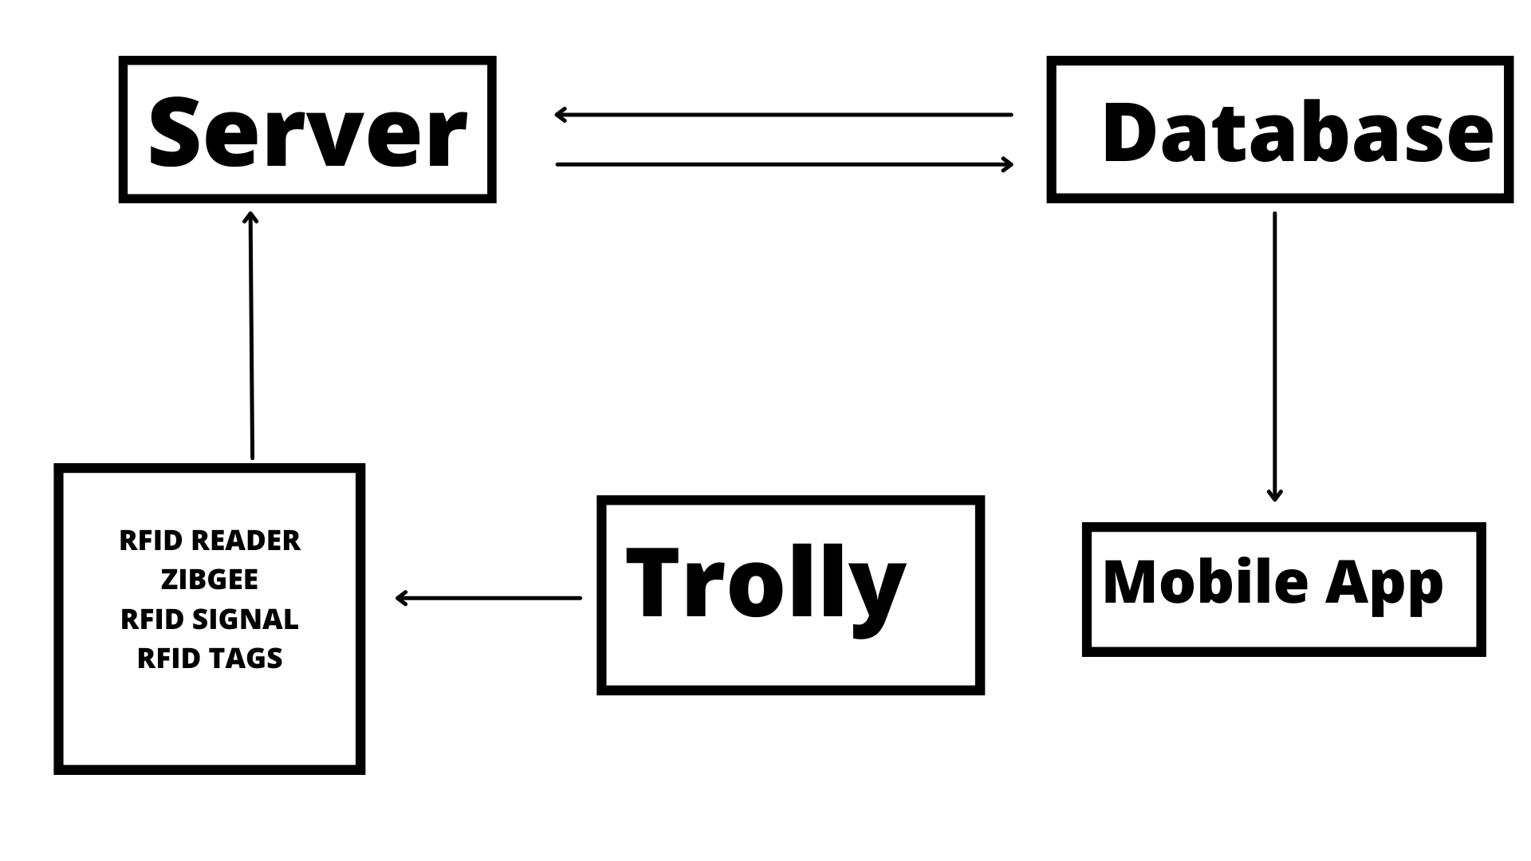

**Figure 6.1** : System Architecture

The above figure explains that the reader emits RF carrier pulses indefinitely and the server monitors the received RF signals for data. The existence of a tag (for the purposes of this article, only passive tags are considered) modulates the rf field, which is sensed by the reader.When enough energy is obtained from the rf field generated by the reader, the passive tag collects a small fraction of the energy emitted by the reader and begins delivering modulated information. It's worth noting that data modulation (modulation for 0s and 1s) can be done via direct modulation, FSK, or Phase modulation.The reader demodulates and decodes the signals received from the tag antenna for further processing.

**6.1.2 Module Design**

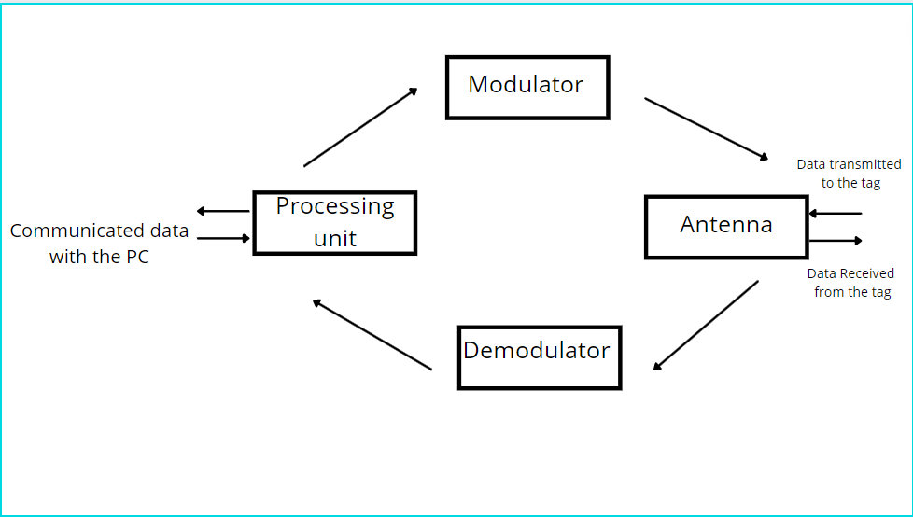**Figure 6.2** : RFID Reader

The above diagram explains handshaking of RFID tag well with interrogator (reader)

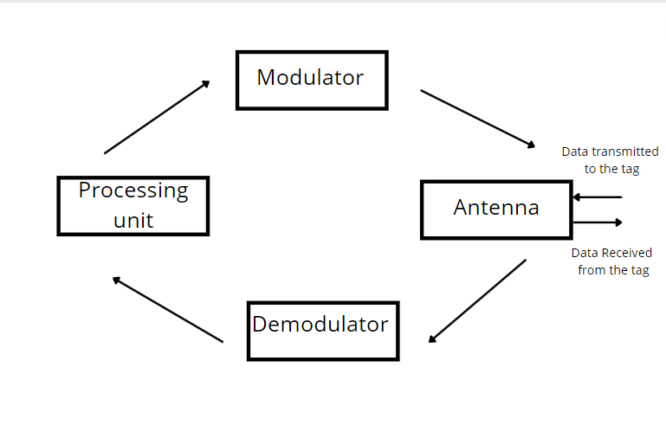

**Figure 6.3**: RFID tag

The above diagram shows a simplified block schematic of an RFID tag (also known as a transponder). The tag's various components are shown in the figure. Normally, the antenna is located outside of the tag chip and is quite large.

**6.2 Detailed Design**

**6.2.1 Data Flow Diagram**

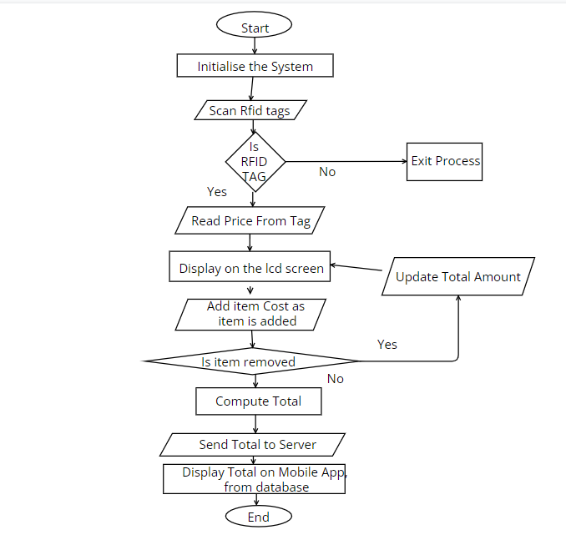

**Figure 6.4** : Data Flow Diagram

**6.2.2 Use case Diagram**

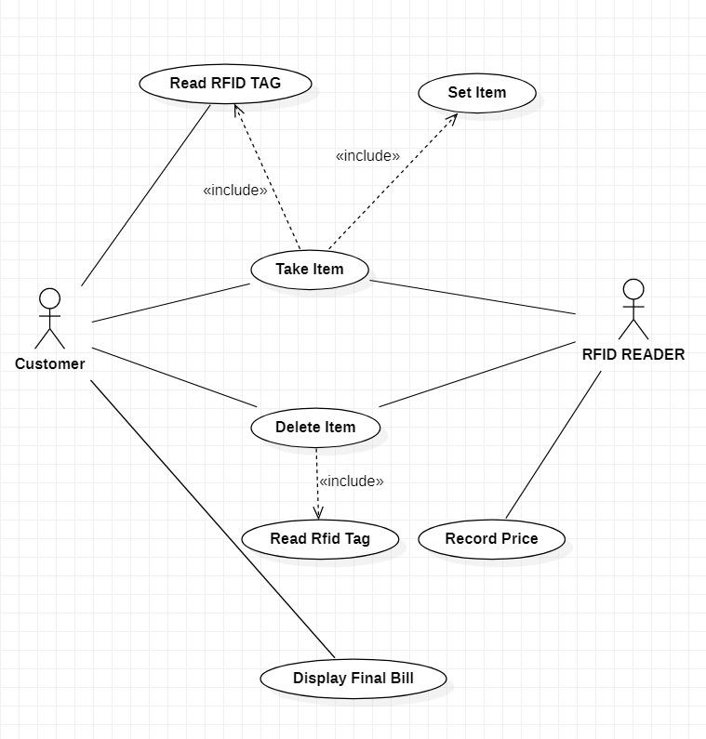

**Figure 6.5** : Use case diagram

**CHAPTER 7**

**APPLICATIONS**

Few supermarkets have a digital presence that allows customers to buy things online, but none have apps for various in-store interactions. We can now effortlessly integrate technologies into one's lifestyle and improve customer experience in today's technological world. The way firms operate is changing dramatically as a result of digital transformation. Android is one of the world's most popular operating systems. It is changing the way the technological sector operates. By acting as a digital assistant, an android-based application can efficiently fulfil the objective of assisting clients in shopping.

With the help of the proposed system it will be possible to solve some of the frequent challenges faced by customers at shopping stores as a result of our research, and present a solution in the form of an android application. Customers can use the application to control smart shopping carts. It can be used to locate products in a supermarket without the help of employees. Users can find products in the store using a store-specific map. The manual tab was created with window shoppers in mind. When items are placed in the shopping cart, RFID technology is used to scan them automatically. You can see all of the goods you've bought and how much they cost. This allows users to keep track of their spending while shopping.

Thousands of shopping trolleys go missing from supermarkets every year. Usually, they wind up in rivers, canals, or people's backyards. Local governments are already levying fees on supermarkets for removing them from local waterways.Trolleys, like roll cages, have similar issues. They're metal, may be stacked, and are subject to hard handling (watch how people push a trolley into the Trolley Park after they've finished shopping and emptied it). Also, due to the nature of supermarkets (which are fairly open plan), it is very easy for shoplifters to put goods into a cart and escape the store without paying.

You may ensure that a trolley entering the store can only exit after passing through a payment point by tagging the trolleys and strategically placing readers throughout the store and in the parking lot. Similarly, by placing readers at car park exits, you may prevent trolleys from being carried off the grounds.Having knowledge of where trolleys are, as well as the ability to record maintenance history, can help with asset tracking. Specific consumers' buying / waking behaviours can be tracked throughout the store by placing readers throughout the aisles and then tying the trolley to a loyalty card. Customer-specific marketing can be advertised as the trolley approaches and is read by the reader by attaching readers in the aisles to displays.

The project has shown that RF tags can be used for a wide variety of purposes. Historically, the cost justification for a given application has been the principal impediment to implementation. The comprehensive functionality demonstrated is supposed to allow implementers to use a WID tag for a variety of applications, enhancing the advantages and boosting the return on investment.

This, together with continued developments in WID technology, will make it more appealing to a broader audience.

**CHAPTER 8**

**CONCLUSION**

The system offers a way to improve the speed with which things can be purchased as well as the speed with which payments can be made.Also providing a technology-driven, low-cost, scalable, and durable solution for supporting in-person shopping.In the case of RFID, no "line of sight" is necessary, which decreases the time it takes to scan the product and enables for more proactive, real-time tracking.The system provides a technology-driven RFID shopping system, which is both scalable and cost-effective.The method mainly focuses on saving the customer, the owner, and the supplier time, energy, and labour.Noting down the key features of RFID technology It's not a direct line of sight.To be read / written, WID tags must be visible.

Robust - Main feature of RFID tag is that it can be enclosed in tough material because they don't have to be visible.They are being protected from the environment in which they are being used. This implies that they have the potential to be. Used in harsh fluid and chemical environments, as well as in situations where there is a lot of movement.

Readspeed - Tass can be read from a long distance (particularly the active version) and can also be read from a short distance.Very quick reading. This is particularly beneficial when the items to be detected are little.On a conveyor, for example, moving swiftly.Several things are being read at the same time-A number of tagged things can be read at the same time in an RF field. This isn't going to work. It's the same with "visible" identifiers.

Security - Tags are significantly more difficult to mess with because they are contained. A unique identity (Serial Identification) is now included on a range of tag kinds that is guaranteed to be unique around the world.

Programmability - Many tags can be read and written, rather than being read-only. This means that data can be added to the tag to show that the thing being tagged has gone through a certain process or that its condition or status has changed in some way. Or, in some circumstances, to keep information about the tagged items, such as the results of a test.

In most situations where tags are employed, a combination of the technological advantages listed above (as well as the price) justifies their use. The uses discussed range from the mundane to the bizarre. Although space constraints limit the number of cases present in this work, have made an effort to keep them diverse. Hopefully, the variety will spark ideas and demonstrate how RFID technology may be applied to unique operational advantages.

**CHAPTER 9**

**BIBLIOGRAPHY**

[1] Applications on Secure Smart Shopping System Suhas B.M1, Tanu.N.Prabhu 2.

*International Research Journal of Engineering and Technology (IRJET) e-ISSN: 2395-0056 Volume: 05 Issue: 02 | Feb-2018*

[2] 2018, Purva S. Puranik1 , Parikshit N. Mahalle2 IoT Application on Smart and Secure Shopping System using RFID, Zig-Bee and Gossamer Protocol. *International Journal of Engineering and Techniques - Volume 4 Issue 3, May - June 2018*

[3] SMART SHOPPING TROLLEY USING RFID P.T. Sivagurunathan# ,P. Seema*, M. Shalini*.I*nternational Journal of Pure and Applied Mathematics Volume 118 No. 20 2018,*

[4] Binary search algorithm of RFID system in supermarket shopping information identification.

*Wu et al. EURASIP Journal on Wireless Communications and Networking (2019) 2019:27*

[5] Smart Cart For Automatic Billing With Integrated Rfid System Shaikh Farhan Shahnoor1 , Ravi Kumar2 , Manish Rathore3 , Shivashish Saha4 , Raji C. *Turkish Journal of Computer and Mathematics Education V ol.12 No.12 (2021), 2487-2493 Research Article 2487*

6] Vallabhuni, R.R., Lakshmanachari, S., Avanthi, G. and Vijay, V., 2020, December. Smart Cart Shopping System with an RFID Interface for Human Assistance. In *2020 3rd International Conference on Intelligent Sustainable Systems (ICISS)* (pp. 165-169). IEEE.

[7] Athauda, T., Marin, J.C.L., Lee, J. and Karmakar, N.C., 2018. Robust low-cost UHF RFID based smart shopping trolley. *IEEE journal of radio frequency identification*, *2*(3), pp.134-143.

[8] Li, R., Song, T., Capurso, N., Yu, J., Couture, J. and Cheng, X., 2017. IoT applications on secure smart shopping systems. *IEEE Internet of Things Journal*, *4*(6), pp.1945-1954.

[9] Nithiavathy, R., Shree, R.A., Kumar, S.P. and Raghul, S., 2021, May. Arduino enabled IoT based Smart Shopping Trolley. In *Journal of Physics: Conference Series* (Vol. 1916, No. 1, p. 012203). IOP Publishing.

[10] Ballestín, F., Pérez, Á., Lino, P., Quintanilla, S. and Valls, V., 2019. Static and dynamic policies with RFID for the scheduling of retrieval and storage warehouse operations. *Computers & Industrial Engineering*, *66*(4), pp.696-709.

[11] M. Shahroz, M. F. Mushtaq, M. Ahmad, S. Ullah, A. Mehmood and G. S. Choi, "IoT-Based Smart Shopping Cart Using Radio Frequency Identification," in IEEE Access, vol. 8, pp. 68426-68438, 2020, doi: 10.1109/ACCESS.2020.2986681.

[12] P. Chandrasekar and T. Sangeetha, "Smart shopping cart with automatic billing system through RFID and ZigBee," International Conference on Information Communication and Embedded Systems (ICICES2014), 2014, pp. 1-4, doi: 10.1109/ICICES.2014.7033996.

[13] R. Li, T. Song, N. Capurso, J. Yu, J. Couture and X. Cheng, "IoT Applications on Secure

Smart Shopping System," in IEEE Internet of Things Journal, vol. 4, no. 6, pp. 1945-1954, Dec. 2017, doi: 10.1109/JIOT.2017.2706698.

[14] T. Athauda, J. C. L. Marin, J. Lee and N. C. Karmakar, "Robust Low-Cost Passive UHF RFID Based Smart Shopping Trolley," in IEEE Journal of Radio Frequency Identification, vol. 2, no. 3, pp. 134-143, Sept. 2018, doi: 10.1109/JRFID.2018.2866087.

[15] S. Mekruksavanich, "Supermarket Shopping System using RFID as the IoT Application," 2020 Joint International Conference on Digital Arts, Media and Technology with ECTI Northern Section Conference on Electrical, Electronics, Computer and Telecommunications Engineering (ECTI DAMT & NCON), 2020, pp. 83-86, doi: 10.1109/ECTIDAMTNCON48261.2020.9090714.