Report: Project 3 – Chord Protocol in Scala

Students: Chiranjib Sur (UFID : 2531 4396)

Pramit Dutta (UFID : 7513 2433)

Course: COP 5615: Distributed Operating Systems Principles

**Tool used for the code:** **IntelliJ** IDEA

**System Configuration Snapshot:**

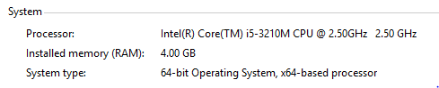

**How to run the code:**

**For the Non-failure Model**.

Run the command in terminal

project3.scala numNodes numRequests

where

numNodes is any numerical value

numRequests is any numerical value (related to m where 2^m is the size of the ring)

**For the Failure Model.**

Run the command in terminal

project3.scala numNodes numRequests

where

numNodes is any numerical value

numRequests is any numerical value (related to m where 2^m is the size of the ring)

The details of the findings and analysis is provided in the folder Report.