Report: Project 4 Part 2 – Facebook Application API in Scala with Security

Students: Chiranjib Sur (UFID : 2531 4396)

Pramit Dutta (UFID : 7513 2433)

Course: COP 5615: Distributed Operating Systems Principles

**Tool used for the code:** **IntelliJ** IDEA

**System Configuration Snapshot:**

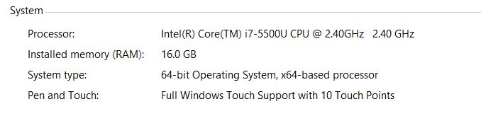

**How to run the code:**

Open both the Projects in **IntelliJ** IDEA.

Start the Server project (named as “project4” folder)

Start the Client project (named as “Project4_1” folder)

Client project will run some scripts and the output will be shown. The Server project is set to default that is “http://localhost:8080”

The details of the findings and analysis is provided in the folder Report.