Report: Project 2 – Gossip Protocol in Scala (With Failure)

Students: Chiranjib Sur (UFID : 2531 4396)

Pramit Dutta (UFID : 7513 2433)

Course: COP 5615: Distributed Operating Systems Principles

**Tool used for the code:** **IntelliJ** IDEA

**System Configuration Snapshot:**

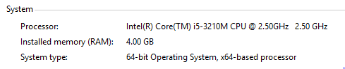

**How to run the code:**

**For the Non-failure Model**.

Run the command in terminal

project2.scala numNodes topology algorithm

where

numNodes is any numerical value

topology is among (“Full”, “Line”, “3D”, “3Dimp”)

algorithm is either “Gossip” or “PushSum”

**For the Failure Model.**

Run the command in terminal

project2-bonus.scala numNodes topology algorithm

where

numNodes is any numerical value

topology is among (“Full”, “Line”, “3D”, “3Dimp”)

algorithm is either “Gossip” or “PushSum”

The details of the findings and analysis is provided in the folder Report.