

Module 7 : XN Group Project Report
Professor: Ajit Appari
Course: ALY6080: Integrated Experiential Learning

Submitted by:

Jian Su,
Pramitha Reddy Kolanu,
Promise Gbama,
Sai Koushal Nakka

Date:11-7-2023

Table of Contents
1. INTRODUCTION 3
2. DATASET DESCRIPTION 3
3. DATA PREPROCESSING 4
4. EXPLORATORY DATA ANALYSIS 7
4.1 Data Distributions and Visualizations 7
4.2 Patient Age Distribution: 7
4.3 Patient Sex Distribution: 7
4.4 View Position Distribution: 8
4.5 Pneumothorax Distribution: 9
4.6 Pneumothorax Presence by Gender: 10
5. IMAGES WITH AND WITHOUT PNEUMOTHORAX 11
6. FUTURE PLAN 13
6.1 Deep Learning Model (Convolutional Neural Network - CNN) 13
6.2 Decision Tree Model (DTM) 13
6.3 Random Forest Model 13
6.4 Support Vector Machine (SVM) 14
7. REFERENCES 15

PREDICTIVE ANALYSIS OF PNEUMOTHORAX PRESENCE USING ADVANCED MACHINE LEARNING TECHNIQUES

1. INTRODUCTION

CLOUDPORT has embarked on an innovative project leveraging artificial intelligence (AI) to pioneer a predictive medical diagnostic model using medical imaging as its source. At its heart, this initiative involves the creation of an AI solution with the ambitious goal of accurately forecasting pneumothorax occurrence; an essential condition characterized by lung collapse that radiologists must identify through medical imaging tests. Recognizing subtle cues within images accurately is paramount. This project leverages a historical DICOM (Digital Imaging and Communications in Medicine) image dataset - the industry standard for medical imaging information storage and transmission - as the foundation of training an AI model with pneumothorax detection masks. These masks serve a crucial function by providing AI models with essential ground truth data they can learn from.

The success of this undertaking depends upon an AI model's ability to meet or surpass a benchmark accuracy rate of 75%, both to validate its use in clinical settings as well as advance machine learning use within healthcare. To this end, various machine learning techniques including convolutional neural networks (CNNs) known for image recognition and classification tasks will be deployed within this endeavor. This project's overarching objective goes far beyond simply analyzing image data; rather, it aims to create an efficient diagnostic tool that facilitates earlier detection and intervention - potentially saving lives through earlier diagnosis and intervention. As such, XN Group remains dedicated to refining its model's design and optimizing its algorithms to exploit AI fully for healthcare advancement.

2. DATASET DESCRIPTION

The dataset is a collection of medical imaging data designed specifically to aid in the analysis and detection of pneumothorax conditions. This dataset is formatted using DICOM, which is the standard protocol for managing and transmitting medical imaging information, with each image assigned a unique identifier known as an "ImageId", which correlates to its annotation data.

Annotations in this dataset consist of run-length-encoded (RLE) masks. These two-value binary masks represent regions where pneumothorax (when the lung collapses) occurs within images and serve as an efficient storage medium; when an image shows pneumothorax, these RLE masks highlight affected areas for efficient AI training, providing another tool in training AI algorithms to detect medical events more reliably. Unusual to this dataset are images with multiple annotations attached to them, possibly reflecting multiple instances or evaluations of pneumothorax within a single image, or differing interpretations by medical professionals and annotation tools. Images without signs of pneumothorax are identified by assigning the mask a value of -1; this allows machine learning models to quickly learn and predict.

The objectives of analysis are two-fold: firstly, to predict pneumothorax within test images; and secondly, to delineate its location and extent if present. Models developed will be trained to generate binary masks using RLE; this form of RLE involves sequential determination of pixels locations from previous runs so as to create compact representations of masks.

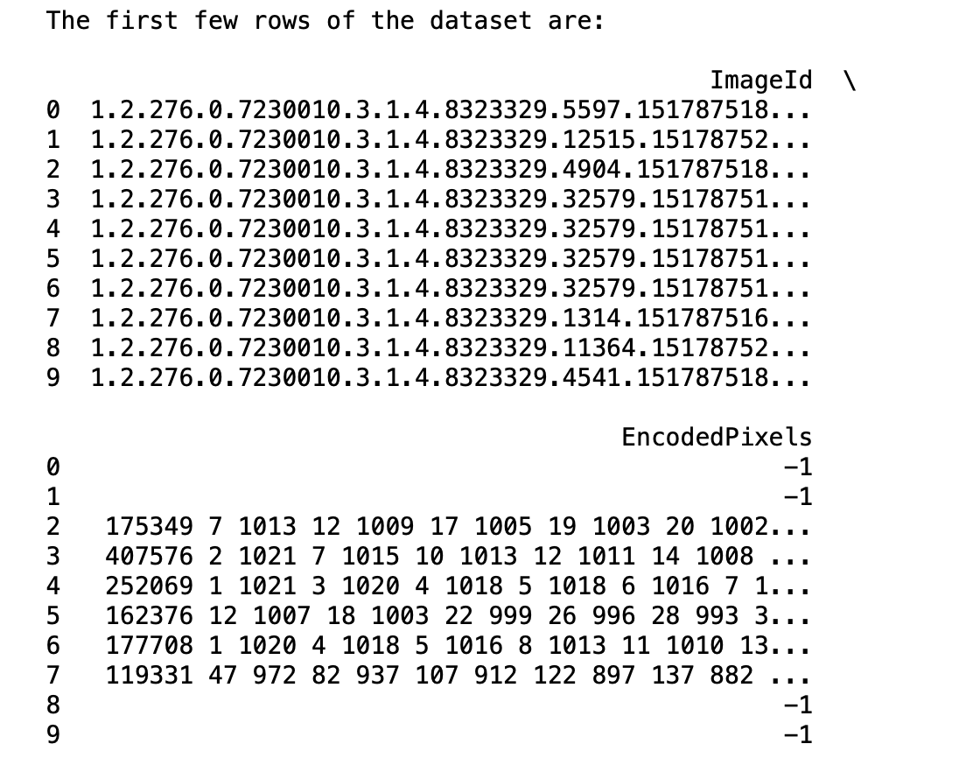

The dataset's structure is straightforward, with only two columns essential to machine learning: ImageId and EncodedPixels - each playing an essential role. ImageId serves as a reference point for each image while EncodedPixels provide essential data needed to detect pneumothorax presence within images and mark pneumothorax presence with encoded masks that serve both as ground truth for training AI models as well as benchmark for measuring their ability to accurately replicate expert annotations.

3. DATA PREPROCESSING

Data preprocessing is an integral part of machine learning algorithm analysis and application. In this project, our initial dataset comprised 11,582 rows that represented images with associated annotations. There were no duplicate rows or null values detected indicating an orderly state to allow for easy preprocessing steps.

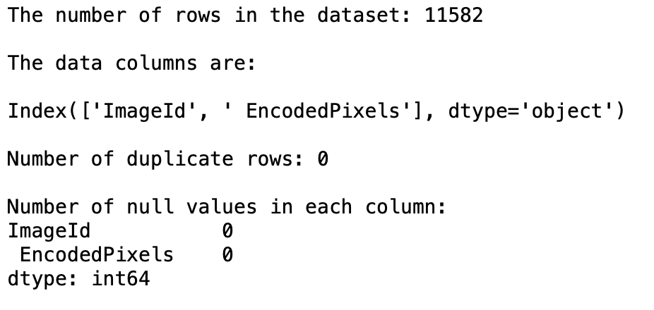

Though free from null values, the dataset still included 1,531 duplicate 'ImageIds. It was noted that no two duplicates shared identical encoded pixels, indicating different annotations for regions affected by pneumothorax in images. To further refine this dataset, a consolidation process was conducted by consolidating all RLE annotations associated with each duplicate 'ImageId' into a comprehensive mask; this led to creating a CSV file named final_combined_rle which underwent its duplicate check, which showed no duplicate rows and confirmed no null values among its 10,675 entries.

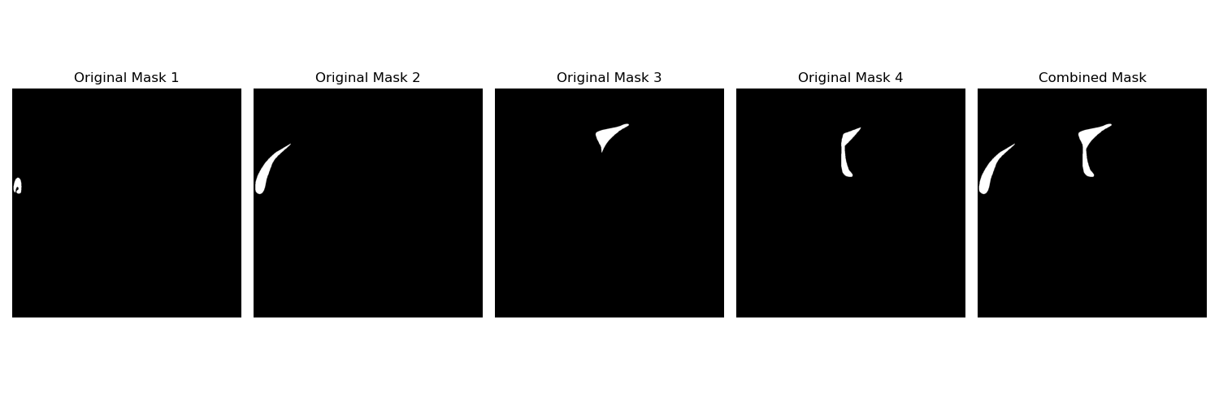

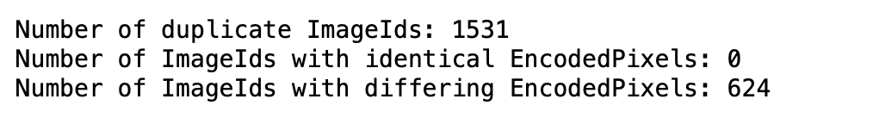

Next, attention was drawn to extracting DICOM metadata, gathering various tags such as 'PatientAge', 'Modality' and 'ViewPosition' into another CSV file labelled 'dicom-metadata' before merging it with the final_combined_rle dataset using ImageId and EncodedPixels to form combined-metadata dataset. Following inspection for missing values within these columns (AccessionNumber/PatientBirthDate/StudyID), all these columns deemed unimportant to analysis thus remaining as-is.

Descriptive statistics for the combined metadata dataset demonstrated consistent data across most DICOM-specific fields, with outliers only evident in PatientAge field. On closer examination, two entries stood out as significant outliers due to being human errors - due to this decision was made not to remove these outliers as they did not seem likely to significantly hinder machine learning task performance.

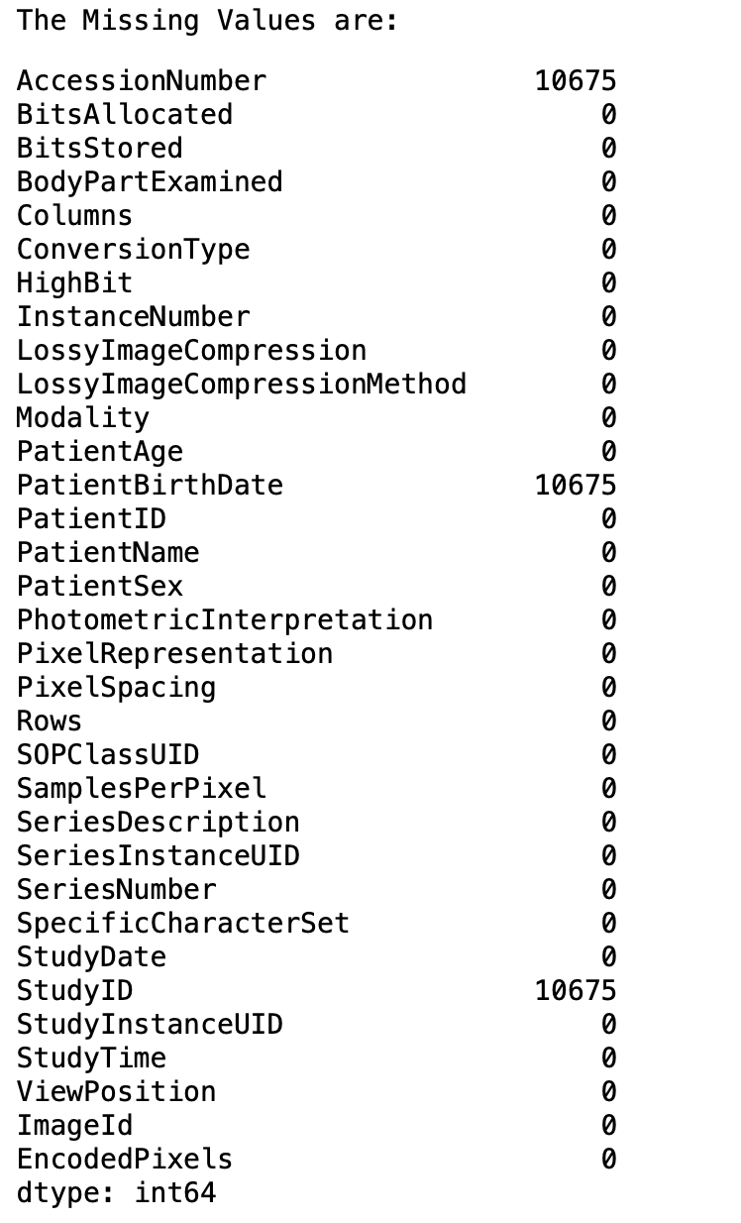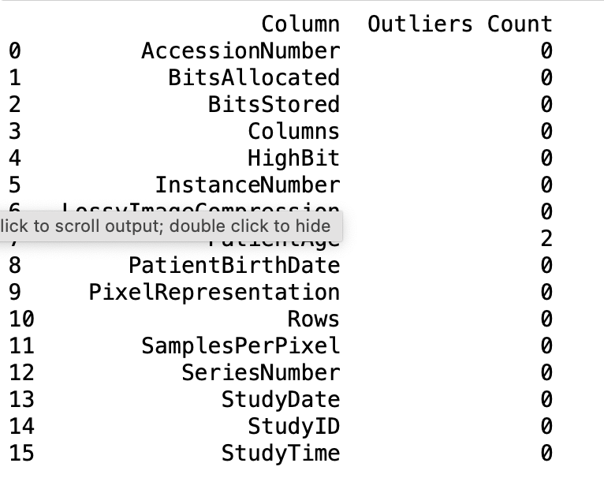

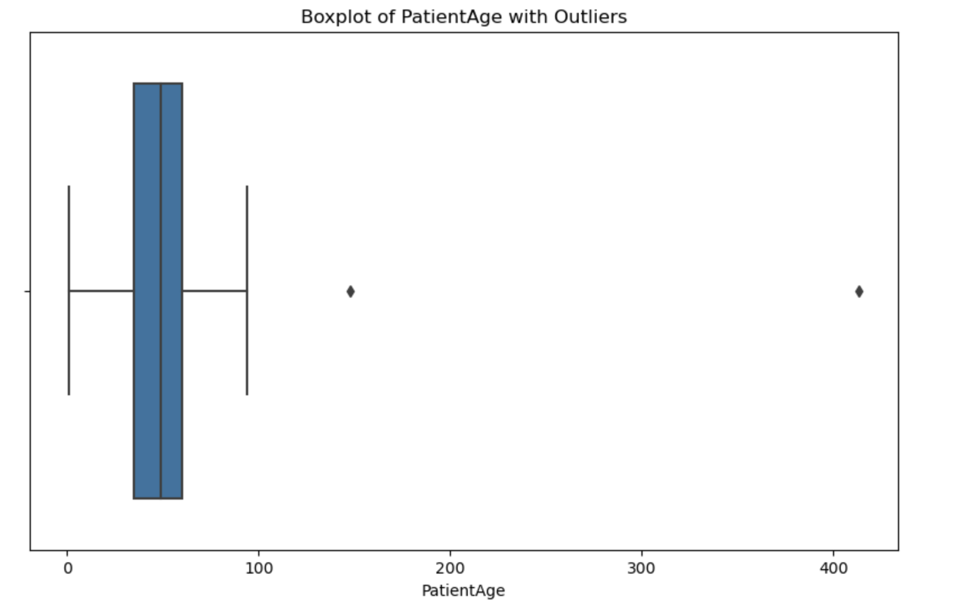

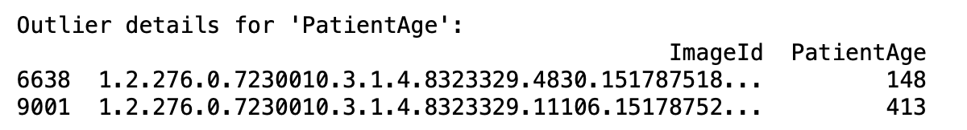

This final dataset, now free from duplications and null values and with a combined and enhanced feature set, was considered ready for subsequent stages of machine learning model development. This rigorous data preprocessing was intended to ensure the training and validation phases could proceed efficiently based on representative, clean data that boosted accuracy in prediction models.

4. EXPLORATORY DATA ANALYSIS

4.1 Data Distributions and Visualizations

To gain a comprehensive understanding of the dataset's characteristics, we ventured into Exploratory Data Analysis (EDA). This phase involved the examination of data distributions and the creation of insightful visualizations.

4.2 Patient Age Distribution:

In our first exploration, we visualized the distribution of patient ages. This distribution, portrayed through a histogram and a kernel density estimate (KDE) plot, offers insights into the age demographics of the patient population within the dataset. The distribution's shape, central tendency, and spread provide crucial information for subsequent analyses.

Here's the visualisation chart:

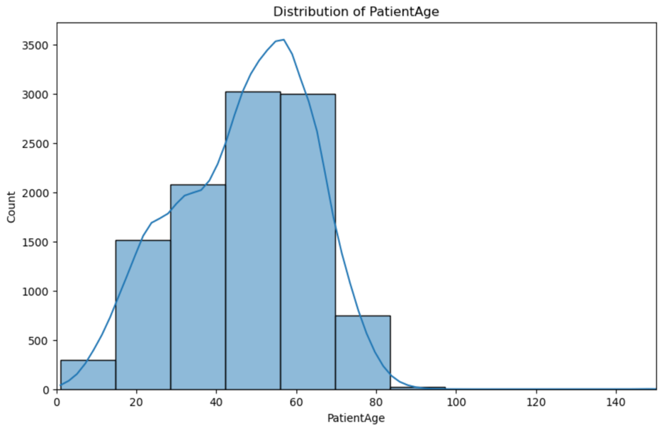

The "Patient Age Distribution" chart vividly displays the age-related demographics of the dataset's patient population. It displays a striking spike in patient frequency between 40-60 years old, suggesting a greater prevalence of medical imaging within this demographic. Patient count increases steadily until middle age before gradually declining after that. This insight into age distribution helps identify which age groups are more commonly associated with specific medical conditions represented in the dataset and demonstrates its significance as an analytical factor.

4.3 Patient Sex Distribution:

The "Patient Sex Distribution" chart displays that 55.08% (5880) of our medical imaging dataset consists of male subjects while 44.92% (4795) consist of female subjects, highlighting an imbalance with more male subjects. This finding is particularly significant as disease prevalence varies according to gender, potentially impacting the representation of certain conditions by male-dominated exams.

Here’s the data visualization chart:

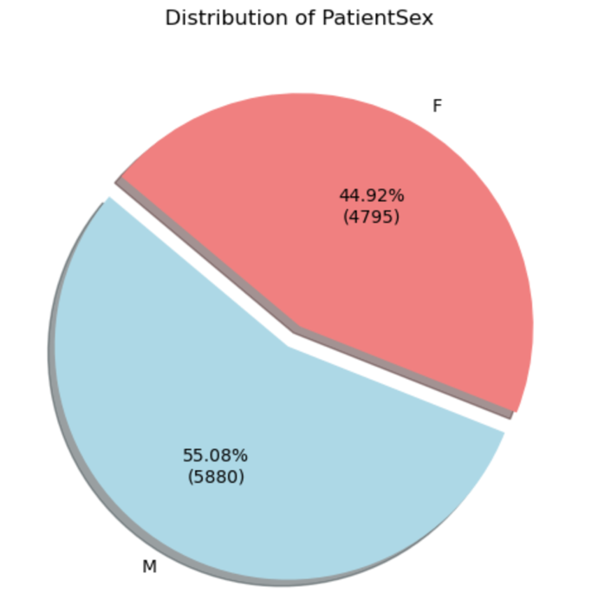

Understanding this gender split is vital for medical research using this dataset to examine gender disparities in disease incidence. The chart helps visualize its diversity for tailored diagnosis and treatment.

4.4 View Position Distribution:

Our analysis included examining the distribution of image view positions using a count plot to compare Anteroposterior (AP) and Posteroanterior (PA) views. The "View Position Distribution" chart highlights the predominance of PA views (6494 instances) over AP views (4181) in our medical imaging dataset, suggesting PA positioning might be preferred; however AP views still hold significance for certain diagnoses.

This chart is of immense benefit for medical professionals and researchers, showing the necessity of considering both view types when conducting analysis or diagnosis. It confirms the prevalence of PA views while emphasizing their significance within datasets and their diagnostic significance.

Here's the data visualization chart:

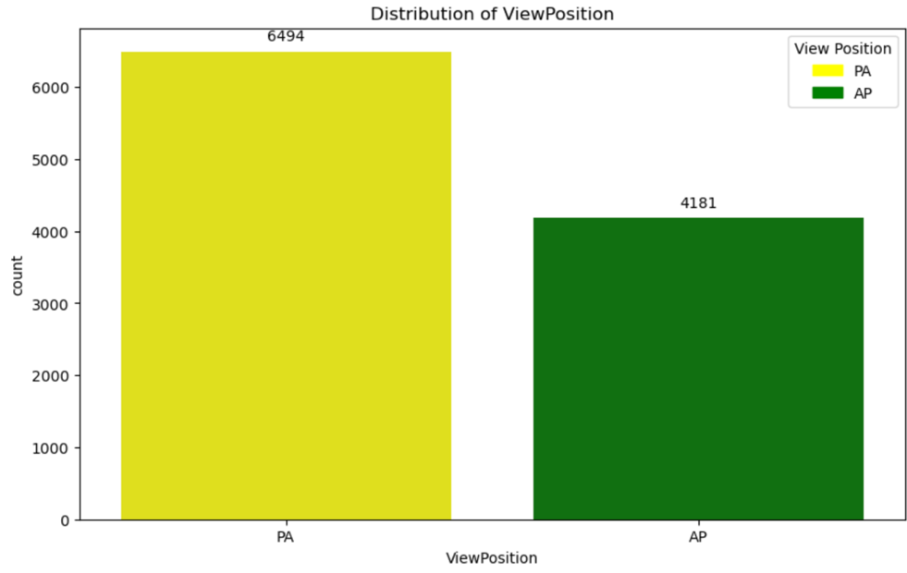

In essence, this chart offers key insights into patient positioning techniques with more emphasis on PA views but still acknowledges AP views for comprehensive image interpretation and treatment planning.

4.5 Pneumothorax Distribution:

The "Pneumothorax Distribution" chart is essential for accurately detecting both pneumothorax's presence and absence. The pink section indicates 22.3% or 2379 cases with pneumothorax; its rarity yet importance should not be overlooked when it comes to patient care. Meanwhile, blue shows 77.7% of cases (8296 in total) lacking pneumothorax altogether - underscoring both its rarity and significance for care delivery. Distribution is essential to both pneumothorax treatment and research on chest and lung conditions, providing researchers with valuable data for studying non-pneumothorax conditions that might otherwise go undetected.

Overall, the chart serves an invaluable purpose in distinguishing pneumothorax cases and emphasizing their need for precise diagnosis and treatment, as well as supporting extensive medical research that furthers our understanding of both clinical utility and research potential for this dataset.

Here’s the data visualization chart:

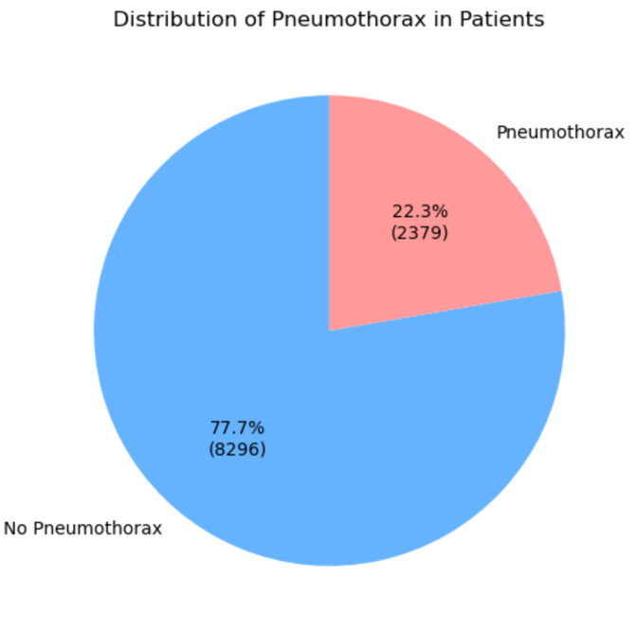

4.6 Pneumothorax Presence by Gender:

The chart "Pneumothorax Presence by Gender" graphically displays these findings. It displays counts in thousands, while gender is separated on its X-axis. Of females ('F') 3742 were free from pneumothorax while 1053 did, suggesting lower prevalence compared to males; 4554 males ('M') were pneumothorax-free while 1326 had it, underscoring the importance of gender-specific medical care.

Here's the data visualization chart:

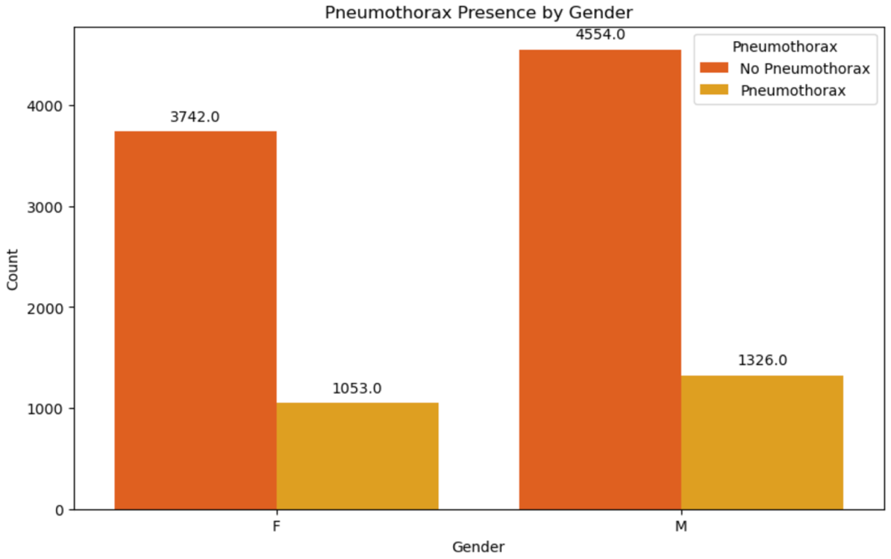

This visual aid is essential in understanding the gender distribution of pneumothorax among patient populations, emphasizing both those without the condition and those affected.

5. IMAGES WITH AND WITHOUT PNEUMOTHORAX

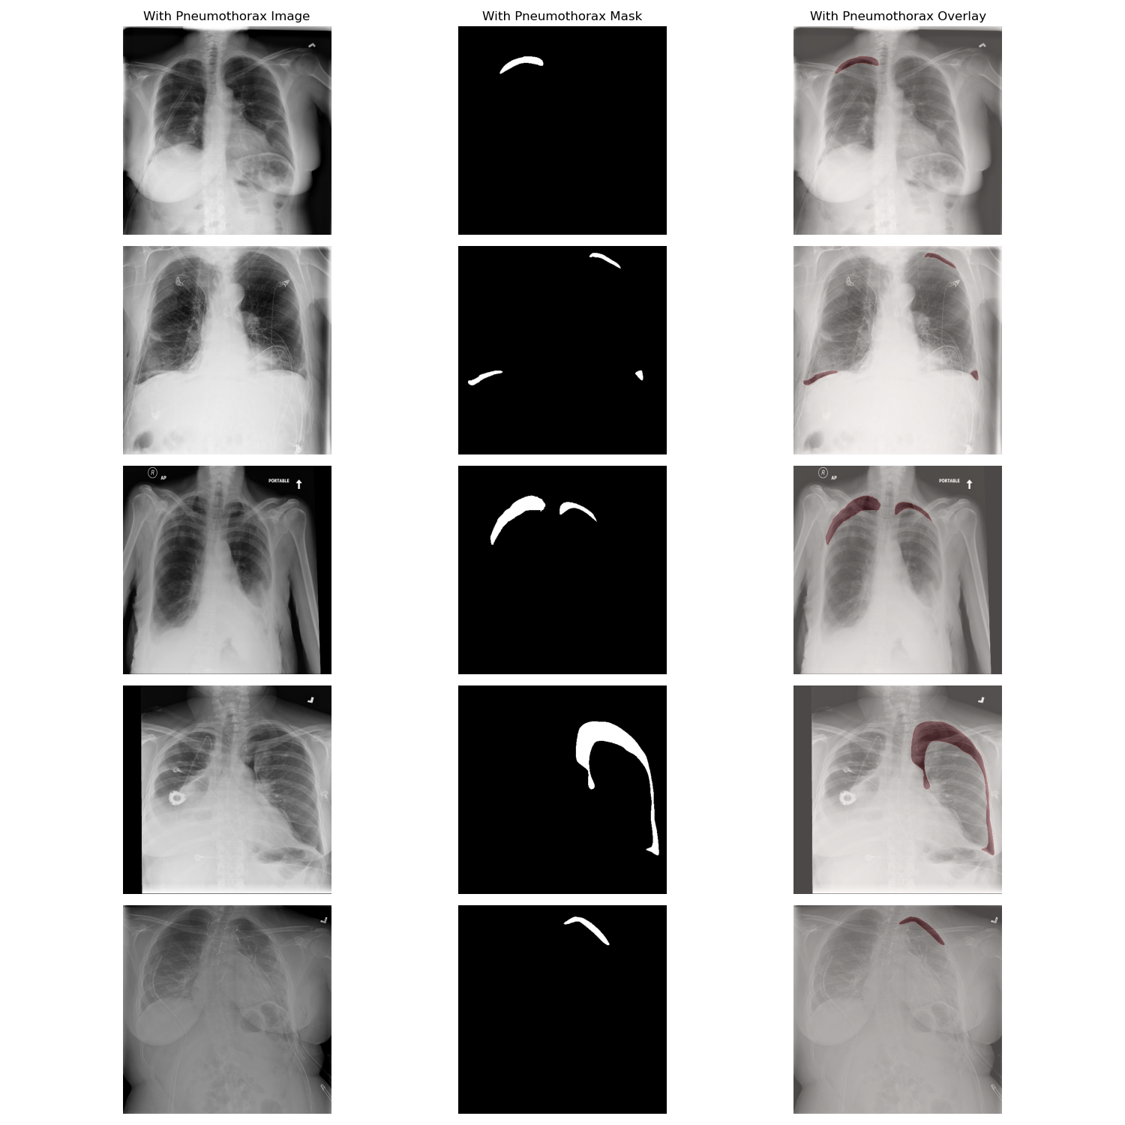

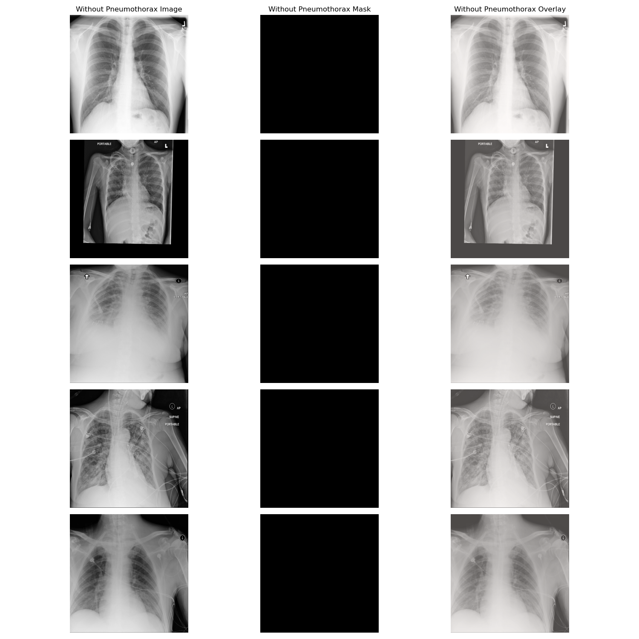

6. FUTURE PLAN

After meticulously preprocessing data, the next steps would involve preparing the dataset for machine learning algorithms to predict pneumothorax presence. Here are three proposed tasks for each algorithm and an additional task as part of this step:

6.1 Deep Learning Model (Convolutional Neural Network - CNN)

Sampling: To ensure an appropriate balance in both training and validation datasets between cases with and without pneumothorax.

Feature Engineering: To increase artificially and introduce variability into a dataset. This could involve rotation, translation, zoom or flip operations as well as normalizing pixel values to facilitate model convergence.
Convert RLE masks into binary mask matrices so the model can use them as target outputs.

Model Development: To develop the model, design a CNN architecture consisting of multiple convolutional and pooling layers in order to extract features from images. Also employ dropout layers in order to avoid overfitting, as well as batch normalization to accelerate training processes.

6.2 Decision Tree Model (DTM)

Sampling: For optimal decision tree performance, balance your dataset by either under or over-sampling methods in order to obtain evenly distributed data sets. Decision trees may become sensitive when exposed to disparate sets of information.

Feature Engineering: Utilizing DICOM metadata such as patient demographics to supplement image-derived features. Convert RLE-encoded data into structured features describing pneumothorax regions' shape and size.

Model Development: Determine the optimal depth of tree to ensure sufficient learning without overfitting, using feature importance scores to identify and retain key features in predicting outcomes.

6.3 Random Forest Model

Sampling: In line with decision trees, sampling should ensure the dataset is balanced. While random forests may handle imbalance better, it's still advised to balance classes as much as possible.

Feature Engineering: To select and create the most pertinent features from image data. - Utilizing methods such as recursive feature elimination or other feature importance evaluation methods for selecting these features. Additionally, create additional features which capture textural and shape characteristics of lung images to make an accurate depiction.

Model Development: Construct an ensemble of decision trees using random features and samples in order to increase robustness and accuracy of the model. Optimize number of trees as well as maximum features per tree for improved performance.

6.4 Support Vector Machine (SVM)

Sampling: Utilize similar stratified sampling techniques across training and validation sets in order to maintain a uniform proportion of classes across each.

Feature Engineering: Use principal component analysis (PCA) or other dimensionality reduction techniques to reduce feature space while still retaining most of its variance. Use kernel trick transformation of input space into higher dimensions that make linear segregation of data simpler.

Model Development: To select suitable kernel functions (linear, polynomial or radial basis functions) based on feature space analysis. Additionally, tune hyperparameters like C (penalty parameter) and Gamma to find optimal decision boundary settings.

Each model requires its own approach to sampling, feature engineering and model development. Deep learning relies heavily on raw image data for complex patterns; decision tree and random forest models prefer carefully engineered features which have more interpretability; SVM can handle high-dimensional spaces more effectively; in turn the next steps would involve iterative cycles of training, validation and hyperparameter tuning to reach maximum predictive performance.

7. REFERENCES

- Varma, D. R. (2012). Managing DICOM images: Tips and tricks for the radiologist. Indian Journal of Radiology and Imaging, 22(01), 4-13.

- Khan, M. Z., Gajendran, M. K., Lee, Y., & Khan, M. A. (2021). Deep neural architectures for medical image semantic segmentation. IEEE Access, 9, 83002-83024.

- Santosh, K. C., Antani, S., Guru, D. S., & Dey, N. (Eds.). (2019). Medical imaging: artificial intelligence, image recognition, and machine learning techniques. CRC Press.

- Li, Z., Zuo, J., Zhang, C., & Sun, Y. (2021, January). Pneumothorax image segmentation and prediction with UNet++ and MSOF strategy. In 2021 IEEE International Conference on Consumer Electronics and Computer Engineering (ICCECE) (pp. 710-713). IEEE.

- Rajpurkar, P., Irvin, J., Zhu, K., Yang, B., Mehta, H., Duan, T., ... & Ng, A. Y. (2017). Chexnet: Radiologist-level pneumonia detection on chest x-rays with deep learning. arXiv preprint arXiv:1711.05225.

- Wiejak, J. S., Buxton, H., & Buxton, B. F. (1985). Convolution with separable masks for early image processing. Computer vision, graphics, and image processing, 32(3), 279-290.

- Röhrich, S., Schlegl, T., Bardach, C., Prosch, H., & Langs, G. (2020). Deep learning detection and quantification of pneumothorax in heterogeneous routine chest computed tomography. European radiology experimental, 4(1), 1-11.

