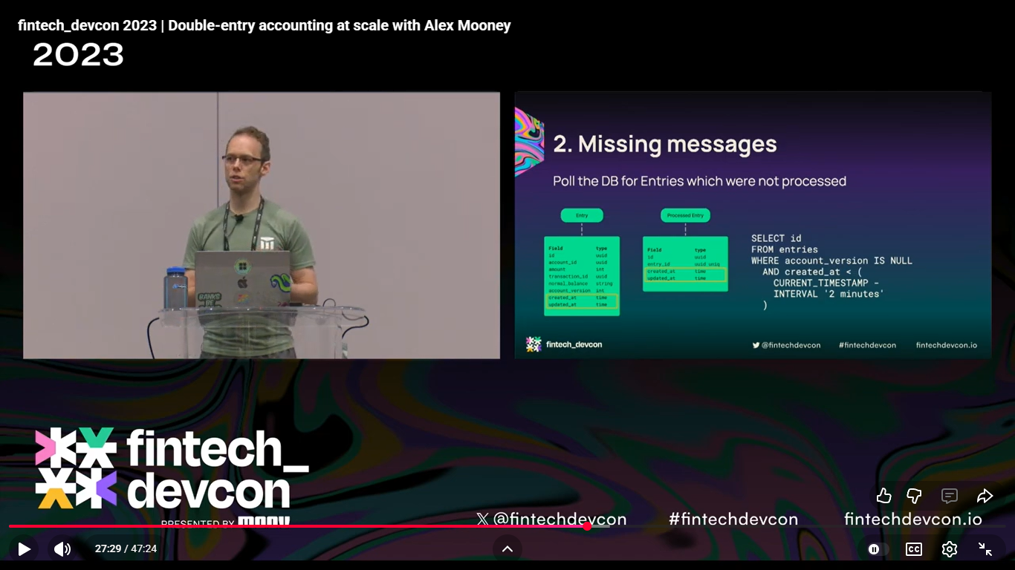
Double Entry Accounting Solutions at Scale: Link

