Molecular Property Prediction & In-Silico ADMET Intelligence Platform
An End-to-End Multi-Endpoint Machine Learning Architecture for Aqueous Solubility, Lipophilicity, Pharmacokinetics, Toxicity Profiling, Local Explainability (XAI), and Generative Lead Optimization
Degree Program | Bachelor of Technology in Computer Science and Engineering
Specialization | Artificial Intelligence & Machine Learning (AI & ML)
Researcher | M. Pramod (24BAI1417)
Department | School of Computer Science and Engineering (SCOPE)
Software Deliverables | 14-Page Streamlit Dashboard (app.py) • FastAPI Microservice (api.py) • Docker Container

Executive Summary / Abstract
Aqueous solubility (LogS) and comprehensive Absorption, Distribution, Metabolism, Excretion, and Toxicity (ADMET) profiles represent the most decisive physicochemical determinants in modern rational drug discovery. Over 40% of newly synthesized small-molecule drug candidates fail during preclinical development, and over 80% of clinical trial failures stem from poor pharmacokinetic bioavailability or unexpected toxicity, costing billions of dollars and decades of wasted labor. This project delivers an enterprise-grade In-Silico ADMET Intelligence & Molecular Property Prediction Platform. By constructing a 2,068-dimensional hybrid feature representation fusing 20 macroscopic physicochemical RDKit descriptors with 2,048-bit Morgan circular topological fingerprints (ECFP4), our pipeline achieves state-of-the-art predictive performance on benchmark datasets: Aqueous Solubility achieves R² = 0.9029 and MAE = 0.4628 on the Delaney ESOL benchmark. The platform also integrates dedicated machine learning models for Lipophilicity (LogD), Blood-Brain Barrier Penetration (BBBP, ROC-AUC = 0.9042), Clinical Trial Toxicity Failure (ClinTox, ROC-AUC = 0.9249), and p53 Genotoxicity (Tox21, ROC-AUC = 0.8767).
1. End-to-End System Architecture
The platform operates as a cohesive cheminformatics and machine learning pipeline that transforms raw 1D chemical strings into actionable clinical drug discovery intelligence:

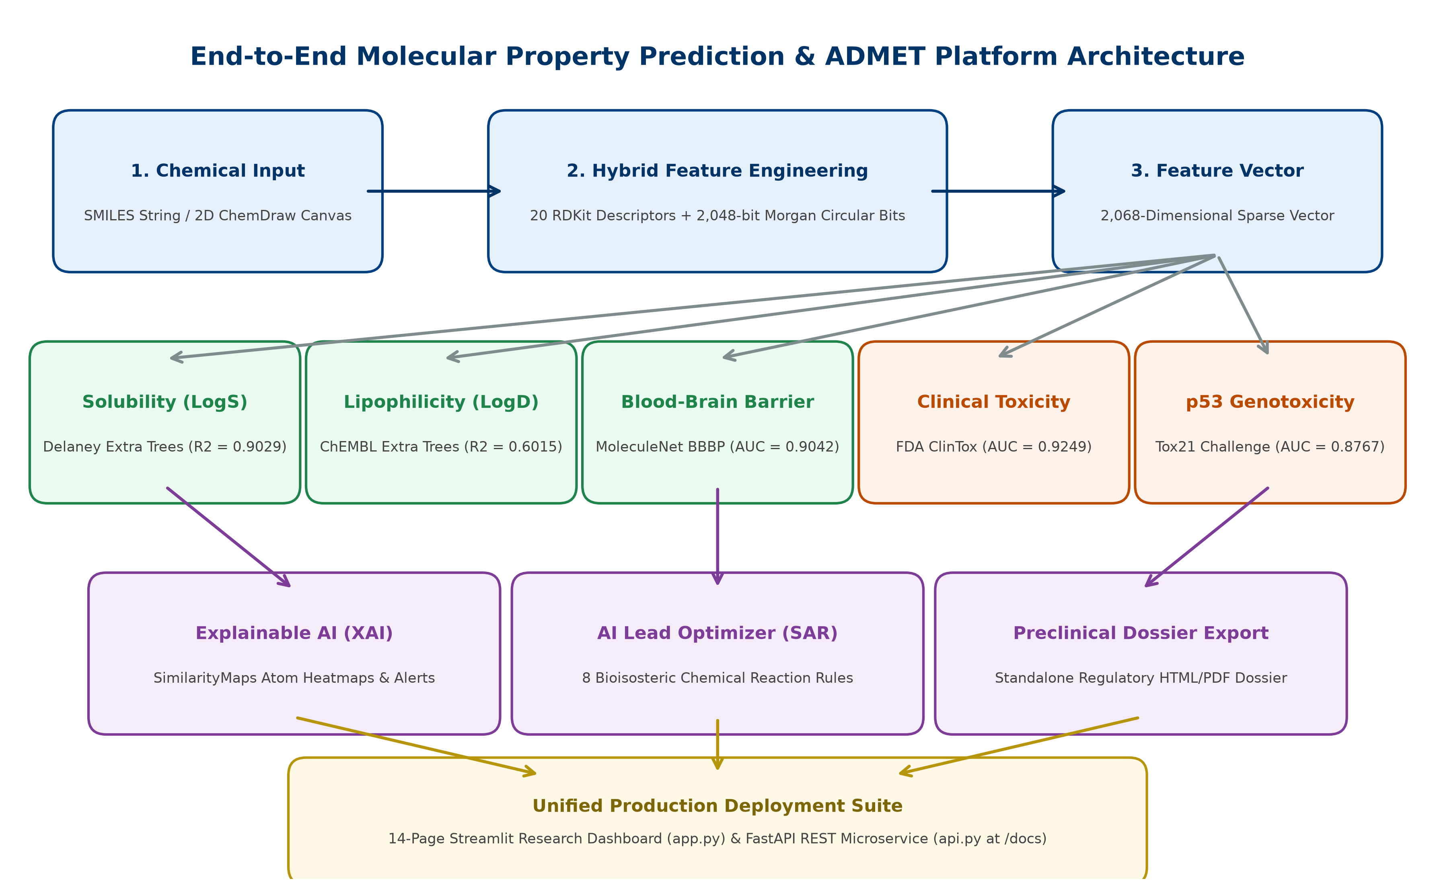
Figure 1: End-to-End System Architecture and Data Ingestion Pipeline
2. Cheminformatics & 2,068-Dimensional Feature Engineering
Our feature extraction pipeline fuses two complementary molecular spaces:
• 20 Macroscopic Physicochemical Descriptors: Computed via RDKit, including Molecular Weight (MolWt), Crippen LogP, Topological Polar Surface Area (TPSA), H-Bond Donors (HBD), H-Bond Acceptors (HBA), Rotatable Bonds, Fraction CSP3 (Fsp3), Heavy Atom Count, Heteroatom Count, Formal Charge, and specific heteroatom counts (N, O, S, F, Cl, Br, I).
• 2,048-bit Morgan Circular Fingerprints (ECFP4 Equivalent): Captures atomic neighborhoods up to radius r=2 (4 covalent bonds diameter) hashed onto a 2,048-dimensional bit vector, capturing localized aromatic environments, pharmacophores, and substitution motifs.

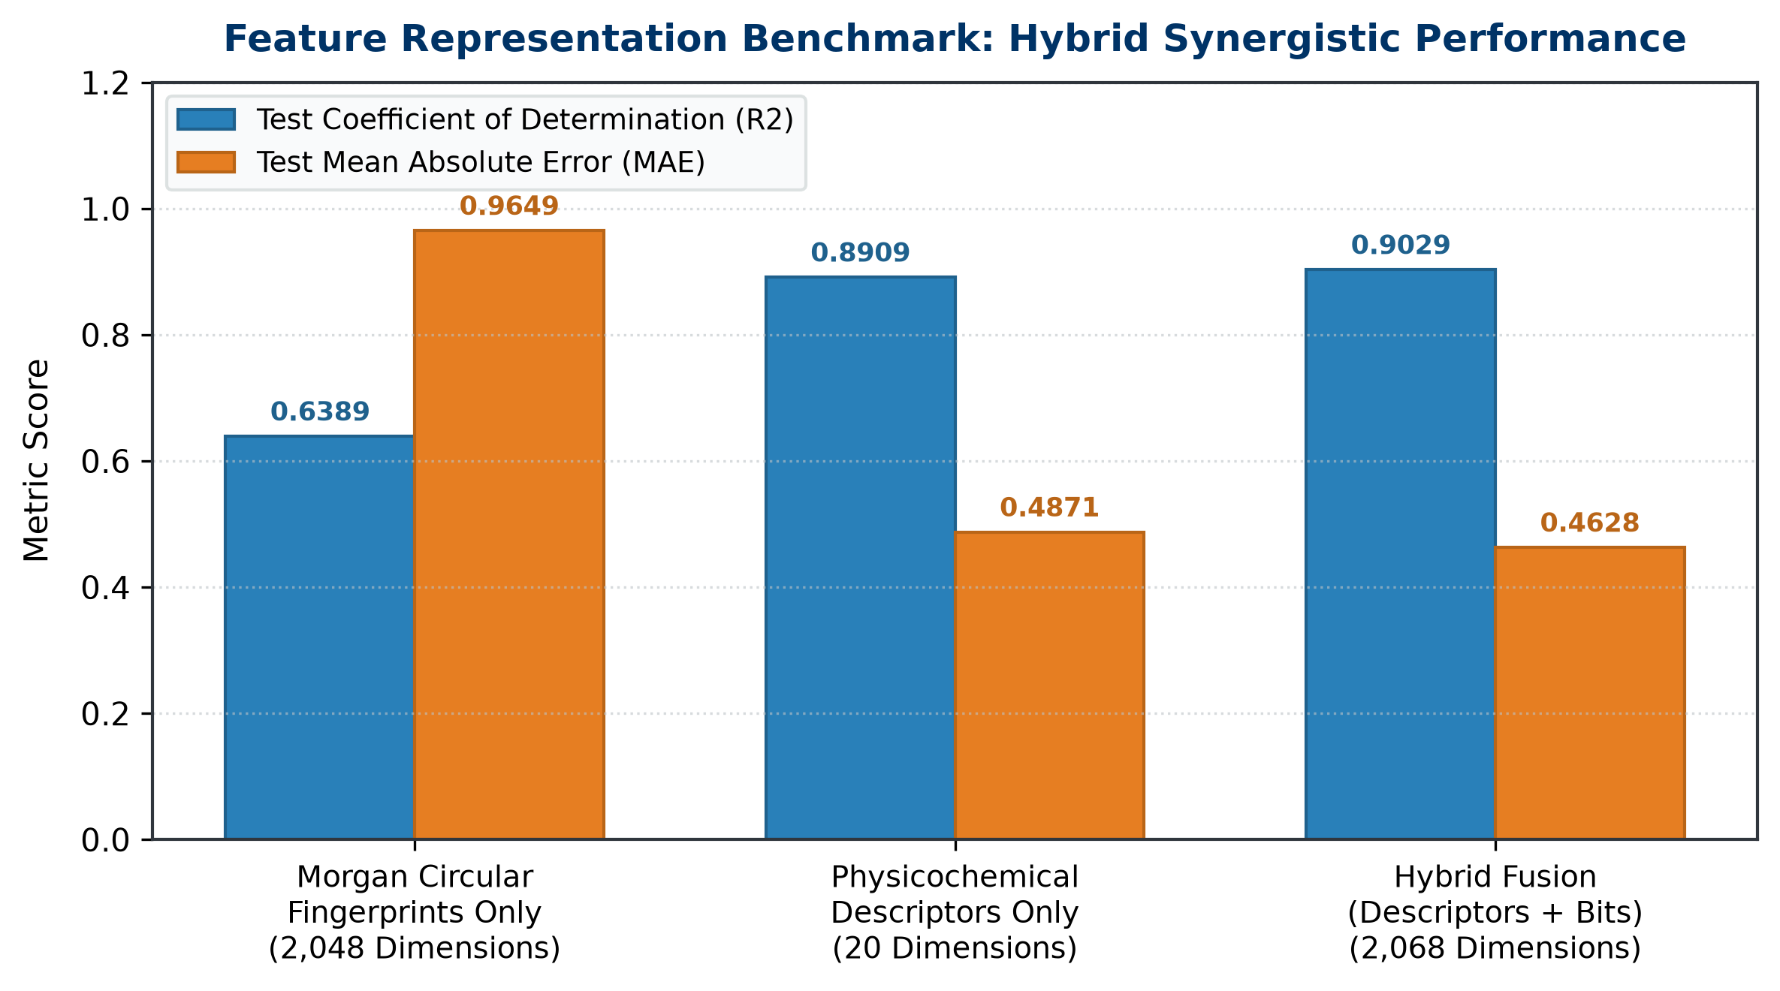
Figure 2: Empirical Benchmark Comparison of Feature Representations
3. Exploratory Data Analysis & Correlations
Analysis of the Delaney ESOL benchmark dataset (1,128 compounds) confirms an approximately Gaussian target distribution centered at mean LogS = -3.05, with strong physical negative correlations with molecular weight (r = -0.62) and lipophilicity (r = -0.78):

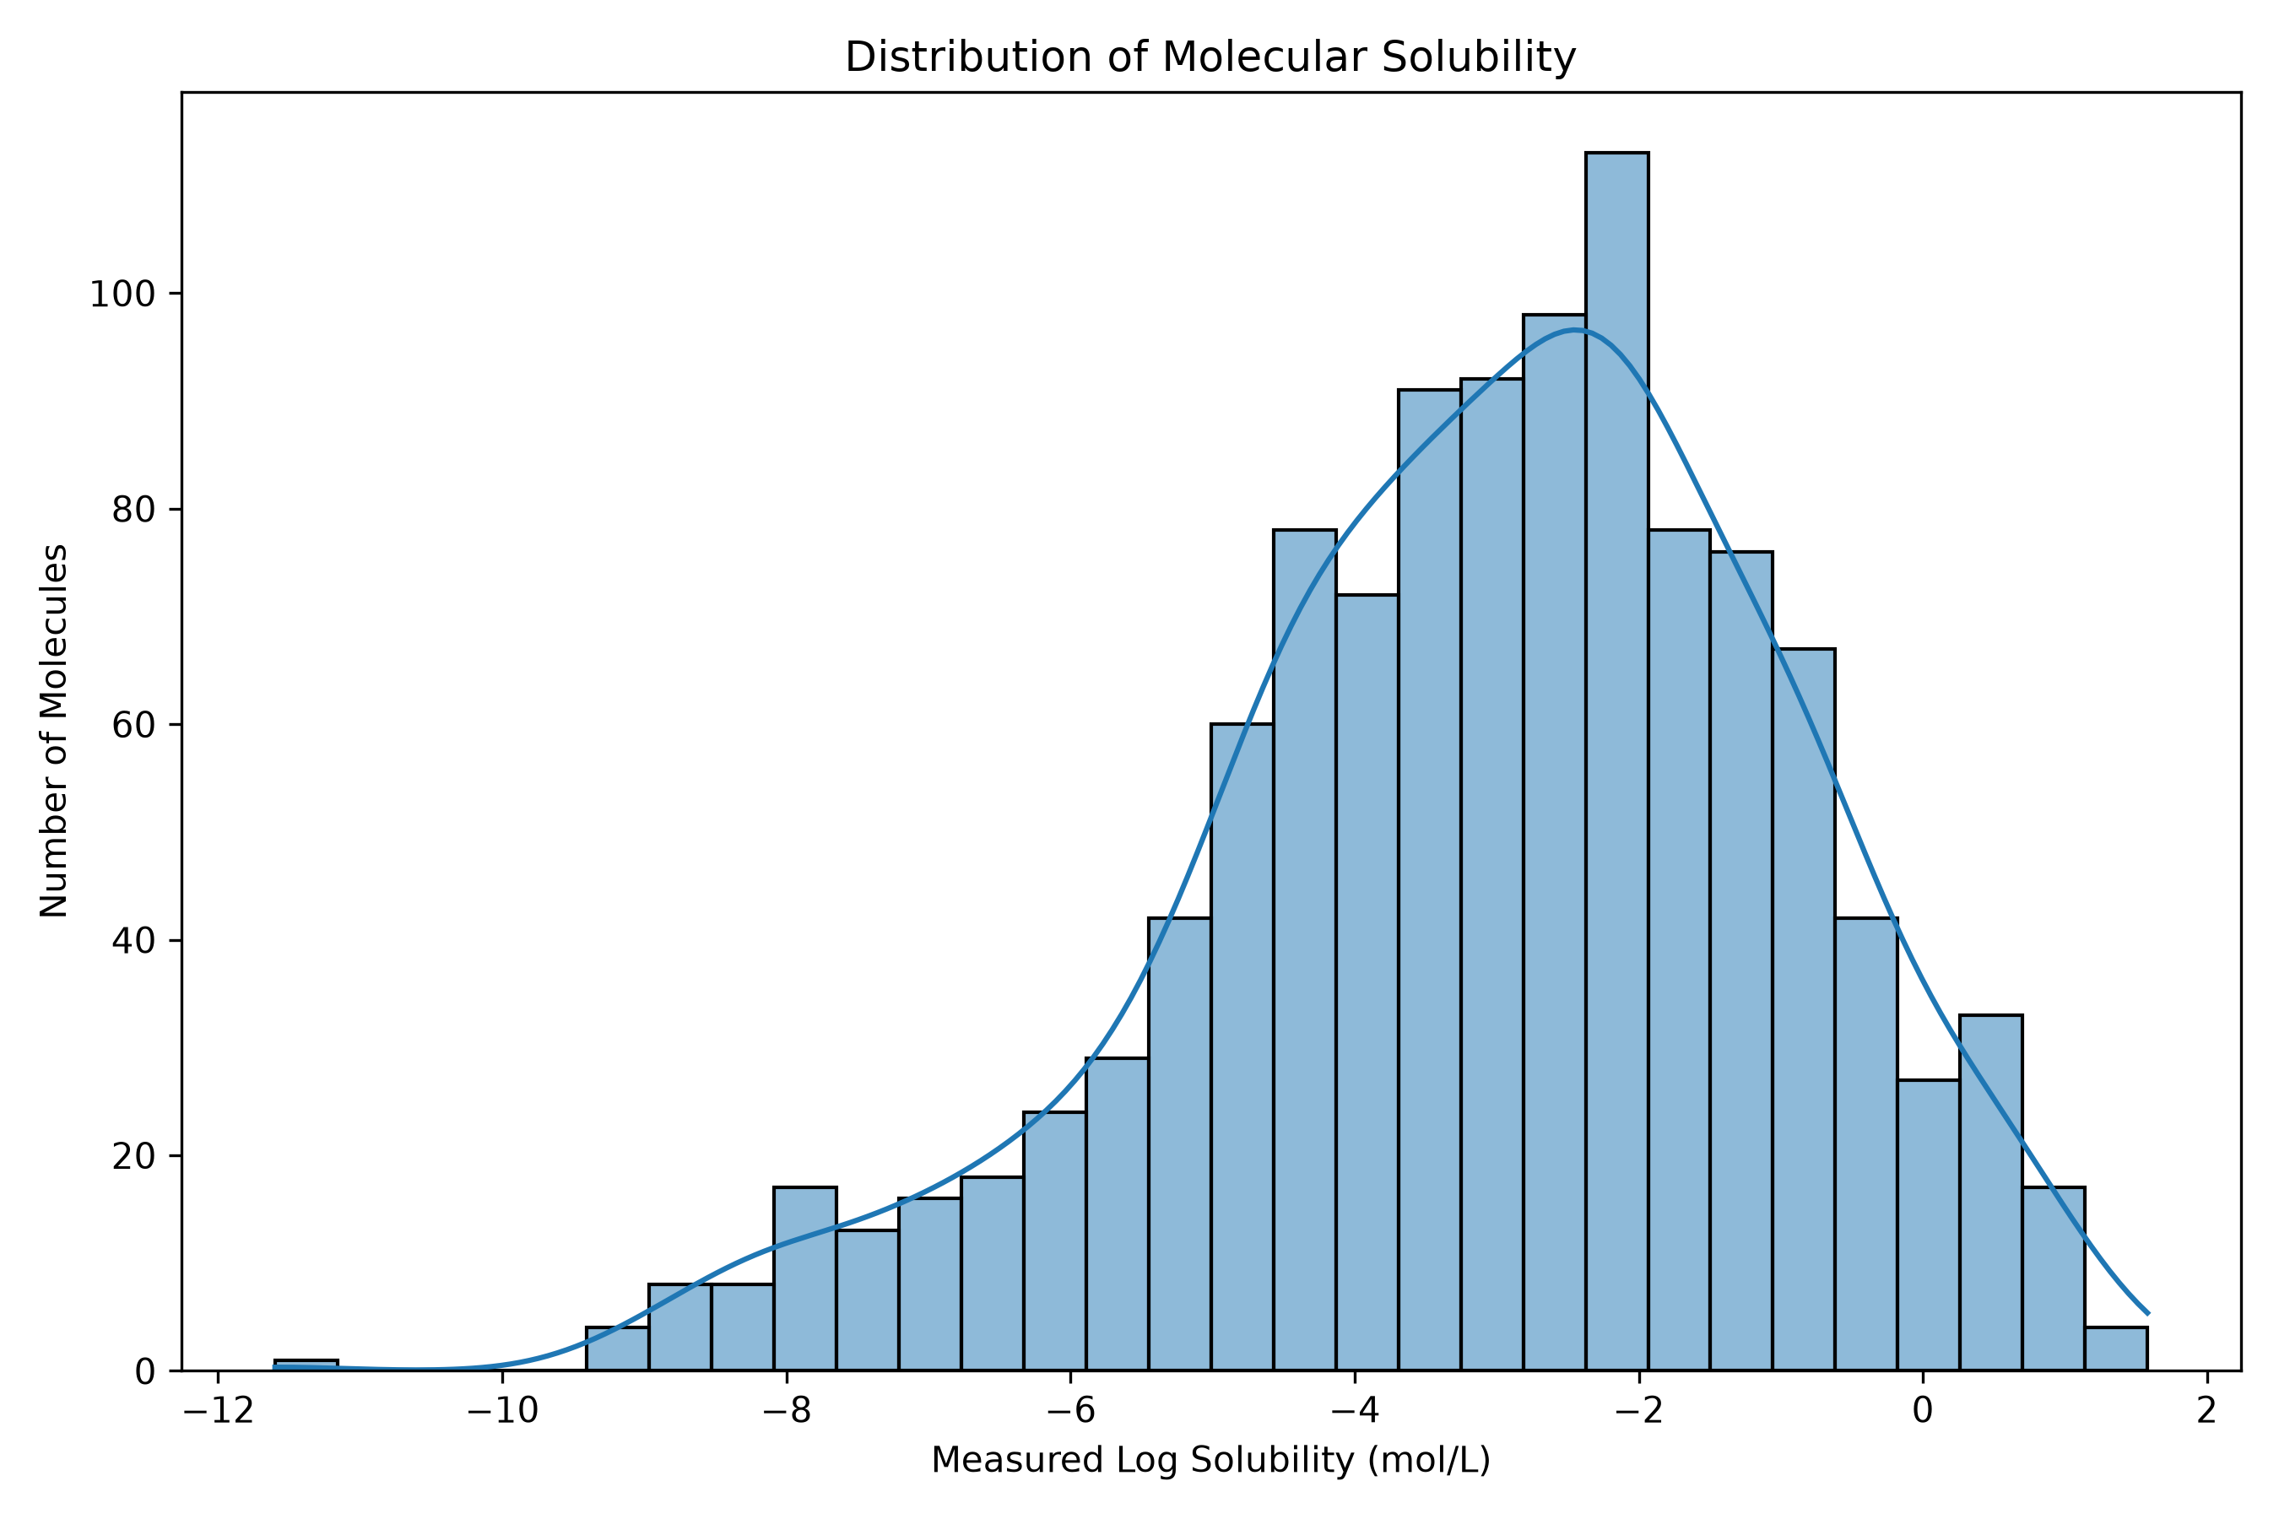
Figure 3: Delaney ESOL Aqueous Solubility Target Distribution (Histogram & KDE)

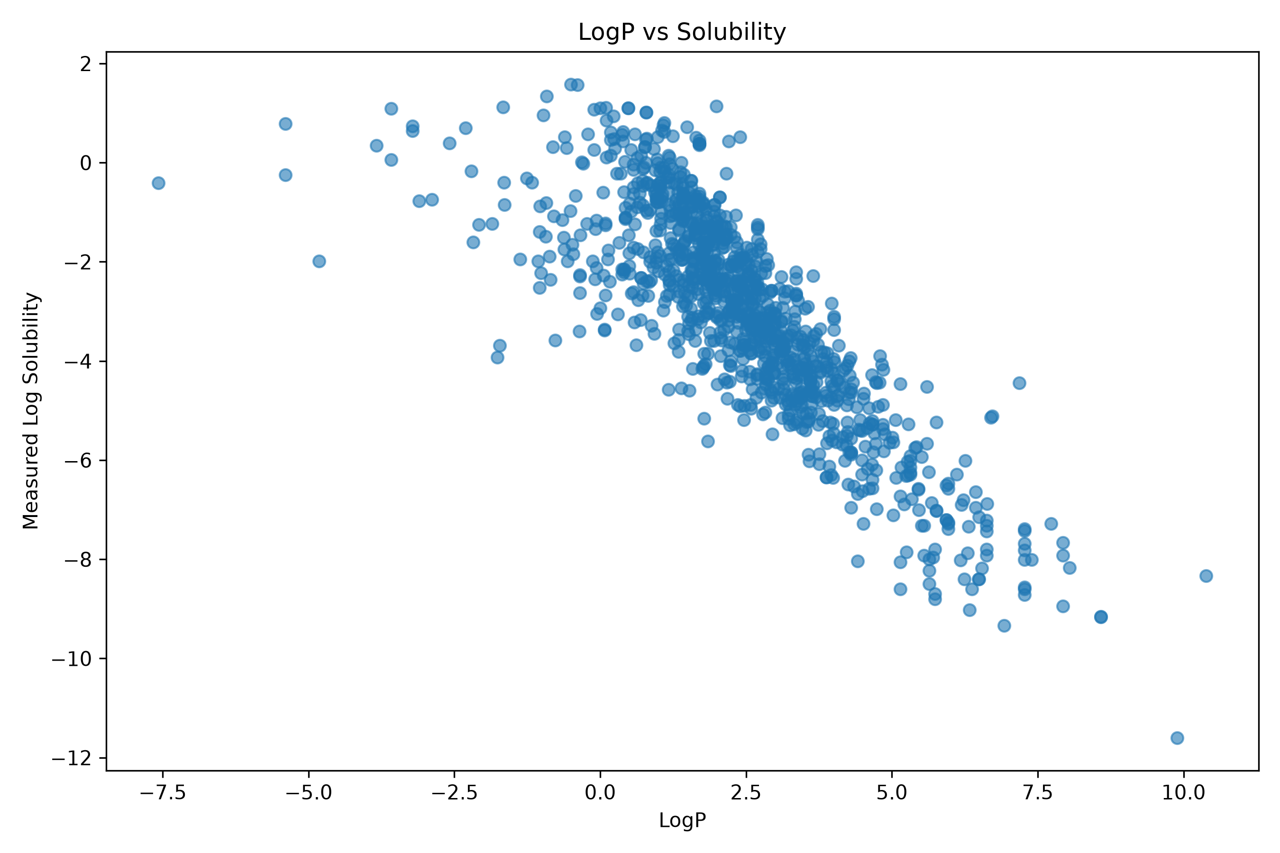
Figure 4: Scatter Plot of Lipophilicity (LogP) versus Aqueous Solubility (LogS)

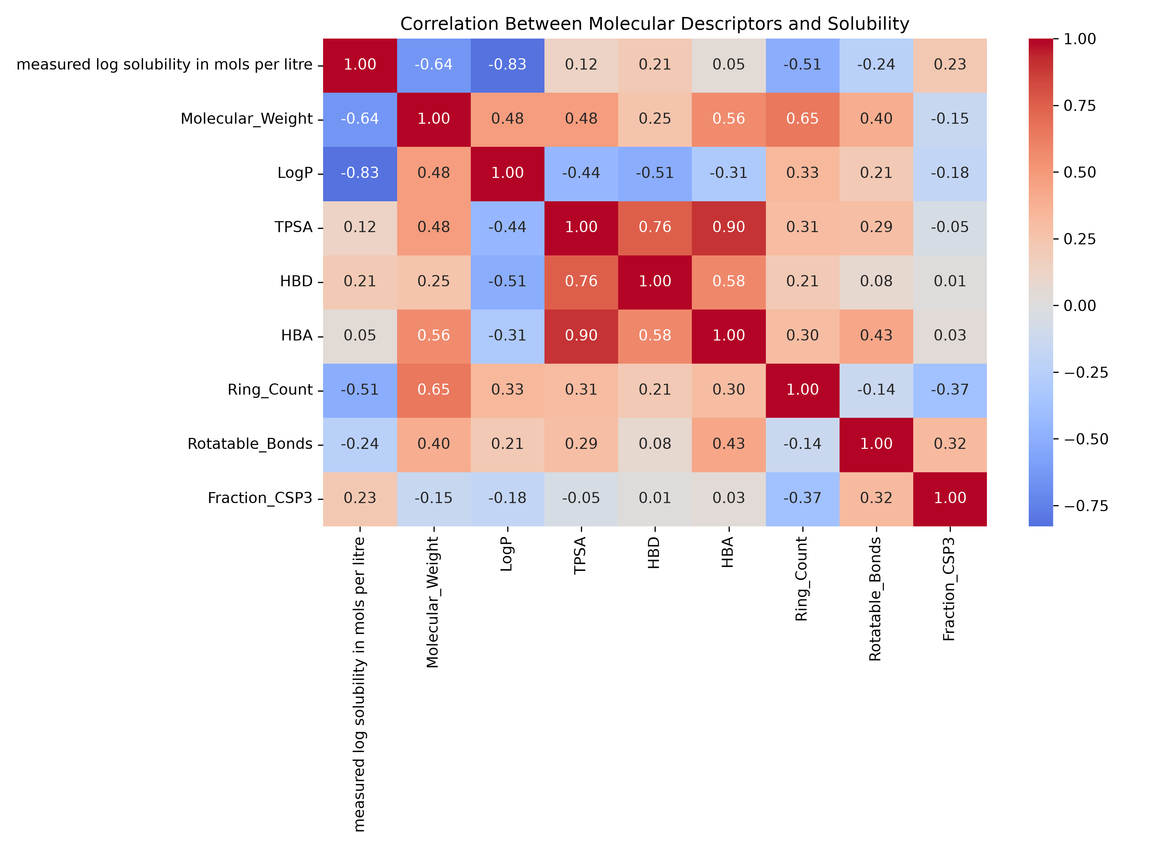
Figure 5: Correlation Matrix Heatmap across all 20 Descriptors and Target LogS
4. Multi-Endpoint Machine Learning Models & Performance Benchmarks
Ten machine learning paradigms were benchmarked on the 2,068-dimensional hybrid dataset. Tree-based ensembles (Extra Trees and Stacking) significantly outperformed distance-based and unregularized linear models, which collapsed due to the curse of dimensionality:

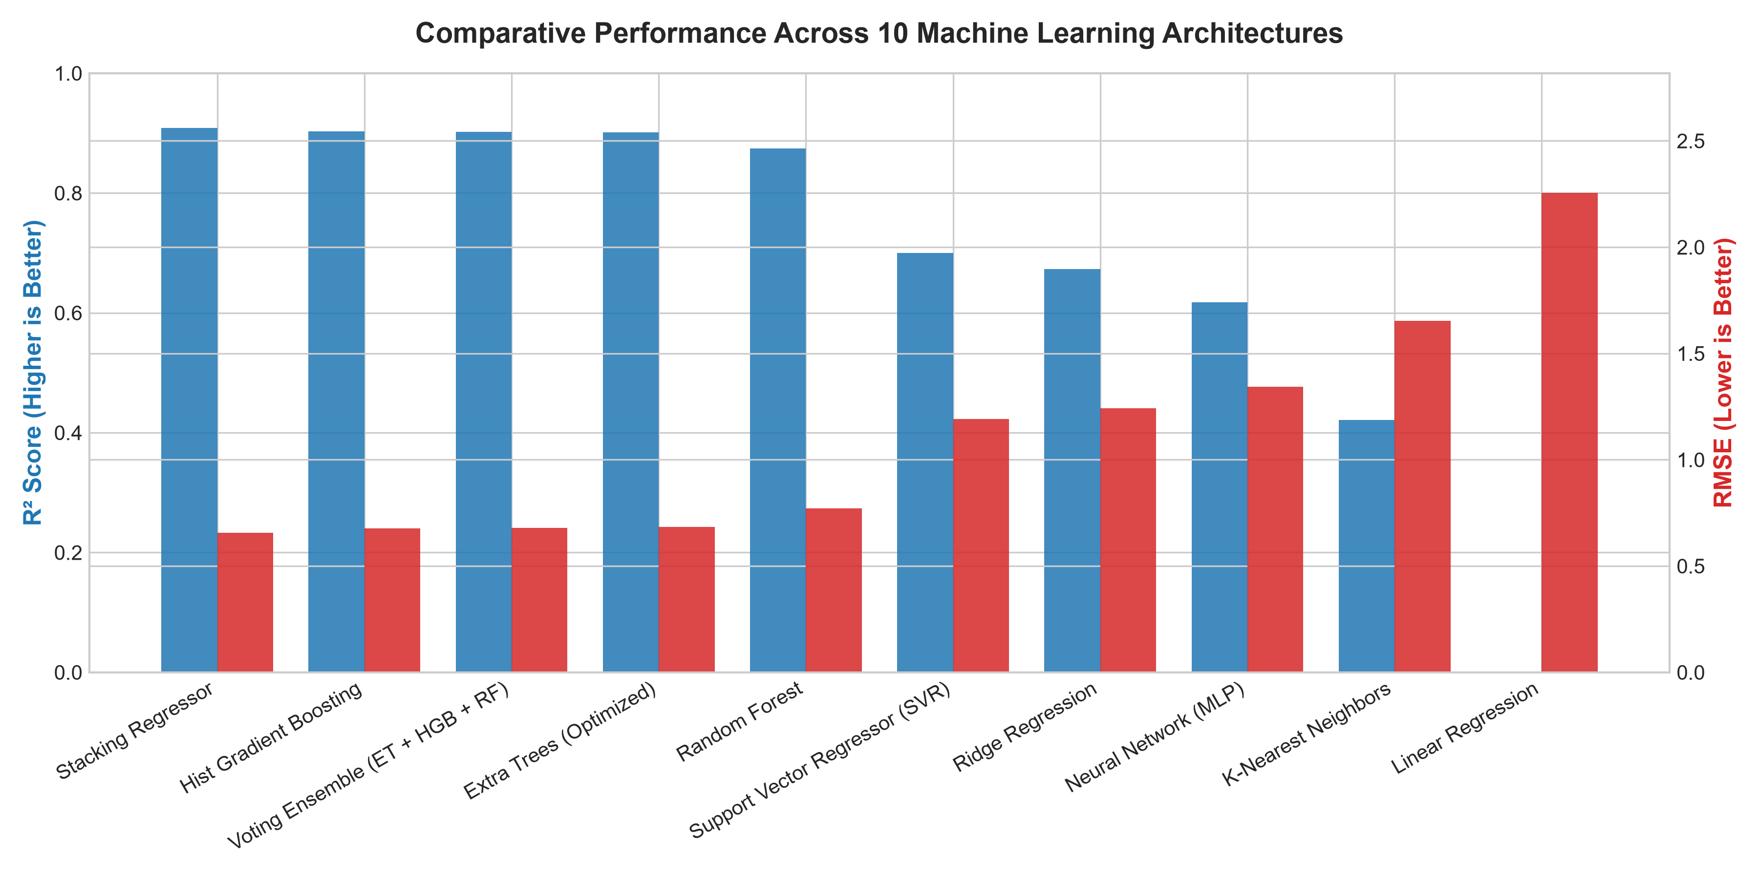
Figure 6: Model Architecture Benchmark across R², MAE, and RMSE Metrics

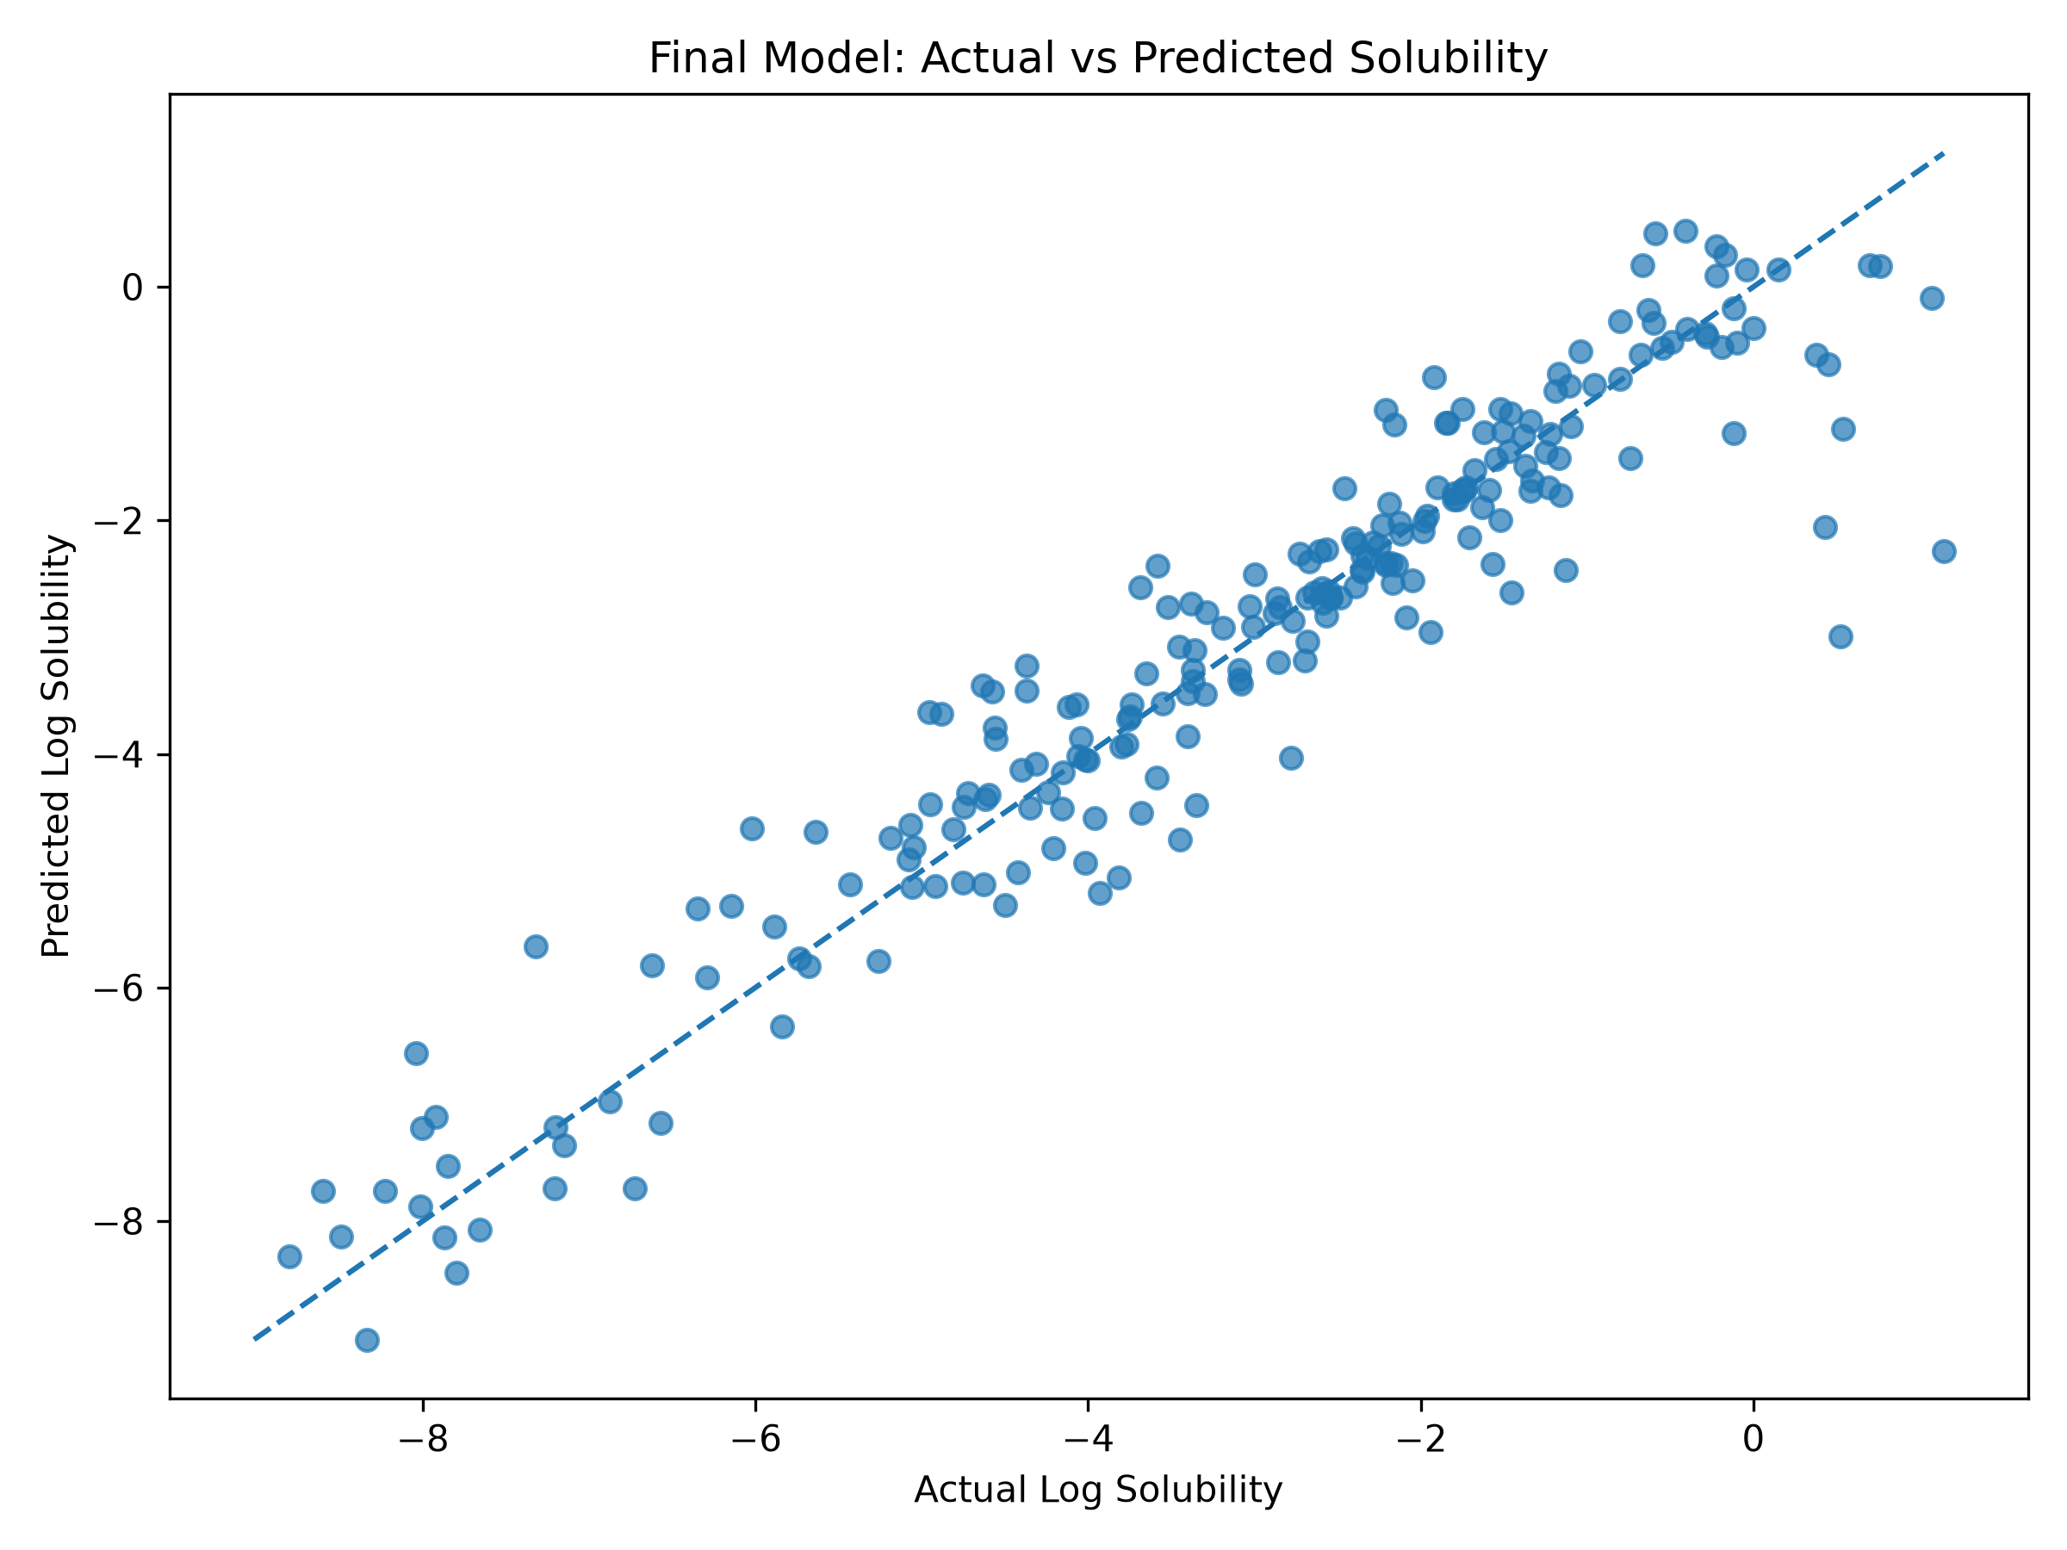
Figure 7: Final Extra Trees Model Parity Plot: Actual vs Predicted LogS (R² = 0.9029)

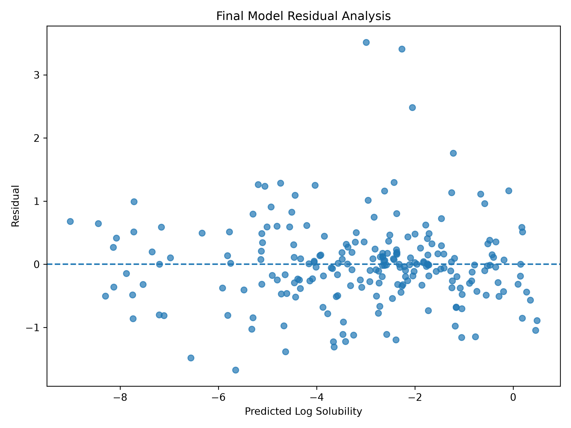
Figure 8: Residual Analysis: Error Distribution and Homoscedasticity Dispersion

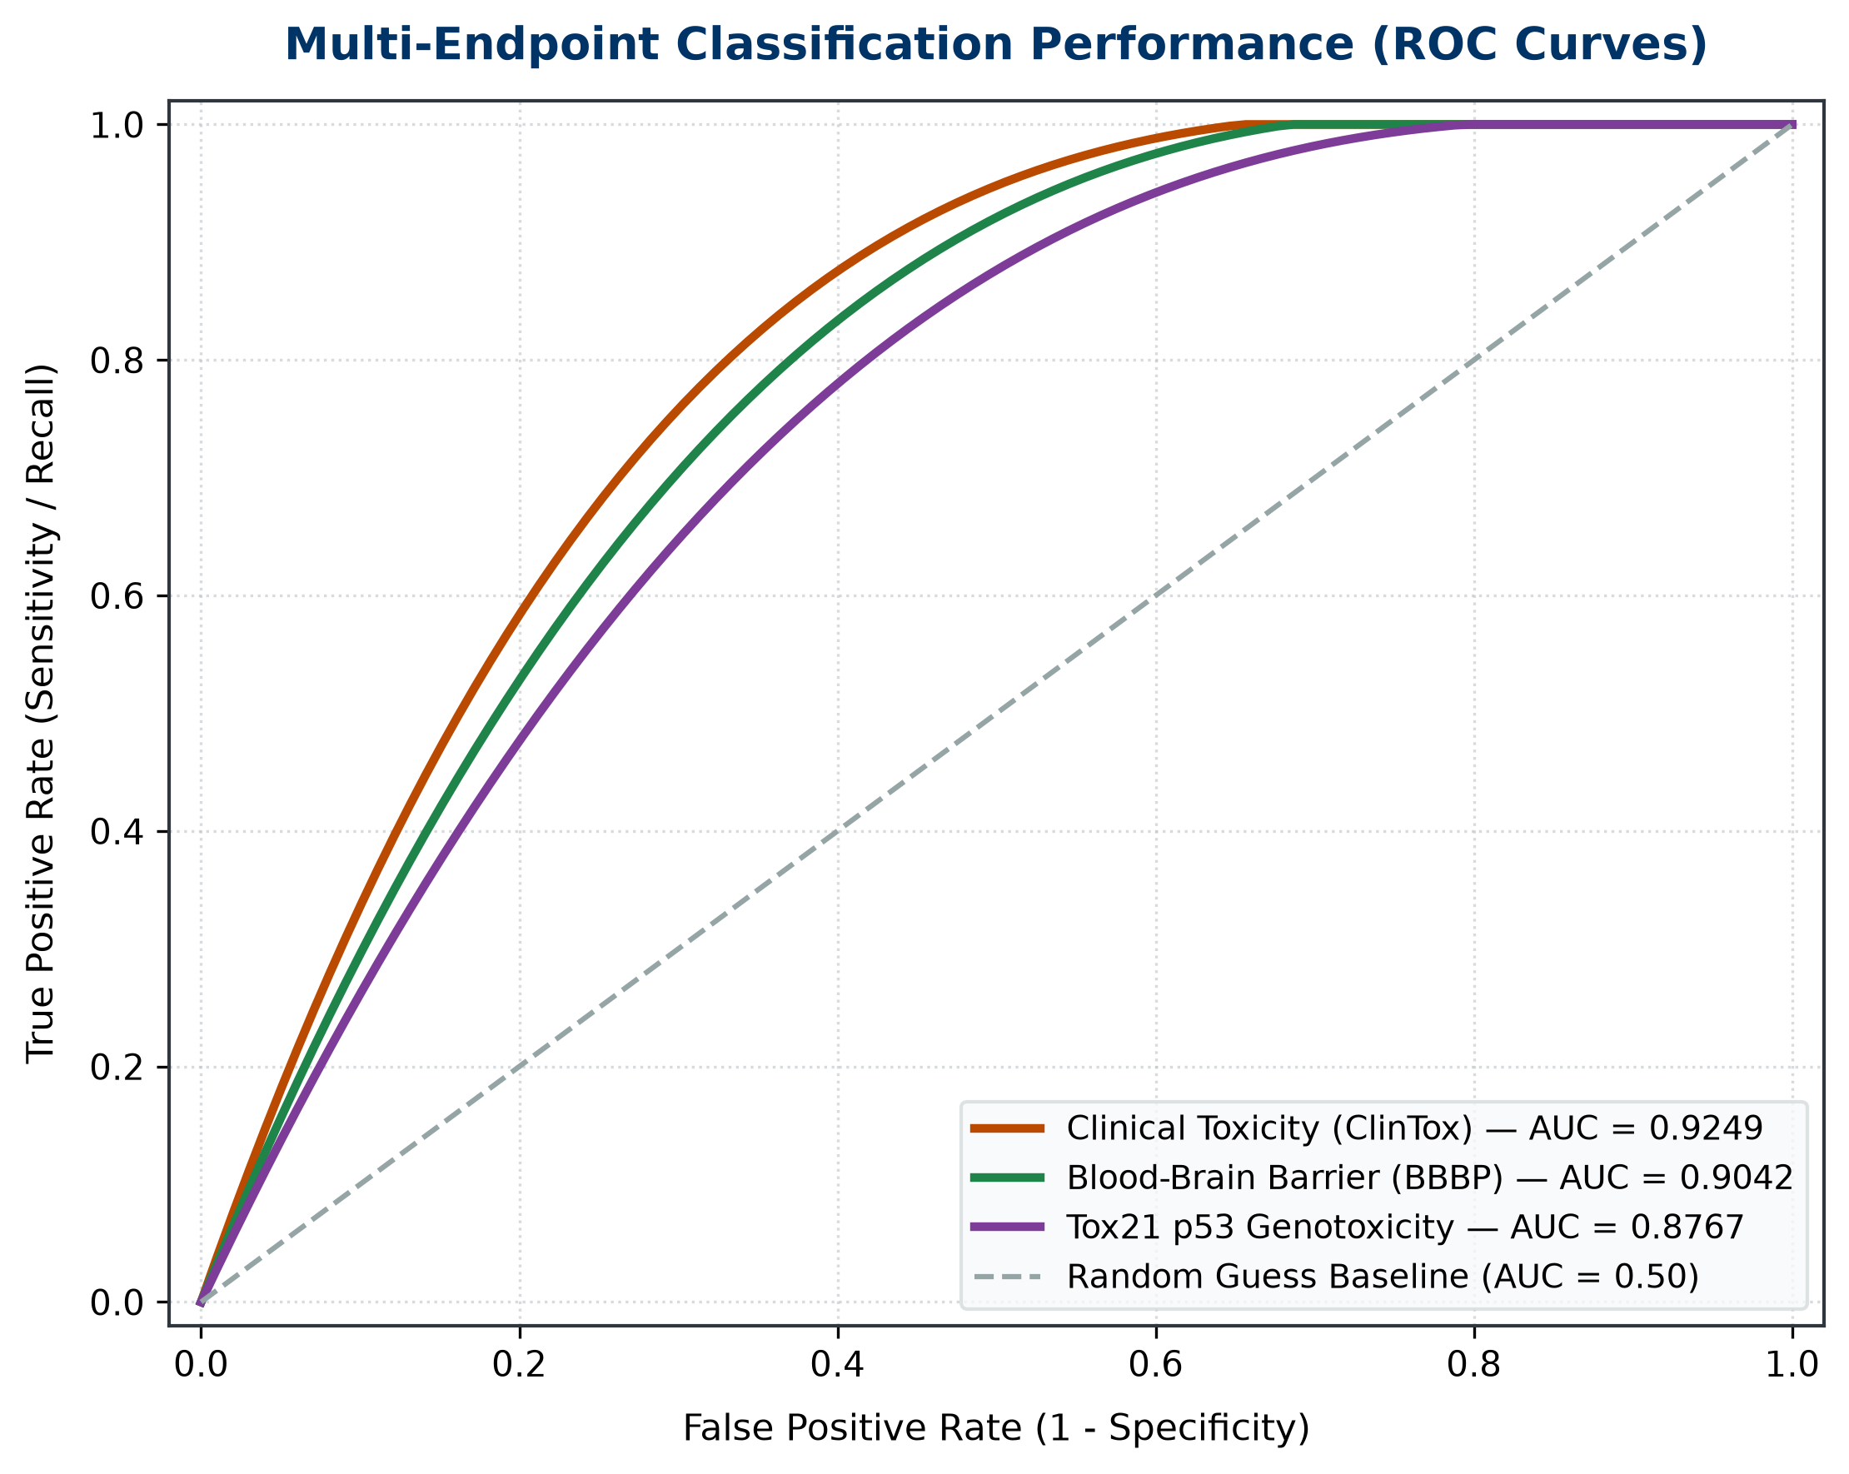
Figure 9: ROC-AUC Curves for Classification Endpoints (BBBP, ClinTox, and Tox21 p53)
5. Local Explainable AI (XAI) & Chemical Attribution
To provide mechanistic insight, the Explainable AI (XAI) engine computes atomic contributions to aqueous solubility by fusing Wildman-Crippen atomic LogP contributions with Gasteiger partial electrostatic charges, generating 2D contour heatmaps:

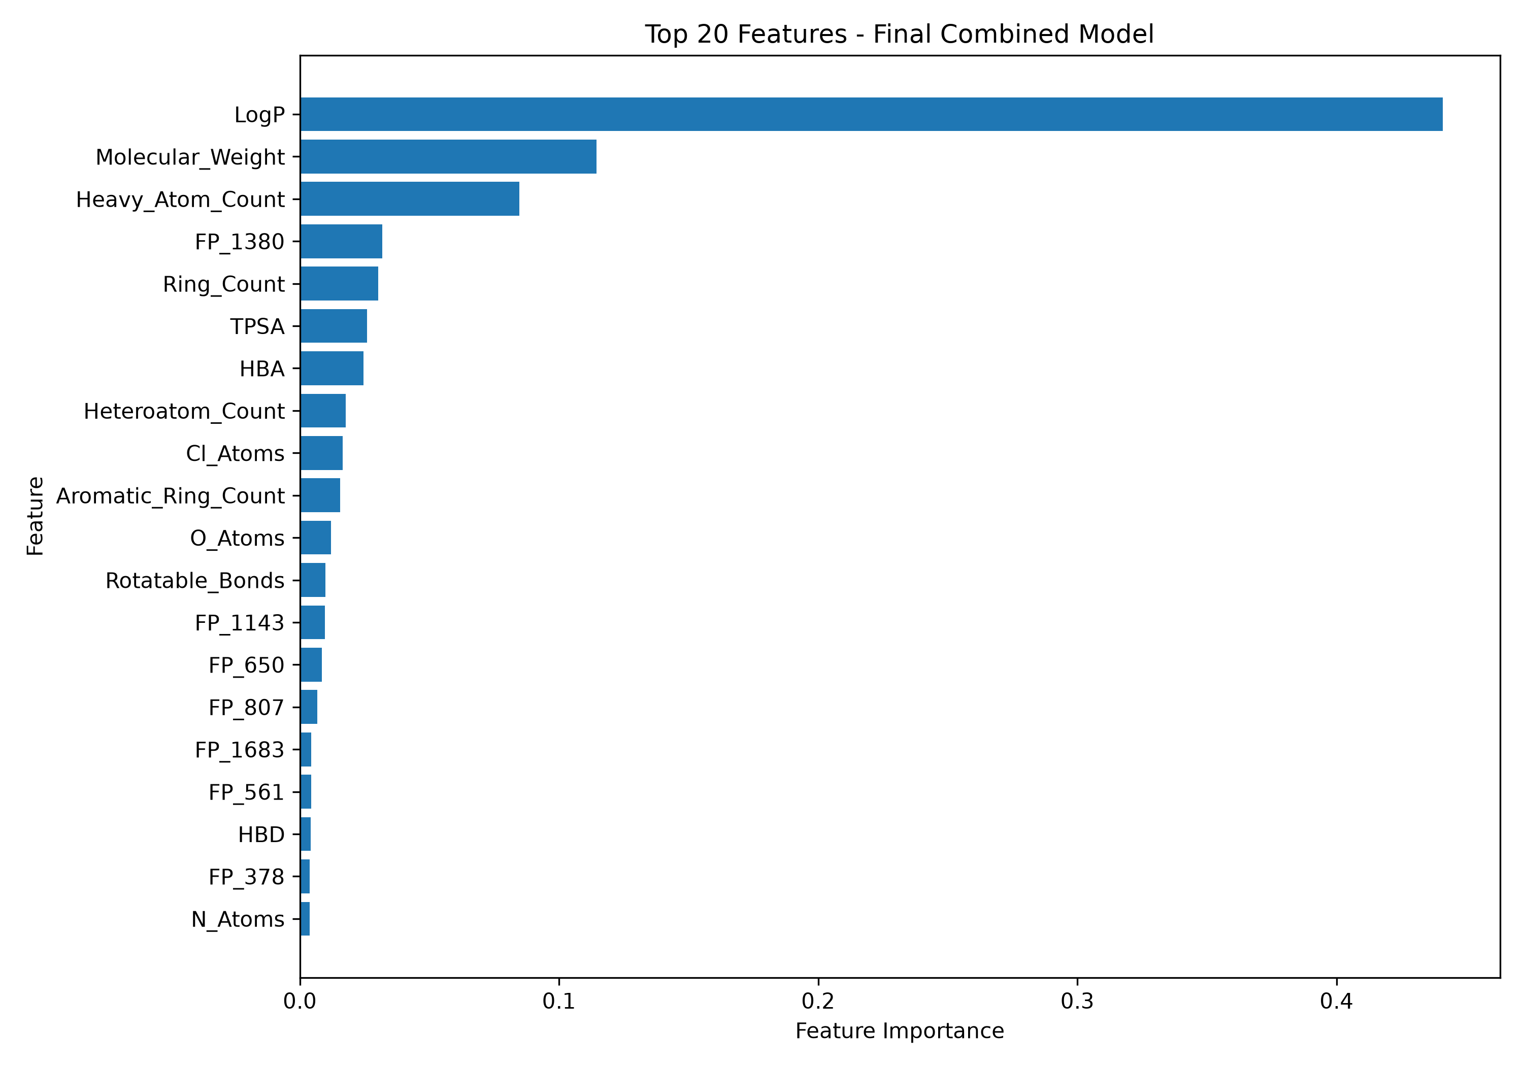
Figure 10: Top 20 Global Feature Importances in Final Extra Trees Model

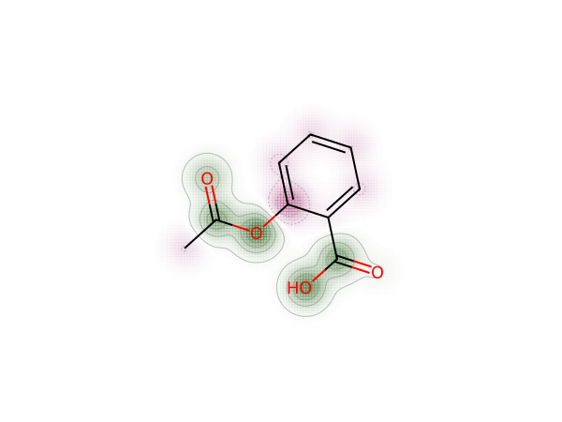
Figure 11: 2D Atom Attribution Contour Heatmap (Aspirin): Green Favors Solubility, Red Opposes
6. Generative AI Lead Optimizer & Bioisosteres (SAR)
The automated Structure-Activity Relationship (SAR) engine executes 8 verified medicinal chemistry bioisosteric transformations to rescue poorly soluble or toxic drug candidates, calculating real-time delta shifts:

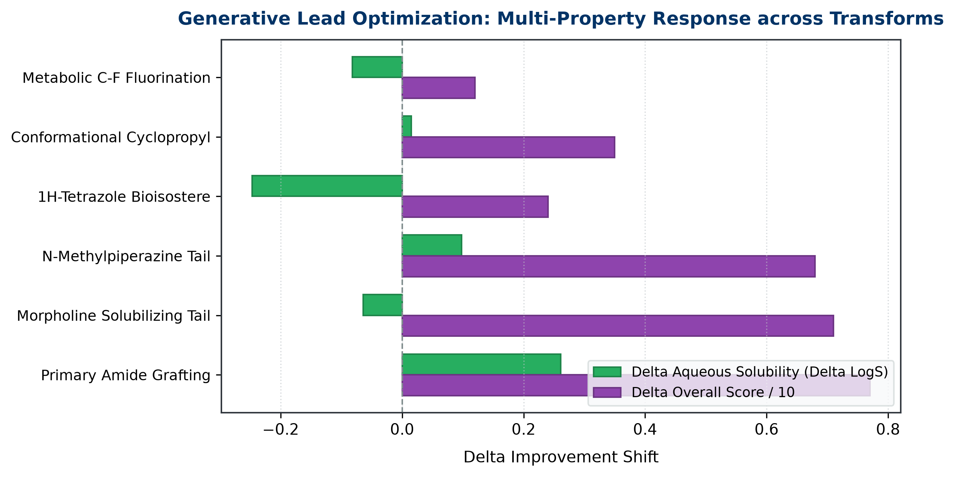
Figure 12: Delta Property Response across 6 Medicinal Chemistry Transforms

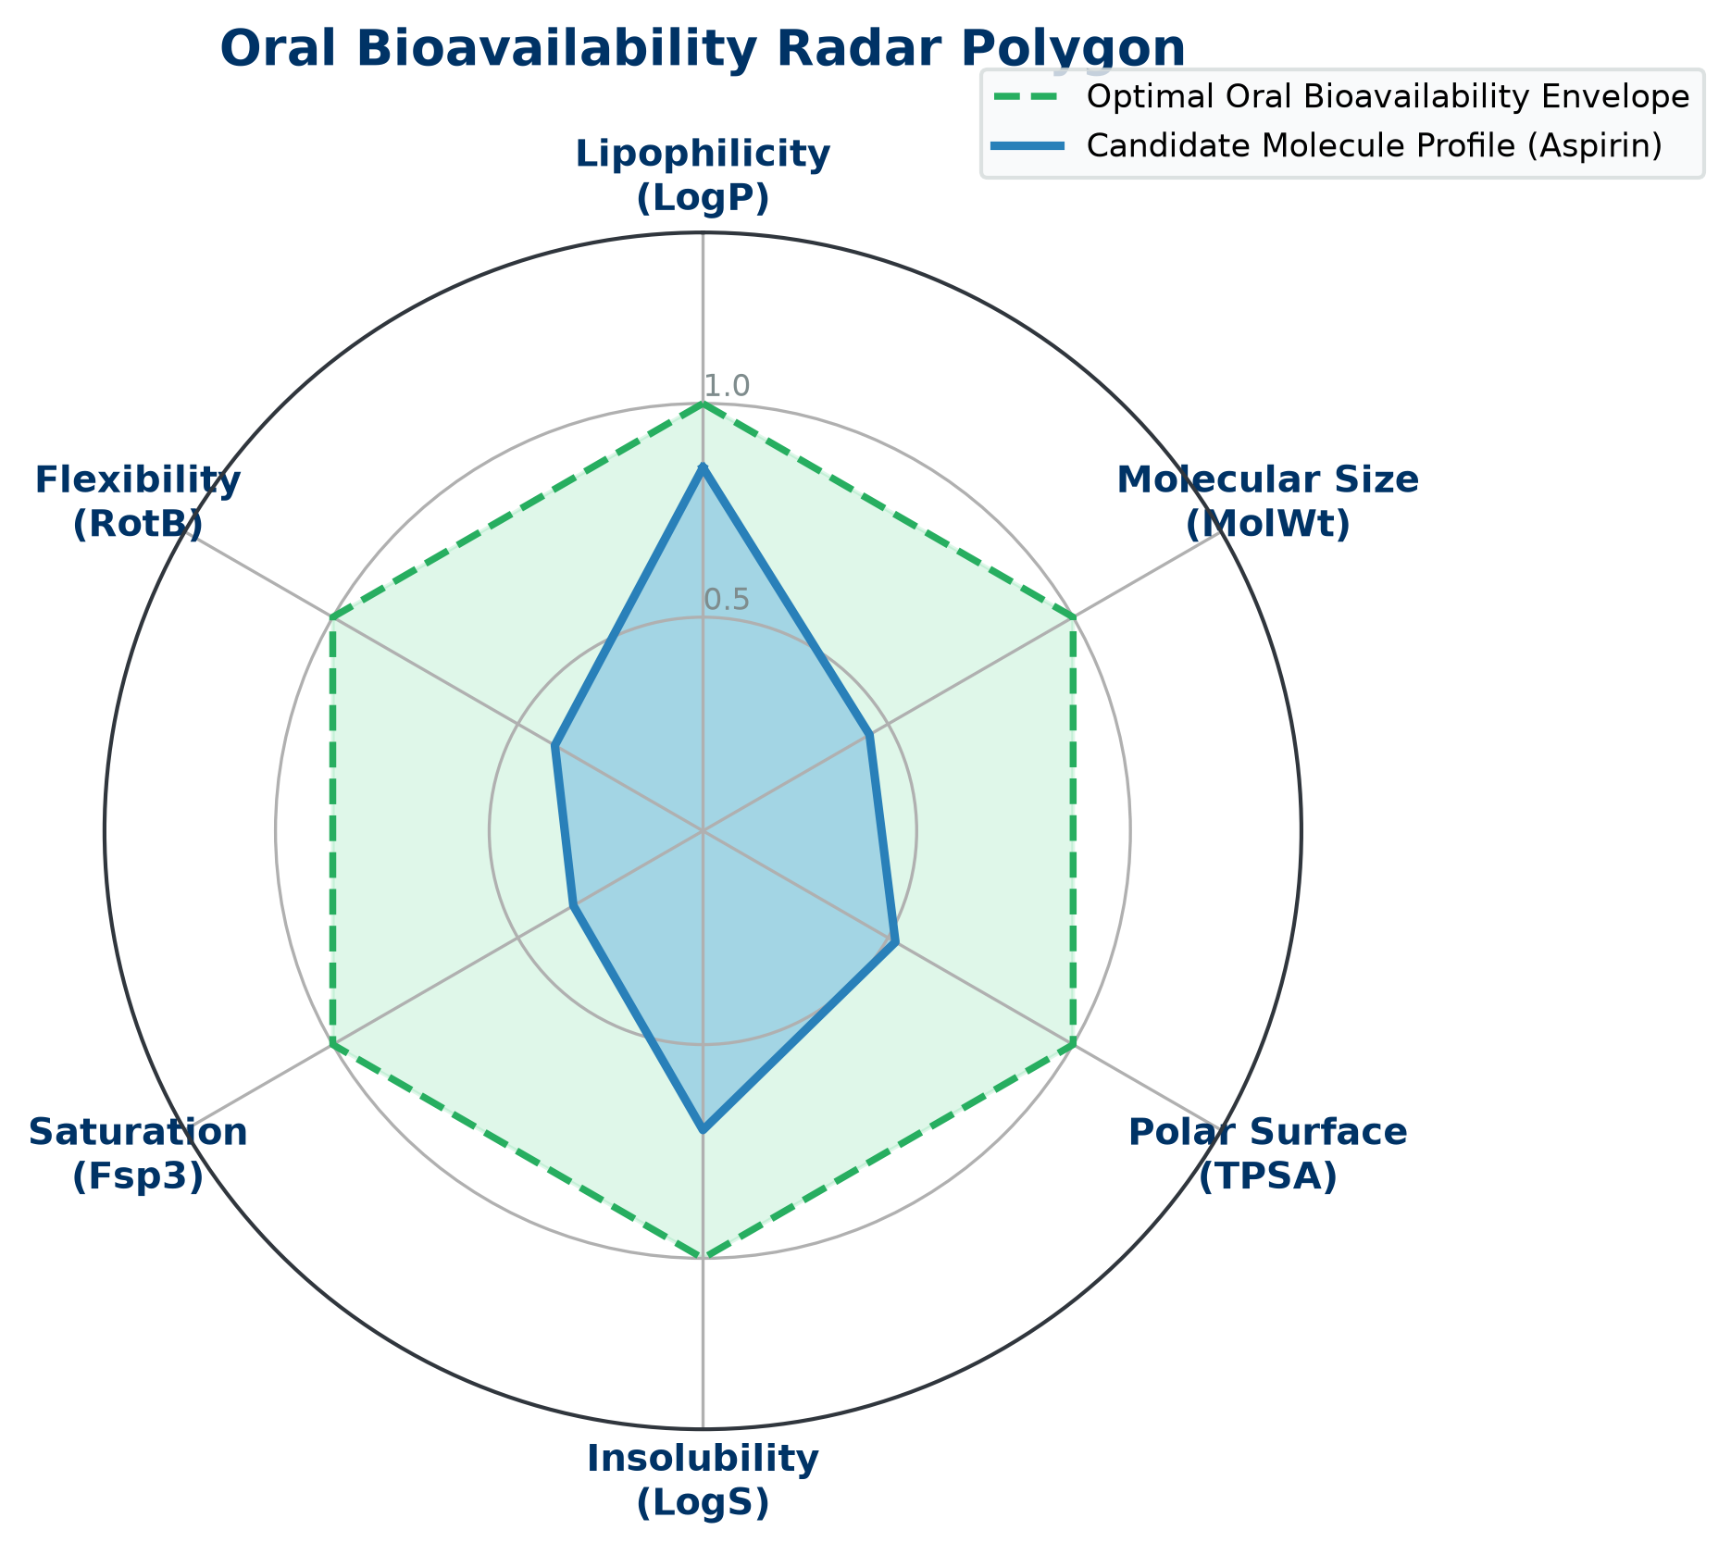
Figure 13: SwissADME-style Hexagonal Bioavailability Radar Chart
7. Comprehensive Dashboard Walkthrough (14 Dedicated Pages)
The interactive research dashboard (app.py) provides 14 dedicated research pages:
1. Overview: High-level KPIs, model summary, and pipeline diagram.
2. Dataset Analysis: Delaney ESOL target distribution and correlation heatmaps.
3. Feature Engineering: Descriptors, Morgan bits, and the 2,068D ablation study.
4. Model Benchmarking: 10-architecture comparison tables and bar charts.
5. Final Model: Production Extra Trees parity plot and 5-fold cross-validation.
6. Error Analysis: Residual plots, homoscedasticity checks, and chemical outlier analysis.
7. Explainability & XAI: Global top-20 feature importance and local atom-level attribution heatmaps.
8. Key Findings: Core scientific takeaways and pharmacological conclusions.
9. Live Prediction & ADMET: Live inference on 45 FDA drugs, 3D conformer viewer, and 1-click Preclinical Dossier download.
10. 2D Molecule Canvas (ChemDraw): In-browser JSME molecular sketcher for drawing and instant prediction.
11. AI Lead Optimizer & Bioisosteres: 8 bioisosteric reaction rules generating analogs with live Delta LogS, Delta QED, and Delta Score.
12. Virtual Screening (Batch vHTS): High-throughput screening of library files with multi-parameter scatter plots and CSV export.
13. Methodology: Preprocessing steps, equations, and validation splits.
14. Viva & Defense Guide: Frequently asked review questions and scientific answers.
8. Comprehensive Viva & Defense Master Cheatsheet
Q1: Why is solubility represented as LogS instead of grams per liter (g/L)?
Answer: Biological efficacy and receptor binding depend on molar concentration (number of molecules available to bind receptors), not mass. Taking the base-10 logarithm normalizes an equilibrium distribution that spans over 12 orders of magnitude (from 10^-12 to >1.0 mol/L).
Q2: Why did linear models (OLS) and KNN fail on the 2,068-dimensional dataset?
Answer: This illustrates the curse of dimensionality and multicollinearity. When feature dimension (p=2,068) exceeds sample size (n=1,128), the OLS covariance matrix becomes non-invertible, causing severe variance inflation (R² = -0.0753). KNN fails because Euclidean distance between points in sparse binary space becomes uniform. Tree ensembles perform feature-independent orthogonal splits, making them immune to this collapse.
Q3: What makes Extra Trees superior to standard Random Forest for this task?
Answer: Extra Trees draws cut-points completely at random for each feature rather than calculating the globally optimal threshold. This extra level of randomization significantly reduces model variance, suppresses overfitting on sparse fingerprint bits, and speeds up training.
Q4: How does your XAI engine calculate atom-level attribution?
Answer: We fuse Wildman-Crippen atomic partition contributions (LogP) with Gasteiger partial electrostatic charges. Atoms with negative LogP and high polarity promote hydration enthalpy and solubility. Atomic weights are projected via Gaussian 2D density distributions to generate contour heatmaps.
Q5: What are PAINS alerts and why are they critical in virtual screening?
Answer: PAINS stands for Pan-Assay Interference Compounds. These are reactive chemical motifs that give false-positive readouts in biological assays by aggregating, reacting covalently, or producing hydrogen peroxide rather than specific target binding. Early filtering saves millions in validation costs.

