Relational Databases - Foundations

Final Project

1. ER diagarm (Using crowfoot) for tracking parcel for big DIY stores chain.

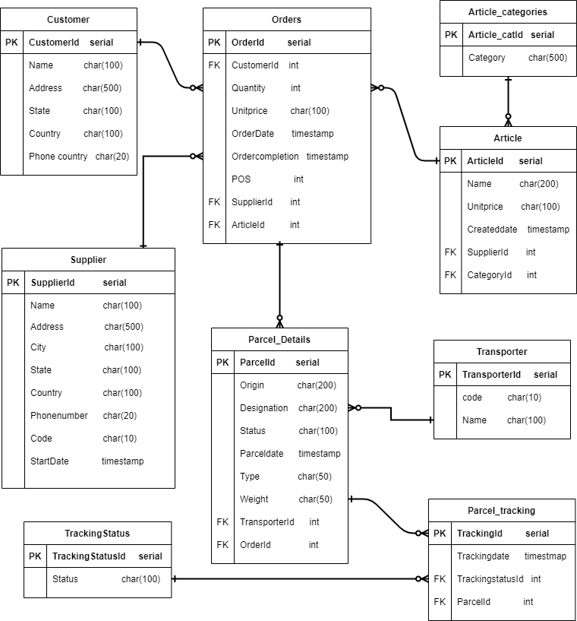

1. Implementing model using DDL

***-- Creating tables***

**--Customer tabel**

create table Customer(

CustomerId serial,

Name char(100) not null,

Address char(500) not null,

State char(100) not null,

Country char(100) not null,

PhoneNumber char(12) not null

);

alter table Customer add constraint CustomerId_pk primary key (CustomerId);

**-- Article_categories table**

create table Article_Categories(

Article_catId serial,

Category char(500) not null

);

alter table Article_Categories add constraint Article_catId_pk primary key (Article_catId)

**--Supplier table**

create table Supplier(

SupplierId serial,

Name char(100) not null,

Address char(500) not null,

City char(100) not null,

State char(100) not null,

Country char(100) not null,

PhoneNumber char(12) not null,

Code char(10) not null,

StartDate timestamp

);

alter table Supplier add constraint SupplierId_pk primary key (SupplierId);

**--Article table**

create table Article(

ArticleId serial,

Name char(200) not null,

Unitprice char(100) not null,

Createddate timestamp,

Article_SupplierId int not null,

Article_Category int not null

);

alter table Article add constraint ArticleId_pk primary key (ArticleId);

alter table Article add constraint "SupplierId_fk" foreign key (Article_SupplierId) references Supplier (SupplierId);

alter table Article add constraint "CategoryId_fk" foreign key (Article_Category) references Article_Categories (Article_catId);

**-- Order table**

create table Orders(

OrderId serial,

Quantity int not null,

Unitprice char(100) not null,

Orderdate timestamp not null default now(),

Ordercompletion timestamp,

POS int,

Order_CustomerId int,

Order_SupplierId int,

Order_ArticleId int

);

alter table Orders add constraint OrderId primary key (OrderId);

alter table Orders add constraint "CustomerId_fk" foreign key (Order_CustomerId) references Customer (CustomerId);

alter table Orders add constraint "ArticleId_fk" foreign key (Order_ArticleId) references Article (ArticleId);

alter table Orders add constraint "SupplierId_fk" foreign key (Order_SupplierId) references Supplier (SupplierId);

**-- Transporter table**

create table Transporter(

TransporterId serial,

code char(10) not null,

Name char(100) not null

);

alter table Transporter add constraint TransporterId_pk primary key (TransporterId);

**--Parcel_details**

create table Parcel_Details(

ParcelId serial,

Origin char(200) not null,

Destination char(200) not null,

Status char(100) not null,

Parceldte timestamp,

Type char(50) not null,

Weight char(50) not null,

Parcel_Transporter int,

Parcel_Order int

);

alter table Parcel_Details add constraint ParcelId_pk primary key (ParcelId);

alter table Parcel_Details add constraint "OrderId_fk" foreign key (Parcel_Order) references Orders (OrderId);

alter table Parcel_Details add constraint "Parcel_Transporter_fk" foreign key (Parcel_Transporter) references Transporter (TransporterId);

**--Parcel_tracking table**

create table Parcel_tracking(

TrackingId serial,

Trackingdate timestamp,

TrackingstatusId int not null,

ParcelId_Tracking int not null

);

alter table Parcel_tracking add constraint TrankingId_pk primary key (TrackingId);

alter table Parcel_tracking add constraint "Parcel_Tracking_fk" foreign key (ParcelId_Tracking) references Parcel_Details (ParcelId);

alter table Parcel_tracking add constraint "Trackingstatus_fk" foreign key (TrackingstatusId) references Trackingstatus (TrackingstatusId);

**--Adding comment row for table Parcel_tracking**

alter table Parcel_tracking add tracking_comments char(255);

**--Trackingstatus**

create table Trackingstatus(

TrackingstatusId serial,

Status char(100) not null

);

alter table Trackingstatus add constraint TrackingstatusId_pk primary key (TrackingstatusId);

***--Insert of data into the tables.***

**--Article categories**

insert into public.Article_Categories (Category) values ('Garden');

insert into public.Article_Categories (Category) values ('Tools');

insert into public.Article_Categories (Category) values ('Bathroom');

insert into public.Article_Categories (Category) values ('Kitchen');

insert into public.Article_Categories (Category) values ('Storage / arrangement');

insert into public.Article_Categories (Category) values ('Carpentry');

insert into public.Article_Categories (Category) values ('Construction materials');

insert into public.Article_Categories (Category) values ('Tiles & parquet');

insert into public.Article_Categories (Category) values ('Decoration, Lighting');

insert into public.Article_Categories (Category) values ('Drugstore & painting');

insert into public.Article_Categories (Category) values ('Electricity & home automation');

insert into public.Article_Categories (Category) values ('Heating & Plumbing');

insert into public.Article_Categories (Category) values ('Hardware');

**--Customer**

insert into public.Customer (Name,Address,State,Country,PhoneNumber) values ('Krrishi yadav','29 Av kremlin','Paris','France','855662228');

insert into public.Customer (Name,Address,State,Country,PhoneNumber) values ('Nikhil gavin','11 Av villejuif','Paris','France','755446892');

insert into public.Customer (Name,Address,State,Country,PhoneNumber) values ('Tahsya justin','28 Av kremlin','Paris','France','988546785');

insert into public.Customer (Name,Address,State,Country,PhoneNumber) values ('Keerthi ch','Emile zola villejuif','Paris','France','288559997');

insert into public.Customer (Name,Address,State,Country,PhoneNumber) values ('Kajol jain','9 Av vitry sur seine','Paris','France','744666892');

insert into public.Customer (Name,Address,State,Country,PhoneNumber) values ('Adithya','Eugene thomas bicetre','Paris','France','988776664');

insert into public.Customer (Name,Address,State,Country,PhoneNumber) values ('Nayani','Emile zola villejuif','Paris','France','235568945');

insert into public.Customer (Name,Address,State,Country,PhoneNumber) values ('Jathi rathnalu','Le kremlin becetre','Paris','France','6547896523');

insert into public.Customer (Name,Address,State,Country,PhoneNumber) values ('Radhe shyma','2021 Oct rue India','Paris','France','986532147');

**--TrackingStatus**

insert into public.Trackingstatus (Status) values ('Ordered');

insert into public.Trackingstatus (Status) values ('Packed');

insert into public.Trackingstatus (Status) values ('Shipped');

insert into public.Trackingstatus (Status) values ('Delivered');

insert into public.Trackingstatus (Status) values ('Returned');

**--Suppiler**

insert into public.Supplier (Name,Address,City,State,Country,PhoneNumber,Code,StartDate) values ('Superprof','51 rue du faubourg','Saint-Denis','Paris','France','985446588','FR001','28-Jan-2021');

insert into public.Supplier (Name,Address,City,State,Country,PhoneNumber,Code,StartDate) values ('Rodrigues Bokolo Charles','Rue Marcel Sembat','Le Kremlin-Bicetre','Paris','France','820254696','FR002','1-Feb-2021');

insert into public.Supplier (Name,Address,City,State,Country,PhoneNumber,Code,StartDate) values ('UASAC','2 Rue Joseph','Sansboeuf','Paris','France','0144908600','FR003','05-Mar-2021');

insert into public.Supplier (Name,Address,City,State,Country,PhoneNumber,Code,StartDate) values ('United Parcel Service France Sas','20 Rue','Escoffier','Paris','France','01559896655','FR004','15-Apr-2021');

insert into public.Supplier (Name,Address,City,State,Country,PhoneNumber,Code,StartDate) values ('Mon courrier de France','149 Avenue','Saint-Denis','Paris','France','0778101479','FR005','6-May-2021');

insert into public.Supplier (Name,Address,City,State,Country,PhoneNumber,Code,StartDate) values ('France Cravates','166 Rue','de la Roquette','Paris','France','0143483559','FR006','20-Jun-2021');

insert into public.Supplier (Name,Address,City,State,Country,PhoneNumber,Code,StartDate) values ('Not Courrier','31 Rue Jean','de la Fontaine','Paris','France','0145258144','FR007','25-Jul-2021');

**--Article**

insert into public.Article (Name,Unitprice,Createddate,Article_SupplierId,Article_Category) values ('Bussiness Man','€100','01-May-2002',2,10);

insert into public.Article (Name,Unitprice,Createddate,Article_SupplierId,Article_Category) values ('Mind collapse','€150','15-Jun-2015',5,6);

insert into public.Article (Name,Unitprice,Createddate,Article_SupplierId,Article_Category) values ('Self confidence','€75','26-Apr-2020',7,2);

insert into public.Article (Name,Unitprice,Createddate,Article_SupplierId,Article_Category) values ('Big boxer','€25','12-Jan-2019',4,9);

**--Parcel Tracking**

insert into public.Parcel_Tracking (Trackingdate,TrackingstatusId,ParcelId_Tracking) values (now(),1,3);

insert into public.Parcel_Tracking (Trackingdate,TrackingstatusId,ParcelId_Tracking) values (now(),2,5);

insert into public.Parcel_Tracking (Trackingdate,TrackingstatusId,ParcelId_Tracking) values (now(),3,6);

insert into public.Parcel_Tracking (Trackingdate,TrackingstatusId,ParcelId_Tracking) values (now(),4,7);

insert into public.Parcel_Tracking (Trackingdate,TrackingstatusId,ParcelId_Tracking) values (now(),5,9);

**--Parcel Details**

insert into Parcel_Details (Origin,Destination,Status,Type,Weight,Parcel_Transporter,Parcel_Order) values ('France','Le kremlin becetre','Not Delivered','Big Cardboard Box','5 kilo',1,45);

insert into Parcel_Details (Origin,Destination,Status,Type,Weight,Parcel_Transporter,Parcel_Order) values ('France','Lyon','Delivered','Matel instruments','8 kilo',1,115);

insert into Parcel_Details (Origin,Destination,Status,Type,Weight,Parcel_Transporter,Parcel_Order) values ('France','Marseille','In progress','Computer','5 kilo',1,550);

insert into Parcel_Details (Origin,Destination,Status,Type,Weight,Parcel_Transporter,Parcel_Order) values ('Germany','Berlin','Not Delivered','Home Materials','10 kilo',1,220);

insert into Parcel_Details (Origin,Destination,Status,Type,Weight,Parcel_Transporter,Parcel_Order) values ('Germany','Startgurd','In progress','Electronics','2 kilo',1,265);

insert into Parcel_Details (Origin,Destination,Status,Type,Weight,Parcel_Transporter,Parcel_Order) values ('Italy','Rome','Delivered','Garden Materials','5 kilo',1,72);

insert into Parcel_Details (Origin,Destination,Status,Type,Weight,Parcel_Transporter,Parcel_Order) values ('France','Le kremlin becetre','Delivered','Big Cardboard Box','5 kilo',1,116);

insert into Parcel_Details (Origin,Destination,Status,Type,Weight,Parcel_Transporter,Parcel_Order) values ('France','Le kremlin becetre','Not Delivered','Wodden Bpx','5 kilo',1,136);

***--MIGRATE DATABASE***

create table Mig_transporter and Order_header from the given files.

**--transporter**

insert into public.Transporter (code,Name) select code,label from public.Mig_transporter;

**--Orders**

insert into public.Orders (Quantity,Unitprice,Orderdate,Ordercompletion,POS) select 5,'€1000',coalesce(date_order,now()),coalesce(date_delivery_expected,now()),cast(num_pos as int) from public.order_header;

1. ***Queries***

**--List of all the arrived orders**

-- a. Total number of arrived orders in POS

select pos, count(1) from orders o

where pos is not null group by pos;

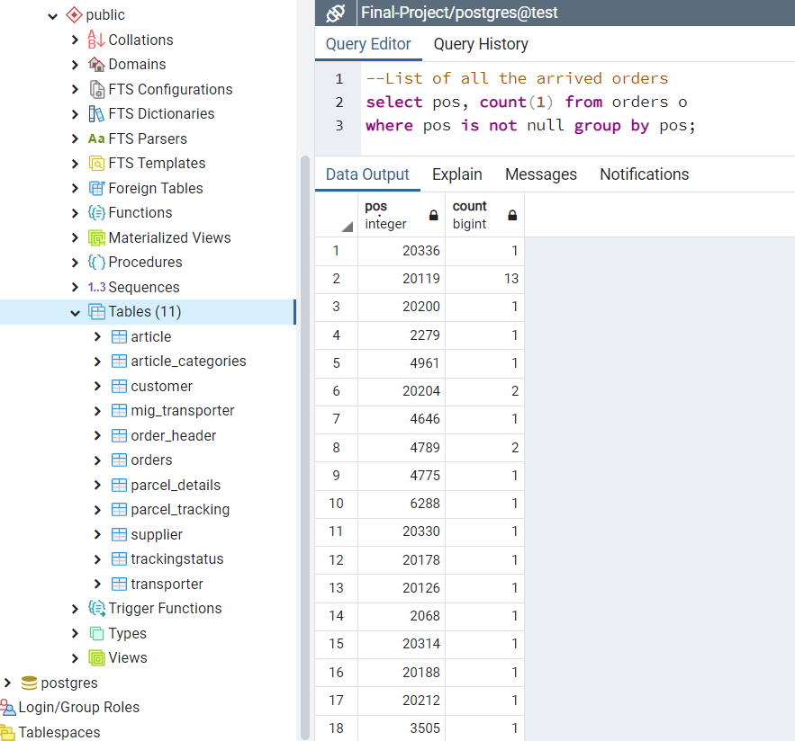

-- b. Total number of arrivied orders for one specific customer

select Order_CustomerId, count(1) from Orders o

where Order_CustomerId=1 group by Order_CustomerId;

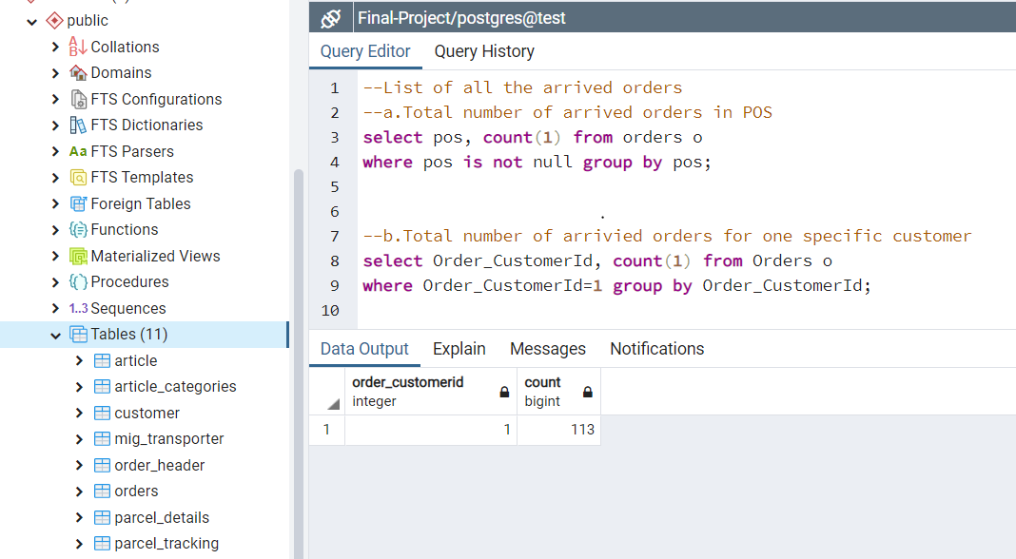

**--search query for the parameters**

--Customer order pick up

--a.Search query that will be able to look for customer orders

select cu.*,o.* from Orders o

join Customer cu on cu.CustomerId =o.Order_CustomerId

where cu.Name like '%Pramod%'

select cu.*,o.* from Orders o

join Customer cu on cu.CustomerId =o.Order_CustomerId

where o.OrderDate between current_date - integer '300' and current_date + integer '10'

select ar.*,o.* from Orders o

join Customer cu on cu.CustomerId =o.Order_CustomerId

join Article ar on ar.ArticleId = o.Order_ArticleId

where o.Order_ArticleId = 1

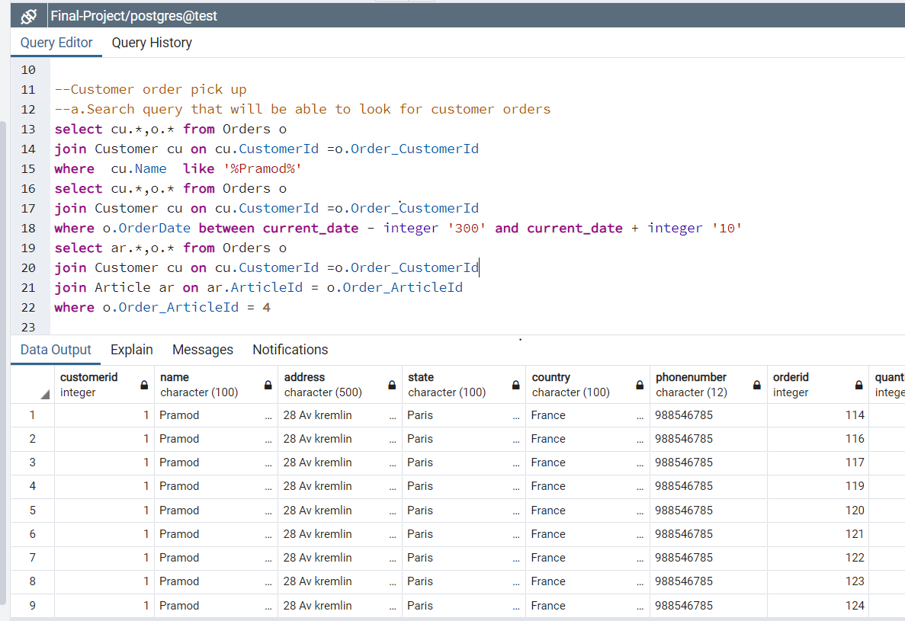

--b. search query at least 2 parameters

select c2.*,o.* from Orders o

join Customer c2 on c2.CustomerId =o.Order_CustomerId

join Article a2 on a2.ArticleId =o.Order_ArticleId

where c2.Name like '%Pramod%' and o.OrderDate between current_date - integer '300' and current_date + integer '10'

and o.Order_ArticleId =4

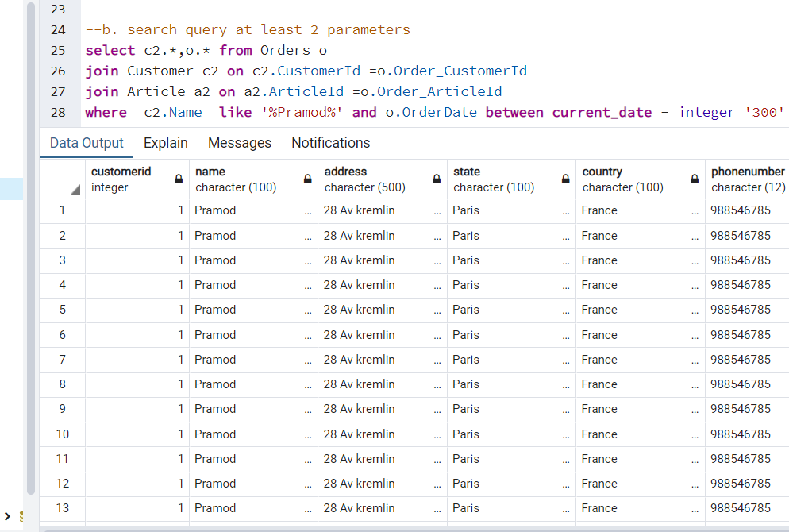

--c.Display orders for specific customers

select Parcel_Details, o.OrderId, cu.Name, Parcel_tracking.Trackingdate, Parcel_tracking.TrackingstatusId, Trackingstatus.Status from Orders o

join Customer cu on cu.CustomerId =o.Order_CustomerId

join Parcel_Details Parcel_Details on Parcel_Details.Parcel_Order = o.OrderId

join Parcel_tracking Parcel_tracking on Parcel_tracking.TrackingId = TrackingId

join Trackingstatus Trackingstatus on Trackingstatus.TrackingstatusId = Trackingstatus.TrackingstatusId

where cu.Name like '%Pramod%'

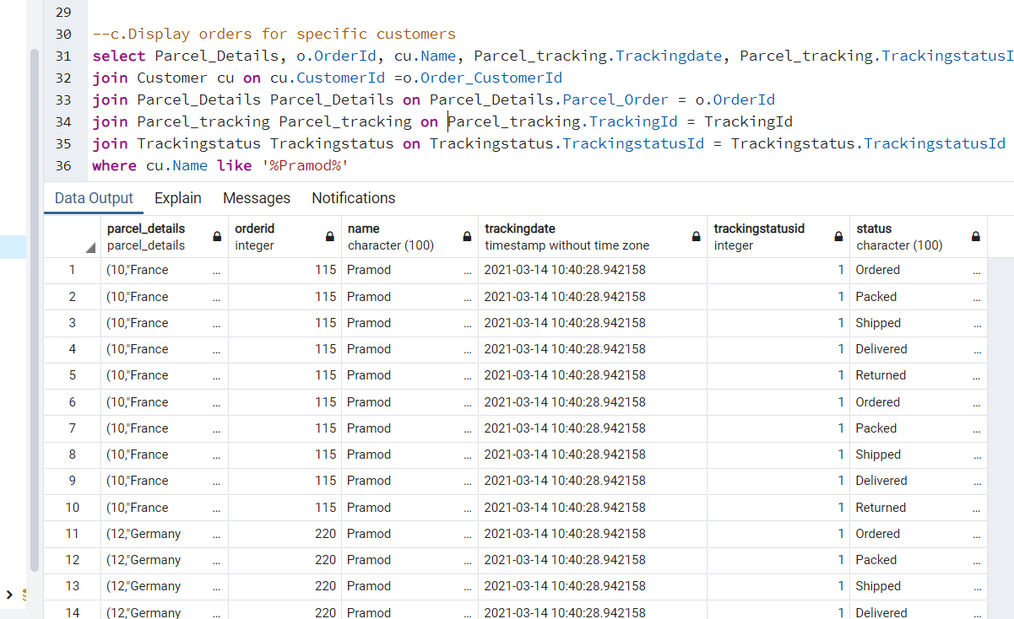

--d.Updating the orders with a text comments and status

update Parcel_tracking set TrackingStatusId=5,

tracking_comments = 'Delivered product to customer'

from Orders o

join Customer cu on cu.CustomerId =o.Order_CustomerId

join Parcel_Details Parcel_Details on Parcel_Details.Parcel_Order = o.OrderId

where o.OrderId = 120 and Parcel_tracking.ParcelId_Tracking = Parcel_Details.ParcelId

update Parcel_tracking set TrackingStatusId=15,

tracking_comments = 'Product returned to the warehouse'

from Orders o

join Customer cu on cu.CustomerId =o.Order_CustomerId

join Parcel_Details Parcel_Details on Parcel_Details.Parcel_Order = o.OrderId

where o.OrderId = 324 and Parcel_tracking.ParcelId_Tracking = Parcel_Details.ParcelId

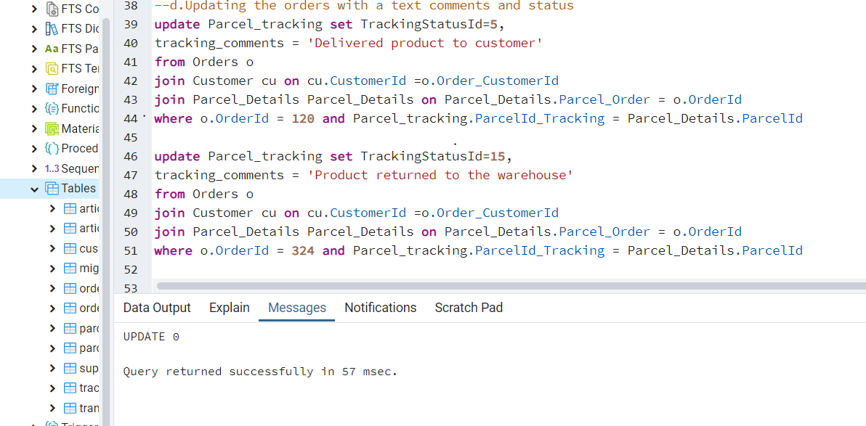

**--Orders that have not been picked up**

**(For this part I used different tool “dbeaver”)**

--a. Find all the unclaimed orders

select o.* from Orders o

join Customer cu on cu.CustomerId =o.Order_CustomerId

join Parcel_Details Parcel_Details on Parcel_Details.Parcel_Order = o.OrderId

join Parcel_tracking Parcel_tracking on Parcel_tracking.TrackingId = TrackingId

join Trackingstatus Trackingstatus on Trackingstatus.TrackingstatusId = Trackingstatus.TrackingstatusId

where o.OrderDate between current_date - integer '20' and current_date and Trackingstatus.TrackingstatusId = 5

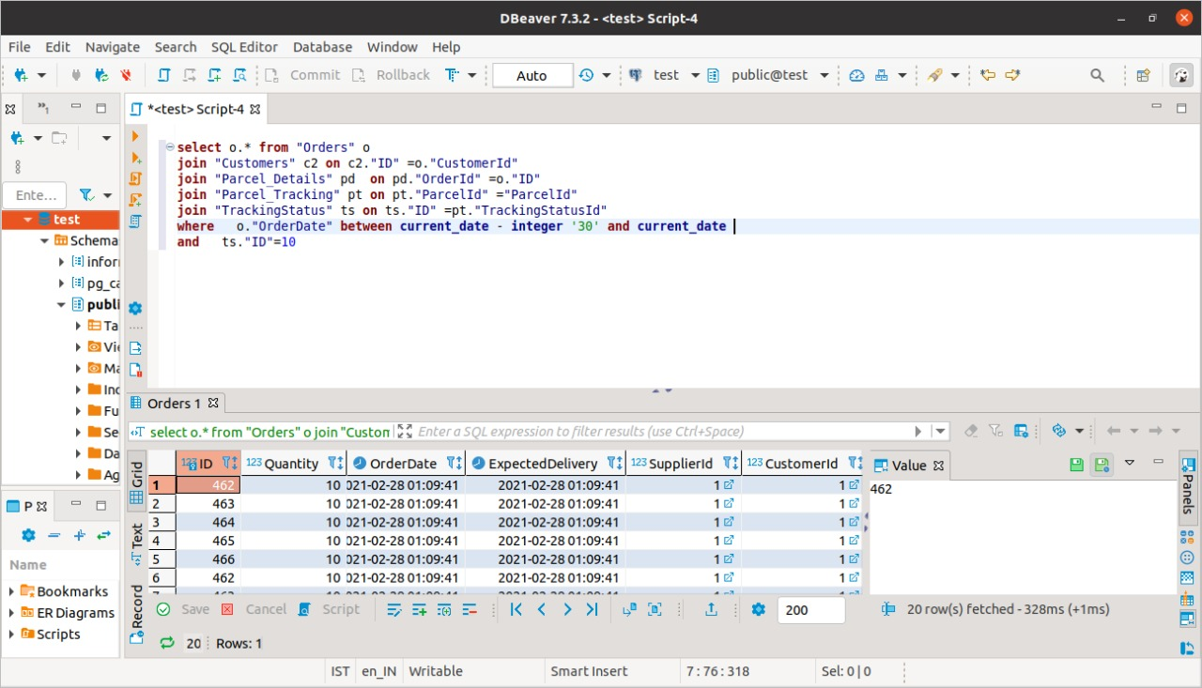

--b Calculate the 3 category the most affected

select ac.Category from Orders o

join Article ar on ar.ArticleId =o.Order_ArticleId

join Article_Categories ac on ac.Article_catId = ac.Article_Category

join Parcel_Details Parcel_Details on Parcel_Details.Parcel_Order = o.OrderId

join Parcel_tracking Parcel_tracking on Parcel_tracking.TrackingId = TrackingId

join Trackingstatus Trackingstatus on Trackingstatus.TrackingstatusId = Trackingstatus.TrackingstatusId

where Trackingstatus.TrackingstatusId=5 group by ac.Category order by count(ac.Category) desc limit 3

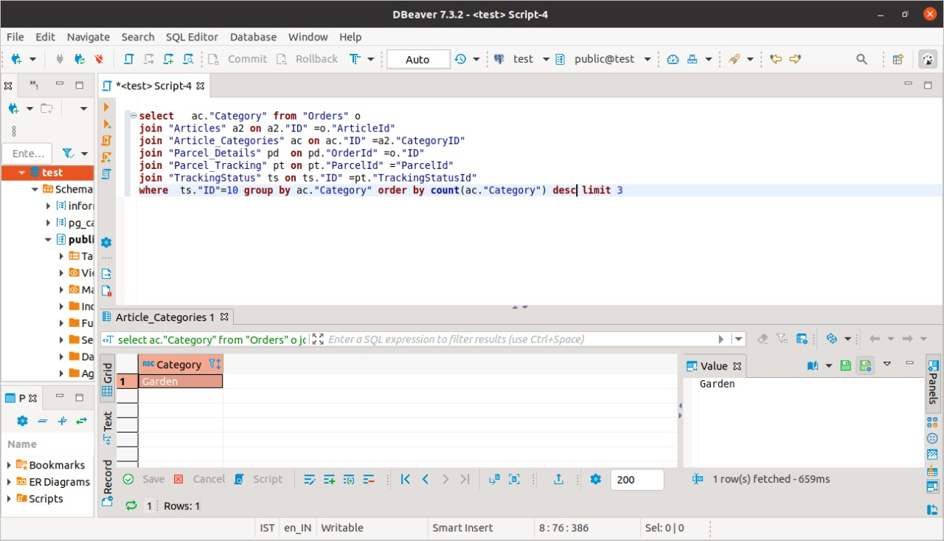

--c Calculate the overall cost

select sum(o.Unitprice) as Price from orders o

join Parcel_Details Parcel_Details on Parcel_Details.Parcel_Order = o.OrderId

join Parcel_tracking Parcel_tracking on Parcel_tracking.TrackingId = TrackingId

join Trackingstatus Trackingstatus on Trackingstatus.TrackingstatusId = Trackingstatus.TrackingstatusId

where Trackingstatus.TrackingstatusId=5

