**SYNOPSIS**

|  |  |  |
| --- | --- | --- |
| **Title** | **:** | IMPLEMENTATION OF IMAGE ENCRYPTION TECHNIQUE USING HENON CHAOTIC MAP |
| **Student Name** | **:** | PRAMOD M  MOHAMMAD QAIS |
| **Reg. No** | **:** | 220948018  220948028 |
| **Specialization** | **:** | CSIS |
| **Base Paper Title** | **:** | Image Encryption Using Chaos Maps |
|  |  |  |

**……………………………………………………………………………………………………………………………………………………**

1. **Abstract**

Image security is a vital issue in multimedia communications. Chaos based image encryption has become very popular now a days due to the properties of chaotic systems such as unpredictability, ergodicity and sensitivity to initial conditions. Chaos-based image encryption technique is one of the more promising encryption algorithms that provide very efficient and fast way of image encryption due to its ubiquitous phenomenon in deterministic nonlinear systems that exhibit extreme sensitivity to initial condition and random like behaviours.

In this project, a new method for image encryption is proposed. The technique is based upon using chaotic properties of Henon map as pseudo-random number generator along with 128 bit secret key to obtain permutation matrix for shuffling of the original image and a cipher image that is used to finally encrypt the shuffled image. The method is vigorously tested on standard test images based upon various security parameters of digital image encryption.

1. **Objectives**

* The main objective of the project is to present new image encryption technique based on Henon map encryprtion technique in order to meet the requirements of secure image transfer.
* Henon Map Encryption technique deals with Encryption of an image by shuffling the pixels of the image by supplying the number of iteartions and Key value.
* After the getting a cipher image which can be used as input to the Decryption process to get a resultant original image.

1. **Methodology**

**3.1 Henon Map Image Encryption Algorithm**

* An Image is choosen to encrypt using Henon Map Image Encryption Algorithm.
* Pixel extraction is done of the input image by taking the image dimension i.e. Height and Width of the image.
* Pixel shuffling of pixels of the input image is done by using the Arnolds Cat map which is chaotic in nature.
* Generation of Key values or the pseudo-random numbers using the Henon map which is chaotic in nature.
* XOR operation is done between the pixel values generated from the input image and the key values generated by Henon map.
* Cipher image or Encrypted image is done successfully and encryption process is over.
  1. **Henon Map Image Decryption Algorithm**
* The cipher image which got from the process of encryption is chosen for the process of decryption.
* Pixel extraction is done of the cipher image by taking the image dimension i.e. Height and Width of the cipher image.
* Pixel shuffling of pixels of the cipher image is done by using the Arnolds Cat map which is chaotic in nature.
* Generation of Key values using the Henon map which behaves chaotically.
* XOR operation is done between the pixel values and the key values generated by Henon map.
* Original image is brought back from the cipher image successfully and decryption process is over.

**3.3 Encryption by Chaotic System**

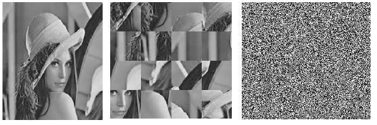

1.3) Cipher Image

1.2) Shuffled Image

1.1) Original Image

**3.4 Decryption by Chaotic System**

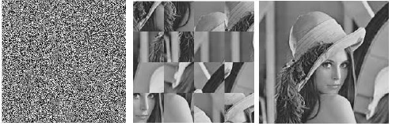

1.2) Shuffled Imageafter decryption

1.1) Original Image

1.3) Cipher Image

**3.5 System Design Architecture**

Input Image of n*n Matrix

Pixels Shuffling of Input Image

Pixel value transformation using Henon Map

Encrypted Image

**3.5.1 Image** **Encryption Process**

Encrypted Image

Decrypted Image

Pixels Shuffling of Input Image

Pixel value transformation using Henon Map

**3.5.2** **Image** **Decryption Process**

1. **System Requirements**

* Operating system : Windows or Linux
* Latest python version should be installed in the system
* Python Application required: Jetbrains PyCharm

1. **Expected Results**

* The proposed scheme will take an image as input and shuffles the pixels based on the number of iteration and key value by using the Chaotic Henon and Arnold’s catmap algorithms.
* The obtained Cipher image after applying the Encryption algorithm is decrypted by using the Henon map decryption algorithm to get original resultant image.

1. **Conclusion**

Chaos based image encryption is very secure because it is known for its randomness. Employed Arnold cat map and Henon map techniques, which are the based on randomization properties of chaotic schemes. Henon map is used to generate the key value, while Arnold cat map is used for pixel shuffle. The same key is used for both encryption and decryption, which is the same operation. Through this procedure, the data will be more securely protected from unauthorized access.

1. **References**

[1] B. Sai Kumar, L. Vikhyath, R. Geetha Krishna Pavansai(2021),”Image Encryption Using Chaos Maps “, International Journal of Scientific & Engineering Research Volume 12, Issue 6, June-2021 12 ISSN 2229-5518.

[2] Pranjali Sankhe1, Shruti Pimple2, Surabhi Singh3, Anita Lahane,(2018) ” An Image Cryptography using Henon Map and Arnold Cat Map.” International Research Journal of Engineering and Technology (IRJET).