Online Course
Admin
- Unable to add the course Details as it is Throwing an Error as Title already existing. IT Throws and Error But it will be added

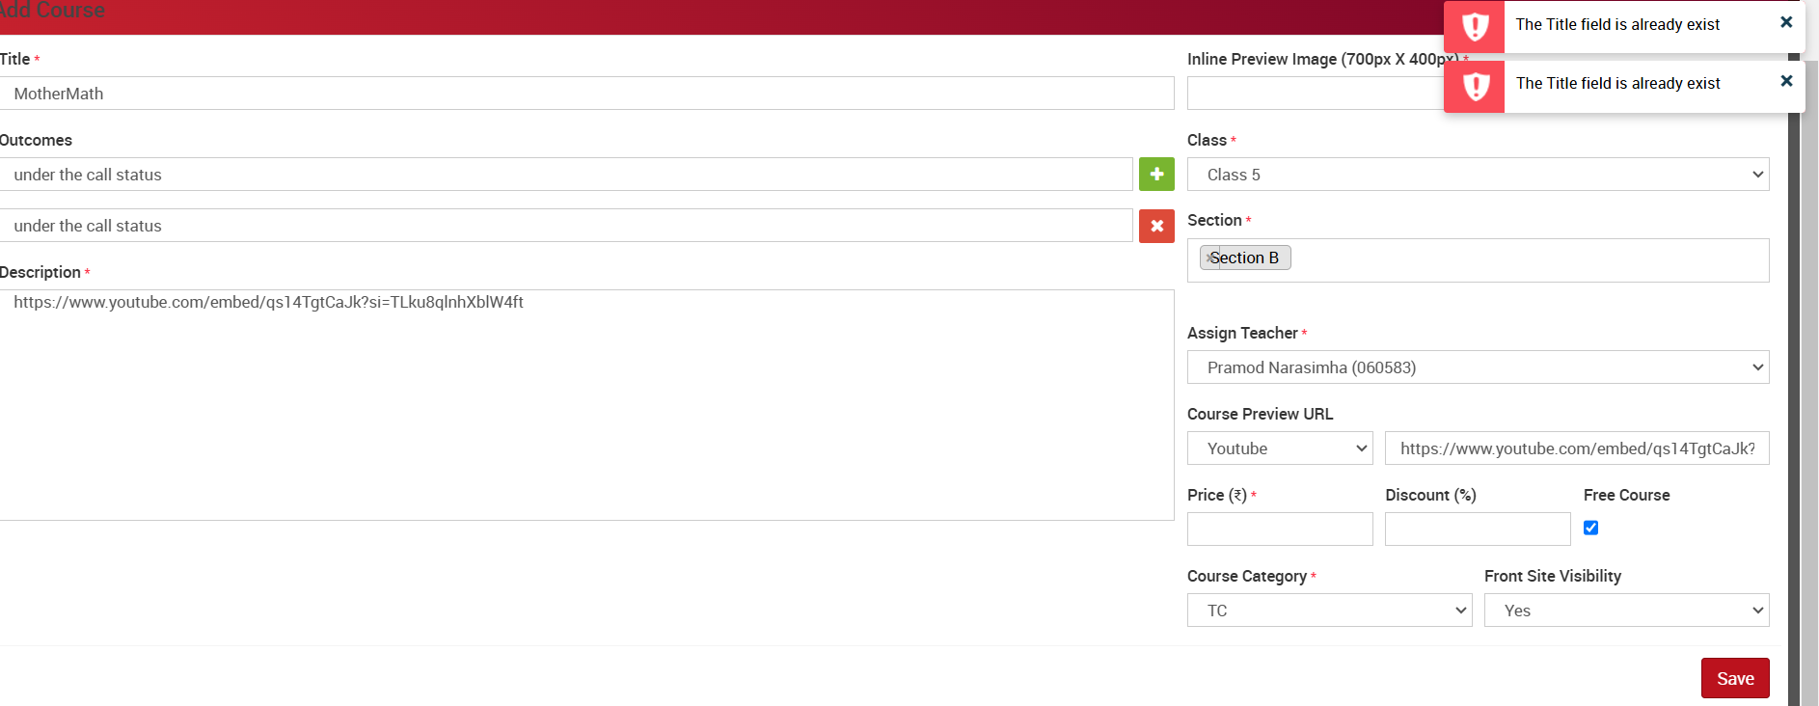
- Please Help me Understand what is this Option Copy to Branch and How Does it Work
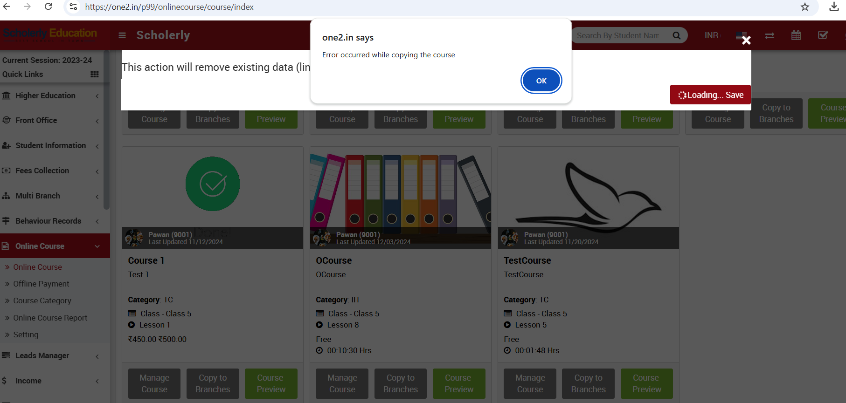
- Uploaded PDF should Show Attachment Icon not a Default Man Image

Staff
- Online Course When I click it is throwing an error Login from Pramod0605@gmail.com and 12345 as password. Cannot Check Further

Student
- Need an Option at the bottom as MyCourses where Only the Purchased or Opted Courses should be displayed.
- Unable to View the Uploaded the Document
- Could not Find an Option to Give Evaluate marks on the Back End
- When I click on the Lesson One Under the Couse it is Throwing an error and Redirecting me to the Home Page
- I see that there is Certificate Uploaded or Generated .. Where do I upload the Certificate or How is it getting Generated
- I need to see the Paid History of the Course Purchased
Exams
- Students Remarks are not Shown
- Marked the student Absent From Back End now the Exam Result is not Showing
- Comment on the Note for the Every Student is not Showing Properly
CBSE Exam :
- Change the name to Advance Exams But Schedule is Fine it Looks Like it is Working
- When we Click on the Icon CBSE Exams it is Only Buffering

