RESPIRATION
Respiration is a vital life process by which living organisms release energy from food to carry out all life activities. The food that organisms consume contains stored chemical energy, but this energy cannot be used directly by the body. Through respiration, this stored energy is
released in a controlled manner and stored in the form of ATP (Adenosine Triphosphate), which is known as the energy currency of the cell. This energy is required for growth, movement, repair of tissues, transport of substances and maintenance of internal balance.
Respiration involves a series of biochemical reactions in which food, mainly glucose, is broken down. Depending on the availability of oxygen, respiration may be aerobic (in the presence of oxygen) or anaerobic (in the absence of oxygen). Aerobic respiration releases a large amount of energy and produces carbon dioxide and water as end products, while anaerobic respiration releases less energy and produces substances like ethanol, carbon dioxide or lactic acid.
It is important to note that respiration is different from breathing. Breathing is only a physical process of taking in oxygen and giving out carbon dioxide, whereas respiration is a chemical process that occurs inside the cells. Breathing supplies oxygen for respiration, but respiration is the actual process that releases energy.
Respiration occurs continuously in all living organisms, including plants and animals, day and night. Even when an organism is resting or sleeping, respiration continues to supply energy for vital internal activities. Thus, respiration is essential for maintaining life.

Diagram: Breakdown of Glucose During Respiration What Diagram Should Be Drawn in Exam “Breakdown of Glucose by Various Pathways”

Diagram Description (Step-by-Step)

Glucose (6-carbon)
|
| (Glycolysis)
|
Pyruvate (3-carbon)
|

| | |
Anaerobic Anaerobic Aerobic (Yeast) (Muscle cells) (With O₂ )
| | |
Ethanol + CO₂ Lactic Acid CO₂ + H₂ O (Less energy) (Less energy) (More energy)

Explanation of Diagram
- Glucose (6-carbon molecule) is first broken down into pyruvate (3-carbon molecule) in the cytoplasm.
- Pyruvate can follow different pathways:
  - In yeast (absence of oxygen), it forms ethanol and carbon dioxide.
  - In muscle cells (lack of oxygen), it forms lactic acid.
  - In the presence of oxygen, pyruvate is completely broken down in mitochondria to form carbon dioxide and water, releasing a large amount of energy.
- The energy released is stored in the form of ATP.
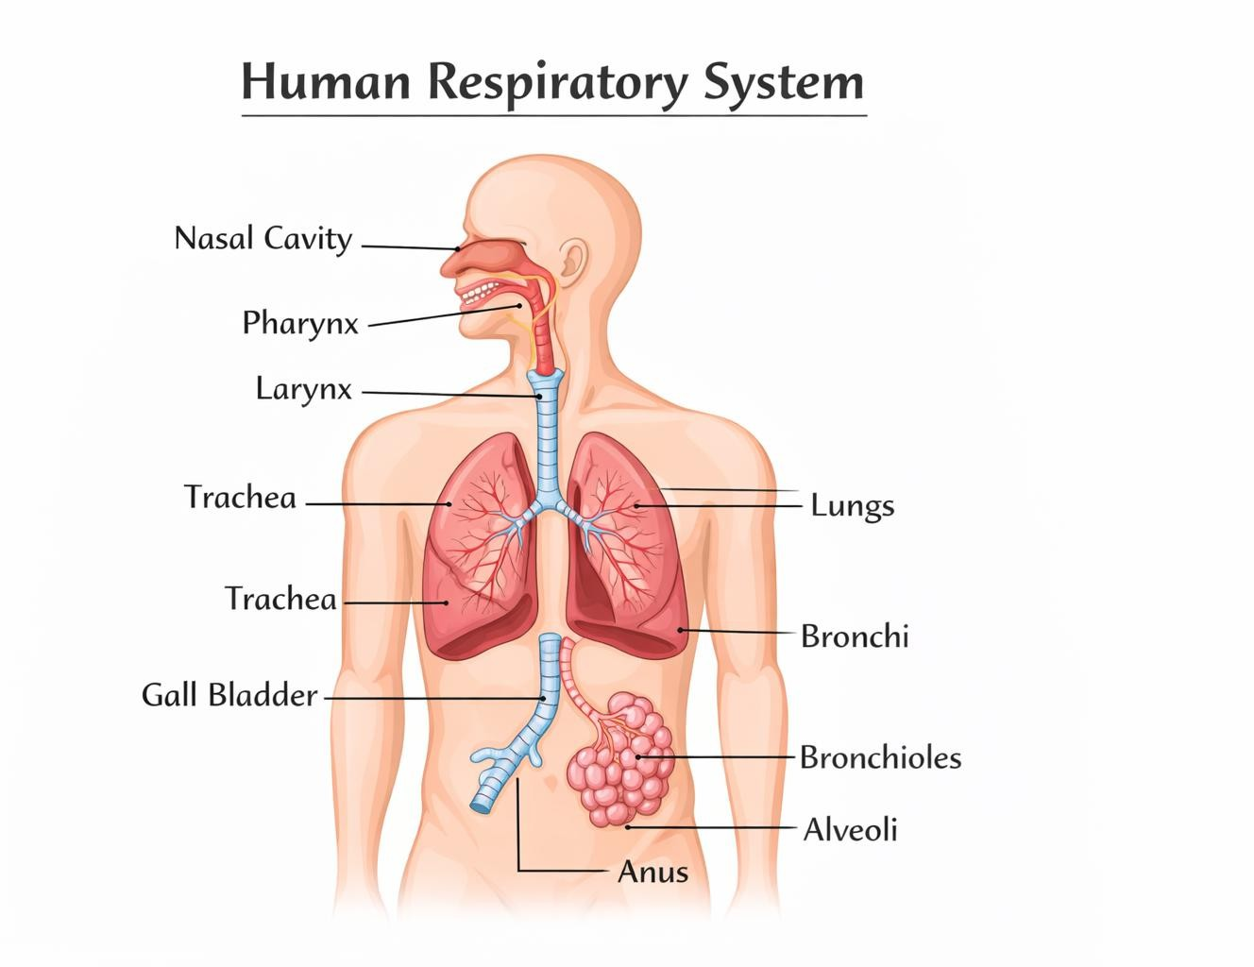

Transportation

Transportation is one of the essential life processes in living organisms. It refers to the movement of various substances such as food, oxygen, water, minerals, hormones and waste products from one part of the body to another. All living cells require a continuous supply of nutrients and oxygen to release energy and carry out metabolic activities. At the same time, waste materials produced during these activities must be removed to prevent harm to the body. Transportation makes this possible and therefore plays a vital role in maintaining life.

In unicellular organisms, transportation of substances occurs by simple diffusion because the entire body is in direct contact with the surrounding environment. However, in multicellular organisms, the body is large and complex, and most cells are not in direct contact with the external environment. In such organisms, diffusion alone is too slow and insufficient to meet the needs of all cells. Hence, specialised transport systems have evolved to ensure efficient and timely distribution of substances.
In human beings and other animals, transportation is carried out by the circulatory system, which includes the heart, blood and blood vessels. This system transports oxygen from the lungs to body cells, digested food from the intestine to various organs, hormones from glands to target tissues, and waste products to excretory organs. Efficient transportation is essential for meeting the high energy demands of active organisms.

In plants, transportation occurs through specialised vascular tissues. Xylem transports water and minerals from roots to leaves, while phloem transports food prepared during photosynthesis from leaves to other parts of the plant. Although plants do not have a pumping organ like the heart, transportation in plants is made possible by processes such as root pressure, transpiration pull and energy-dependent translocation of food.

Transportation is closely linked with other life processes. Nutrients obtained through nutrition are transported to cells, oxygen required for respiration is carried to tissues, and waste products formed during metabolism are transported for excretion. Therefore, transportation acts as a connecting link between all major life processes.
This topic is important for Class 10 CBSE examinations as it helps students understand the functioning of the human circulatory system and plant vascular tissues. It also forms the basis for advanced studies related to circulation, transport mechanisms and physiological systems in higher classes.

RESPIRATION

- Respiration is the process of
- breathing
- intake of oxygen

- release of energy from food
- exchange of gases
Answer: (c)

The site of gaseous exchange in human lungs is
- bronchi
- trachea
- alveoli
- diaphragm
Answer: (c)

Which of the following is an anaerobic process?
- Respiration in humans
- Respiration in plants
- Fermentation in yeast
- Respiration in animals
Answer: (c)

During aerobic respiration, glucose is broken down into
- alcohol and CO₂
- lactic acid
- CO₂ and water
- methane and water
Answer: (c)

