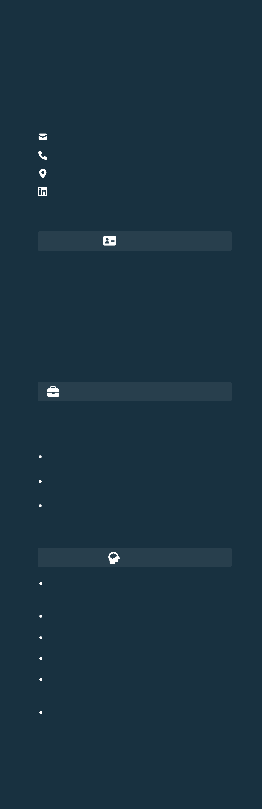

**Pramod Devanand Jadhav**   
Software Developer

[pramodjadhav1876@gmail.com](mailto:pramodjadhav1876@gmail.com)   
[8668231876](mailto:pramodjadhav1876@gmail.com)   
[Thane , Maharashtra , India](tel:8668231876)   
[linkedin.com/in/pramod-jadhav-80655223](https://linkedin.com/in/pramod-jadhav-80655223)

**PROFILE**

**EDUCATION**   
**Bachelor of Engineering (B.E.) in Computer Engg.**

Marathwada Mitra Mandal’s College of Engineering, Pune 2021 – present   
**Higher Secondary Certificate (H.S.C.)**   
B.N. Bandodkar College of Science, Thane   
2019 – 2020   
**Secondary School Certificate (S.S.C.)**   
Tai-Bai Madhyamik Vidyalay, Thane   
2017 – 2018

|  |  |
| --- | --- |
| Passionate about technology with a strong | **PROJECTS** |

skillset in programming, data structures, algorithms, and software development.

Proficient in **Python, JavaScript, and C++**, well-versed in **web and backend development**.

Enthusiastic about **AI, automation, and**   
**innovative tech solutions**. Eager to learn and apply skills to solve real-world problems.

**PROFESSIONAL EXPERIENCE**

**International Marketing Corporation Pvt.Ltd.** Business Development Associate

12/2020 – 01/2022  
•Promoted and sold company products while effectively handling customer objections.

•Developed strong sales strategies and improved customer engagement.

•Built and led a high-performing team, ensuring consistent sales growth.

**AI Assistant for Document Handling & Management Operations**

•Developed an **AI-powered document management system** enabling users to **scan, convert, resize, merge, and process files**.

•Integrated **speech-to-text commands** for hands-free interaction.

•Implemented **bulk processing and automation** for efficient file operations.

**AI-powered Gift Recommendation Website**

•Created an **AI-driven gift recommendation platform**  using **machine learning & NLP**.

•Suggested personalized gifts based on **user**  **preferences, occasions, trends,budgets etc**.

**Human Face, Age, and Gender Detection using CNN** Developed a Deep Learning model using Convolutional Neural Networks (CNN) to detect human faces, estimate age, and determine gender from images with high   
accuracy.

**SKILLS**  **Functional Testing of E-Commerce Website**   
 Conducted functional testing on the Sauce Demo e-Programming Languages - Python, C++, commerce website using Python, Selenium, and Chrome Javascript WebDriver, ensuring smooth user interactions, login

Frontend Frameworks - React.js   
Backend Frameworks - Django, Node.js Database - MySQL   
ML & DL Frameworks - Pandas, Numpy, Scikit Learn, Matplotlib, CNN etc.

Data visualization - Power BI, MS-Excel

authentication, and cart functionality.

**CERTIFICATES**

**MCQ Coding Assessment, Talent Park (Unstop)**   
Actively participated and certified in the **MCQ+ coding assessment** organized by Unstop Talent Park - Tech.

**College Youth Ideathon, 2025**

•Participated in the **national-level College Youth Ideathon for Startups**, organized by ThinkStartup in collaboration with Youth Ideathon and ranked in top 1000 teams in 2nd round.