LAB 2.3
Task 1: Word Frequency from Text File
❖ Scenario: You are analyzing log files for keyword frequency.
Prompt used: # generate a python code that reads a text file and count word frequency then explain code take user input path
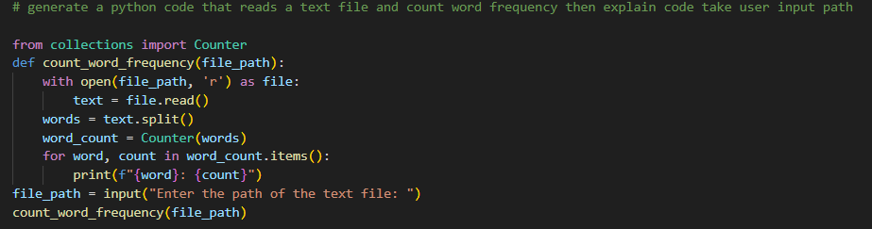
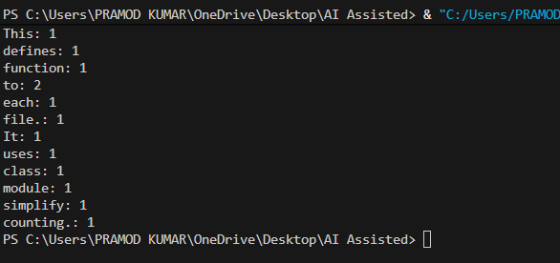

Task 2: File Operations Using Cursor AI
❖ Scenario: You are automating basic file operations.
Prompt used: perform basic file operations by creating a text file, writing sample content, then reading and displaying it take user input

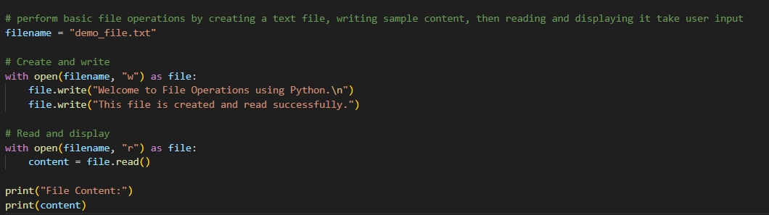
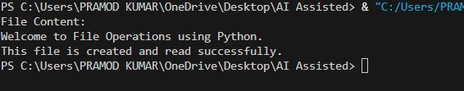

Task 3: CSV Data Analysis
❖ Scenario: You are processing structured data from a CSV file
Prompt used: read a CSV file and compute mean, minimum, and maximum values of numeric columns
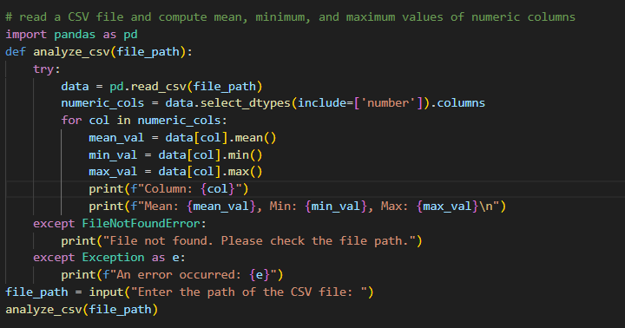

Task 4: Sorting Lists – Manual vs Built-in
❖ Scenario: You are reviewing algorithm choices for efficiency.
Prompt used: implement bubble sort and Python’s built-in sort() for a list and compare their efficiency take user input

