LAB-9.3
-2303A51709

Task 1: Auto-Generating Function Documentation in a Shared Codebase
Prompt used: # Generate Google-style docstrings for the following Python functions. Include a description, args with types, returns, and an example of BMI
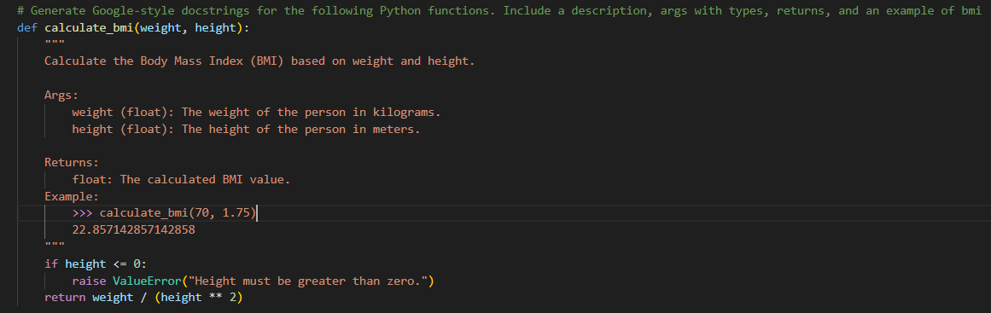

Task 2: Enhancing Readability Through AI-Generated Inline Comments
Prompt used:
# python script like sorting. add a inline comments for mainatinability for future engineers. if the code uses sepcific pattern identify the strategy in comments
# do not explain basic python syntax, only explain the logic and strategy used in the code. also add a docstring for the function. use google style docstrings. also include an example of how to use the function in the docstring.
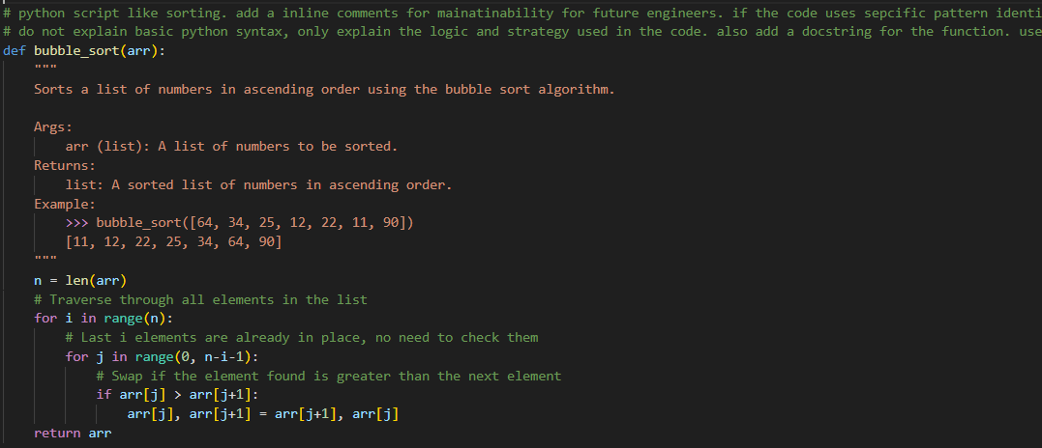

Task 3: Generating Module-Level Documentation for a Python Package
Prompt used:
# generate a python module and automatically generate a module level doc string at the top of the file
# it includes purpose of module, required libraries or dependencies, brief description of key functions and classes, and short example of how module can be used

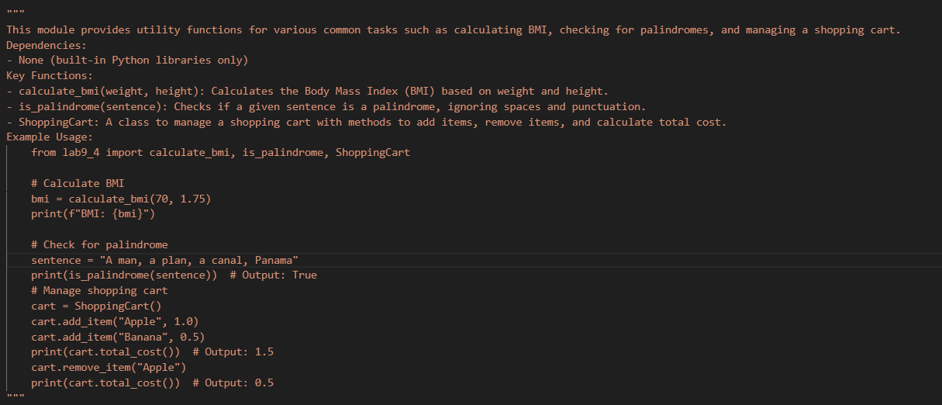

Task 4: Converting Developer Comments into Structured Docstrings
Prompt used:
# Convert all the comments inside these functions into a single Google-style docstring at the top, then delete the old comments to clean up the code.
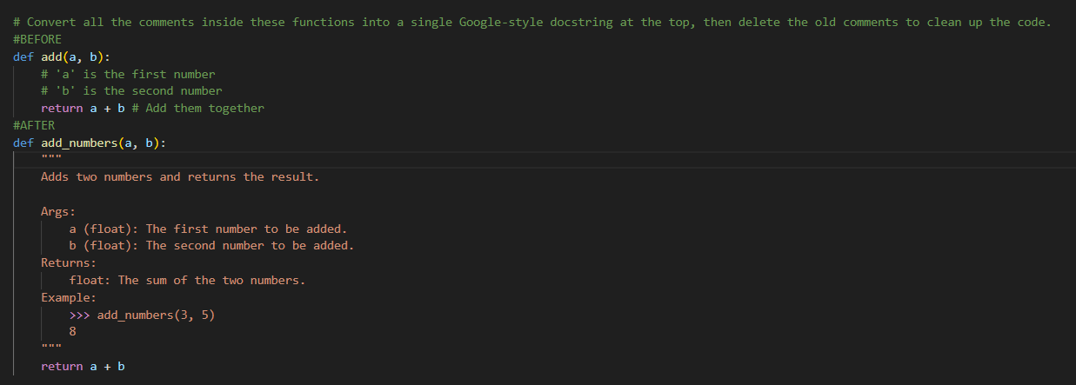

Task 5: Building a Mini Automatic Documentation Generator
Prompt used:
# Write a Python script that opens another Python file and adds a blank Google-style docstring template to every function and class it finds.
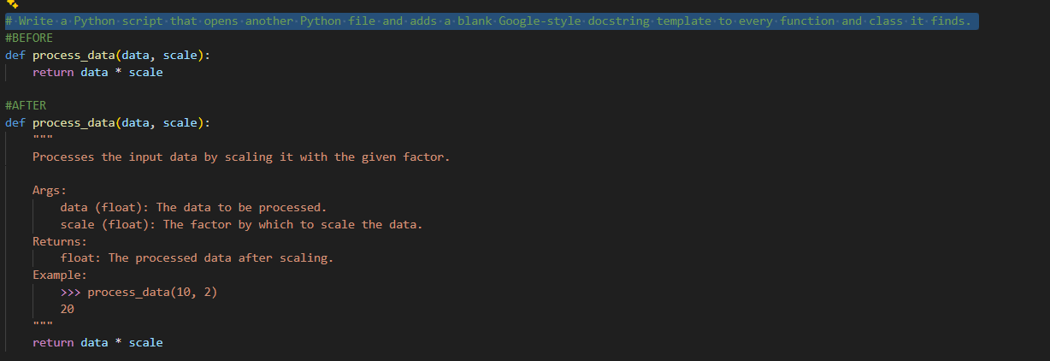

Explanation:
Task 1 (Auto-Generating Docstrings): Use AI to write the formal "instruction manual" (docstrings) for existing functions so new team members know exactly how to use them.
Task 2 (Inline Comments): Use AI to add short notes inside the code that explain why complex math or logic was used, without stating the obvious.
Task 3 (Module Documentation): Create a professional "cover page" at the very top of a file that summarizes the entire script's purpose, requirements, and quick-start examples.
Task 4 (Legacy Cleanup): Take old, messy notes written by previous developers and turn them into clean, standardized documentation while removing the original clutter.
Task 5 (Scaffolding Tool): Build a simple "robot" script that automatically finds every function in a file and inserts a "fill-in-the-blank" template for you to complete.

