LAB-8.3
-2303A51709
Task 1: Email Validation using TDD
Scenario: You are developing a user registration system that requires reliable email input validation.
Prompt used:
# generate a python function for developing a user registration thar requires user input validation
# it must contains @ and . character and must not start or end with any special charcter
# it should not allow multiple @
# the function should return true if the email is valid and false if it is invalid.
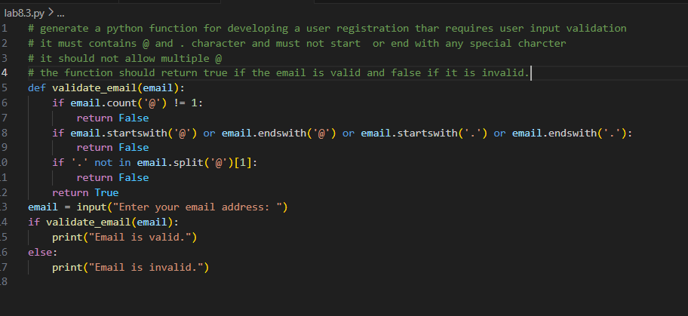
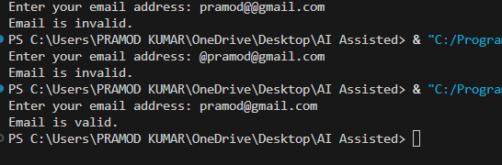

Task 2: Grade Assignment using Loops
Scenario: You are building an automated grading system for an online examination platform.
Prompt used:
# generate a python function for automated grading system
# if the grade is 90-100 print A, 80-89 print B, 70-79 print C, 60-69 print D, below 60 print F
# include boundary values 60, 70, 80, 90 in the test cases
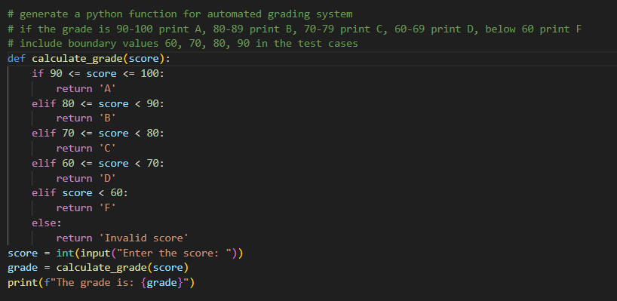
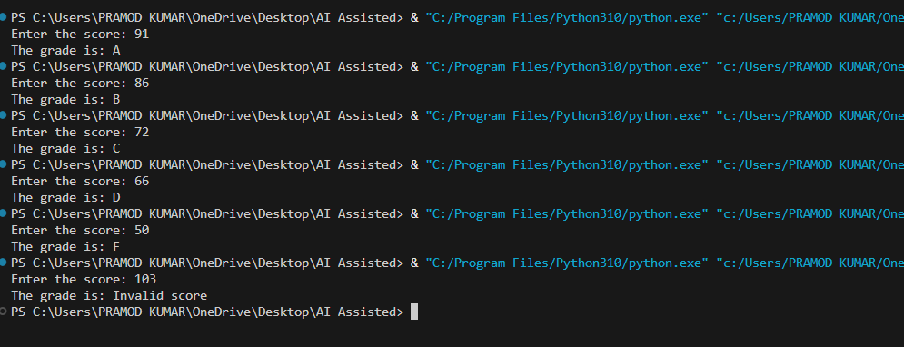

Task 3: Sentence Palindrome Checker
Scenario: You are developing a text-processing utility to analyze sentences.
Prompt used:
# generate a python program for if the sentence is a palindrome or not
# ignore spaces and punctuation
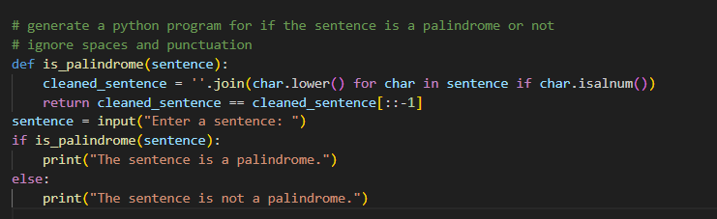
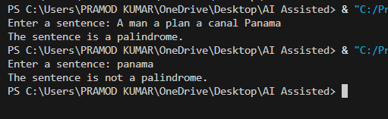

Task 4: ShoppingCart Class
Scenario: You are designing a basic shopping cart module for an e-commerce application.
Prompt used:
# generate a python function for shopping cart. the class must include add_item(name,price)
# remove_item(name), total_cost(). validate correct addition, removal and cost calculation.
# also handle empty cart scenarios. take user input
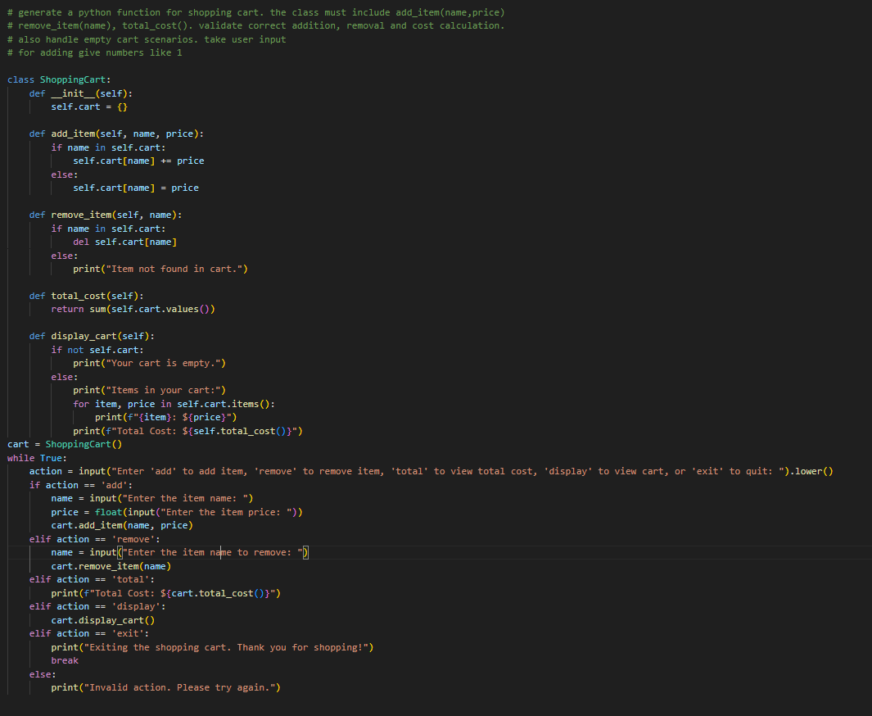
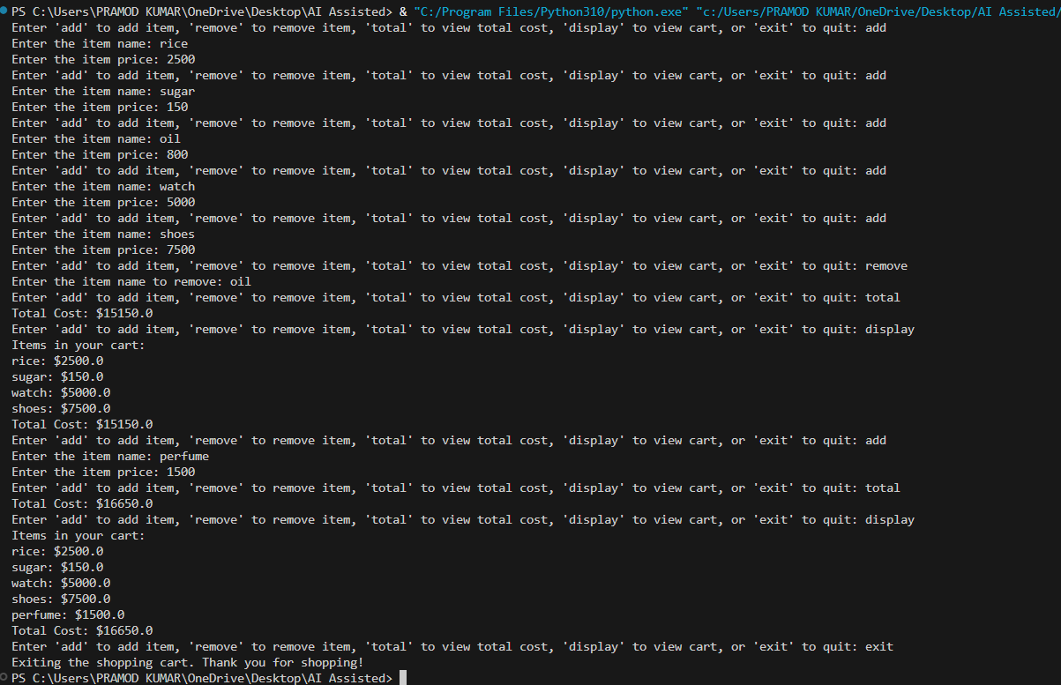
Task 5: Date Format Conversion
Scenario: You are creating a utility function to convert date formats for reports.
Prompt used:
# Write a Python function that converts a date from "YYYY-MM-DD" format to "DD-MM-YYYY" format
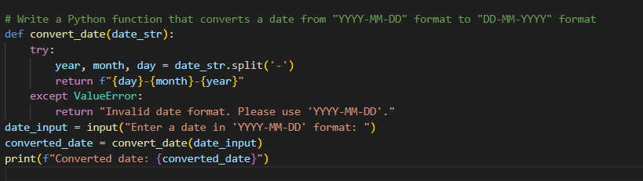
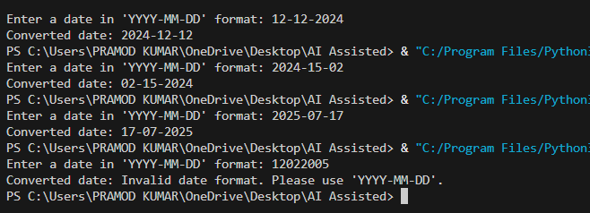

Explanation:
1. The first snippet is a function to validate email addresses based on specific criteria.
2. The second snippet is a function to calculate letter grades based on numerical scores.
3. The third snippet checks if a given sentence is a palindrome, ignoring spaces and punctuation.
4. The fourth snippet defines a ShoppingCart class that allows users to add and remove items, calculate total cost, and display the cart contents.
5. The fifth snippet is a function that converts a date from "YYYY-MM-DD" format to "DD-MM-YYYY" format.

