Project 2: Questions & Answers for Image Classification (CNN)

Section A: Data and Preprocessing
Q1. What is the shape of a single image in your dataset (height, width, channels)? How many training and test samples are there? How many classes?
Ans:
Shape of a Single Image:
Height: 28 pixels
Width: 28 pixels
Channels: 1 (Grayscale image)
So, the final shape is: (28, 28, 1)
Number of Samples:
Training Samples: 60,000 images
Test Samples: 10,000 images
Number of Classes: 10

Q2. How did you normalize pixel values? Why is normalization important for training a CNN?
Ans:
Pixel values were normalized by dividing them with 255 to bring them between 0 to 1 range, which helps the model train faster and perform better.

Q3. Did you use a validation split? If yes, how did you create it (e.g., from training data)? What is the rationale for having a separate validation set?
Ans:
I used a 20% validation split from training data to monitor performance and avoid overfitting.

Q4. Describe the data augmentation techniques you applied (e.g., rotation, horizontal flip, zoom). For each, state the parameter range (e.g., rotation range in degrees) and why it is suitable for your dataset.
Ans:
I used rotation (±10°), horizontal flip, and zoom (10%) to create more variations and improve model performance.

Section B: Model Architecture and Training
Q5. Describe your CNN architecture layer by layer: number of conv layers, filter sizes, pooling, flatten, dense layers, and activation functions. How many trainable parameters does your model have?
Ans:
Model Architecture (Layer by Layer):
Data Augmentation Layer:
Applies transformations like rotation, flip, zoom. Helps increase data variety
Conv2D Layer 1:
- Filters: 32
- Kernel size: (3,3)
- Activation: ReLU
MaxPooling Layer 1:
- Pool size: (2,2)
Conv2D Layer 2:
- Filters: 64
- Kernel size: (3,3)
- Activation: ReLU
MaxPooling Layer 2:
- Pool size: (2,2)
Flatten Layer:
Converts feature maps into 1D vector
Dense Layer:
- Units: 128
- Activation: ReLU
Dropout Layer:
- Rate: 0.5
- Helps reduce overfitting
Output Layer:
- Units: 10
- Activation: Softmax
Trainable Parameters:
- Total parameters: ~1.2 Million (approx)

Q6. Why do we use convolutional layers instead of only dense layers for image data? Explain in terms of spatial structure and parameter count.
Ans:
Convolutional layers are used because they capture image patterns and use fewer parameters, while dense layers ignore spatial structure and are very heavy.

Q7. Where did you apply dropout (after which layers) and what dropout rate did you use? How did dropout affect validation accuracy or overfitting compared to a model without dropout?
Ans:
Dropout (0.5) was applied after the dense layer to reduce overfitting and improve validation performance compared to a model without dropout.

Q8. Did you use early stopping? If yes, what metric did you monitor and what patience value did you set? If not, how did you choose the number of epochs?
Ans:
I used early stopping by monitoring validation loss with a patience of 3 to stop training when the model stopped improving.

Section C: Evaluation and Interpretation
Q9. Report test set accuracy and display the confusion matrix. Which class(es) had the lowest accuracy? Suggest one possible reason (e.g., visual similarity between classes).
Ans:
The model achieved 85.63% accuracy, and classes like shirt and t-shirt had lower accuracy due to their visual similarity. 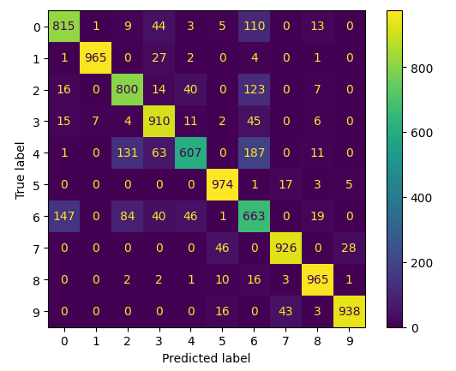

Q10. Plot (or describe) training vs validation loss and accuracy. Did the model overfit? How did data augmentation and dropout change the gap between training and validation performance?
Ans:
Training and validation performance were close, showing no major overfitting, and data augmentation with dropout helped reduce the gap and improve generalization.
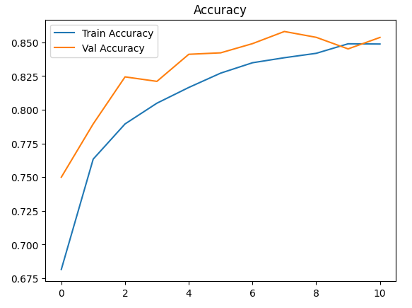

Section D: Extension and Reflection
Q11. If you had more compute and time, name one architectural change you would try (e.g., more layers, batch normalization, different optimizer) and why.
Ans:
I would add batch normalization layers to make training faster, more stable, and improve model accuracy.

Q12. In a real product (e.g., mobile app), what would you consider for deploying this CNN (e.g., model size, latency, quantization)?
Ans:
For deployment, we consider model size, speed, quantization, and battery usage to ensure fast and efficient performance on devices.

