To run project double click on ‘run.bat’ file to get below screen

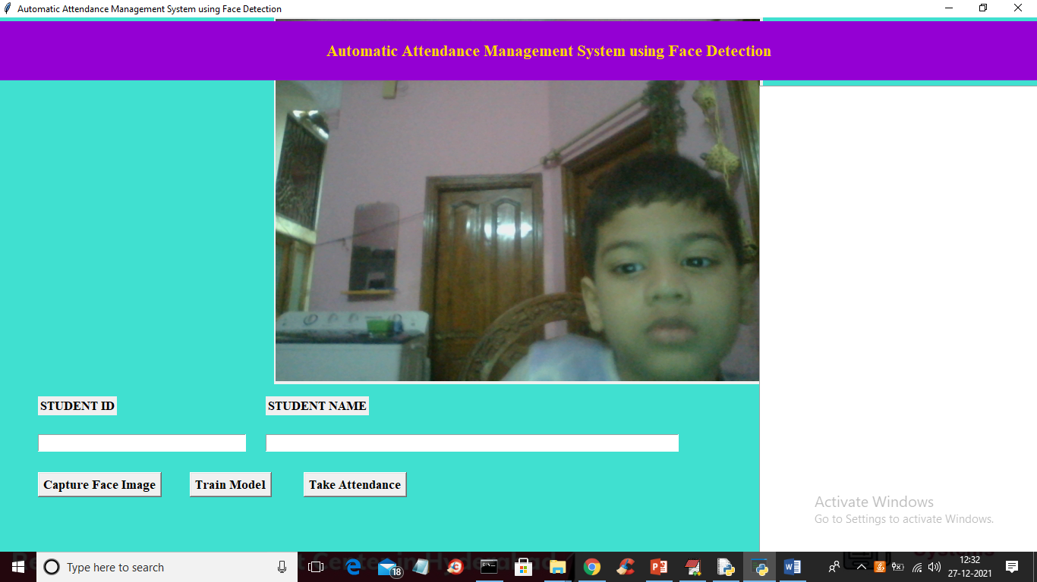

In above screen enter student id and name and then click on ‘Capture Face Image’ button to capture face like below screen

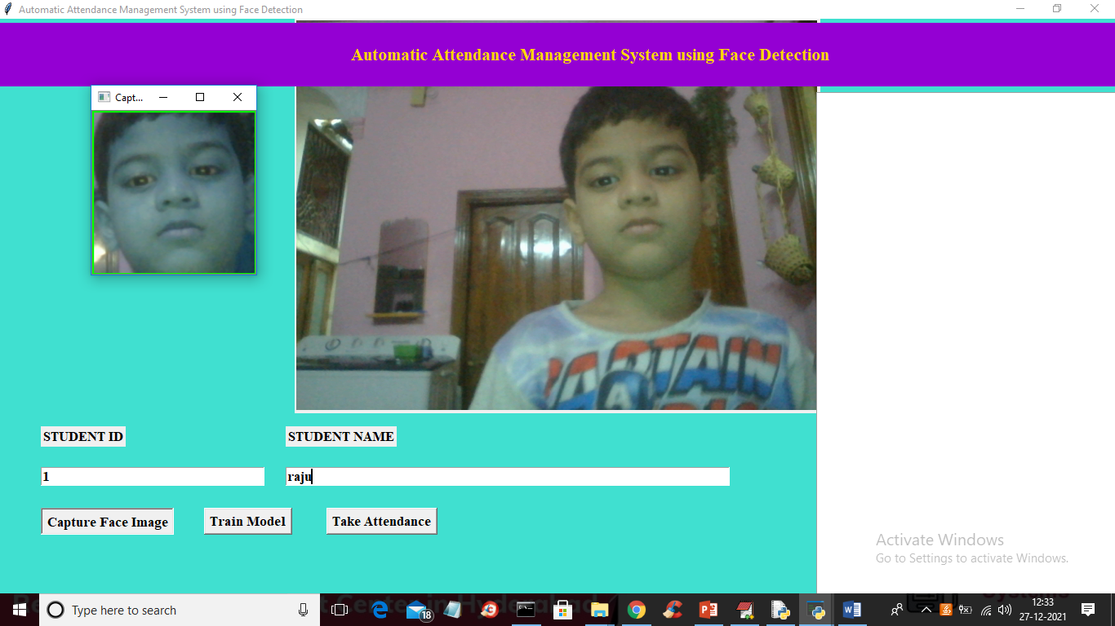

In above screen face is detected and now click on ‘Train Model’ button to perform training like below screen

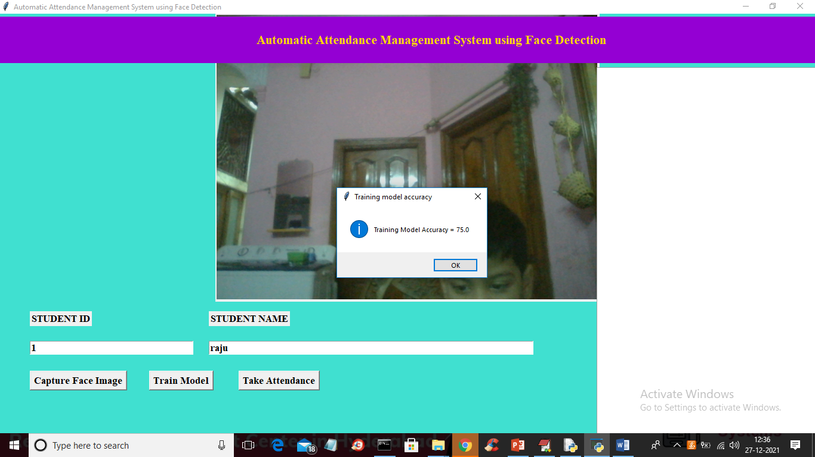

In above screen training completed with accuracy 75% and then any time click on ‘Take Attendance’ to recognized student and mark attendance

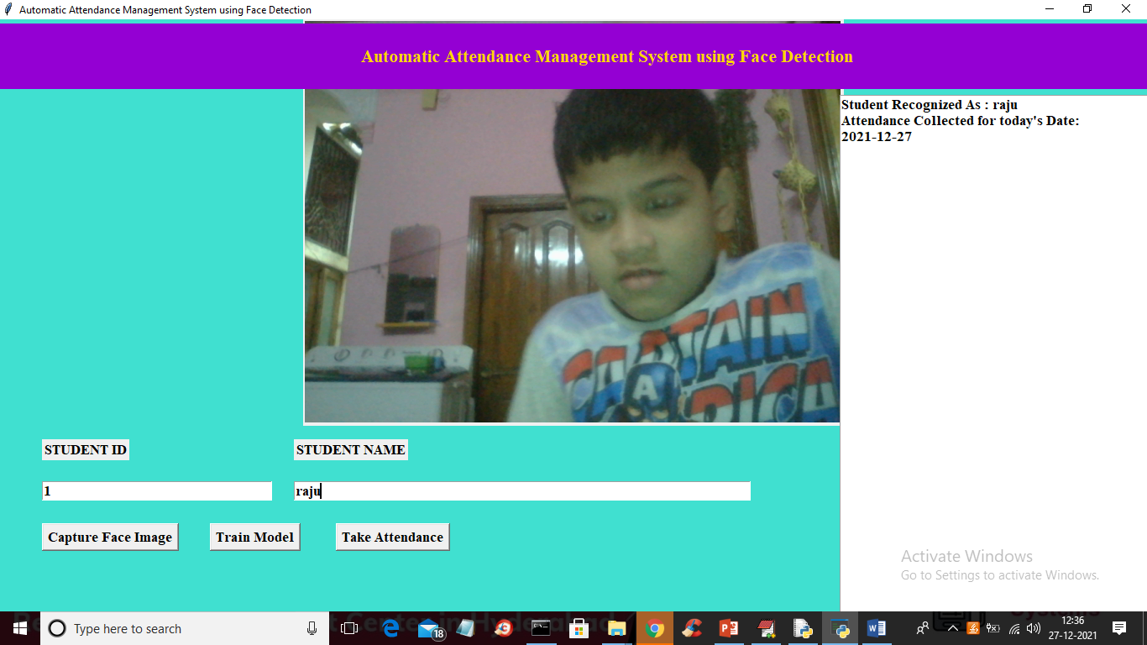

In above screen in text area we can see student identified as Raju. Similarly you can capture N student and take attendance.

Note: this application depend on camera clarity so identifying of student may be correctly recognized 5 times out of 10. This types of application need more refinement to build accurate model

Note: to train model atleast two students must be added or registered