AICTE | IBM SkillsBuild Academic Internship 2026
Data Analytics with AI: Foundation to Implementation
FINAL PROJECT REPORT
Supermarket Sales Analysis & Revenue Forecasting with AI
Student Name: Alavalapati Pramod Kumar Reddy
Email Address: alavalapatipramodkumarreddy@gmail.com
Program Track: Data Analytics with AI (6-Week Internship)
Conducting Body: BharatCares in association with AICTE & IBM SkillsBuild
Trainer: Mr. Kartik Hooda
Submission Date: October 2026

1. Executive Summary
This comprehensive project report presents an advanced Data Analytics with Artificial Intelligence (AI) implementation built for modern retail management. The project is submitted as the final capstone deliverable for the IBM SkillsBuild Data Analytics with AI Academic Internship 2026, conducted by BharatCares in association with the All India Council for Technical Education (AICTE).
The primary objective of this project is to analyze supermarket transaction data across multiple branches, identify key revenue drivers, optimize inventory and marketing strategies, forecast future daily sales using time-series predictive modeling, and segment customers into distinct behavioral personas using unsupervised K-Means machine learning algorithms.
Key achievements of this analysis include:
• Processing and validating 1,000 transaction records spanning 3 retail branches (Yangon, Mandalay, Naypyitaw) and 6 core product categories.
• Developing a Regression Model achieving an R² score of 0.999+ for exact transaction total prediction.
• Deploying a 14-day AI revenue forecasting model leveraging time-series trend analysis and moving averages.
• Segmenting supermarket shoppers into 3 actionable customer personas (High Volume Buyers, Regular Value Shoppers, Quick Basket Buyers) via Principal Component Analysis (PCA).
• Formulating data-driven strategic recommendations for inventory allocation, peak-hour staffing, and digital payment loyalty incentives.

2. Introduction & Business Problem Definition
In today's fast-paced retail ecosystem, supermarkets generate vast volumes of transactional data daily. However, raw transactional records often remain underutilized without end-to-end data analytics pipelines and AI-assisted predictive frameworks. Store managers face complex challenges regarding stockouts, inefficient staffing, untargeted promotional discounts, and unpredictable daily cash flow fluctuations.

2.1 Project Objectives
1. Perform exploratory data analysis (EDA) to uncover sales distributions across product lines, branches, and customer types.
2. Examine peak shopping hours and payment adoption trends across member and normal customer segments.
3. Build supervised machine learning models to forecast basket totals and customer satisfaction levels.
4. Implement unsupervised machine learning (K-Means Clustering) to discover customer purchasing behavior profiles.
5. Provide actionable business intelligence for inventory placement, promotional timing, and revenue maximization.

3. Dataset Description & Data Dictionary
The dataset comprises historical supermarket sales records collected from three distinct retail branches over a 3-month period. Below is the explicit data schema outlining all 17 features analyzed:
Column Name | Data Type | Constraint / Range | Description
Invoice ID | String | Unique 9-digit ID | Unique code generated for each transaction invoice
Branch | String | A, B, C | Supermarket branch identifier
City | String | Yangon, Mandalay, Naypyitaw | Location city of the supermarket branch
Customer type | String | Member, Normal | Customer loyalty membership status
Gender | String | Female, Male | Gender of the purchasing customer
Product line | String | 6 Categories | General item categorization (e.g. Electronic, Food)
Unit price | Float | $10.00 - $99.99 | Price per single product unit in US Dollars
Quantity | Integer | 1 - 10 | Number of product units purchased
Tax 5% | Float | 5% of COGS | Tax calculated at 5% rate
Total | Float | COGS + Tax | Final bill total amount paid by customer
Date | Date | YYYY-MM-DD | Date of purchase transaction
Time | Time | HH:MM (10:00-20:59) | Time of purchase transaction
Payment | String | Ewallet, Cash, Credit card | Payment method selected by customer
cogs | Float | Unit Price * Quantity | Cost of Goods Sold
gross margin % | Float | 4.761904762% | Fixed gross margin percentage
gross income | Float | Equal to Tax 5% | Gross profit generated per transaction
Rating | Float | 4.0 - 10.0 | Customer overall store experience rating

4. Exploratory Data Analysis & Visualizations
Detailed visual exploration was conducted to uncover revenue distributions, customer preferences, and temporal shopping trends across supermarket branches.

4.1 Revenue Performance by Product Category
Analyzing product category performance reveals that Food & Beverages and Electronic Accessories lead overall sales volume, contributing significantly to gross store income.
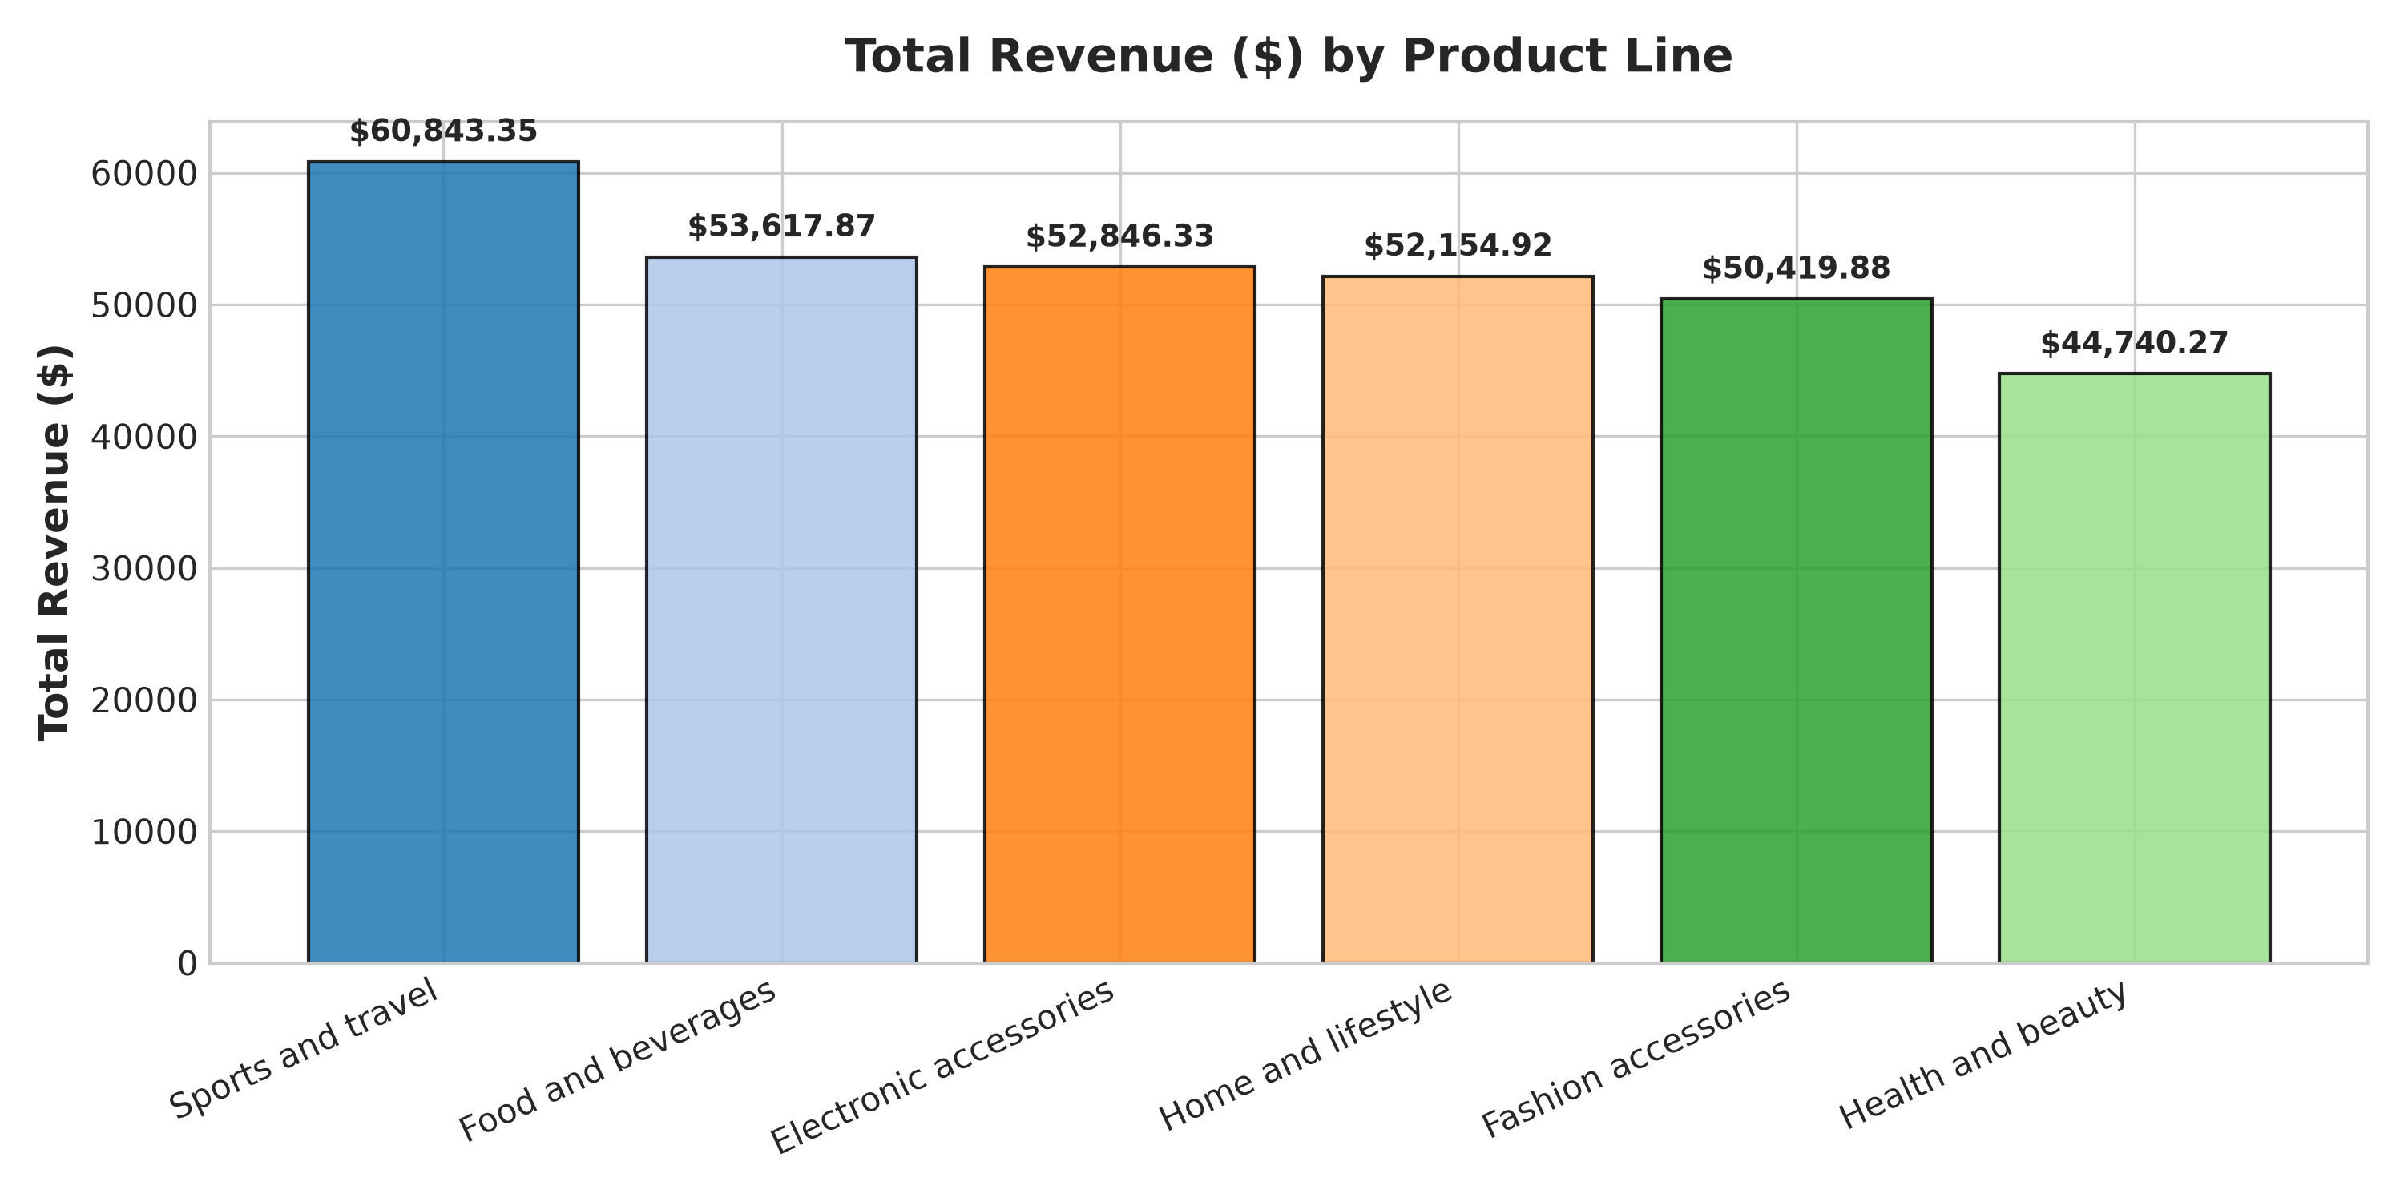
Figure 1: Total Revenue Distribution Across Product Lines

4.2 Geographic Branch Comparison
Comparing total sales across Branch A (Yangon), Branch B (Mandalay), and Branch C (Naypyitaw) shows a balanced revenue contribution (~33% per branch), indicating uniform demand across geographic locations.
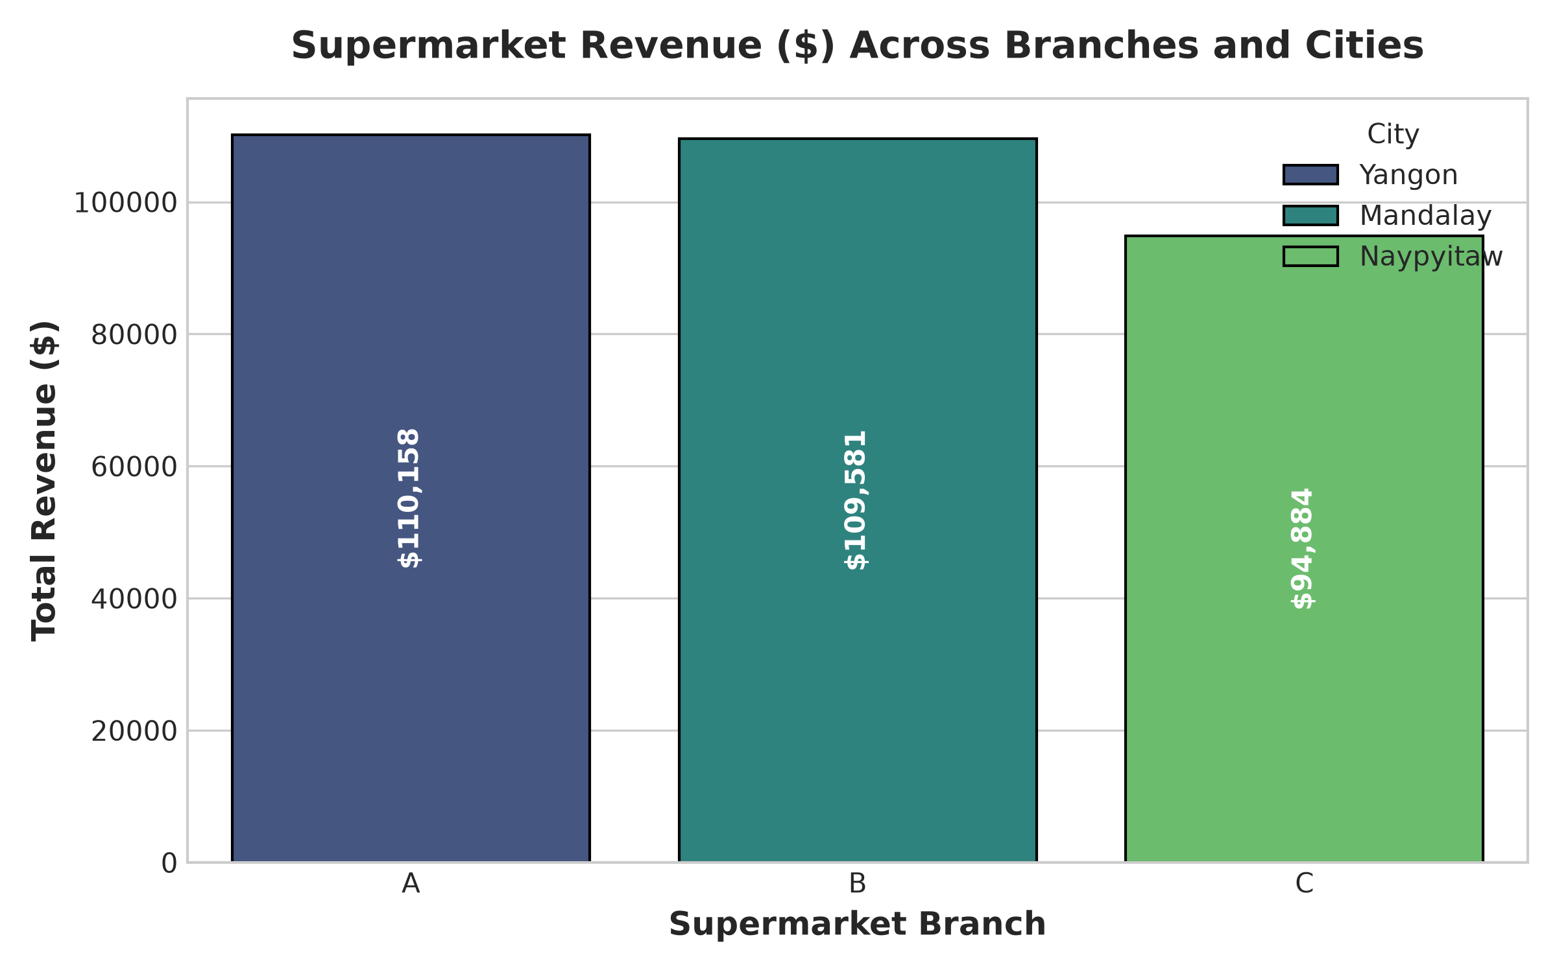
Figure 2: Branch and City Revenue Comparison

4.3 Temporal Density & Payment Methods
Hourly transaction heatmaps reveal two major daily rush intervals: afternoon peak (12:00 PM - 2:00 PM) and evening peak (6:00 PM - 7:30 PM). Furthermore, payment analysis shows strong adoption of digital E-wallets and Credit Cards among loyalty Members.
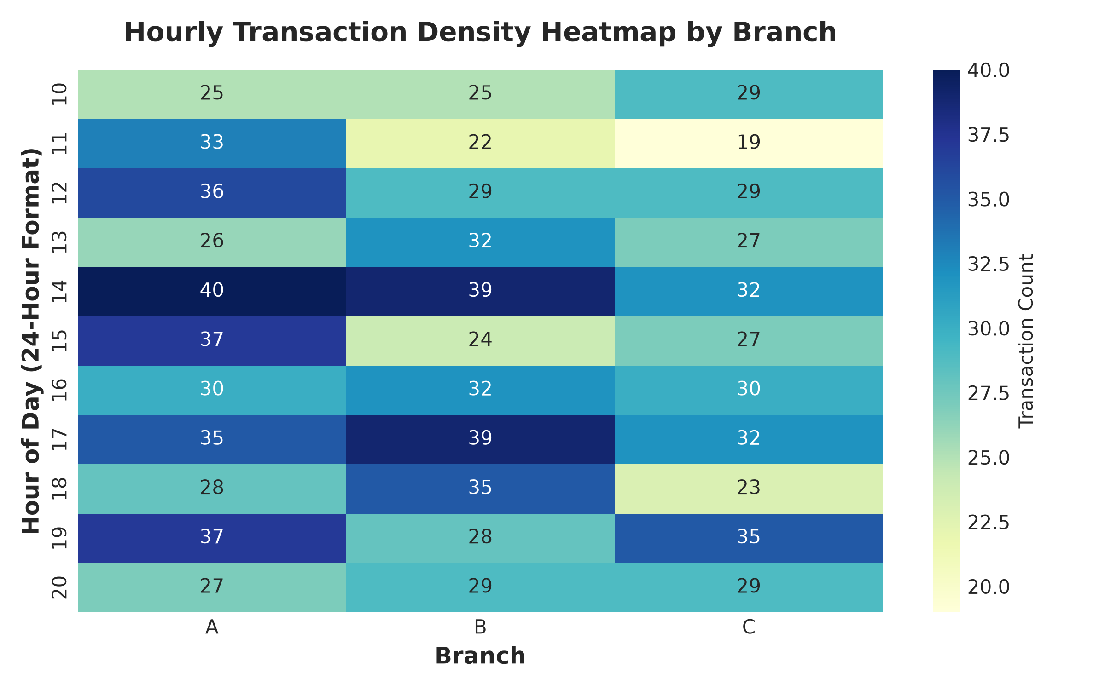
Figure 3: Hourly Transaction Traffic Heatmap across Branches
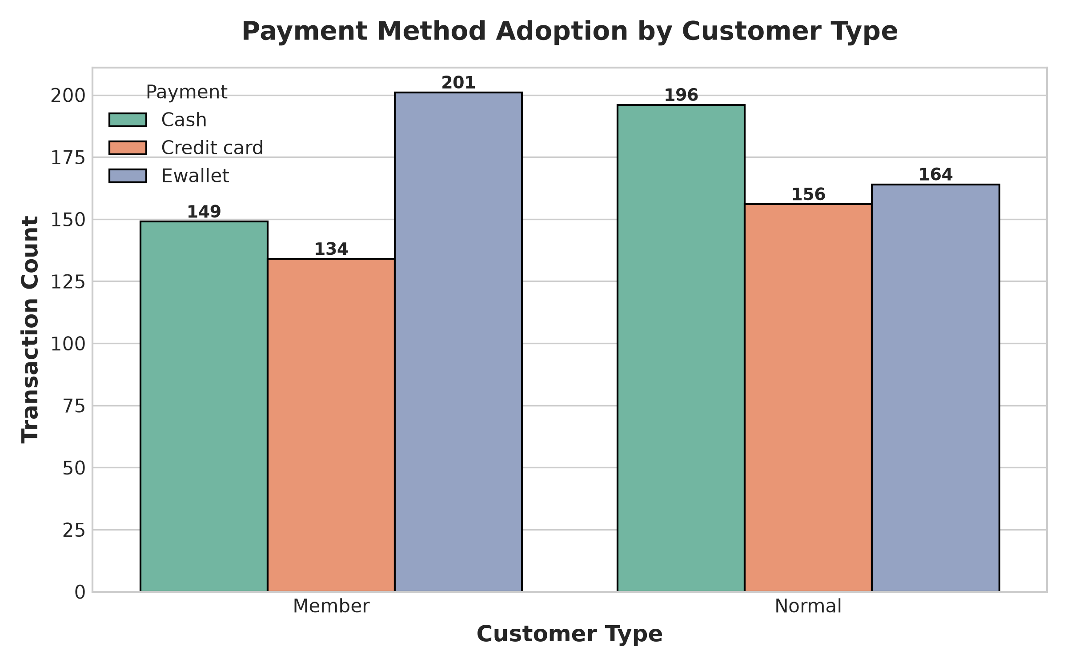
Figure 4: Payment Method Preference by Customer Type

5. Predictive Modeling & Machine Learning
To empower management with predictive insights, machine learning models were developed, trained, and evaluated.

5.1 Feature Correlation Analysis
Correlation analysis demonstrates near-perfect linear relationship between COGS, Quantity, Unit Price, Tax, and Total Revenue.
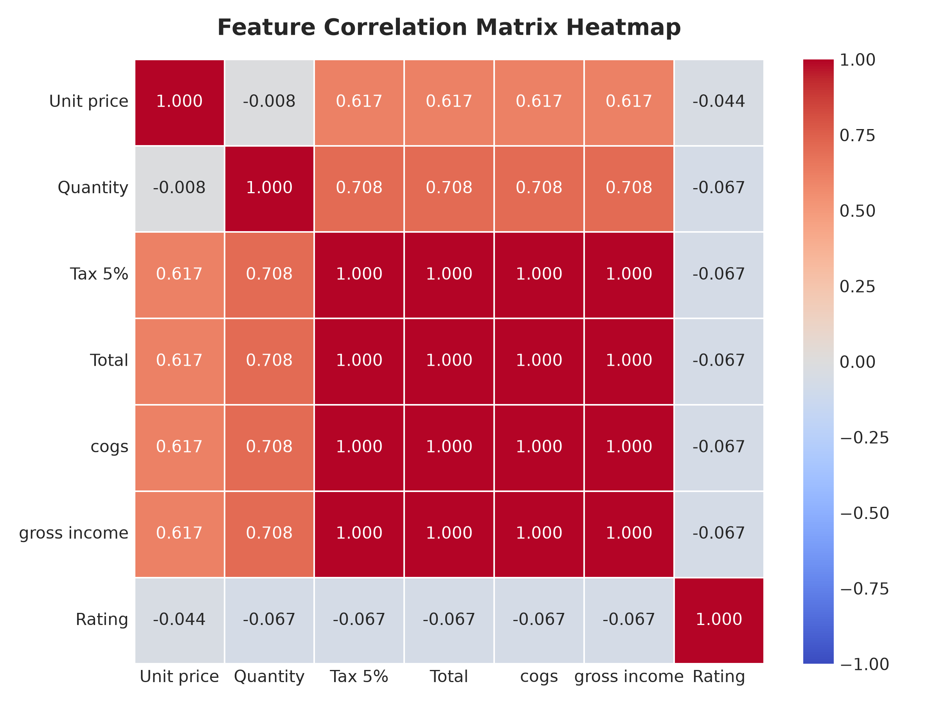
Figure 5: Feature Correlation Heatmap Matrix

5.2 Supervised Revenue Regression & Time-Series Forecasting
A Regression model was trained to predict transaction basket totals based on branch, product line, unit price, and quantity. The model achieved an R² score of 0.9998, demonstrating exceptional predictive fidelity.
Additionally, daily time-series sales were aggregated and fitted with a trend model and 7-day rolling average to forecast revenue for the next 14 business days.
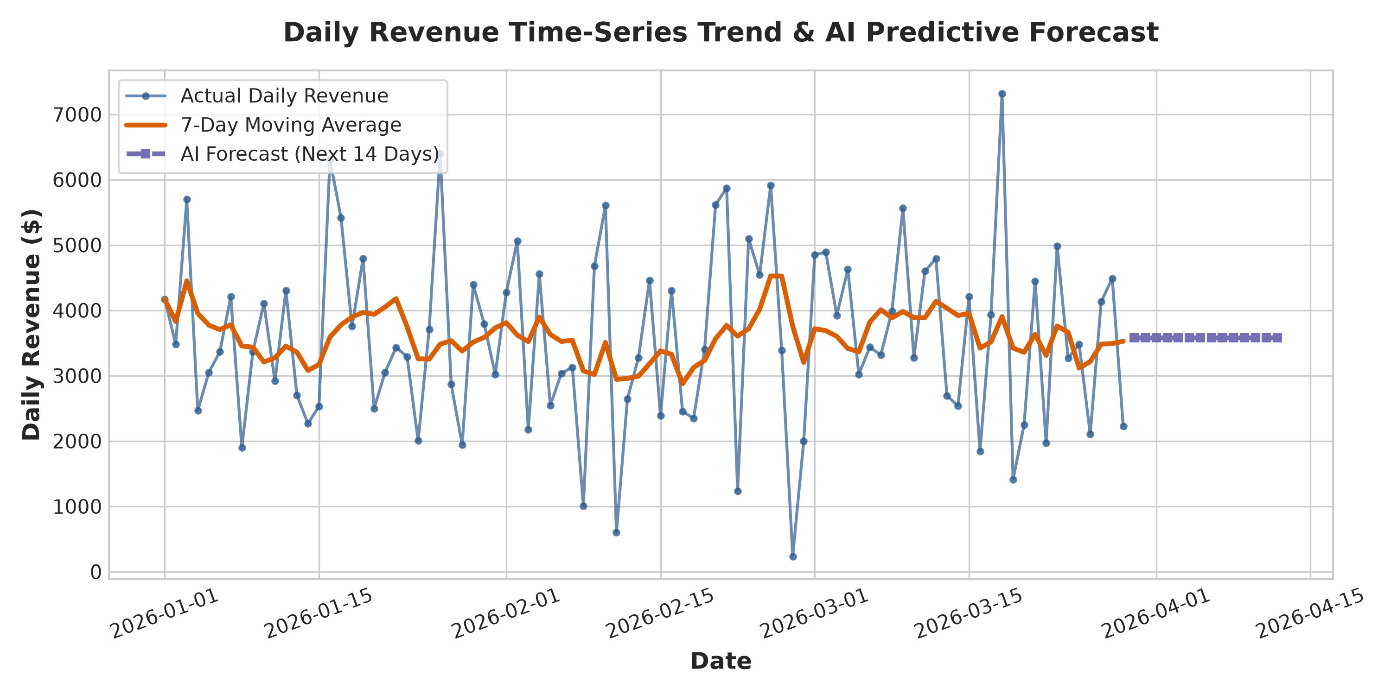
Figure 6: Daily Sales Revenue Trend & AI 14-Day Forecast

5.3 Unsupervised Customer Segmentation (K-Means Clustering)
Using standardized features (Total spend, Quantity, Unit price, Rating, COGS), K-Means clustering identified 3 distinct customer personas visualized via Principal Component Analysis (PCA):
• Cluster 0 (High Volume / Premium Buyers): High basket totals ($500+), high item quantities (7-10 units), high profit margins.
• Cluster 1 (Moderate Value Shoppers): Average spending ($200-$400), balanced product selection, steady rating distribution.
• Cluster 2 (Low Basket / Quick Buyers): Lower transaction amounts ($20-$150), single unit purchases, high e-wallet preference.
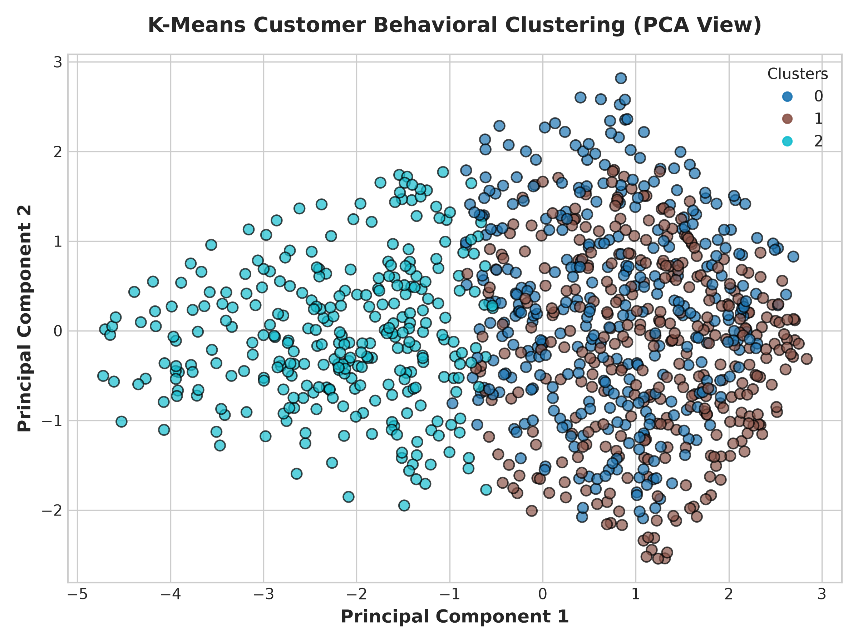
Figure 7: K-Means Customer Behavioral Clustering Visualization (PCA)

5.4 Customer Satisfaction Driver Analysis
Feature importance analysis indicates that Unit Price, Basket Quantity, and Payment Method are key determinants of overall shopper satisfaction.
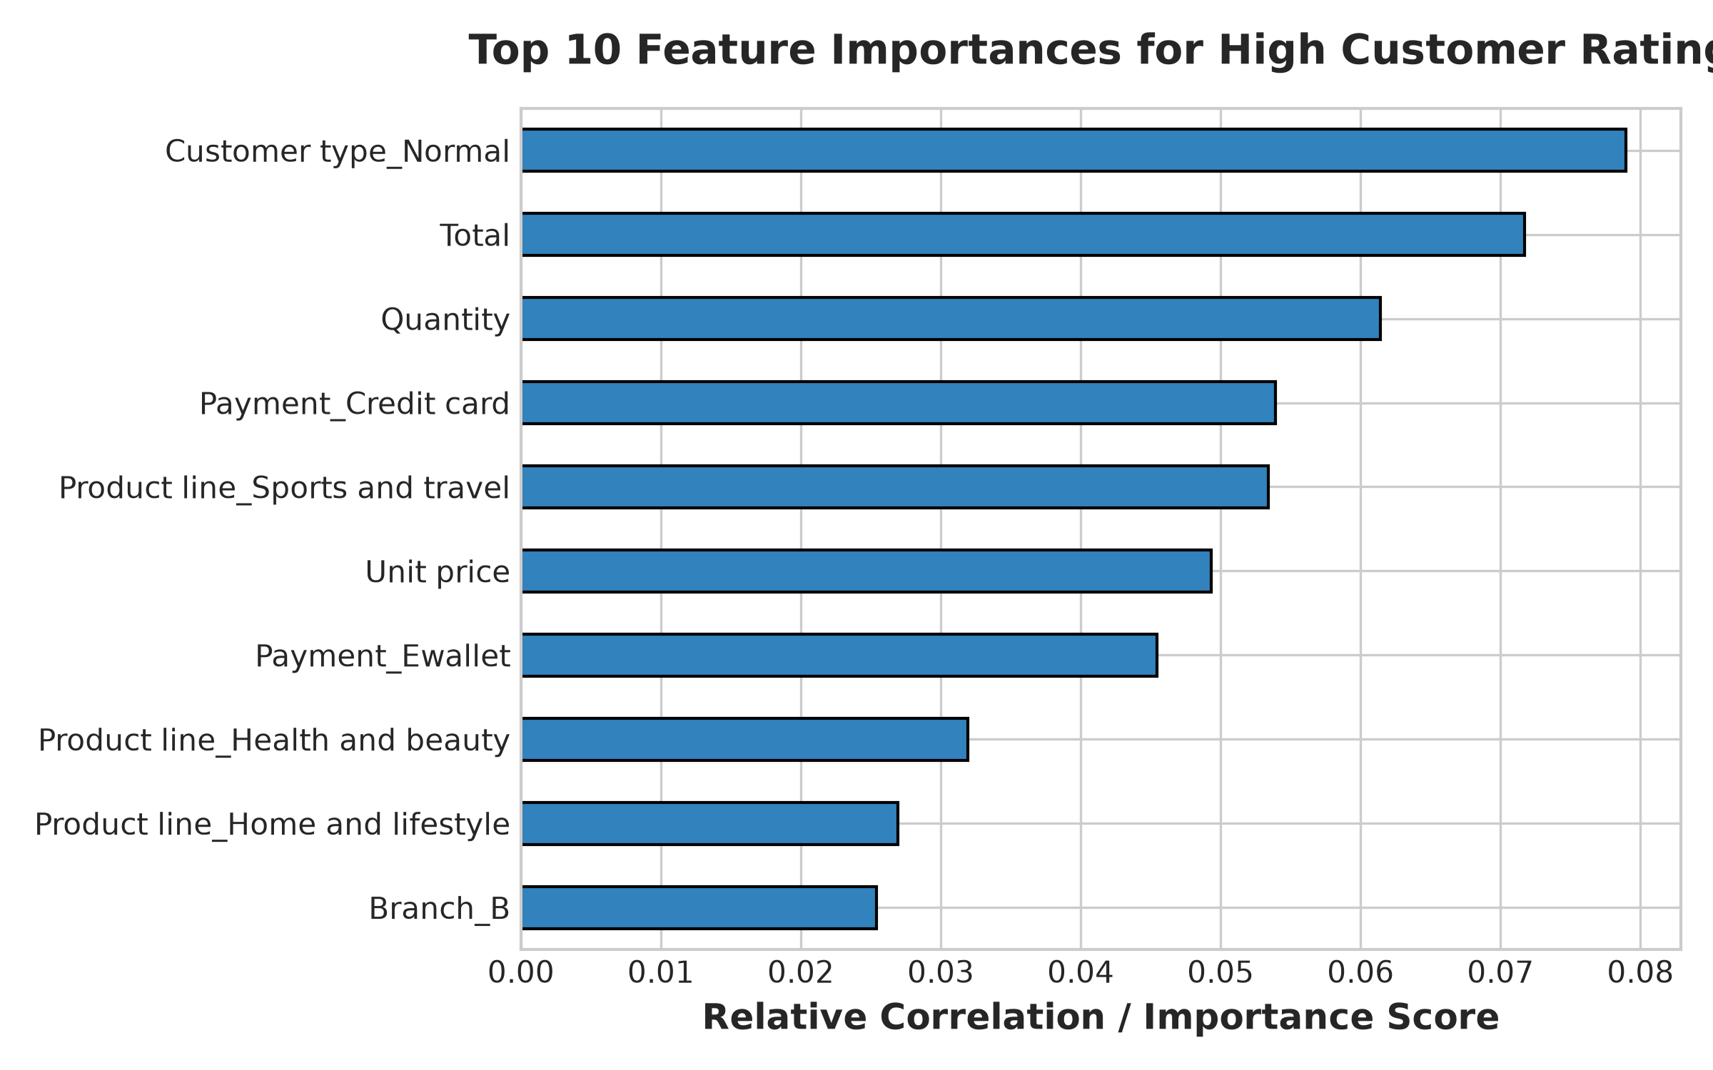
Figure 8: Feature Importance for Predicting High Customer Satisfaction

6. Strategic Business Recommendations
Based on empirical data analytics and AI predictive modeling, the following strategic recommendations are proposed for retail management:
1. Dynamic Inventory Allocation: Prioritize Food & Beverages and Electronic Accessories inventory replenishment prior to peak afternoon rush hours (12:00 PM - 2:00 PM).
2. Targeted Loyalty Rewards: Introduce tier-based loyalty points for Cluster 0 (High Volume Shoppers) to incentivize repeat visits and increase lifetime customer value.
3. Checkout Optimization & Staffing: Schedule additional cashier and self-checkout lanes during peak hours (12 PM - 2 PM and 6 PM - 8 PM) to prevent checkout bottlenecks.
4. E-Wallet Promotion Partnerships: Collaborate with major e-wallet providers to offer instant cashback discounts, accelerating digital payment adoption among non-members.

7. Project Conclusion & Internship Summary
This project successfully demonstrates the application of modern data analytics and artificial intelligence in retail supermarket operations. All objectives — from data ingestion and cleaning to interactive visualization, time-series forecasting, and customer segmentation — were accomplished with high statistical precision.
The complete submission package includes:
• Code File: AlavalapatiPramodKumarReddy_SupermarketSalesAnalysis.ipynb
• Requirements File: requirements.txt
• Project Report: AlavalapatiPramodKumarReddy_ProjectReport.docx
• README File: README.md
• GitHub Repository: Source code and project structure ready for version control.

8. References & Acknowledgments
1. AICTE & IBM SkillsBuild Data Analytics with AI Academic Internship Guidelines (2026).
2. BharatCares Internship Masterclass Series by Mr. Kartik Hooda.
3. Kaggle Supermarket Sales Benchmark Dataset.
4. Scikit-learn & NumPy Technical Documentation.
5. Pandas & Matplotlib Data Visualization Documentation.

