**BATCH -3 REPORT**

**PROVISION SYSTEM FOR REGION BASED JOBS AND**

**FACILITIES USING FULL STACK DEVLOPMENT**

**Week-1 : DATE : 12-09-2023**

**GOAL :** Deciding project goal and Abstract review.

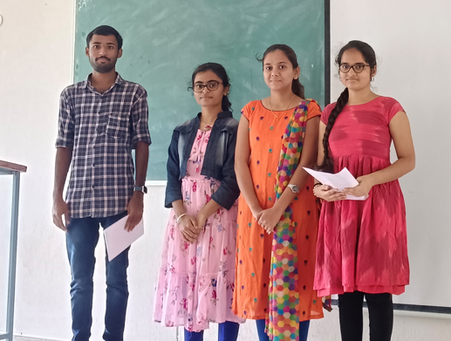

**Project goal:**

The current unemployment crisis highlights the need for solutions that not only connect job seekers with vacancies but also promote local job opportunities. The PROVISION SYSTEM FOR REGION–BASED JOBS AND FACILITIES aims to address this issue by enabling individuals to find work in their local area and support nearby businesses. This technology can be implemented in various local areas and scaled up to serve larger communities. By facilitating local job opportunities and supporting small businesses, this system has the potential to reduce unemployment rates and contribute to local economic growth.

**Abstract review:**

1.Abstract Presentation:

**Pramod Reddy:(**Introduced our batch and our project with some examples.**)**

Our project- PROVISION SYSTEM FOR REGION BASED JOBS AND

FACILITIES USING FULL STACK DEVLOPMENT is a website which provides an interface between producers and consumers in a region . For example , In our busy schedule we might not know where the small business are like carpentry, plumbing or even cycle repairing. So through we can directly contact them and do our work.

**Sayali: (**Explained examples and main objectives.**)**

For example :

1.In our busy schedule we might not know where the small business are like carpentry, plumbing or even cycle repairing. So through we can directly contact them and do our work.

2. A person who wants to work part time registers as driving teacher and a person who needs it for a day finds him through this system and discuss the payment and continue with their jobs.

Main objectives :

1.To create a neat website to show various categories of jobs and businesses present in respected region.

2.To create a smooth communication interface between producers and consumers.

3.To improve the publicity of small regional businesses

4.To reduce unemployment to some extent

The project is planned to be developed in 12 weeks.

**Bhavana**:( Explained week plan of the project)

Week 1 : Deciding project goal and Abstract review.

Week 2: Determining Action Plan and Requirement Analysis.

Week 3,4: Designing and Planning of the project.

Week 5,6,7,8,9 :Coding. (includes frontend, backend and integration).

Week 10,11 : Testing.

Week 12 : implementation and maintenance.

The team is asked to decrease the time taken for the development of project .So the time is decreased to do in 10 weeks by decreasing the time for testing and implementation to 1 week.

**Hasini:(**Explained the methodologies required for project.**)**

Project Planning: Start by defining the project's goals, requirements, and scope. This includes understanding the client's needs and expectations.

Architecture Design: Design the overall structure of the application, including databases, server infrastructure, and user interfaces. Choose the appropriate technologies and frameworks for each layer.

Front-end Development: Develop the user interface (UI) and user experience (UX) components of the application using technologies like HTML, CSS, and JavaScript. This includes creating responsive designs and ensuring cross-browser compatibility.

Back-end Development: Build the server-side logic and database components of the application. Use technologies like Node.js, Python, Ruby, Java, or others depending on your project's requirements. Implement APIs for communication between the front-end and back-end.

Database Design: Create and manage the database schema, ensuring data integrity and security. Use database management systems like MySQL, PostgreSQL, MongoDB, or others as per your project's needs.

Integration: Connect the front-end and back-end components, making sure they work together seamlessly. Implement data retrieval, storage, and manipulation functionalities.

Testing: Perform rigorous testing of the application, including unit testing, integration testing, and user acceptance testing (UAT). Identify and fix bugs and issues.

Deployment: Prepare the application for deployment to a production environment. Configure servers, set up domain names, and ensure security measures like SSL certificates are in place.

Monitoring and Maintenance: Continuously monitor the application's performance and user feedback in the live environment. Address any issues promptly and regularly update the application to add new features or improvements.

Documentation: Maintain clear and up-to-date documentation for your codebase, APIs, and system architecture. This is essential for future development and troubleshooting.

Security: Implement security best practices throughout the development process to protect against common vulnerabilities like SQL injection, Cross-Site Scripting (XSS), and others.

Performance Optimization: Continuously optimize the application's performance by identifying and resolving bottlenecks, minimizing load times, and optimizing database queries.

Scalability: Plan for scalability from the beginning, allowing the application to handle increased traffic and data as it grows.

**The project team received the following advice from the project guide:**

1.To provide the justification to all the tools used in the project.

2.To design the architecture for project planning.