Module-2: Defining the Research Problem Research Problem, Selecting the Problem, Necessity of Defining the Problem, Technique Involved in Defining a Problem, An Illustration, Reviewing the literature: Place of the literature review in research, Bringing clarity and focus to your research problem, Improving research methodology, Broadening knowledge base in research area, Enabling contextual findings, How to review the literature, searching the existing literature, reviewing the selected literature, Developing a theoretical framework, Developing a conceptual framework, Writing about the literature reviewed.

Defining the Research Problem
A researcher must find the problem and formulate it so that it becomes susceptible to research. To define a problem correctly, a researcher must know: what a problem is?
WHAT IS A RESEARCH PROBLEM?
A research problem, in general, refers to some difficulty which a researcher experiences in the context of either a theoretical or practical situation and wants to obtain a solution for the same.
Usually we say that a research problem does exist if the following conditions are met with:
(i) There must be an individual (or a group or an organisation), let us call it ‘I,’ to whom the problem can be attributed. The individual or the organisation, as the case may be, occupies an environment, say ‘N’, which is defined by values of the uncontrolled variables, Y_{j}.
(ii) There must be at least two courses of action, say C₁ and C₂, to be pursued. A course of action is defined by one or more values of the controlled variables.
(iii) There must be at least two possible outcomes, say O₁ and O₂, of the course of action, of which one should be preferable to the other.
(iv) The courses of action available must provides some chance of obtaining the objective, but they cannot provide the same chance, otherwise the choice would not matter. Thus P(O_{j}|I,C_{j},N) represents the probability that an outcome O_{j} will occur, if I select C_{j} in N, P(O₁|I,C₁,N) not equal to P(O₁|I,C₂,N) choices must have unequal efficiencies for the desired outcomes.
The individual is said to have a problem only if “I” does not know what course of action is best, i.e., “I” must be in doubt about the solution.
Thus there will be research problem, if there is one or more desired outcomes, when faced with two or more courses of action that have some but not equal efficiency

We can, thus, state the components of a research problem as under:
(i) There must be an individual or a group which has some difficulty or the problem.
(ii) There must be some objective(s) to be attained at. If one wants nothing, one cannot have a problem. Ex: Does use of technology helps save time
(iii) There must be alternative means (or the courses of action) for obtaining the objective(s)one wishes to attain. This means that there must be at least two means available to a researcher for if he has no choice of means, he cannot have a problem.
Ex: Is television going to survive in digital eye or will it become obsolete like digital camera
(iv) There must remain some doubt in the mind of a researcher with regard to the selection of alternatives. This means that research must answer the question concerning the relative efficiency of the possible alternatives.
(v) There must be some environment(s) to which the difficulty pertains.
A researcher must find out the best solution for the given problem. by which course of action the objective can be attained optimally.
A researcher must find out the best solution for the given problem. by which course of action the objective can be attained optimally.
There are several factors which may result in making the problem complicated:
- environment may change affecting the efficiency of the course of action.
- the number of alternative course of action may be very large.
- persons not involved in making the decision may be affected by it and react to it favorably or unfavorably.

2.2 Selecting the problem
The research problem undertaken for study must be carefully selected. A research guide can at most only help a researcher choose a subject.
The following points may be observed by a researcher in selecting a research problem or a subject for research:
(i) Subject which is overdone should not be normally chosen, for it will be a difficult task to throw any new light in such a case.
(ii) Controversial subject should not become the choice of an average researcher.
Ex:Are cell phones dangerous?, Are law enforcement cameras an invasion of privacy?, Cloning, cyber bullying, politics
(iii) Too narrow or too vague problems should be avoided. Ex: health care
(iv) The subject selected for research should be familiar and feasible so that the related research material or sources of research are within one’s reach.
Ex: How is text messaging affecting teen literacy?
(v) The importance of the subject, the qualifications and the training of a researcher, the costs involved, the time factor are few other criteria that must also be considered in selecting a problem. A researcher must himself ask the following questions.
(a) Whether he is well equipped in terms of his background to carry out the research?
(b) Whether the study falls within the budget he can afford?
(c) Whether the necessary cooperation can be obtained from those who must participate in research as subjects?
(vi) The selection of a problem must be preceded by a preliminary study. This may not be necessary when the problem requires the conduct of a research closely similar to one that has already been done. if the field of enquiry is new then feasibility study must be undertaken.
2.3 NECESSITY OF DEFINING THE PROBLEM.
A proper definition of research problem will enable the researcher to be on the track whereas an ill-defined problem may create hurdles.
Questions like:
- What data are to be collected?
- What characteristics of data are relevant and need to be studied?
- What relations are to be explored?
- What techniques are to be used for the purpose?
Example: impact of texting
Thus defining a research problem properly is a prerequisite for any study and is a step of the highest importance. formulation of the problem is more important than the solution.

2.4 TECHNIQUE INVOLVED IN DEFINING A PROBLEM
Defining a problem involves the task of laying down boundaries within which researcher shall study the problem with a pre-determined objective in view. The researcher should himself pose a question and set up techniques and procedures for throwing light on the question.
research problem should be defined in a systematic manner, giving due weightage to all relating points.
The technique for the purpose involves the undertaking of the following steps generally one after the other:
- statement of the problem in a general way;
- understanding the nature of the problem;
- surveying the available literature
- developing the ideas through discussions;
- rephrasing the research problem into a working proposition.
(i) Statement of the problem in a general way; the guide puts forth the problem in general terms, the researcher narrow it down, the problem stated in broad general way may contain various ambiguities which must be resolved rethinking over the problem, the researcher may undertake some sort of preliminary survey or pilot survey, the feasibility of the solution must also be considered.
(ii) Understanding the nature of the problem; understand the problem origin and nature clearly. discuss the problem with the person who first raised it in order to find out how the problem originally came. if the researcher has stated the problem himself, he should consider what made him to take the general statement of the problem. The researcher should also keep in view the environment within which the problem is to be studied
(iii) Surveying the available literature: all available literature concerning the problem must be surveyed, before the problem definition is given the researcher must be knowledgeable in relevant theories, reports and records and all relevant literature He must devote sufficient time in reviewing of research already undertaken on related problems to identify certain gaps in theories, difficulties in the present study and also analytical shortcomings.
(iv) developing the ideas through discussions: A researcher must discuss his problems with his colleagues and others who have enough experience in the same area of research this is known as experience survey.
This helps the researcher to focus his attention on specific aspect of the field. Discussions will also include the approach to the given problem, techniques that might be used, possible solutions etc.
(v) rephrasing the research problem: once the nature of the problem has been understood, the environment has been defined, discussions over the problem has taken place, and the available literature has been surveyed, rephrasing the problem into operational terms in not difficult task.
The following points must also be observed while defining a research problem.
- Technical terms and words or phrases, with special meanings used in the statement of the problem, should be clearly defined.
- Basic assumptions or postulates (if any) relating to the research problem should be clearly stated
- A straight forward statement of the value of the investigation (i.e., the criteria for the selection of the problem) should be provided.
- The suitability of the time-period and the sources of data available must also be considered by the researcher in defining the problem.
- The scope of the investigation or the limits within which the problem is to be studied must be mentioned explicitly in defining a research problem.
AN ILLUSTRATION
The technique of defining a problem outlined above can be illustrated for better understanding by taking an example as under:
“Why is productivity in Japan so much higher than in India”?
In this form the question has a number of ambiguities such as: What sort of productivity
is being referred to? With what industries the same is related? With what period of time
the productivity is being talked about?
“What factors were responsible for the higher labour productivity of Japan’s manufacturing industries during the decade 1971 to 1980 relative to India’s manufacturing industries?”

This latter version of the problem is definitely an improvement over its earlier version for the various ambiguities have been removed to the extent possible. Further rethinking and rephrasing might place the problem on a still better operational basis as shown below:
“To what extent did labour productivity in 1971 to 1980 in Japan exceed that of India in respect of 15 selected manufacturing industries? What factors were responsible for the productivity differentials between the two countries by industries?”
With this sort of formulation, the various terms involved such as ‘labour productivity’, ‘productivity differentials’, etc. must be explained clearly. The researcher must also see that the necessary data are available.

Reviewing the Literature
In this chapter you will learn about:
The functions of the literature review in research, How to carry out a literature search, How to review the selected literature, How to develop theoretical and conceptual frameworks, How to write a literature review

The place of the literature review in research
Go through the existing literature in order to acquaint yourself with the available body of knowledge in your area of interest. Consolidate your knowledge base and helps you to integrate your findings with existing knowledge, In the initial stages of research it helps you to establish the theoretical roots of your study, clarify your ideas and develop your research methodology. Later in the process, the literature review serves to enhance and consolidate your own knowledge base and helps you to integrate your findings with the existing body of knowledge.
The literature review is an integral part of the research process and makes a valuable contribution to almost every operational step.
In summary, a literature review has the following functions:
- It provides a theoretical background to your study.
- It helps you establish the links between what you are proposing to examine and what has already been studied.
- It enables you to show how your findings have contributed to the existing body of knowledge in your profession.
In relation to your own study, the literature review can help in four ways. It can:
1. bring clarity and focus to your research problem;
2. improve your research methodology;
3. broaden your knowledge base in your research area; and
4. contextualise your findings.
Bringing clarity and focus to your research problem
On the one hand, you cannot effectively undertake a literature search without some idea of the problem you wish to investigate. On the other hand, the literature review can play an extremely important role in shaping your research problem because the process of reviewing the literature helps you to understand the subject area better and thus helps you to conceptualise your research problem clearly and precisely and makes it more relevant and pertinent to your field of enquiry. When reviewing the literature you learn what aspects of your subject area have been examined by others, what they have found out about these aspects, what gaps they have identified and what suggestions they have made for further research. All these will help you gain a greater insight into your own research questions and provide you with clarity and focus which are central to a relevant and valid study.
Improving your research methodology
Going through the literature acquaints you with the methodologies that have been used by others to find answers to research questions similar to the one you are investigating. A literature review tells you if others have used procedures and methods similar to the ones that you are proposing, which procedures and methods have worked well for them and what problems they have faced with them. By becoming aware of any problems and pitfalls, you will be better positioned to select a methodology that is capable of providing valid answers to your research question.
Broadening your knowledge base in your research area
The most important function of the literature review is to ensure you read widely around the subject area in which you intend to conduct your research study. It is important that you know what other researchers have found in regard to the same or similar questions, what theories have been put forward and what gaps exist in the relevant body of knowledge. When you undertake a research project for a higher degree (e.g. an MA or a PhD) you are expected to be an expert in your area of research.
Enabling you to contextualise your findings
Obtaining answers to your research questions is comparatively easy: the difficult part is examining how your findings fit into the existing body of knowledge. How do answers to your research questions compare with what others have found? What contribution have you been able to make to the existing body of knowledge? How are your findings different from those of others? Undertaking a literature review will enable you to compare your findings with those of others and answer these questions.
How to review the literature
you should review the literature in your broad area of interest with the aim of gradually narrowing it down to what you want to find out about. After that the literature review should be focused around your research problem. It can condition your thinking about your study and the methodology you might use, resulting in a less innovative choice of research problem and methodology than otherwise would have been the case.

There are four steps involved in conducting a literature review:
1. Searching for the existing literature in your area of study.
2. Reviewing the selected literature.
3. Developing a theoretical framework.
4. Developing a conceptual framework.
Searching for the existing literature
To search effectively for the literature in your field of enquiry, it is imperative that you have at least some idea of the broad subject area and of the problem you wish to investigate, in order to set parameters for your search. Next, compile a bibliography for this broad area. There are three sources that you can use to prepare a bibliography:
(a) books;
(b) journals;
(c) the Internet.
Books
Though books are a central part of any bibliography, they have their disadvantages as well as advantages. The main advantage is that the material published in books is usually important and of good quality, and the findings are ‘integrated with other research to form a coherent body of knowledge’ The main disadvantage is that the material is not completely up to date, as it can take a few years between the completion of a work and its publication in the form of a book. The best way to search for a book is to look at your library catalogues. Use the subject catalogue or keywords option to search for books in your area of interest. Narrow the subject area searched by selecting the appropriate keywords. When you have selected 10–15 books that you think are appropriate for your topic, examine the bibliography of each one. It will save time if you photocopy their bibliographies. Go through these bibliographies carefully to identify the books common to several of them. If a book has been referenced by a number of authors, you should include it in your reading list, make an annotated bibliography. An annotated bibliography contains a brief abstract of the aspects covered in a book and your own notes of its relevance.

Journals
You need to go through the journals relating to your research in a similar manner. Journals provide you with the most up-to-date information, even though there is often a gap of two to three years between the completion of a research project and its publication in a journal. As with books, you need to prepare a list of the journals you want to examine for identifying the literature relevant to your study. This can be done in a number of ways.
You can:
- locate the hard copies of the journals that are appropriate to your study;
- look at citation or abstract indices to identify and/or read the abstracts of such articles;
- search electronic databases.
Select one of these journals and, starting with the latest issue, examine its contents page to see if there is an article of relevance to your research topic. There are several sources designed to make your search for journals easier and these can save you enormous time. They are:
- indices of journals (e.g. Humanities Index);
- abstracts of articles (e.g. ERIC);
- citation indices (e.g. Social Sciences Citation Index).
Each of these indexing, abstracting and citation services is available in print, or accessible through the Internet. In most libraries, information on books, journals and abstracts is stored on computers. In each case the information is classified by subject, author and title. You may also have the keywords option (author/keyword; title/keyword; subject/keyword; expert/keyword; or just keywords). There are specially prepared electronic databases in a number of disciplines. These can also be helpful in preparing a bibliography. For example, most libraries carry the electronic databases shown in Table 3.1.
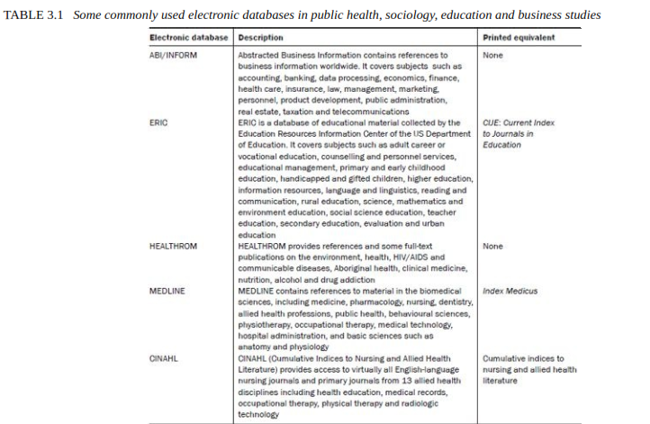
The Internet
An Internet search is carried out through search engines, of which there are many, though the most commonly used are Google and Yahoo. Searching through the Internet is very similar to the search for books and articles in a library using an electronic catalogue, as it is based on the use of keywords. According to Gilbert (2008: 73), ‘Most search facilities use Boolean logic, which allows three types of basic search “AND”, “OR” and “NOT”.’ With practice you will become more efficient and effective in using keywords in combination with AND, OR and NOT, and so learn to narrow your search to help you identify the most relevant references.
Reviewing the selected literature
Now that you have identified several books and articles as useful, the next step is to start reading them critically to pull together themes and issues that are of relevance to your study. Unless you have a theoretical framework of themes in mind to start with, use separate sheets of paper for each theme or issue you identify as you go through selected books and articles. The following example details the process.
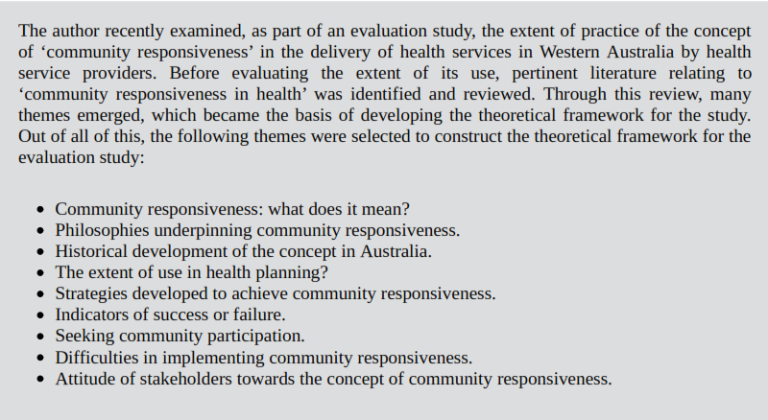
While going through the literature you should carefully and critically examine it with respect to the following aspects: Note whether the knowledge relevant to your theoretical framework has been confirmed beyond doubt. Note the theories put forward, the criticisms of these and their basis, the methodologies adopted (study design, sample size and its characteristics, measurement procedures, etc.) and the criticisms of them. Examine to what extent the findings can be generalised to other situations. Notice where there are significant differences of opinion among researchers and give your opinion about the validity of these differences. Ascertain the areas in which little or nothing is known – the gaps that exist in the body of knowledge.
Developing a theoretical framework
The information obtained from different books and journals now needs to be sorted under the main themes and theories, highlighting agreements and disagreements among the authors and identifying the unanswered questions or gaps. You will also realise that the literature deals with a number of aspects that have a direct or indirect bearing on your research topic. Unless you review the literature in relation to this framework, you will not be able to develop a focus in your literature search: that is, your theoretical framework provides you with a guide as you read. until you go through the literature you cannot develop a theoretical framework, and until you have developed a theoretical framework you cannot effectively review the literature. The solution is to read some of the literature and
then attempt to develop a framework, even a loose one, within which you can organise the rest of the literature you read. Literature pertinent to your study may deal with two types of information:
1. universal;
2. more specific (i.e. local trends or a specific programme).
Look at the example in Figure 3.1a and 3.1b
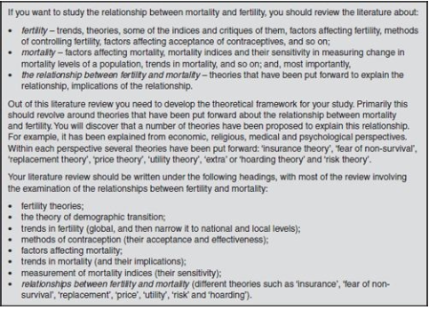
FIGURE 3.1a Developing a theoretical framework – the relationship between mortality and fertility
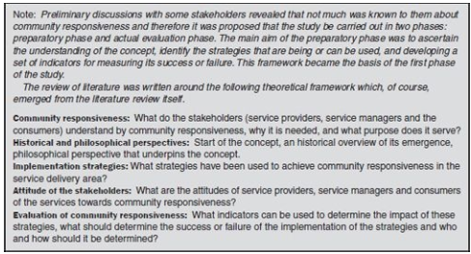
FIGURE 3.1b Theoretical framework for the study ‘community responsiveness in health’
Developing a conceptual framework
The conceptual framework is the basis of your research problem. It stems from the theoretical framework and usually focuses on the section(s) which become the basis of your study. For instance, in the example cited in Figure 3.1a, the theoretical framework includes all the theories that have been put forward to explain the relationship between fertility and mortality. However, out of these, you may be planning to test only one, say the fear of non-survival. Similarly, in Figure 3.1b, the conceptual framework is focused on indicators to measure the success or failure of the strategies to enhance community responsiveness.
Writing about the literature reviewed
Two of the broad functions of a literature review are (1) to provide a theoretical background to your study and (2) to enable you to contextualise your findings in relation to the existing body of knowledge in addition to refining your methodology.
In order to fulfil the first purpose, you should identify and describe various theories relevant to your field; and specify gaps in existing knowledge in the area, recent advances in the area of study, current trends and so on. In order to comply with the second function you should integrate the results from your study with specific and relevant findings from the existing literature by comparing the two for confirmation or contradiction.
While reading the literature for theoretical background of your study, you will realise that certain themes have emerged. List the main ones, converting them into subheadings. Some people write up the entire literature review in one section, entitled ‘Review of the literature’, ‘Summary of literature’ or ‘The literature review’, without subheadings, but the author strongly suggests that you write your literature review under subheadings, These subheadings should be precise, descriptive of the theme in question and follow a logical progression. Figure 3.2 shows the subheadings used to describe the themes in a literature review conducted by the author for a study entitled ‘Intercountry adoption in Western Australia’.
